You are here: [Home](https://emcrit.org/) / [PULMCrit](https://emcrit.org/category/pulmcrit/) / PulmCrit- WHO guidelines regarding fluid administration for coronarvirus are dangerously misguided

PulmCrit- WHO guidelines regarding fluid administration for coronarvirus are dangerously misguided

February 4, 2020 by [Josh Farkas](https://emcrit.org/author/pulmcrit/) [8 Comments](https://emcrit.org/pulmcrit/coronavirus/#comments)



The Surviving Sepsis Campaign is a blight on modern, evidence-based medicine.​1​  It’s been clear for some years that its [fundamentals were flawed](https://emcrit.org/pulmcrit/sepsis-myths/) (centering around rapid, large-volume fluid resuscitation).  Rather than adapt guidelines to modern evidence, the campaign recently doubled down on immediate administration of fluid and antibiotics within one hour.  This provoked widespread protest, including a [petition](https://emcrit.org/pulmcrit/ssc-petition/) to retire the Surviving Sepsis Campaign that garnered over 6,000 signatures.   Whether or not to retire the campaign was openly debated in the journal [CHEST.](https://emcrit.org/wp-content/uploads/2019/02/chestprocon.pdf)​2​

Change takes time, meanwhile the Surviving Sepsis Campaign continues to lumber forward.  One consequence of this is that recommendations in the one-hour sepsis bundle have started to creep into other literature.  If 30 cc/kg fluid and antibiotics are good for septic shock, then perhaps they’re beneficial for other patients?  One example of collateral damage from these guidelines is their mis-application to viral pneumonia.

[](https://twitter.com/PulmCrit/status/1201535910233477121/photo/1)

[528](https://twitter.com/intent/like?tweet_id=1201535910233477121" \o "Like)

[7:17 PM - Dec 2, 2019](https://twitter.com/PulmCrit/status/1201535910233477121)

[Twitter Ads info and privacy](https://support.twitter.com/articles/20175256)

[157 people are talking about this](https://twitter.com/PulmCrit/status/1201535910233477121" \o "View the conversation on Twitter)

I tweeted a joke about this some months ago.  At that point, the idea of giving 30 cc/kg fluid to a patient with viral pneumonia seemed obviously and hilariously misguided.  Well, the joke is on me, because that’s *exactly* what the World Health Organization is recommending for many patients with coronavirus.

World Health Organization (WHO) guidelines regarding fluid administration in coronavirus

Portions of the [current WHO guidelines](https://www.who.int/publications-detail/clinical-management-of-severe-acute-respiratory-infection-when-novel-coronavirus-(ncov)-infection-is-suspected) regarding fluid management are below.  The first two recommendations suggest limiting fluid administration in patients with ARDS and patients who aren’t shocked, to avoid exacerbating pulmonary edema.  These are sensible, evidence-based recommendations.  Notably, these recommendations apply well to patients with coronavirus, whose primary life-threat is ARDS:

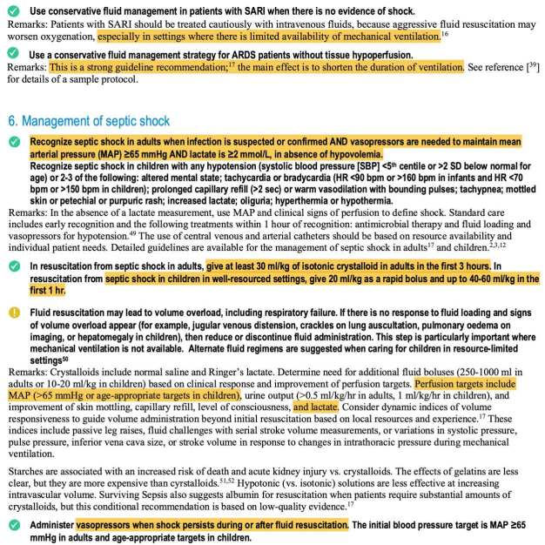

Subsequent recommendations regarding “septic shock” slide off the rails.  First, septic shock is defined as anyone with a MAP <65 mm and lactate >2 mM in the absence of hypovolemia.  Really? Septic shock is ultimately a clinical diagnosis which defies any one-line definition (yes, I know that many definitions exist, but they’re all pretty bad).  This one-liner definition of septic shock fails on two accounts:

* Maintaining a MAP >65 mm is not required to ensure adequate perfusion and organ function.  Lots of people happily live their lives with a baseline MAP below 65 mm (e.g. younger women, patients with heart failure, or patients with cirrhosis).   The recent [65 trial](https://vimeo.com/383967830?utm_source=newsletter_495&utm_medium=email&utm_campaign=ccr20-live-stream-urls) provides RCT-level evidence that maintaining a MAP >65 isn't mandatory.
* Hyperlactatemia is [not generally a measurement of perfusion](https://emcrit.org/pulmcrit/understanding-lactate-in-sepsis-using-it-to-our-advantage/), but more often it merely functions as indicator of endogenous catechol release due to physiologic stress.  It’s common to encounter patients with viral pneumonia and lactate >2 mM due to the stress of having an increased work of breathing.

This definition will result in a large swath of patients being mis-labeled as having “septic shock.”  Unfortunately, the next step is to drown these patients with large volumes of fluid (in a misguided reflex reaction coined the [lacto-bolo reflex](http://jtd.amegroups.com/article/view/34647)).​3​

We are increasingly recognizing that rapid administration of large boluses of fluid is potentially dangerous and [devoid of evidentiary support](https://emcrit.org/pulmcrit/bolus/).   Robust evidence shows that the vast majority of administered fluid will rapidly leave the vasculature, causing tissue edema.  Emerging clinical data from the FEAST trial and Andrews et al. 2017 indicate that an aggressive, fluid-first resuscitation strategy causes harm.​4,5​

An aggressive fluid resuscitation strategy in viral pneumonia is *especially* misguided.  The primary life-threat facing these patients is ARDS (not hypoperfusion, and certainly not hypovolemia).  Perfusion can generally be easily maintained with early administration of low-dose vasopressors and a conservative fluid strategy if necessary (although most patients with viral pneumonia have adequate perfusion to begin with).  Notably, if hyperlactatemia is being driven by dyspnea causing sympathetic activation, this will only be *exacerbated* by fluid (which will worsen the respiratory failure).

Currently little evidence is available about coronavirus, so this post is written as an extrapolation from other forms of viral pneumonia.  However, available reports suggest that the primary cause of morbidity and mortality is usually single-organ respiratory failure.  The largest available study on 2019 Coronavirus reported low rates of septic shock or acute kidney injury upon admission (4% and 3% of patients, respectively) – suggesting that coronavirus by itself doesn’t tend to cause multiorgan failure or septic shock.​6​

Applying the above sepsis guidelines may precipitate respiratory failure, requiring invasive mechanical ventilation.  The Surviving Sepsis Campaign doesn’t seem to be bothered by this.  Indeed, in 2016 the Surviving Sepsis Guidelines recommended intubating some patients *solely* for the *intentional* purpose of giving them additional fluid (I’m not making this up – see the figure below).​7​  Intubation to facilitate fluid administration is exceedingly stupid, because the hemodynamic stresses of sedation and positive pressure ventilation likely outweigh any short-lived benefit from fluid.

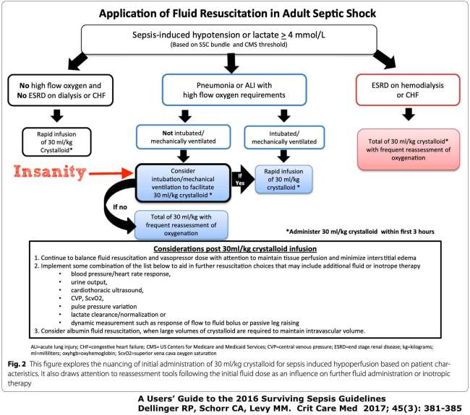

In the event of a coronavirus epidemic, a strategy which increases the rate of intubation would be highly problematic.  Even in well-resourced countries, we could rapidly exhaust our supply of ICU beds and mechanical ventilators (as I write this, there are exactly *two* free beds in my ICU).  Not only is large-volume resuscitation poor care for any individual patient, but it could be catastrophic when leveraged across a patient population during an epidemic.

One parting thought on 30 cc/kg fluid is that at the *very least*, this should be changed to 30 cc/kg *ideal body weight.* It is increasingly common to encounter severe morbid obesity in the intensive care unit, at least in the United States. Administration of 30 cc/kg fluid as a single bolus based on *absolute* body weight may result in insane volumes (for example, a 4-7 liter fluid bolus!). One might hope that common sense would prevent this, but in times of crisis protocols may supersede rationality.



* The Surviving Sepsis Campaign has recommended an aggressive fluid-first resuscitation strategy, despite mounting evidence that fluid boluses are dangerous and usually don’t cause sustained clinical benefit.
* The Surviving Sepsis guidelines have been applied to coronavirus.  In the context of viral pneumonia, large-volume fluid resuscitation may be particularly misguided (since the primary life-threat facing these patients is ARDS).
* In the event of a pandemic of viral pneumonia, any treatment strategy which increases the number of ventilated patients could exhaust available ICU beds (even in well-resourced countries).

references

1.Spiegel R, Farkas J, Rola P, et al. The 2018 Surviving Sepsis Campaign’s Treatment Bundle: When Guidelines Outpace the Evidence Supporting Their Use. *Ann Emerg Med*. 2019;73(4):356-358. doi:[10.1016/j.annemergmed.2018.06.046](https://doi.org/10.1016/j.annemergmed.2018.06.046)

2.Marik P, Farkas J, Spiegel R, Weingart S, collaborating authors. POINT: Should the Surviving Sepsis Campaign Guidelines Be Retired? Yes. *Chest*. 2019;155(1):12-14. doi:[10.1016/j.chest.2018.10.008](https://doi.org/10.1016/j.chest.2018.10.008)

3.Spiegel R, Gordon D, Marik PE. The origins of the Lacto-Bolo reflex: the mythology of lactate in sepsis. *J Thorac Dis*. February 2020:S48-S53. doi:[10.21037/jtd.2019.11.48](https://doi.org/10.21037/jtd.2019.11.48)

4.Andrews B, Semler M, Muchemwa L, et al. Effect of an Early Resuscitation Protocol on In-hospital Mortality Among Adults With Sepsis and Hypotension: A Randomized Clinical Trial. *JAMA*. 2017;318(13):1233-1240. doi:[10.1001/jama.2017.10913](https://doi.org/10.1001/jama.2017.10913)

5. Maitland K, Babiker A, Kiguli S, Molyneux E, FEAST Trial Group. The FEAST trial of fluid bolus in African children with severe infection. *Lancet*. 2012;379(9816):613; author reply 613-4. doi:[10.1016/S0140-6736(12)60260-8](https://doi.org/10.1016/S0140-6736(12)60260-8)

6. Huang C, Wang Y, Li X, et al. Clinical features of patients infected with 2019 novel coronavirus in Wuhan, China. *Lancet*. January 2020. doi:[10.1016/S0140-6736(20)30183-5](https://doi.org/10.1016/S0140-6736(20)30183-5)

7. Dellinger R, Schorr C, Levy M. A Users’ Guide to the 2016 Surviving Sepsis Guidelines. *Crit Care Med*. 2017;45(3):381-385. doi:[10.1097/CCM.0000000000002257](https://doi.org/10.1097/CCM.0000000000002257)