**Clinical scenario N 1.**

Male, 62 years old, lost consciousness in the lobby of the clinic, was transported into procedural room for emergency care.

Clinical examining: no consciousness, no reaction to hail, pathological flexion (lowering) of lower limbs (extremities) when painful stimulation is introduced, pupil response is stored, skin is pale, wet. Shallow irregular breathing, pulse is not performed on the carotid arteries, BP not determined. During auscultation of the heart tones are not bugged.

ECG before you (25 mm/sec):

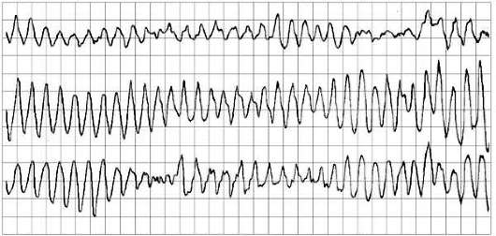

1. Make the preliminary diagnosis.

2. Provide emergency care.

3. Determine further tactics – next step.

Correct answer:

1.Paroxismal ventrical fibrillation

2.Medical aid:

1) cardiopulmonary resuscitation (compression of chest –indirectly heart massaging ) with a frequency of 100–120 per instant and a depth of 5–6 sm, ratio breaths to compression is 2:30)

2) electric pulse therapy(defibrillation) 100-360 J with subsequent ECG –monitoring

3) Amiodarone 300 mg (Sol.Amiodarone5% 6 ml – 2 ampoules) IV (intravenous bolus; repetition if necessary through 5 min 150 mg (Sol. Amiodarone 5%3ml – 1ampoule).

3. Medical call, hospitalization in the intensive care unit ( Intensive Care Unit - ICU) bypassing emergency ward.

**Clinical scenario N 2.**

Female 68years old, lost consciousness near ECG-examining cabinet, was transported into procedure room for emergency care.

According to the daughter report last time her mother felt occasional attacks of dizziness with severe weakness, dyspnea, chest pain .

Objectively: unconscious, no reaction to hail, of eye opening reaction and confused speech when painful stimulation is introduced; skin is pale, limbs cyanosis. Respiration rate is 24 per min, pulse is filiform on the carotid arteries, counting difficult; BP 70/0 mm Hg; During auscultation the heart sounds are deaf.

ECG before you (25 mm/sec):

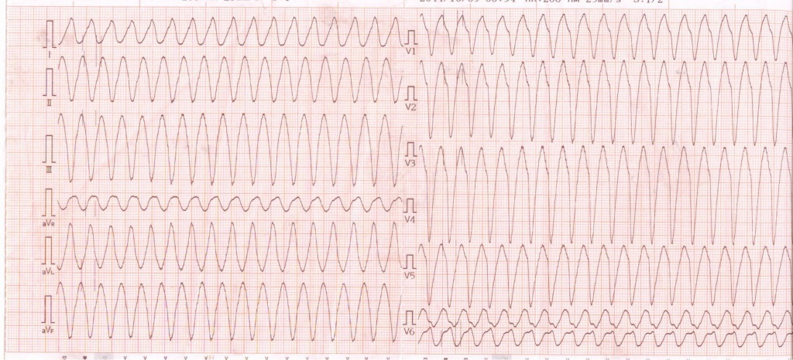

1. Make the preliminary diagnosis.

2. Provide emergency care.

3. Determine further tactics.

Correct answer:

1. Paroxismal ventrical tachycardia

2. Medical aid :

1) Amiodarone 300 mg (5% solution of Amiodarone 6 ml – 2 ampoules ) IV (intravenous bolus; repetition if necessary through 5 min 150 mg (Sol. Amiodarone 5%3ml – 1ampoule)

or

Sol. Procainamide 10% 5-10 ml (up 17 mg/kg) intravenously slowly with Sol. Mesatoni

1% - 0,3-0,5 ml.

3) Medical call, hospitalization in profile office.

**Clinical scenario N 3.**

Male, 56 years old, lost consciousness in the lobby of the clinic, was transported into procedural room for emergency care.

Objectively: skin is pale, limbs cyanosis. Shallow breathing, RR is 22 per min, pulse is filiform on the carotid arteries, counting difficult; BP 60/0 mm Hg, pulse on the peripheral arteries is not carried out; During auscultation the tones of heart deaf, HR is 180 per min, arrhythmic.

ECG before you (25 mm/sec):

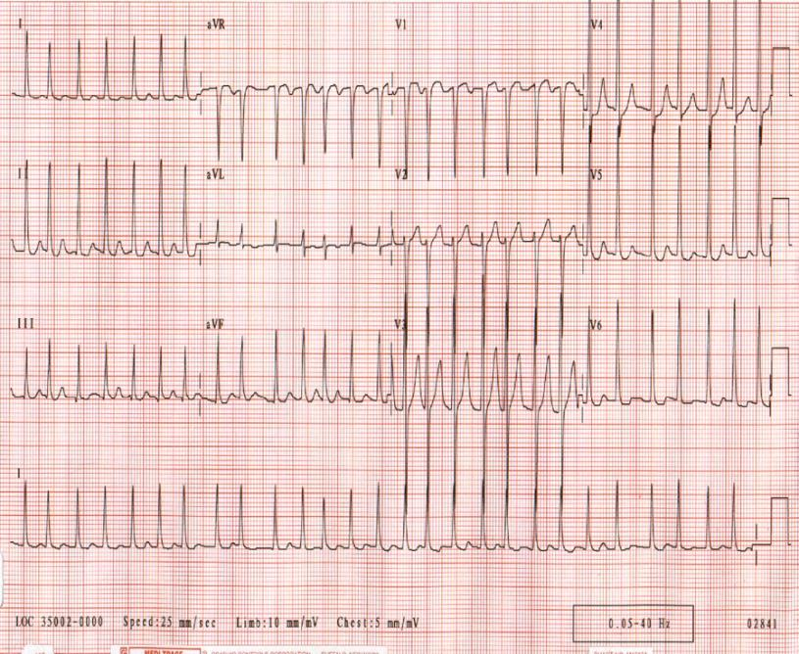

1. Make the preliminary diagnosis.

2. Provide emergency care.

3. Determine further tactics.

Correct answer:

1. Paroxismal atrium fibrillation

2. Medical aid :

1) electric pulse therapy (defibrillation) 100-360 J with subsequent ECG –monitoring

2) Amiodarone 300 mg (Sol. Amiodarone 5% 6 ml – 2 ampoules ) IV (intravenous bolus, repetition if necessary through 5 min150 mg (Sol. Amiodarone 5% 3ml – 1 ampoule)

or

Sol. Procainamide 10% 5-10 ml (up 17 mg/kg) intravenously slowly with Sol. Mesatoni

1% - 0,3-0,5 ml.

3.Medical call, hospitalization in profile office.

**Clinical scenario N 4.**

Female 58 years old, addressed to policlinic department with complains on sharp deterioration in health within the last day, severe weakness, feeling of a lack of air, dyspnea, headache.

According to the daughter her mother last time felt occasional attacks of dizziness with severe weakness, dyspnea, chest pain.

Objectively: clear consciousness, skin is pale, light limbs cyanosis. RR is 22 per min; BP 135/80 mm Hg, PS is arrhythmic 128 per min; during auscultation HR is 142 per min, the heart sounds are deaf, arrhythmic, accent on II tones over an aorta; vesicular breath over lungs, single cracles in back lower departments; abdomen is soft, painless; pastosity of shins and feet.

From anamnesis are noted some similar episodes annually, is under observation of GP.

ECG – example before you (25 mm/sec):

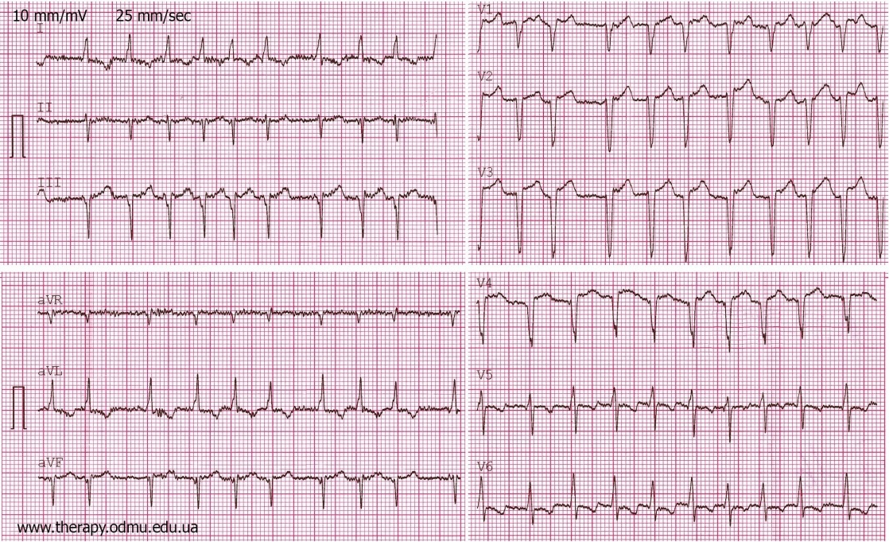

1. Make the preliminary diagnosis.

2. Provide emergency care.

3. Determine further tactics.

Correct answer:

1. Paroxismal atrium fibrillation

2. Medical aid :

1) Sol. Procainamide 10% 5-10 ml (up 17 mg/kg) intravenously slowly with Sol. Mesatoni1% - 0,3-0,5 ml.

or

2) Amiodarone 300 mg (Sol. Amiodarone 5% 6 ml – 2 ampoules ) IV (intravenous bolus; repetition if necessary through 5 min 150 mg (Sol. Amiodarone 5% 3 ml

or

3) using orally medicines of class 1С : Propafenone150-450 mg once

or

Etacizine 50-100 mg if necessary repeated taking trough 1-2 hours;

without serious heart pathology may be added B-blocker – Metoprolol 25-50 mg.

3. Medical call, when positive dynamic is absence hospitalization in profile office. After correct rhythm restoring treatment should be continued under next medical observing at general practitioner.

**Clinical scenario N 5.**

Female 56 years old, addressed to policlinic department with complains on dyspnea, filling of a lack of air, severe common weakness. She notes worsening for last 3 days.

Objectively: clear consciousness, skin is pale, light limbs cyanosis. RR is 18 per min; BP 155/85 mm Hg, PS is rhythmic 65 per min; during auscultation HR is 65 per min, the heart sounds are deaf, accent of II tones over an aorta; systolic murmurs over top of the heart, pulmonary artery, point Botkin-Erb; vesicular breath over lungs, single fine wheezing in back lower departments of left side; abdomen is soft, painless; pastosity of shins and feet.

ECG – example before you (25 mm/sec):

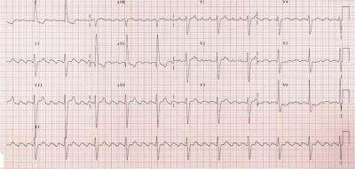

1. Make the preliminary diagnosis.

2. Provide emergency care.

3. Determinefurthertactics.

Correct answer:

1. Paroxismal atrium fibrillation

2. Medical aid :

1) Acidum acetylsalicilicum 250-500 mg chew

2) orally Sotalol160 mg

or

Metoprolol 50-100 mg

Using orally medicines of class 1С : Propafenone 150-450 mg once

or

Etacizine 50-100 mg if necessary repeated taking trough 1-2 hours;

without serious heart pathology may be add B-blocker – Metoprolol 25-50 mg.

3. Medical call, hospitalization in the emergency room in hospital and then to the profile department.

**Clinical scenario N 6.**

Female 38 years old, addressed to policlinic with complains on sharp deterioration of health, common severe weakness, filling of a lack of air, dyspnea, palpitation, chest pain in operating time.

Objectively: clear consciousness, patient is exited, skin is normal color and wet. RR is 23 per min; BP = 115/70 mm Hg, PS is arrhythmic 128 per min; during auscultation HR is 128 per min, the heart sounds are clear; vesicular breath over lungs; abdomen is soft, painless.

ECG – example before you (25 mm/sec):

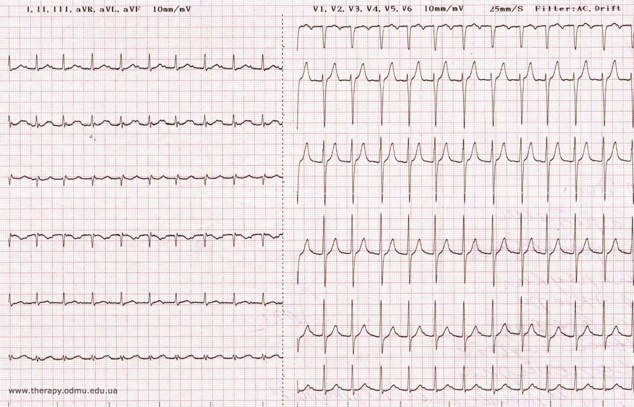

1. Make the preliminary diagnosis.

2. Provide emergency care.

3. Determine further tactics.

Correct answer:

1.Paroxismal supraventrical tachicardia

2. Medical aid:

1) Nervous vagus tests - stimulation (sinocarotis zones and oculus massage, straining)

2) Propranolol 40 mg orally

3. Treatment and next general practitioner medical observing.

**Clinical scenario N 7.**

OPD. Male 42 years old, addressed to GP with complains on morning headache, occasionally (periodically) attack of nausea and dizziness.

It is known from patient’s history that patient had rheumatic miocarditis. While taking blood from a vein for biochemical tests patient lost consciousness. Medical nurse called the GP.

Objectively: skin is pale, cyanosis of nasolabial triangle. Shallow breathing, RR is 22 per min; BP 130/8 mm Hg, pulse on the carotid arteries is rare near 13 per min; during auscultation the heart sounds are deaf, HR is approximate 13 per min.,

ECG – example before you (25 mm/sec):

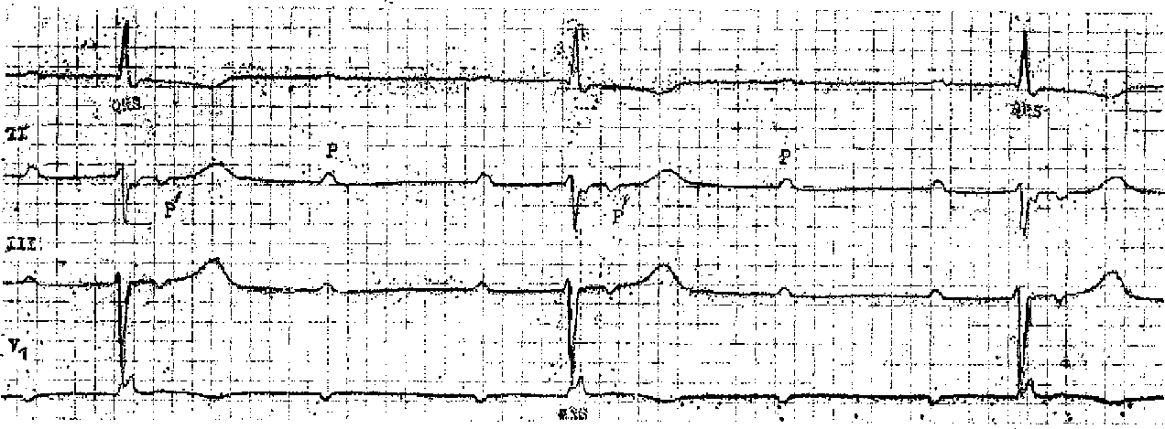

1. Make the preliminary diagnosis.

2. Provide emergency care.

3. Determine further tactics.

Correct answer:

1. Morgagni-Adams –Stokes syndrome

2. Medical aid:

1) Sol. Atropini0,1% - 1 ml in breeding of physiologic solution 10 ml 0,9% intravenous bolus every 3-5 min before positive result.

2) Sol. Adrenalini 0,1% 1 мl in breeding of physiologic solution 10 ml 0,9% intravenous bolus.

3. Medical call, hospitalization in intensive care unit (Intensive Care Unit - ICU) bypassing emergency ward.

**Clinical scenario N 8.**

Male 48 years old, before plan FGDS investigation (preliminary diagnosis - gastro-esophageal disease) felt burning pain in xiphoid process, severe weakness.

Objectively: skin covering is pale, wet (cold sticky sweat), cyanosis of nasolabial triangle. RR is 22 per min; BP = 165/95 mm Hg, peripheral artery pulse is rhythmic 68 per min; over lungs vesicular breathing without wheezing, the heart sounds are deaf, systolic murmur in mitral valve projection, HR is 68 per min; abdomen is soft, light painfull in epigastric area; peripheral edema is absence.

During movement to the ECG- office, the pain increased.

ECG – example before you (25 mm/sec):

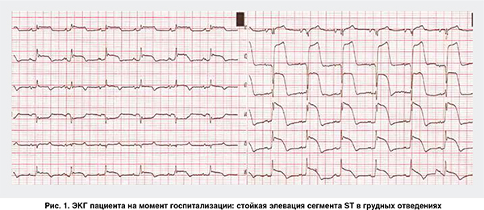

1. Make the preliminary diagnosis.

2. Provide emergency care.

3. Determine further tactics.

Correct answer:

1. Acute Coronary Syndrome with ST-segment elevation.

2. Emergency care:

1) Glyceriltrinitrate (Nitroglycerine) 0,5 mg sublinqually

2) Acidum acetylsalicilicum 250-500 mg chew

3) Sol. Morfini hydrochloridi 1% 1 ml IV or subcutaneously

4) Clopidogrel 300mg (because age of patient <75 years old),

5) Heparini 4000 units intravenous bolus

6) Metoprolol 50-100 mg orally

7) Captopril 6,25-50 mg orally

8) Atorvastatin 40 mg per os

9) Sol. Isosorbid dinitrate 0,1%-10,0 in breeding of physiologic solution 10 ml 0,9% intravenous titration under monitoring systolic BP and HR

3. Medical call, hospitalization in intensive care unit (Intensive Care Unit - ICU) bypassing emergency ward.

**Clinical scenario N 9.**

Female 64 years old having type 2 DM and AH 2 degree, risk 4 addressed to GP with complains on occasional chest pain. Deterioration of state P. notes for last week.

According to the daughter her mother last time felt occasional attacks of dizziness with severe weakness, dyspnea, chest pain.

Objectively: clear consciousness, skin is pale, light limbs cyanosis. Respiration rate is 21 per min; BP 180/95 mm Hg, on radial artery pulse is rhythmic 88 per min; during auscultation vesicular breath over lungs, fine wheezing in right back lower departments;the heart sounds are deaf, systolic murmur in aortic and mitral valves projection, HR is 88 per min;

abdomen is soft, painless; pastosity of shins and feet.

While ECG–investigation severe burning retrosternal pain was appeared.

ECG – example before you (25 mm/sec):

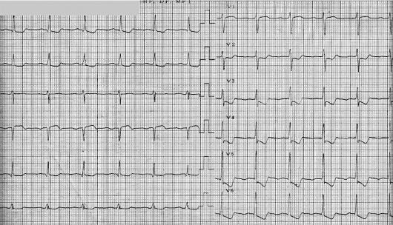

1. Make the preliminary diagnosis.

2. Provide emergency care.

3. Determine further tactics.

Correct answer:

1. Acute coronary syndrome without ST-segment elevation

2. Emergency care:

1) Glyceriltrinitrate (Nitroglycerine) 0,5 mg sublinqually

2) Acidum acetylsalicilicum 250-500 mg chew

3) Sol. Morfini hydrochloridi 1% 1 ml IV or subcutaneously

4) Clopidogrel 300mg (because age of patient <75 years old),

5) Heparini 4000 units intravenous bolus

6) Metoprolol 50-100 mg orally

7) Captopril 6,25-50 мg per os

8) Atorvastatin 40 mg per os

9) Sol. Isosorbide dinitrate 0,1%-10,0 in breeding of physiologic solution 10 ml 0,9% intravenous titration under monitoring systolic BP and HR – stationary stage.

3. Medical call, hospitalization in the emergency room in hospital.

**Clinical scenario N10.**

Male73 years old, addressed to GP for prescription of medicines in connection with IHD, postmyocardial cardiosclerosis and heart insufficiency.

Suddenly P. felt a lack of air, increasing dyspnea, appeared paroxysmal cough, firstly- dry and then - with frothy sputum discharge.

Patient immediately was transported to GP office, procedure room.

Objectively: clear consciousness, excited, occupies a forced sitting position; skin is pale, light limbs cyanosis, neck vein swelling. Respiration rate is 26 per min; during auscultation mixed wet rales in the lower and middle parts of lungs,; the heart sounds are deaf, protodiastolic gallop rhythm, BP 140/60 mm Hg, on radial artery pulse is rhythmic 120 per min;

abdomen is soft, painless; pastosity of shins and feet.

ECG – example before you (25 mm/sec):

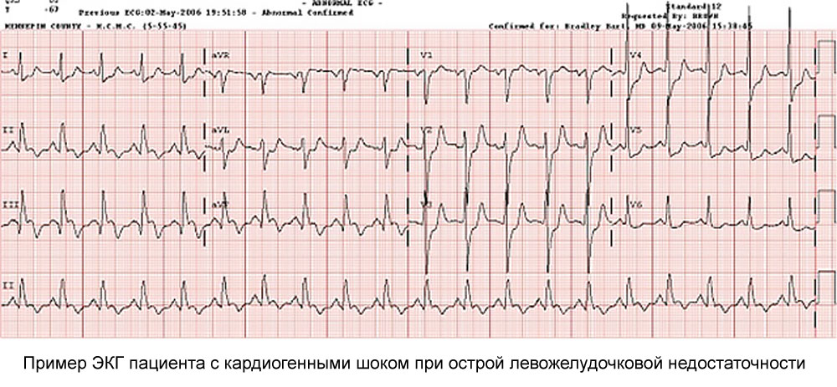

1. Make the preliminary diagnosis.

2. Provide emergency care.

3. Determine further tactics.

**Correct answer:**

1. Pulmonary edema, acute right ventricle failure.

2. Emergency care:

1) Furosemide 40-100 mg intravenously (2-5 ampoules);

2) Sol.Morfini.hydrochloridi 1% 1 ml IV inbreedingofphysiologicsolution 10 ml 0,9%

3) Glyceriltrinitrate (Nitroglycerine) 0,5 mg sublinqually each 15-20 min under BP checking up.

3. Medical call, hospitalization in intensive care unit (Intensive Care Unit - ICU) bypassing emergency ward.

**Clinical scenario N 11.**

Male 54 years old, the builder, was transferred to GP-office from working place with suddenly appeared severe dyspnea, chest pain, interruptions in heart work, heaviness in right upper corner. Worsening of feeling during intensive physical exertion connected with professional duty of patient although from early morning patient was not very well.

Objectively: overweigh, clear consciousness, excited, occupies a forced sitting position; skin and limbs are cyanosis, neck vein swelling. RR is 30 per min; PS is frequent, small feeling and strength, 126 per min; during auscultation the heart sounds are deaf, HR is 126 per min, accent II tone under pulmonary artery, gallop rhythm, systolic murmur at the base of the bovine (xiphoid) process increasing during inspiration; BP = 80/30 mm Hg; abdomen is soft, painless, increased in volume; liver protrudes from-under edge of right rib arc by +3 sm; pastosity of shins and feet; varicose extension of vein of both heads with hyperpigmentation and some trophic skin changes;

ECG – example before you (25 mm/sec):

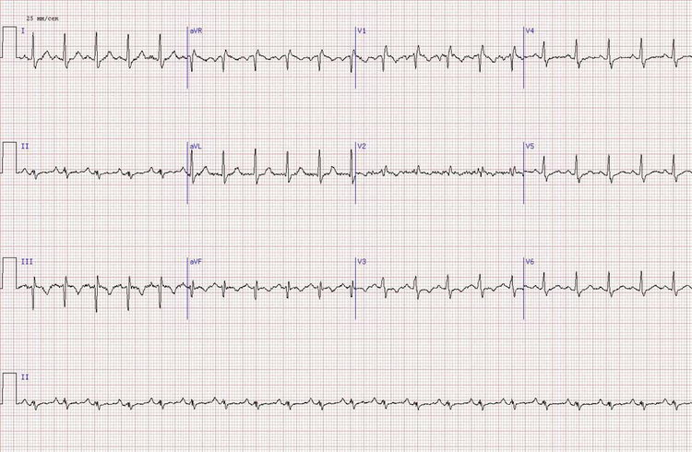

1. Make the preliminary diagnosis.

2. Provide emergency care.

3. Determine further tactics.

**Correct answer:**

1. Pulmonary edema. Acute right ventricle failure.

2. Emergency care:

1) Dopamine 4%-5,0 IV by drop infusion in breeding of physiologic solution 200 ml 0,9% under constant BP-level control;

2) Furosemide 40-100 mg intravenously (2-5 ampoules);

3) Sol. Morfini hydrochloridi 1% 1 ml IV in breeding of physiologic solution 10 ml 0,9%

4) Glyceriltrinitrate (Nitroglycerine) 0,5 mg sublinqually each 15-20 min (BP control).

5) Acidum acetylsalicilicum 250-500 mg chew;

6) Clopidogrel 300mg (because age of patient <75 years old),

7) Heparini 4000 units intravenous bolus;

3. Medical call, hospitalization in intensive care unit (Intensive Care Unit - ICU) bypassing emergency ward.

**Clinical scenario N 12.**

Female 49 years old, the accountant, was brought to GP-office from patient’s working place with severe headache, palpitation, common shiver and sharp weakness after serious emotional-psychological problems.

P. is on the dispansery register in connect with AH II degree risk 2, regularly takes Enalapril 10 mg twice a day.

Objectively: normal constitution, clear consciousness, excited, face hyperemia is noted, skin is dry. RR rate is 19 per min, vesicular breathing; BP = 220/110 mm Hg, PS on radial artery is rhythmic 85 per min; the heart sounds are clear, accent over an aorta; abdomen is soft, painless; pastosity of shins and feet.

ECG – example before you (25 mm/sec):

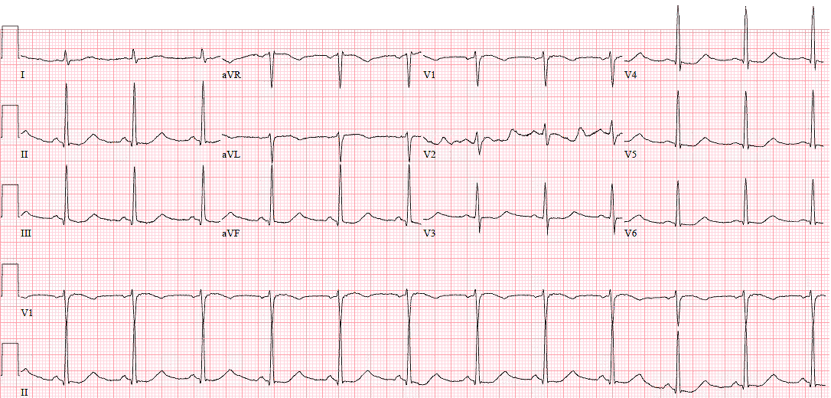

1. Make the preliminary diagnosis.

2. Provide emergency care.

3. Determine further tactics.

**Correct answer:**

1. Hypertensive crises noncomplicated

2. Emergency care:

1) Clonidine 0,75 -0,15 mg per os

or

0,01% Clonidine solution (0,5 -1ml) intramuscular or IV,

or

Nifedipine 5-10 mg sublingually,

or

Captopril 25-50 mg per os,

or

Propranolol 40 mg per os,

or

Enalapril IV 0,5-1 ml

3.Treatment, long term management and further medical observing at GP.

**Clinical scenario N 13.**

Male 55 years old having AH II degree risk 3 lost a consciousness during passing a driving commission at the policlinic department.

Patient was transferred into procedure room for rapid necessary diagnostics and emergency medical assistance.

Objectively: overweigh, consciousness is absent without any reaction on voice of a doctor, on pain irritant – non-member speech, an extension of extremities, in case of bar irritation of the skin of the outer edge of the foot, the extension of the thumb, stiff neck; face hyperemia, skin is wet, pupils are expanded, a sluggish reaction to light; vesicular breathing over both lungs, RR about 19 per min with respiratory standstill periods; BP= 270/120 mmHg, HR is 56 beats per min, heart sounds are clear, accent of II tone over aorta; abdomen is soft;

ECG – example before you (25 mm/sec):

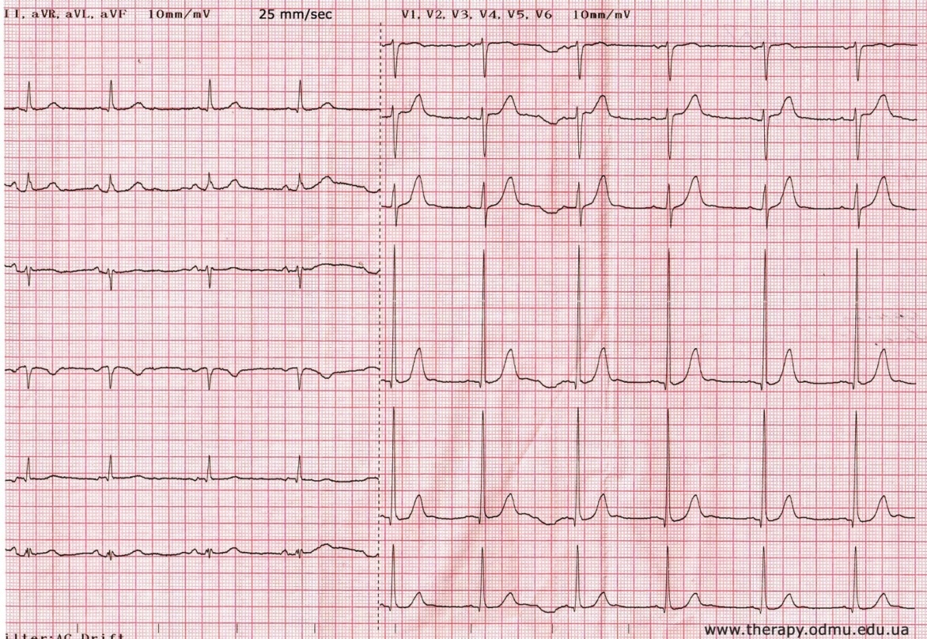

1. Make the preliminary diagnosis.

2. Provide emergency care.

3. Determine further tactics.

**Correct answer:**

1. Hypertensive crises complicated

2. Emergency care:

1) Furosemide 40-100 mg intravenously (2-5 ampoules);

2) Solution of Magnii sulfatis 20% (5-20 ml) IV

3. Medical call, hospitalization in intensive care unit (Intensive Care Unit - ICU) bypassing emergency ward.

**Clinical scenario N 14.**

OPD. Female 44 years old, library worker, suffers allergic bronchial asthma without regular basic treatment.

Complains on sudden onset of severe cough, lack of air, increasing dyspnea during walking in the park. Used Salbutamol inhalation without improvement.

Worsening of feeling, disturbance (violation) of an exhalation for last 3 days.

Objectively: overweight, excited, skin is pale, cyanosis of nasolabial triangle, neck vein swelling. RR is 25 per min, breathing noisy, exhalation is difficult, multiple diffuse dry whistling wheezes across all lung fields; BP = 150/80 mm Hg, PS on radial artery is rhythmic 90 per min; the heart tones are muffled; abdomen is soft, painless;

ECG – example before you (25 mm/sec):

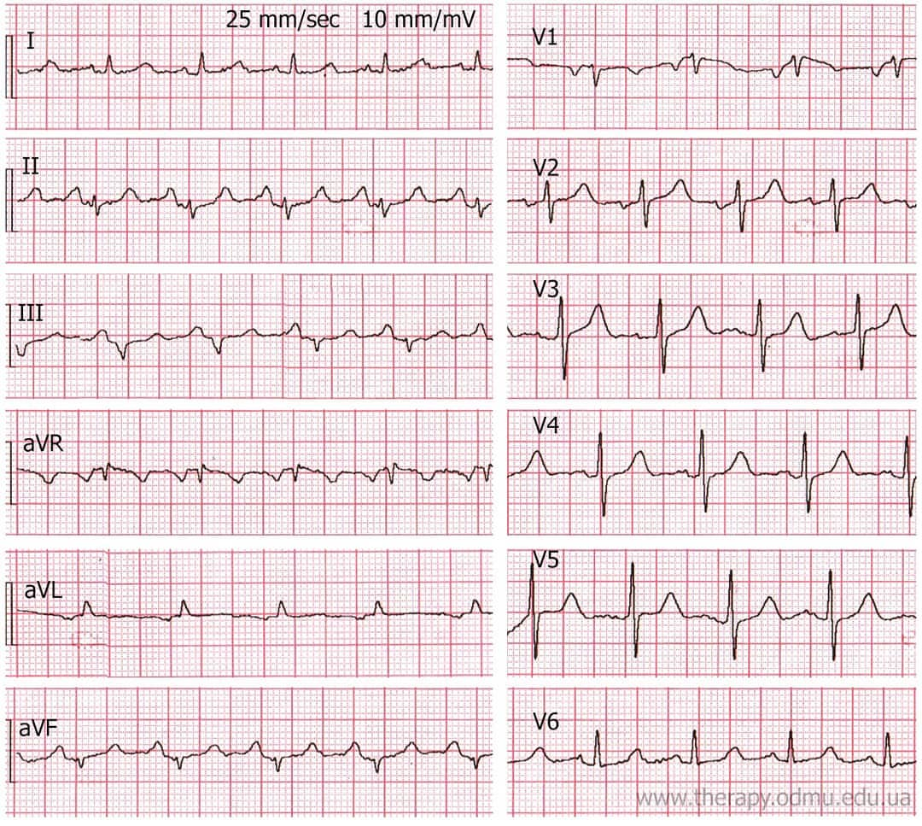

1. Make the preliminary diagnosis.

2. Provide emergency care.

3. Determine further tactics.

**Correct answer:**

1. Acute attack of bronchial asthma.

2. Emergency care:

1) Berodual – inhalation through nebulizer;

2) Prednisolon 60-150 mg (2 -5 ml) IV bolus;

3) Sol. Euphillini 2,4%-10,0 ml IV bolus

3. Treatment, further medical observing and long term management at GP.

**Clinical scenario N 15.**

Home visit. Influenza epidemic situation.

Male 38 years old, driver, presents sharp weakness, feeling of the heat, severe headache, dry painful cough, muscle, joints and eyes pain.

Objectively: clear consciousness, slowed down, answers on questions slowly with difficulty with closed yeses, skin covering are hyperemic, hot to the touch; T= 40,2°С; during auscultation - shallow rigid breathing, without (rattles, crackles) wheezes, RR rate is 22 per min, BP 100/60 mm Hg, PS on radial artery is rhythmic 125 per min; the heart tones are muffled; abdomen is soft, painless; edema is absence.

ECG – example before you (25 mm/sec):

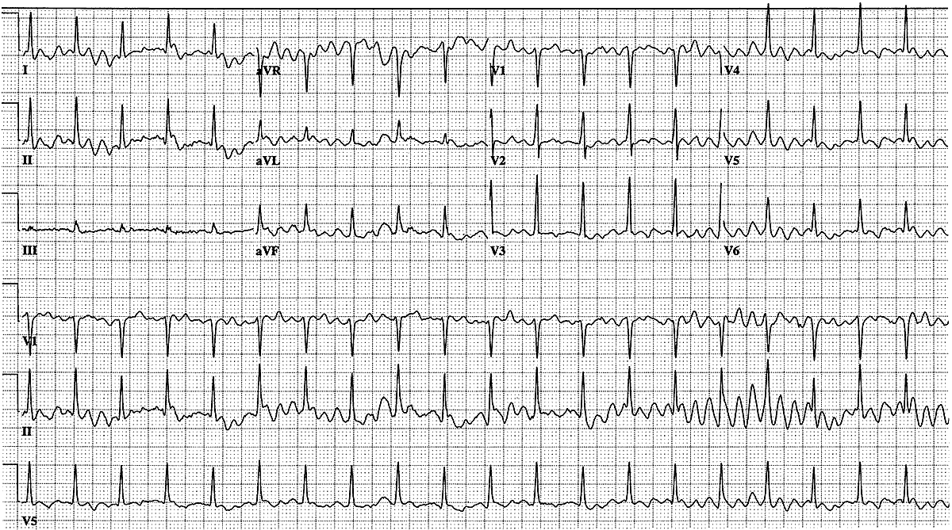

1. Make the preliminary diagnosis.

2. Provide emergency care.

3. Determine further tactics.

**Correct answer:**

1. Hypertermic syndrome.

2. Emergency care:

1) Ketorolac 3% -1,0 ml IV;

3. Treatment, further close medical observing at GP.

**Clinical scenario N 16.**

Female 46 years old, addressed to GP with complains on abdomen pain which appeared yesterday in umbilical region without any visible causes.

At night P. notes nausea once and temperature rise to 37,4 degree.

Objectively: normal constitution, clear consciousness, excited, takes the forced position sitting bent; skin is pale, RR is 30 per min; pulse is 90 per min; BP 110/75 mm Hg; during auscultation the heart sounds are clear, vesicular breathing over both lungs; abdomen (the stomach) is intense, painful in epigastric region and in the right iliac with sharp increasing in pain when after deep palpation sudden relief of pressure; while abdomen palpation was conducted pulse suddenly increased to 120 beats per min.

ECG – example before you (25 mm/sec):

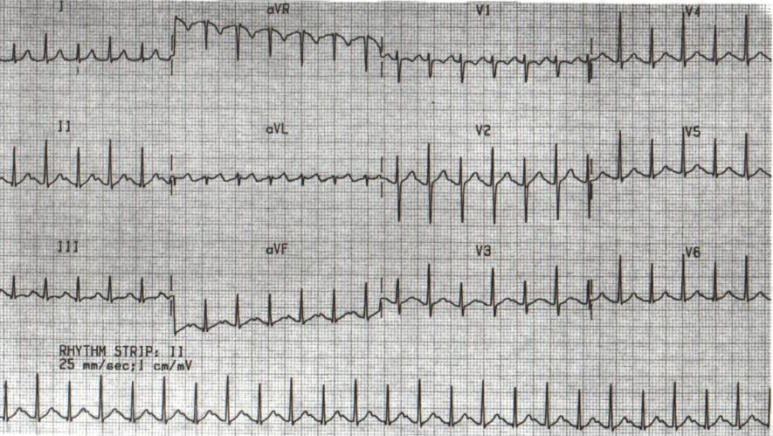

1. Make the preliminary diagnosis.

2. Provide emergency care.

3. Determine further tactics.

**Correct answer:**

1. “Acute abdomen”

2. Emergency care:

1) “Cold” on a stomach (hot-water bottle with ice);

2) Hunger and rest;

3. Emergency call, delivery to hospital reception for more accurate diagnosis and consultation of the necessary specialists.

**Clinical scenario N 17.**

OPD. Male 56 years old, builder, addressed to GP with complains on substernal acute pain with heartburn, vomiting with some blood impurity yesterday, common weakness, dyspnea.

The P. smokes and excessively takes alcohol, 2 years ago hepatic cirrhosis with portal hypertension was diagnosed.

Objectively:

ECG – example before you (25 mm/sec):

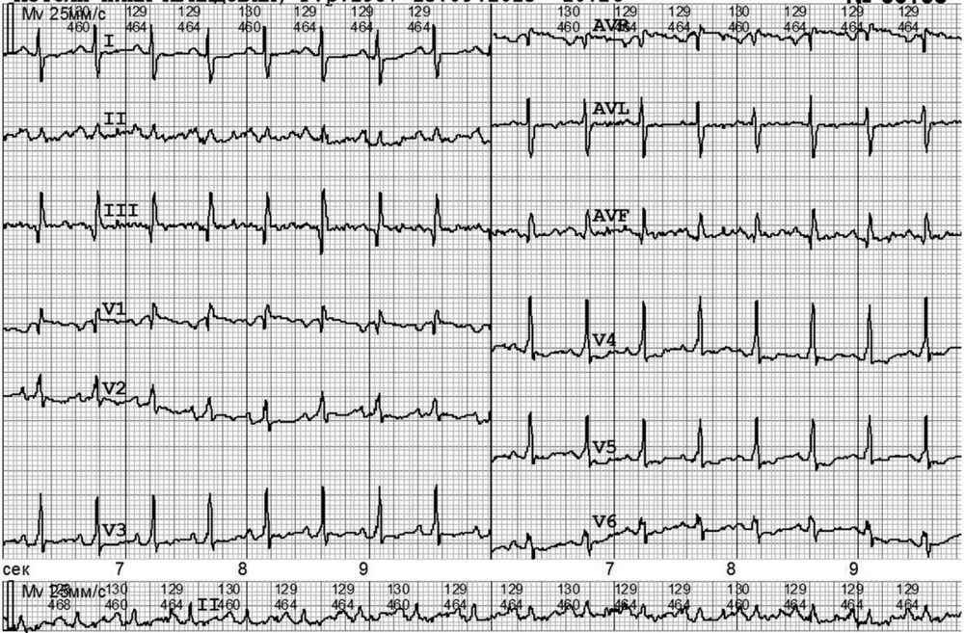

1. Make the preliminary diagnosis.

2. Provide emergency care.

3. Determine further tactics.

**Correct answer:**

1. Gastro-intestinal bleeding

2. Emergency care:

1) IV infusion of electrolite solutions;

2) Sol. Etamzilati natrii12,5% - 2-4 ml IV;

3) Phenilnephrine (Mezaton) 1%-1 ml in 800 мl 5% Glucose

4) “Cold” on a stomach (hot-water bottle with ice);

3. Emergency call, delivery to hospital reception for more accurate diagnosis and consultation of the necessary specialists.

**Clinical scenario N 18.**

Female 35 years old, addressed to GP with complains on sharp pain in right upper abdominal region, suddenly appeared after dinner.

Objectively: normal constitution, clear consciousness, excited; skin is usual color and humidity, RR is 18 per min; PS is rhythmic 115 per min; BP = 120/80 mm Hg; during auscultation the tones of heart are clear, vesicular breathing over both lungs; abdomen (the stomach) is tense, painful in the right sub-rib; Ortner’s symptom; peripheral edema is absent.

ECG – example before you (25 mm/sec):

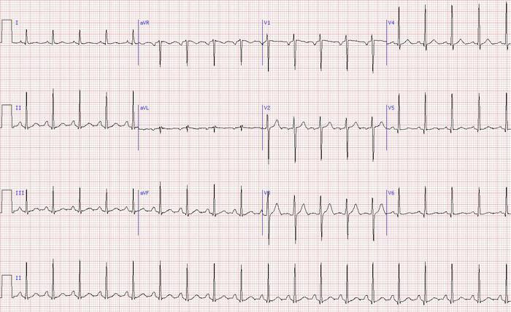

1. Make the preliminary diagnosis.

2. Provide emergency care.

3. Determine further tactics.

**Correct answer:**

1. Hepatic colic

2. Emergency care:

1) Sol. Drotaverini 2% 2,0-4,0 ml IV bolus

2) IV infusion of electrolite solutions;

3. Emergency call, delivery to hospital reception for more accurate diagnosis and consultation of the necessary specialists.

**Clinical scenario N 19.**

OPD. Male 52 yars old, teacher, addressed to GP with complains on sharp pain in right lumbar region, which appeared suddenly during walking to school, frequent urination with constant desires to urination, change of urea color - from pink to red.

Objectively: overweight, clear consciousness, exited, can’t sit down, goes along the doctor’s office and tries find optimal position to decrease pain; skin is usual color, wet, hyperemic and bloated face, RR is 17 per min; pulse is arrhythmic 65-70 per min; BP 160/95 mm Hg; during auscultation the tones of heart are muffled, accent II tone over aorta; vesicular breathing over both lungs; abdomen (the stomach) is soft, sharp painful in right kidney projection, syndrome of pounding on the right rib arch from behind (back side) is positive, frequent urination; pastosity of shins (legs) and feet.

ECG – example before you (25 mm/sec):

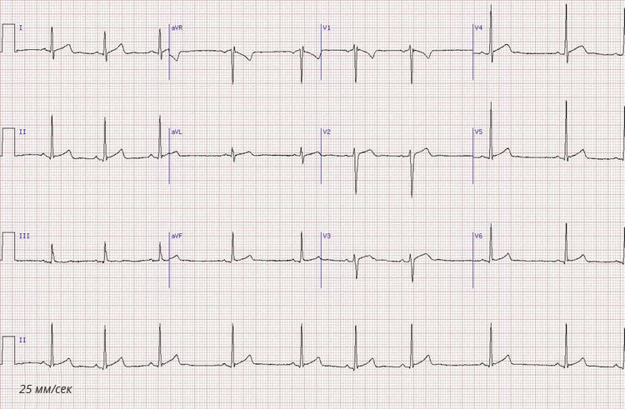

1. Make the preliminary diagnosis.

2. Provide emergency care.

3. Determine further tactics.

**Correct answer:**

1. Renal colic

2. Emergency care:

1) Sol. Drotaverini 2% 2,0-4,0 ml IV bolus

3. Emergency call, delivery to hospital reception for more accurate diagnosis and consultation of the necessary specialists.

**Clinical scenario N 20.**

Male 42 years old lost consciousness in procedure room during IV injection of Ceftriaxone.

Medical nurse stopped injection and duty doctor called by medical staff arrived to render emergency care.

Objectively: patient lies down without consciousness, overweight; skin is cyanotic color, the wheezing breath, pulse on radial artery is not carried out, BP is not defined;

ECG – example before you (25 mm/sec):

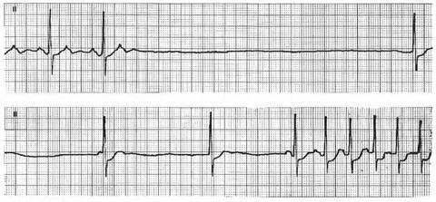

1. Make the preliminary diagnosis.

2. Provide emergency care.

3. Determine further tactics.

**Correct answer:**

1. Anaphylactic shock

2. Emergency care:

1) Epinephrini IV 0,5 ml in breading tо 20 ml 0,9% physiological solution

2) cardiopulmonary resuscitation (compression of chest –indirectly heart massaging ) with a frequency of 100–120 per instant and a depth of 5–6 sm, ratio breaths to compression is 2:30)

3) physiological solution IV – infusion

4) Prednisoloni 60-150 mg IV bolus (2-5 ampules)

5) Difenhydramine 25–50 mg intramascularly

3. Medical call, hospitalization in the anesthesiology and intensive care unit ( Intensive Care Unit - ICU) bypassing emergency ward.

**RESPONSE OPTIONS**

Response options for all clinical tasks are unified.

On question N 1 only 1 correct answer is possible from the proposed set of variants. Correct answer gives 33,33% from 100%.

On question N 2 for each clinical task from 1 to 9 variants of answers are possible.

Correct answer gives 50% if not complete answer differentiation of value possible from 5,56 tо 44,44%.

On question N 3 only 1 correct answer is possible from the proposed set of variants. Correct answer gives 16,67%.

Answer N 1:

Anaphilactic shock

Bronchial asthma, acute attack

Hyperglicemic coma

Hypertermic syndrome

Hypertensive crises uncomplicated

Hypertensive crises complicated

Gastro-intestinal bleeding

Venricle extrasystolia

Coma of unclear genesis

ACS without ST-elevation

ACS with ST-elevation

Ortostatic collaps

Acute pneumonia

«Acute abdomen»

Pulmonary edema. Acute left ventricle failure.

Pulmonary edema. Acute right ventricle failure.

Paroxismal ventricle tachycardia

Paroxismal supraventricle tachycardia

Paroxismal atrial fibrillation

Paroxismal ventricle fibrillation

Hepatic colic

Morgagni -Adams-Stokes syndrome

Renal colic

Answer 2

Atorvastatin 40 mg per os

Sol. Atropini0,1% - 1 ml in breeding of physiologic solution 10 ml 0,9% intravenous bolus every 3-5 min before positive result.

Sol.Adrenalini 0,1% 1мl in breeding of physiologic solution 10 ml0,9% IV bolus.

Amiodarone 300 mg (Sol.Amiodarone5% 6 ml – 2 ampoules) IV (intravenous bolus; repetition if necessary through 5 min 150 mg (Sol. Amiodarone 5%3ml – 1ampoule).

Acidum acetylsalicilicum 250-500 mg chew

Berodual – inhalation through nebulizer;

Heparini 4000 units intravenous bolus

Glyceriltrinitrate (Nitroglycerine) 0,5 mg sublinqually

Glyceriltrinitrate (Nitroglycerine) 0,5 mg sublinqually each 15-20 min (BP control).

Hunger and rest;

Difenhydramine 25–50 mg intramascularly

Dopamine 4%-5,0 IV by drop infusion in breeding of physiologic solution 200 ml 0,9% under constant BP-level control;

Sol. Drotaverini 2% 2,0-4,0 ml IV bolus

Sol. Isosorbid dinitrate 0,1%-10,0 in breeding of physiologic solution 10 ml 0,9% intravenous titration under monitoring systolic BP and HR

IV infusion of electrolite solutions;

IV infusion of physiologic solution 200 ml 0,9%

Captopril 6,25-50 mg orally

Captopril 25-50 mg per os,

Ketorolac 3% -1,0 ml IV;

Clopidogrel 300mg ( age of patient <75 years old), 75 mg (age of patient >75 years old)

Clonidine 0,75-0,15mg per os or 0,01% Clonidine solution (0,5-1ml) intramuscular or IV,

Metoprolol 50-100 mg orally

Solution of Magnii sulfatis 20% (5-20 ml) IV

Sol. Morfini hydrochloridi 1% 1 ml IV or subcutaneously

Sol. Morfini hydrochloridi 1% 1 ml IV in breeding of physiologic solution 10 ml 0,9%

Nifedipine 5-10 mg sublingually,

Prednisoloni 60-150 mg в/в bolus (2-5ampules)

Using orally medicines of class 1С : Propafenone 150-450 mg once or Etacizine 50-100 mg if necessary repeated taking trough 1-2 hours;

without serious heart pathology B-blocker – Metoprolol 25-50 mg. may be added

Sol. Procainamide 10% 5-10 ml (up 17 mg/kg) intravenously slowly with Sol. Mesatoni

1% - 0,3-0,5 ml.

Propranolol 40 mg per os,

Cardiopulmonary resuscitation (compression of chest –indirectly heart massaging ) with a frequency of 100–120 per instant and a depth of 5–6 sm, ratio breaths to compression is 2:30)

Sotalol 160 mg per os

Nervous vagus stimulation (sinocarotis zones and oculus massage, straining)

Phenilephrine (Mezaton) 1%-1 ml in 800 мl 5% Glucose IV drip

Furosemide 40-100 mg intravenously (2-5 ampoules);

Furosemide 40-200 mg IV (2-10 ampoules)

“Cold” on a stomach (hot-water bottle with ice);

Electric pulse therapy(defibrillation) 100-360 J with subsequent ECG –monitoring

Enalapril IV 0,5-1 ml

Epinephrini IV 0,5 ml in breading tо 20 ml 0,9% physiological solution; if necessary repetition each 5 min);

Sol. Etamzilati natrii12,5% - 2-4 ml IV;

Sol. Euphyllini 2,4%-10,0 ml IV bolus

Answer 3

Medical call, hospitalization in the intensive care unit ( Intensive Care Unit - ICU) bypassing emergency ward.

Emergency call, hospitalization in the emergency room of a hospital.

Medical call, delivery to the hospital reception and then to the profile department.

Medical call, when positive dynamic is absence hospitalization in profile office. After correct rhythm restoring treatment should be continued under next medical observing at general practitioner.

Medical call for consultation and determining of doctor strategy.

Treatment, further medical observing and long term management at GP.

Medical call, hospitalisation to the profile department if positive dynamic is absence

Treatment at general practitioner if rhytm has restored

Medical call, stabilization of patient hemodynamics, hospitalization in the intensive care unit ( Intensive Care Unit  - ICU)  bypassing emergency ward

Medical call, delivery to the hospital reception and then to the profile  department

Medical call for consultation and determining of doctor strategy

Treatment, further medical observing and long term management at general practitione}

**Continue the emergency care algorithm.  Prescribe another medication necessary in this case:**

After performing the algorith for the initial examination of the patient  (ABCD), assesment of impaired vital functions, ensuring dequate breathing, performing the first stages of pulmonary cardiac resusitation (PСR), дефибрилляции и введения Sol.Adrenalini  0,18% 1мl (1 мг) intravenous bolus every 3-5 min without doses limitation. Cosistensy PCR: «defibrillator shock- drug-defibrillator shock – drug-defibrillator shock ».

ECG-control showed that heart rhytm disturbances persist, normal heart function has not been restored.

**Emergency care:**ThePatient is starting cardiopulmonary resuscitation, Sol.Adrenalini  0.5 ml was injected in breeding 0,9% Na Cl  20 ml  IV bolus, IV infusion 0,9% Na Cl, Sol. Diphenhydramini 50 mg IM (5 ampoules).

**Prescribe another medication necessary in this case:**{15:MULTICHOICE:=Prednisoloni 150 mg IV bolus (5 ampoules)~Sol. Chloropyramini  20 mg/ml - 40 mg IV bolus in breeding~Sol. Phenilephrine (Mezaton) 1%-1 ml in 800 мl 5%  Glucose IV drip~Sol. Rheopolyglukini 400 ml IV drip~Solution of Magnii sulfatis 20% (5-20 ml) IV bolus slowly~Morfini hydrochloridi 1% 1 ml IV slowly in breeding of physiologic solution 10 ml 0,9%}

**Determine further tactics:**{10:MULTICHOICE:=Medical call, hospitalization in the intensive care unit (Intensive Care Unit  - ICU)  bypassing emergency ward~Medical call, hospitalisation to the surgical department ~Medical call, hospitalisation to the profile department if positive dynamic is absence~Medical call for consultation and determining of doctor strategy~Treatment, further medical observing and long term management at general practitione}