Displacement of the uterus. Pelvic organ prolapse

What Is a Prolapsed Uterus?

The uterus is not a fixed organ. Minor variations in position in any direction occur constantly with changes in posture, with straining, with full bladder or loaded rectum. Only when the uterus rests habitually in a position beyond the limit of normal variation should it be called displacement.

Displacement includes retroversion and Pelvic organ prolapse

Pelvic organ prolapse (POP) is one of the common clinical conditions met in day-to-day gynecological practice especially among the parous women. The entity includes descent of the vaginal wall and/or the uterus. It is in fact a form of hernia.

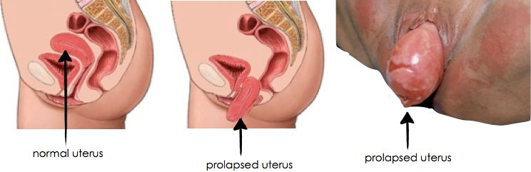
The uterus is normally held in place inside the pelvis with various muscles, tissue, and ligaments. Because of pregnancy, childbirth or difficult labor and delivery, in some women these muscles weaken. Also, as a woman ages and with a natural loss of the hormone estrogen, the uterus can slip down into the vagina or protrude out of the vagina, causing the condition known as a prolapsed uterus. Uterine prolapse can occur in women of any age. But it often affects postmenopausal women who've had one or more vaginal deliveries. Currently, there is an increase in the incidence of disease due to the gradual increase in life expectancy over the past century.
Pelvic organ prolapse (POP) and urinary incontinence (UI) are common conditions affecting many adult women today. POP is the abnormal descent or herniation of the pelvic organs from their normal attachment sites or their normal position in the pelvis.
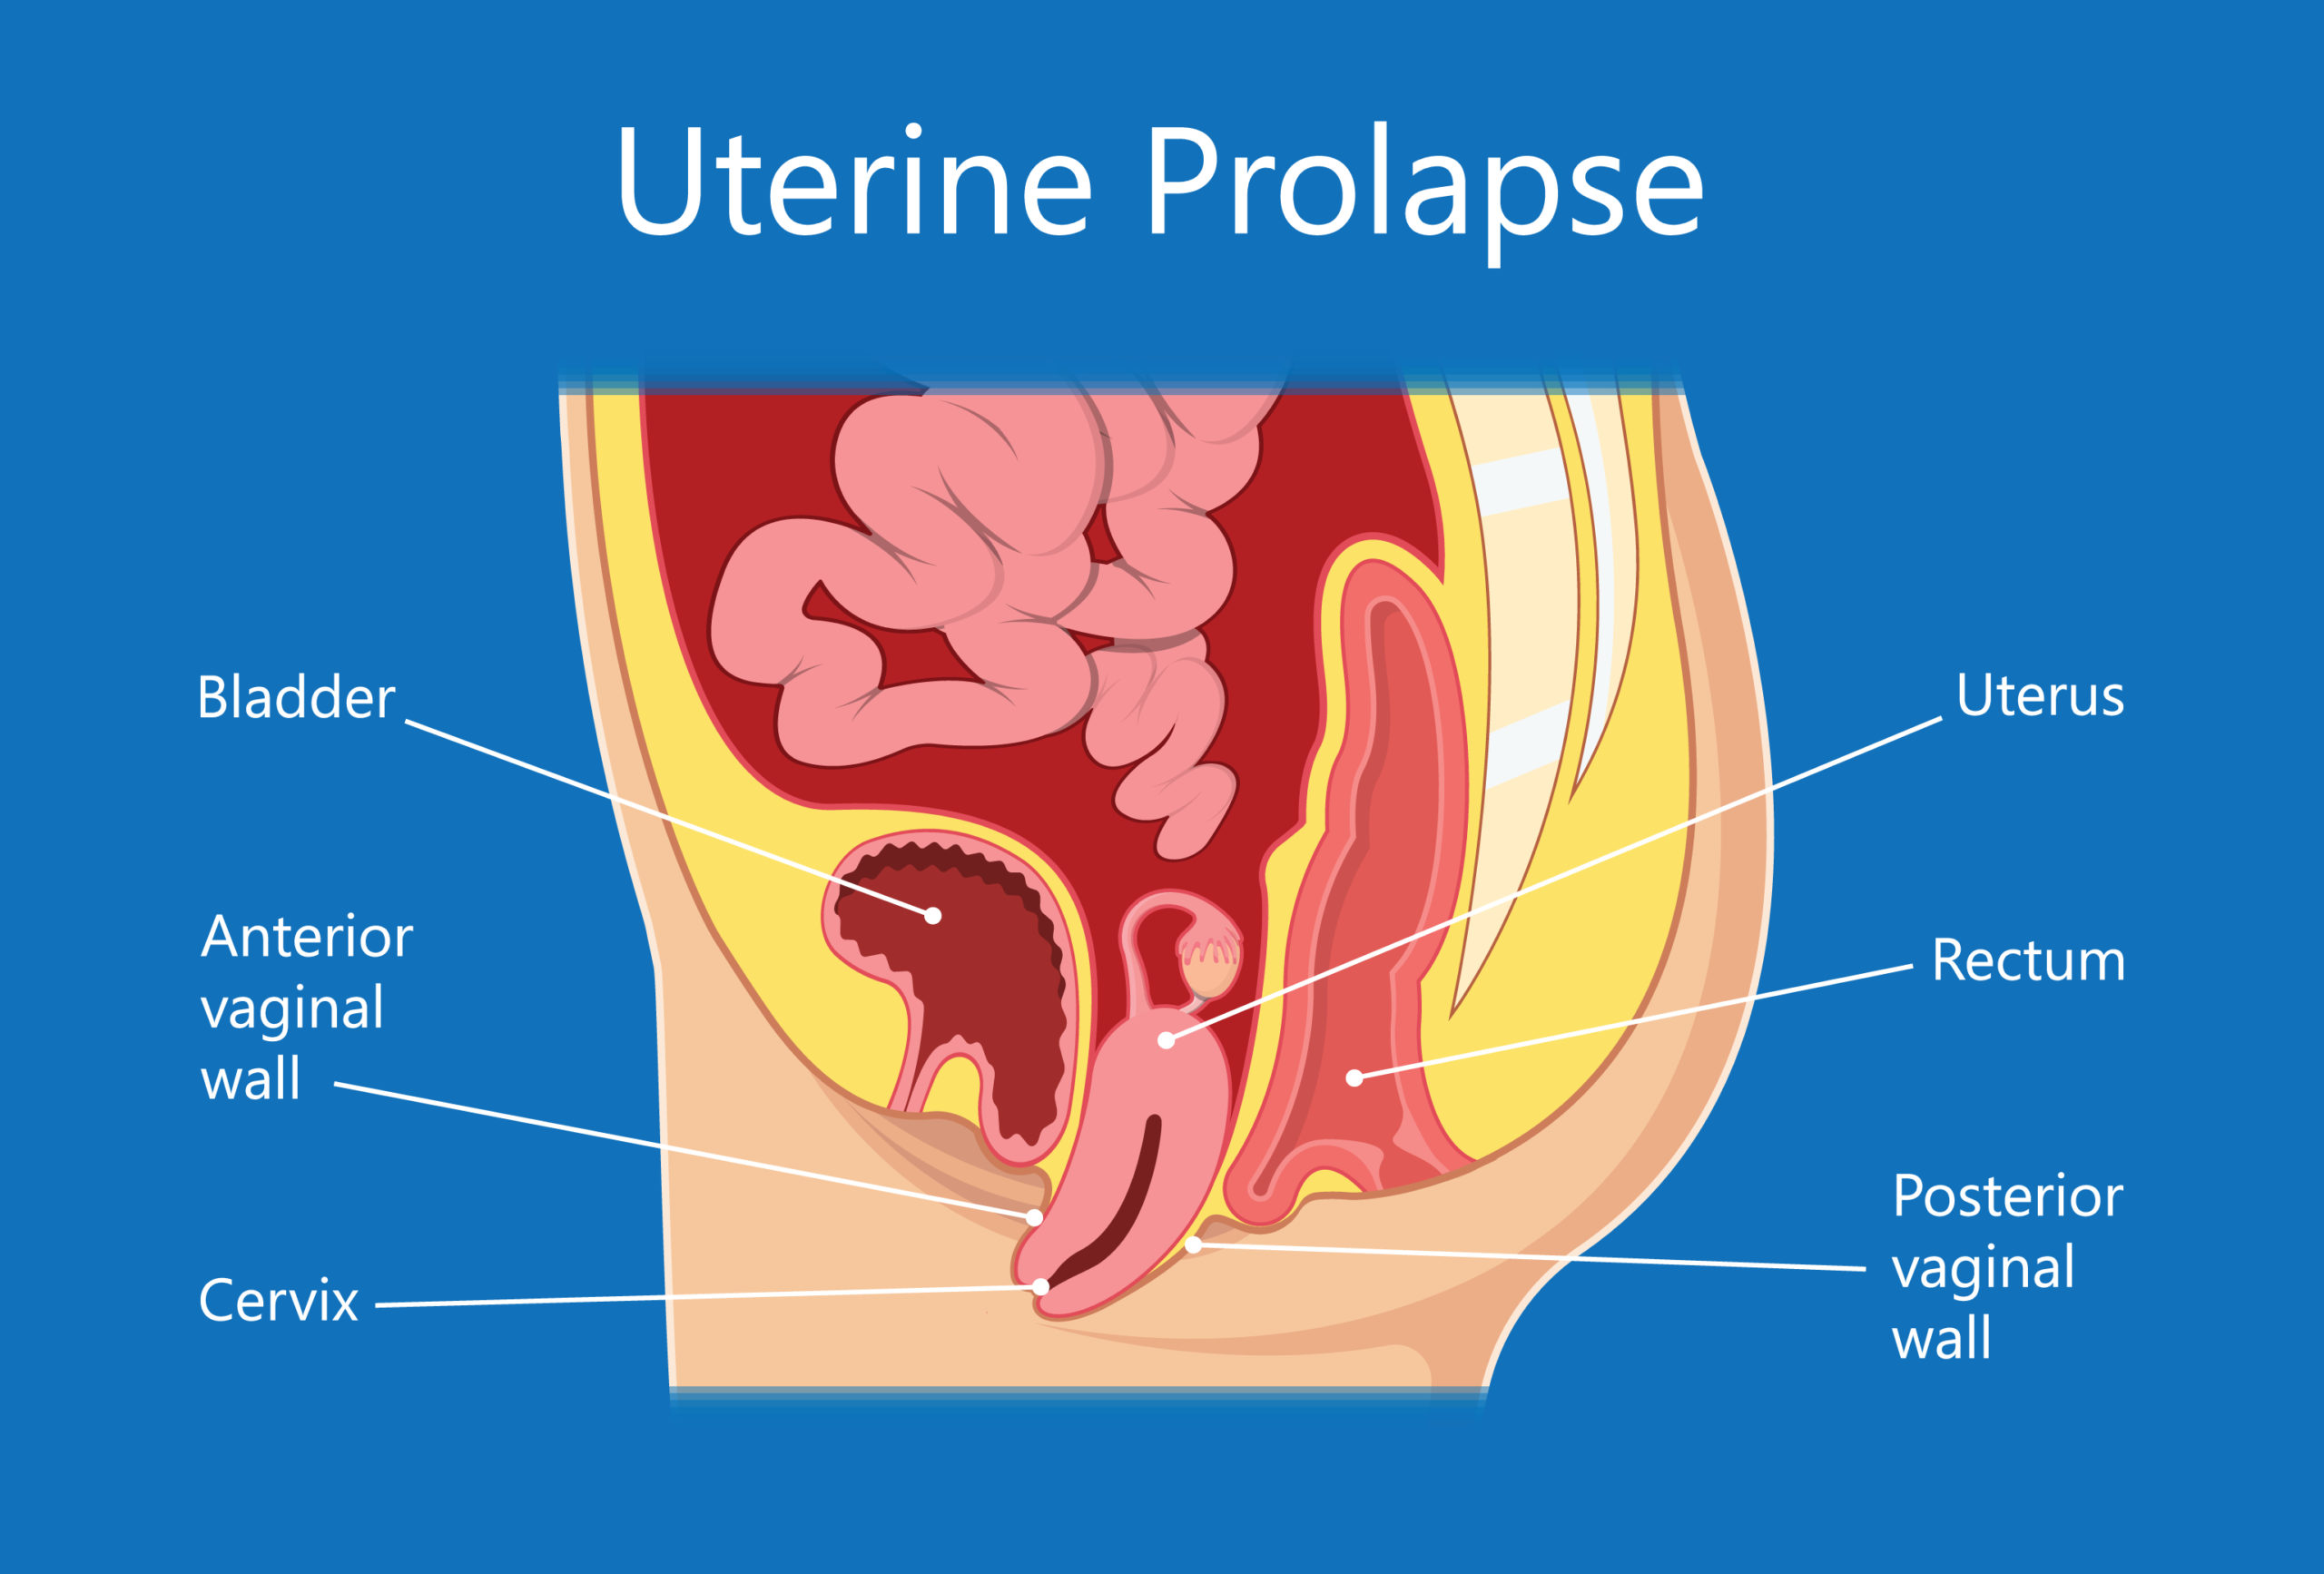

Degrees of uterine prolapse
Uterine prolapse is described in stages, indicating how far it has descended. Other pelvic organs (such as the bladder or bowel) may also be prolapsed into the vagina. The four categories of uterine prolapse are:
- Stage I – the uterus is in the upper half of the vagina
- Stage II – the uterus has descended nearly to the opening of the vagina
- Stage III – the uterus protrudes out of the vagina
- Stage IV – the uterus is completely out of the vagina.

First degree — The uterus descends down from its normal anatomical position (external os at the level of ischial spines) but the external os still remains inside the vagina.

Second degree — The external os protrudes outside the vaginal introitus but the uterine body still remains inside the vagina.

Third degree (Syn: Procidentia, Complete prolapse ) — The uterine cervix and body descends to lie outside the introitus.

Procidentia involves prolapse of the uterus with eversion of the entire vagina.
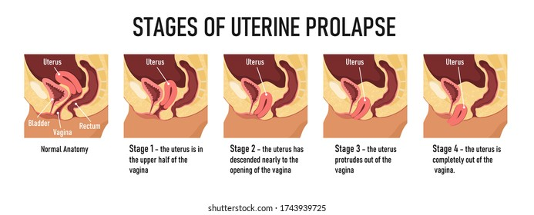
Pelvic Organ Prolpase Quantification (POP-Q) system has been recommended by the International Continence Society as it standardizes terminology and is most objective, site specific and anatomical (see Fig. 15.10 on page 206 in the Dutta textbook).
Other conditions are usually associated with prolapsed uterus. They weaken the muscles that hold the uterus in place:
Cystocele: A herniation (or bulging) of the upper anterior vaginal wall where a part of the bladder bulges into the vagina. It’s also called a prolapsed bladder. This may lead to urinary frequency, urgency, retention, and incontinence (loss of urine).
Enterocele: The herniation of the upper posterior vaginal wall where a small bowel portion bulges into the vagina. Standing leads to a pulling sensation and backache that is relieved when lying down.
Rectocele: The herniation of the lower posterior vaginal wall where the rectum bulges into the vagina. This makes bowel movements difficult.

Prolapsed Uterus Symptoms
Mild uterine prolapse generally doesn't cause signs or symptoms. Signs and symptoms of moderate to severe uterine prolapse include:
- A feeling of fullness or pressure in the pelvis. There may be a feeling of sitting on a small ball or as if something is falling out of the vagina
- Low back pain
- Tissue protruding from the vagina
- Urinary problems, such as urine leakage (incontinence) or urine retention
- Trouble having a bowel movement
- Discomfort walking
- Painful sexual intercourse
Often, symptoms are less bothersome in the morning and worsen as the day goes on.

Causes and Risk Factors
Uterine prolapse results from the weakening of pelvic muscles and supportive tissues. Causes of weakened pelvic muscles and tissues include:
- Difficult labor and delivery or trauma during childbirth
- Delivery of a large baby
- Repeated excess heavy lifting
- Weakening and loss of tissue tone after menopause and loss of natural estrogen
- Conditions leading to increased pressure in the abdomen such as chronic cough (with bronchitis and asthma), Chronic constipation or frequent straining during bowel movements, pelvic tumors (rare), or an accumulation of fluid in the abdomen
- Overweight or obese with its additional strain on pelvic muscles
- Smoking
- Family history of weakness in connective tissue

Diagnosis

A site-specific physical evaluation is essential.
Evaluate the patient in both the lithotomy and standing positions, during relaxation and maximal straining. To do this, the patient is asked to cough or strain to increase the pressure in the abdomen. This often helps to demonstrate a prolapse which may not be seen at rest. To perform the evaluation, place a standard double-bladed speculum in the vaginal vault to visually examine the vagina and cervix. The speculum is removed and taken apart, leaving only the posterior blade, which is then replaced into the posterior vagina, allowing visualization of the anterior wall. The mono valve speculum is then everted to view the posterior wall. Note the point of maximal descent of the anterior, lateral, and apical walls in relation to the ischial spines and hymen. Next, place 2 fingers into the vagina such that each finger opposes the ipsilateral vaginal wall, and ask the patient to bear down. After evaluating the lateral vaginal support system, assess the apex (cervix and apical vagina). Repeat the examination with the patient standing and bearing down in order to note the maximum descent of the uterine prolapse.
Next, grade the strength and quality of pelvic floor contraction, asking the patient to tighten the levators around the examining finger. Assess the external genitalia, noting estrogen status, diameter of the introitus, and length of perineal body. Perform a careful bimanual examination and note uterine size, mobility, and adnexa. Lastly, perform a rectal examination, assessing the external sphincter tone and checking for the presence of rectocele or enterocele.
- Specific conditions, such as ureteral obstruction due to complete prolapse, may need an intravenous pyelogram (IVP) or renal sonography.
- Ultrasound may be used to rule out other pelvic problems. In this test, a probe is passed over the abdomen or inserted into the vagina to create images with sound waves.
- Pelvic magnetic resonance imaging (MRI) is sometimes done if the patient have more than one prolapsed organ or to help plan surgery.
Prior to surgery, cervical cytology (Papanicolaou smear) should be considered. Endometrial biopsy is recommended prior to uterine preservation for women with postmenopausal vaginal bleeding.

Treatment
The management of uterine prolapse may involve conservative versus surgical therapies.

Offer conservative treatments as the first option, and always try them before any surgical endeavor.
Pelvic exercises (Kegel exercises) and pessaries are the current mainstays of nonsurgical management of patients with uterine prolapse. Routine Kegel exercises can improve pelvic floor muscle tone and stress urine incontinence.
In postmenopausal women a hormone (Estrogen ) cream or suppository ovules or rings inserted into the vagina can help in restoring the strength and vitality of tissues in the vagina.
A pessary is a supportive device that inserted into vagina to support the falling uterus. Ones can be used temporarily or permanently. If the prolapse is severe, a pessary may not work. Many different types of pessaries can be used, and pessary fitting is far from an exact science. Trial and error is the rule. Pessaries can be effective temporarily or permanently if they are checked and cleaned as often as necessary. Vaginal support devices are excellent options for treating patients with uterine prolapse conservatively, and pessary use has few contraindications aside from acute pelvic inflammatory disease and pain after insertion. Recurrent vaginitis is a relative contraindication and may require removal of the pessary.
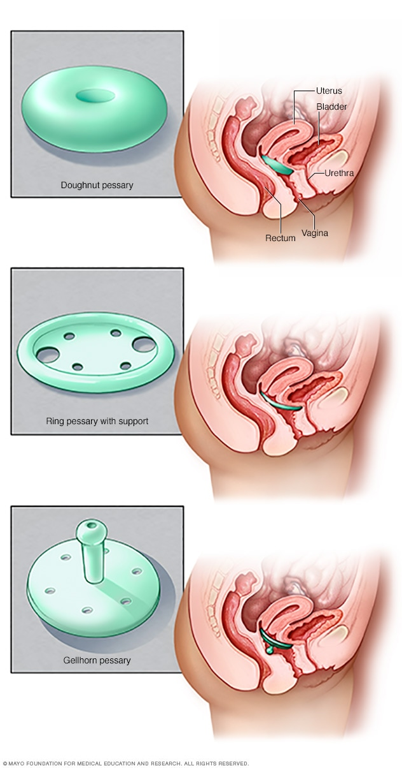
Surgery
When a surgical intervention is undertaken, the primary goals are to restore anatomy and to ma Surgical procedures may be: Restorative — correcting her own support tissues (anterior colporrhaphia, colpoperineorrhaphia et others).
Compensatory — using permanent graft material;
Extirpative — removing the uterus and correcting the support tissues.
Obliterative — closing the vagina (colpocleisis).
With a trend toward minimally invasive endoscopic surgery, procedures have been developed to accomplish repair of pelvic defects via laparoscopic approaches. Although results in short-term subjective reports are excellent, long-term randomized controlled trials are lacking. The attractive advantages of laparoscopic vault suspension are shorter hospitalizations, better cosmetic results, less morbidity, and shorter postoperative recovery periods.
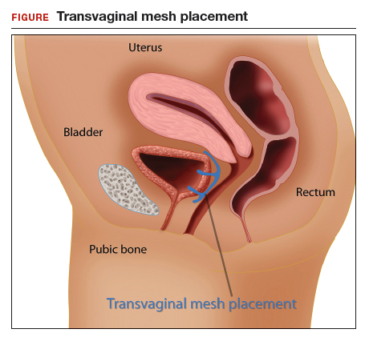
New! On April 16, 2019, the FDA mandated that all manufacturers of surgical mesh intended for transvaginal repair of anterior compartment prolapse (cystocele) stop selling and distributing their products. The FDA has determined that the vaginal mesh kit manufacturers have not demonstrated reasonable assurance of safety and effectiveness for these devices, which is the premarket standard that now applies to them since the FDA reclassified them into class III (high risk) in 2016.
Please note that the FDA restrictions for transvaginal mesh for pelvi organ prolapse do not affect the abdominally or laparoscopically placed mesh for POP (sacrocolpopexy mesh), nor the mesh sling used to treat stress urinary incontinence.

Recommendations for Prevention
- Perform Kegel exercises regularly. These exercises can strengthen the pelvic floor muscles — especially important after childbirth.
- Treat and prevent constipation. Drink plenty of fluids and eat high-fiber foods, such as fruits, vegetables, beans and whole-grain cereals.
- Avoid heavy lifting and lift correctly. When lifting, use the legs instead of the waist or back.
- Control coughing. Get treatment for a chronic cough or bronchitis, and don't smoke.
- Avoid excessive weight gain.

