**EXTERNAL OBSTETRIC EXAMINATION**

Purpose: To determine the position of the fetus in the uterus.

Equipment: couch.

Preparatory stage: the pregnant woman lies on the couch on her back with the thighs slightly flexed. Abdomen is fully exposed. The examiner stands on the side of the patient, face to face (1-3 Leopold maneuvers), the 4th maneuver is performed when the doctor is positioned faces the patient’s feet.

Stages of the examination.

The 1st maneuver (grip) of the external obstetric examination allows to determine the height of the uterine fundus and part of the fetus which is located at the bottom of the uterus.

The palmar surfaces of both hands are placed on the uterus so that they tightly cover the bottom with the adjacent areas of the corners of the uterus, and the fingers are facing the nail phalanges to each other. Most often (96%) at the end of a pregnancy the buttocks are determined in the bottom of the uterus. They differ from the fetal head with less pronounced roundness and sphericity, less density and less smooth surface.

The second maneuver is used to determine the back and smaller parts of the fetus (fetus position).

Both hands move to the uterine side surfaces at the navel level. Palpation of parts of the fetus is performed alternately with the right and left hand. The left hand lies in one place, the fingers of the right hand slide along the left side of the uterus and feel the part of the fetus turned there. Then the right hand lies on the side wall of the uterus, and the left hand touches the parts of the fetus facing the right side of the uterus. With the longitudinal lie of the fetus the back is probed on one side, with the small parts of the fetus on the opposite side of the limb. The back is located as a firm broad smooth object, while the small parts of the fetus are felt by the examining fingers as small prominences which often change their position. If the fetal back is turned to the left - the first position, if to the right - the second position.

The third maneuver is used to determine the presenting part of the fetus.

One hand (usually the right one) is placed slightly above the symphysis pubis so that the thumb is on one side and the four others fingers on the other side of the uterine lower segment. The fingers are then slowly and gently depressed into the abdomen to grasp the presenting part. Determine the presentation: head or breech. The head is felt as a dense and rounded part with definite outlines. In breech presentation the fingers feel a bulky but softer part having no rounded shape. The presenting part can not be identified in transverse or oblique presentation. The 3rd maneuver can be used to assess mobility of the head. By short slightly pushing the head the examiner tries to move it to either side. The head is ballotable, which can be readily felt by the fingers. The higher the head locates above the entrance to the true pelvis the stronger the balloting. With the head standing at the entrance to the true pelvis and also with the breech presentation - balloting is not available.

The fourth maneuver of external obstetric examination aims to determine the location of the presenting fetal part (above the pelvis inlet, in the inlet or in the cavity of the true pelvis) relative to the plane of entry into the true pelvis.

The examiner faces the patient’s feet.

The hands are placed on both sides of the lower part of the uterus with the tips of the fingers reaching the symphysis. The fingers are then gently impressed into the abdomen in the direction of the pelvic cavity, between the presenting part and the symphysis. The degree of insertion of the presenting part into the true pelvis is determined as follows: if it is located over the pelvic inlet then the examiner can put the fingers between the fetus head and the pubic bones; if the presenting part is pressed to the pelvis inlet, then fingers can not be held between it and pubic bones.

**MEASUREMENT OF THE EXTERNAL DIMENSIONS OF THE PELVIS**

Purpose: measuring the size of the bone pelvis allows you to indirectly judge the size of the true pelvis.

Equipment: couch, pelvimeter.

Preparatory stage: when measuring the transverse dimensions of the pelvis (distantia spinarum, distantia cristarum, distantia trochanterica), the pregnant woman lies on the couch on the back, her legs extended and held together. While measuring the direct size (сonjugata externa) the pregnant woman lies on the left (right) side with her back to the doctor, the lower leg is flexed in knee and hip joints, the upper one is extended.

Stages of measurement of the external dimensions of the pelvis.

To take measurements, the doctor takes the pelvimeter so that the scale is facing upward, and the thumb and index fingers lie on the buttons of the pelvimeter.

1. Measurement of Distantia spinarum: without releasing the pelvimeter from the hands, with the index fingers we find the Spina Iliaca Anterior Superior on the both sides and put the pelvimeter’s buttons at these points along the outer edge. On the pelvimeter’s scale we determine the size: normally it is non less that 26 cm.

2. Measurement of Distantia cristarum: do not take away the pelvimeter from the previous points, glide along the outer edge of the Iliac Crest until the maximum distance (the farthest points). Normally, this size is 28-29 cm.

3. Measurement of the Distantia trochanterica. The pelvimeter arms rest on the most prominent points of the greater trochanters. The normal distance 30-31 cm. In obese women the location of the wanted points can be facilitated if the women turns her feet inwardly and outwardly.

4. Measurement Conjugata externa. One arm of the pelvimeter rests on the superior margin of the symphysis, and the other arm – on the the junction of the V lumbar and I sacral vertebrae (supracranial fossa). The Conjugata externa is normally 20-21 cm.

**MEASURES FOR THE PREVENTION OF HYPOTONIC UTERINE BLEEDING**

Purpose: the prevention of hypotonic uterine bleeding.

In the risk group for hypotonic bleeding: multiparous women, with polyhydramnios, large fetus, abnormalities of uterine activity, preeclampsia, extragenital diseases and complicated obstetric and gynecological history.

Equipment: sterile syringe, sterile urinary catheter, ampoule with oxytocin 1 ml (5 IU), gauze balls, alcohol 96%, ice bag.

Preparatory stage: the woman lies on the Rakhmanov’s bed on her back.

These prophylacticmeasures should be done.

Oxytocin solution 1 ml (5 units) intramuscularly or 0.5 ml intravenously (in 10 ml of 0.9% sodium chloride solution) is administered with the crowning of the head.

Catheterization of the maternal bladder is carried out immediately after the childbirth.

After the delivery of the placenta one put the ice bag on the suprapubical abdominal area for 25-30 minutes.

**MANUAL EXAMINATION OF THE UTERUS**

The aim: to check the integrity of the uterine walls after the delivery in women with a uterine scar, after performing obstetric operations to identify uterine rupture (applying the obstetric forceps, removing the retained part of the placenta, stopping hypotonic uterine bleeding (uterine massage on the fist).

 Equipment: Rakhmanov's bed, sterile aural forceps or tweezers, sterile gloves, diapers, gauze balls or tampons.

Preparatory stage: the mother is placed on a transverse bed and her bladder is evacuated.

The obstetrician wears an apron, a mask, a cap, washes the hands till the elbows, puts on a sterile medical gown and sterile gloves. General intravenous anesthesia is necessary.

Stages of the operation.

• Treat the labia, pubis, inner thighs, crotch and anus of the woman with 5% tincture of iodine.

• While introducing the hand, the labia are separated by the fingers of the left hand.

• A conically shaped right “obstetrician hand” is introduced into the vagina and further into the uterine cavity. The invading hand should be directed with its palm toward the symphysis, reaching the uterine fundus.

• The left hand should then be placed on the bottom of the uterus.

• The uterus is manually explored. The examining hand feels thoroughly the uterine walls, its fundus and the tube angle, successively moving from the fundal area to the internal uterine oss. The uterus is manually explored to search for retained tissue and identify uterine rupture to search for retained tissue and identify uterine rupture. After the uterine cavity has been examined thoroughly, the hand should be removed from the uterus.

• Remove the inner hand from the uterus

.

**DETERMINATION OF THE GESTATIONAL AGE AND THE EXPECTED** **DATE OF BIRTH**

Purpose: to determine the gestational age and the expected date of delivery.

Equipment: calendar.

Preparatory stage: to determine the gestational age and the expected date of delivery it is necessary to know the dates of the first day of the last normal menstruation and the date of a first fetal movement, the date of ultrasound investigation produced in the first half of pregnancy.

Stages of performance of calculations.

Determination of the date of birth according to the first day of the last menstruation.

The woman has the date of the last menstruation on September 1. She turned to a women's consultation on October 20.

To determine the gestational age by the calendar, we find the date corresponding to the first day of the last menstruation (September 1), we add to this date week-by week till the day of the women's visit to a consultation (October 20) – we’ve got a gestation term of 7 weeks.

To determine the date of birth by the date of the first day of the last menstruation (September 1), add 40 weeks to determine the date of delivery - June 8. The date of birth can also be determined by taking 3 months from the 1st day of the last menstruation and adding 7 days (June 8).

Determination of the date of delivery according to ultrasound.

 According to ultrasound at November 1st, pregnancy was 7 weeks. By the calendar by this time, we add 33 weeks to 40 weeks and thus determine the date of delivery - June 20th.

Determination of the date of delivery for the first fetal movement.

By the date of the first fetal movement (February 1st) according to the calendar, it is necessary to add 20 weeks for a primigravida woman - the date of birth on June 20th (22 weeks are added in a multigravida, as the first quickening is felt in 18 weeks).

**DETERMINATION OF THE ESTIMATED WEIGHT OF THE FETUS**

The aim: prognoses the course of labor and choose the method of delivery.

Equipment: a couch, a centimeter tape, a hightmeter, an ultrasound device.

Preparatory stage: The estimated weight of the fetus is calculated by the formulas and is determined by the ultrasound data.

To calculate the expected weight of the fetus (X), the following measurements should be made: the abdominal circumference (AC) (cm), the fundal height (FH) (cm), the woman’s weight in kg, the woman’s height in cm.

Stages of performance.

Lankowitz’s formula:

X = (FH + AC + woman's weight in kg + woman's height in cm) х10

Jordania’s formula:

X = AC x FH

To determine the estimated fetal weight during ultrasound examination, the biparietal diameter, head circumference, abdominal circumference, the femur length are measured.

**THE PRIMARY CARE OF THE NEWBORN**

Purpose: the primary care of the newborn.

Equipment: newborn infusion tray, sterile Kocher’s forceps, scissors, staple for umbilical cord, gauze pads and a tampon, catheter, napkins, pipette, ethanol 96%, potassium permanganate solution 5%, swaddling table with heated, electric pump.

Stages of performing the primary care of the newborn.

1. For newborn born through meconium-stained fluid, suctioning of the mouth, or pharynx or the nose with a catheter is performed.
2. Evaluate the newborn's condition. If the newborn is healthy place the baby on the mother’s abdomen to minimize transfusion of blood from the cord to the infant. Thoroughly dry the baby with a sterile warm diaper, remove the wet cloth.
3. Not earlier than after 1 min (in Rh-negative women immediately) after the birth of the baby, the sterile Kocher’s forceps are applied on the umbilical cord at a distance of 10 and 12 cm from the umbilical ring. The cord between the forceps is treated with 96% alcohol and is cut with sterile scissors.
4. The child is shown to the mother, the fetal sex is announced and he/she is transferred to a warm table covered with a sterile napkin.
5. The umbilical cord is wiped with a sterile cotton wool ball soaked in 96 % ethanol, then with a dry gauze pad, and clamp the cord.
6. The free edge of the umbilical cord cut at a distance of 1.5-2 cm from the staple and treat the cut surface with 5% potassium permanganate solution.
7. If the mother has not been examined, we perform prophylaxis of gonoblenorea: we put erythromycin ointment under the lower eyelid of the newborn one hour after birth.

**INSPECTION OF THE CERVIX AFTER DELIVERY**

Purpose: diagnosis the rupture of the cervix after the delivery.

Equipment: sterile vaginal speculum, sponge holding forceps (ring forceps), sterile gauze balls or tampons, gloves.

Preparatory stage: the woman is asked to lie supine on the Rakhmanov's bed, with her legs knees apart.

An obstetrician washes the hands, puts on sterile gloves.

Stages of performing the manipulation.

• Treat the labia, pubis, inner thighs, crotch and anus area with a gauze ball moistened with 5% tincture of iodine.

• Separate the labia by the first and second fingers of the left hand.

• Introduce the Sims’ posterior vaginal speculum into the vagina sideways by your right hand, rotate the speculum and press, pulling the posterior vaginal wall down.

• Insert the vaginal wall retractor into the vagina and pull up the anterior vaginal wall. Give the tools to the assistant.

• Apply two forceps to the visible part of the cervix.

• Pull the right edge of the cervix to the left by the forceps, then remove the left forceps and re-apply one to the made visible edge of the cervix. Thus, alternately removing and moving the forceps, examine the cervix along the entire circumference clockwise.

**METHODS OF EXPULSION OF THE PLACENTA IN THE THIRD STAGE OF LABOR**

The aim: to delivery the separated placenta.

Equipment: Rakhmanov's bed, urinary catheter.

Preparatory stage: the mother is lying on her back on the Rakhmanov’s bed, covered with a sterile diaper, legs are bent in the hip and knee joints and are divorced in the sides.

Before each procedure, the bladder is emptied by a catheter, the uterus is brought to the middle position, a careful external uterine massage is performed.

Stages of performing the methods.

1. Abuladze's method.

The obstetrician is standing on the side of the woman. The front abdominal wall (together with the rectus abdominal muscles) is then taken by both hands to form a longitudinal fold (Figure 1) and the woman is asked to bear down. The separated placenta would normally slide out without difficulty.

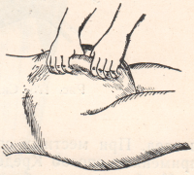

Fig. 1 Delivery of the placenta according to Abuladze

2. Genter’s method.

The obstetrician stands on the side of the patient facing her legs.

The bladder is emptied and the uterine fundus is brought to the median position. The clenched fists are placed on the uterine fundus (in the insertion of the fallopian tubes) and a pressure is applied to the uterus in the downward and medial direction (Fig. 2). The woman should not push during this procedure.

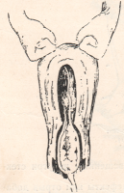

Fig.2 Genter’s method

3. Lazarevich-Crede’s method.

The obstetrician stands on the left side of the patient, facing her legs.

The bladder is emptied, and the uterine bottom is brought to the median position. The uterus is gently rubbed to induce its contraction. The obstetrician takes hold of the uterine fundus by the right hand so that the thumb is located upon the anterior wall of the uterus, the palm is on the uterine fundus, and the four fingers on the posterior surface of the uterus. The obstetrician compresses the uterine fundus in the downward direction and anteriorly along the pelvic axis. The separated placenta is thus expressed from the uterus (Figure 3).

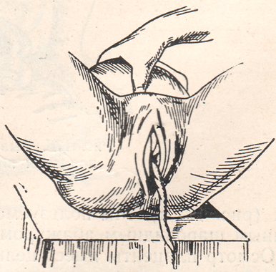

Fig. 3 Lazarevich-Crede’s method

**MANUAL SEPARATION AND REMOVAL OF THE PLACENTA**

Purpose: to stop the bleeding if there is partial adherence of the placenta or incarceration of the placenta (if the placenta fails to be removed by external manevres), detachment of the placenta with its complete adherence.

 Equipment: Rakhmanov's bed, sterile aural forceps or tweezers, sterile gloves, diapers, gauze balls or tampons.

Preparatory stage: the mother is placed on a transverse bed and her bladder is evacuated.

The obstetrician wears an apron, a mask, a cap, washes the hands till the elbows, puts on a sterile medical gown and sterile gloves. General intravenous anesthesia is necessary.

Stages of the operation.

• Treat the labia, pubis, inner thighs, crotch and anus of the woman with 5% tincture of iodine.

• While introducing the hand, the labia are separated by the fingers of the left hand.

• A conically shaped right “obstetrician hand” is introduced into the vagina and further into the uterine cavity. The invading hand should be directed with its palm toward the symphysis, reaching the uterine fundus. (Fig. 1).

• Fix the bottom of the uterus with the left hand through a sterile diaper (Fig. 2).

• The right hand should follow the umbilical cord, in order to reach the placenta and find it’s margin. The hand should be inserted in space between the placenta and the uterine wall; while the right hand acts like a saw to separate the placenta from the uterine wall, the left hand should press gently on the uterine bottom to aid the internal hand (Fig. 3).

• As soon as the entire placenta has thus been separated, remove the placenta from the uterus by pulling it on the umbilical cord by the outside hand.

• The internal hand remains in the uterus to examine it for complete removal of the placenta. Remove the inner arm from the uterus, making sure the uterine cavity has been examined thoroughly.

• Send the placenta to a histological study.

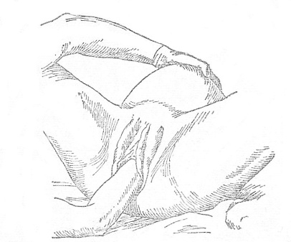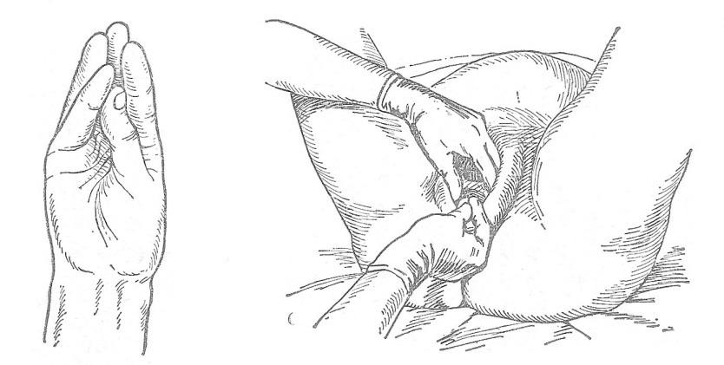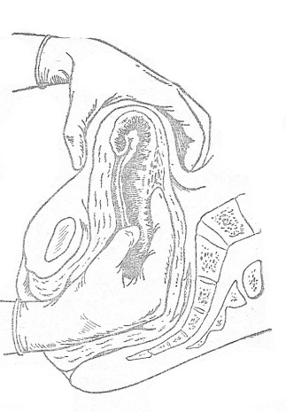

Fig. Fig. 1,2,3 The main stages of the operation of manual separation and removal of the placenta.

**MIDWIFERY SUPPORT IN VERTEX LABOR**

Preparatory stage: the mother is lying on her back on Rachmanov's bed with her hips split, her feet rest against the bed rings, under the woman a sterile diaper.

A midwife in the cap, mask, sterile coat and gloves treat labia, bosom, inner thighs, crotch with antiseptic solution with aural forceps and gauze ball. One should begin to provide the manual assistance since the eruption of the head.

Stages of the manipulation

1. Protection of the perineum

Borrowing of tissues from the labia is carried out in order to reduce the perineal strain. To do this the right hand’s palmar surface is located on the perineum so that four fingers fit snugly to the left labia and the thumb to the area of ​​the right labia. Tissue of the labia are carefully lowered downward towards the perineum.

If the crotch is a significant obstacle to the emerging head or there are signs of its possible rupture, one should not strive to maintain its integrity. It is necessary to perform operative expansion of the vulvar ring (episiotomy or perineotomy).

2. Regulation of pushing process.

After the birth of parietal tubercles and fixation of the suboccipital fossa to the lower edge of the symphysis the mother is offered to deep and frequent breathing with her mouth open. The fetal head is born during one of the contraction, but without pushing!

The midwife with her right hand "descends" the perineal tissues from the fetal forehead and from the face. In this case, the head is completely born.

3. Birth of the fetal shoulders and the trunk.

After birth of a head one should check up whether there is no **entanglement of the cord round the neck of the baby**. If entanglement is tight cut the umbilical cord between the two clamps; when entanglement is weak - weaken the umbilical cord tension and wait for the next pushing. Don’t hurry! Cyanosis of the fetal face is not a dangerous sign!

The head has been born should not be turned and pulled for it. The birth of the fetus must occur by itself without the medical intervention, the midwife does not extract the baby but only supports him/her from sagging during delivery.

If the shoulders are not born by itself, the one put the palms of the both hands on the right and left temporo-buccal region of the fetal head and keep the head according it's itself moving. After upper shoulder would be fixed under the symphysis, the left hand gently lifts the head up, and the right hand shifts the perineum from the posterior shoulder. After birthing of the head the index fingers are entered to the armpits from the side of the baby's back, the baby is raised anteriorly and upwards, finishing the delivery.

**ALGORITHM FOR THE EMERGENCY CARE FOR SEVERE PREECLAMPSIA**

1. Hospitalize the patient in the intensive care unit (ward) (joint supervision by anesthesiologist and obstetrician):

Manipulation:

1. Evaluate the severity of the patient's condition: blood pressure, consciousness, headache, cramps, respiratory rate, abdominal pain, bleeding from the vagina, palpitation of the fetus.

2. Venous access - peripheral vein, if necessary - catheterization of the subclavian vein.

3. Catheterization of the bladder.

4. Making the decision of the time and a method of a delivery.

Monitoring of the main functions.

Maternal:

• Measurement of the blood pressure: every 15 minutes until stabilization is achieved, then every 30 minutes.

• Heart rate monitoring - every hour, breathing rate - every 2 hours.

• Blood test - platelets, hematocrit, hemoglobin.

• Biochemical blood test - total protein and its fractions, urea, bilirubin and its fractions, creatinine, ALAT, ASAT, LDH, glucose, electrolytes (sodium, potassium, chlorine, calcium, magnesium).

• Coagulogram - fibrinogen, international normalisated ratio, Activated partial thromboplastin time, D-dimers.

• Determination of blood group and Rh-factor.

• Consultation of a therapist, ECG.

• Hourly monitoring of diuresis.

• General urine analysis: daily monitoring (total protein, creatinine).

Fetal monitoring:

• CTG (continuously, until blood pressure stabilizes; continuously, if in labor).

• Ultrasound (fetometry, amniotic fluid index, placentometry), dopplerometry (umbilical artery, middle cerebral artery).

Prenatal (preoperative) preparation based on basic therapy of the preeclampsy (in the absence of the indications for urgent delivery):

• anticonvulsant therapy: magnesium sulfate 4 g (16 ml 25% solution) intravenously for 10-15 min, then 1 g / h (4 ml / hour 25% solution) using infusomate;

• antihypertensive therapy: - sodium nitroprusside (possibly: nifedipine, nitroglycerin, clonidine) - intravenously in 250 ml of 5% glucose solution, start with 0.25 mg / kg / min, max up to 5 mg / kg / min;

• Infusion therapy: balanced polyelectrolyte crystalloids (Ringer's solution, Sterofundin), 6% solutions of HAES (gamovene), colloidal solutions based on gelatin; in according to indications (hypoproteinemia) - albumin. The infusion rate is 40-45 ml / h (maximum - 80 ml / h);

• Delivery within 2-6-24 hours after prenatal (pre-operative) preparation on the basis of basic preeclampsia therapy and stabilization of the woman's condition (if there is no evidence that there is threaten the patients' life/ indications for urgent delivery).

**THE ALGORITHM OF EMERGENCY CARE AT ECLAMPSIA**

1. During the seizure of eclampsia (the stage of tonic and clonic seizures) prevent the possibility of mechanical trauma and biting of the tongue.

2. After a fit of seizures - put the patient on a flat surface in the position on the left side to reduce the risk of aspiration of the stomach contents, vomit and blood. Free from contents the oral cavity quickly, opening the mouth and pushing the lower jaw forward; evacuate or aspirate the contents if it's necessary.

3. After restoring spontaneous breathing to prevent repeated seizures provide an anesthesia: thiopental sodium (450-500 mg); when there is no access to the vein - inhalation. All manipulations (catheterization of veins, bladder, obstetric manipulation, etc.) should be performed under anesthesia. Do not use ketamine!

4. Catheterization of the peripheral vein (in according to indications - subclavial vein), bladder.

5. Anticonvulsant therapy: magnesium sulfate 4 g for 5 minutes intravenously, then maintenance therapy (1 g / h) with careful control of blood pressure and the heart rate. If the seizures continue, inject intravenously for 2 g of magnesium sulfate (8 ml of 25% solution) for 3-5 minutes. If there is no effect, use diazepam intravenously slowly (10 mg).

6. Elimination of peripheral vasospasm (when hypotensive effect of magnesium sulfate is insufficient): myogenic vasodilators - sodium nitroprusside 8-400 mcg / min or calcium canals’ blocker adalat 5 mg - 4-6 ml / h intravenously.

7. Infusion therapy (infusion rate 40-45 ml / h, not more than 80 ml / h, total volume up to 800 ml).

8. Simultaneously with the emergency care:

- monitoring the patient's condition: blood pressure, heart rate, pulse oximetry, ECG, cerebral symptoms, body temperature, general blood test (platelets, hematocrit, hemoglobin), general urine analysis (proteinuria assessment), biochemical blood test (total protein and its fractions, bilirubin and its fractions, hepatic enzymes, glucose, urea, creatinine, sodium electrolytes, potassium, chlorine, calcium, magnesium), hourly diuresis, CVP, coagulogram (D-dimer);

- fetal monitoring (continuously CTG).

9. After stabilizing the patient's condition, carry out the delivery (cesarean section).

**ALGORITHM OF EMERGENCY CARE FOR HYPOTONIC BLEEDING**

I stage - with blood loss of 400-600 ml the following measures are taken:

- Emptying the bladder with a catheter.

- Gentle external massage of the uterus.

- Introduction of intravenous bolus medications that increase the tone of the uterus: oxytocin 5 ED (1 ml), methylergometrine 0,5-1 ml of a 0,02% solution or misoprostol 800 mg per rectum, followed by intravenous injection of prostaglandins or oxytocin.

- With stopped bleeding - an ice bag on the lower abdomen for 30-40 minutes.

II stage - With continued bleeding and blood loss of 600-1000 ml:

- Manual uterine examination and its internal massage.

Methods of temporary mechanical and reflex stop of bleeding are applied (introduction of a balloon catheter into the uterine cavity and / or application of terminal clamps according to Baksheev).

- In the absence of effect - the deployment of the operating room and the stopping of bleeding by operational methods.

III stage - blood loss 1000-1500 ml - laparotomy.

Stop uterine bleeding during surgery:

- B-Lynch compression suture and multiple square sutures on the uterus,

- ligation of vessels that feed the uterus (ascending branches of uterine vessels, vessels in ligamentae ovariae propriae, in round uterine ligaments.

-For continuing bleeding from the vagina - ligation of the iliac arteries (performed by a vascular surgeon).

- After stopping bleeding and stabilizing hemodynamics, a decision is made to preserve the uterus or to remove it.

In the absence of effect - hysterectomy or supravaginal amputation of the uterus

**Simultaneously with the stop of bleeding, the blood loss is compensated depending on the blood volume deficiency.**