Topic 2. Menstrual function and its disorders (amenorrhea, dismenorrhea, abnormal uterine bleeding).
- Neurohumoral regulation of menstrual cycle.
The reproductive system has 5 levels and is regulated by feedback mechanism. High level structures control the lower level.
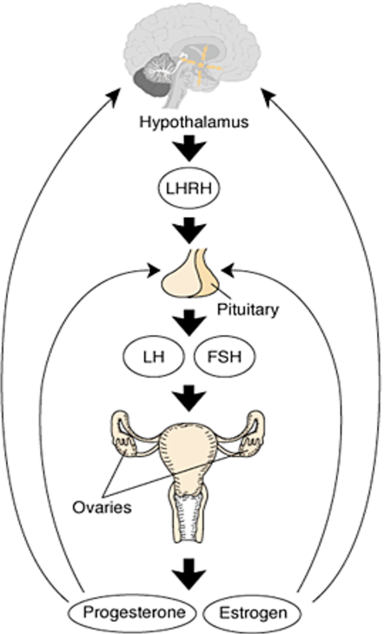
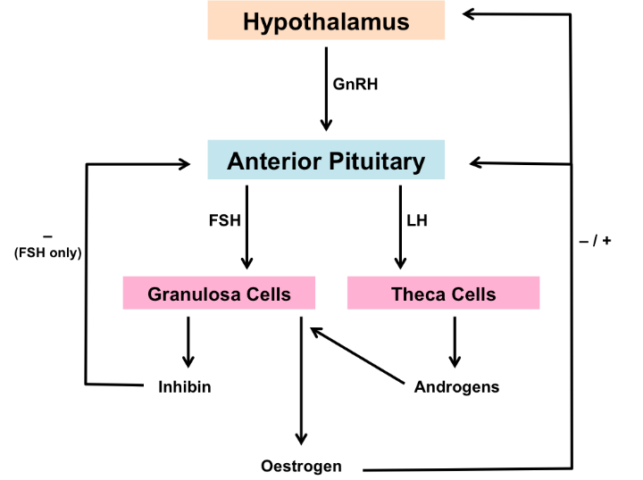

V-level is suprahypothalamic cerebral structures.. Receiving of information from environment and interreceptions with neurotransmitter structures of central nerves system sends impulses to neurosecretory hypothalamic nuclei.
IV level—hypothalamus.Hypothalamic nuclei produce the specific neurohormones, which stimulate pituitary (Liberins)and inhibit it (Statins)- gonadotropin releasing hormones (GnRH). The hypothalamus is the pulse generator of the reproductive clock. There is a network of neurons in the anterior and medial parts of the hypothalamus that produces GT-RH. Pulsative infusion of GnRH at 70-90-minutes intervals depends on the level of estradiol hormones.
III level—anterior pituitary. Anterior pituitary produces such gonadotropin hormones as follicular-stimulating hormone (FSH), luteinizing hormone (LH), prolactin and other tropin hormones.
- FSH stimulates the growth and maturation of follicles and follicular fluid secretion.
- LH reacts to the massive secretion of estradiol and causes the rupture of the follicle (ovulation), the formation of the corpus luteum and the production of progesterone.
- Prolactin performs the opposite functions of FSH and LH It affects the breast maturation and milk secretion.
II level—ovaries (ovarian cycle).
An ovary is a target organ for the pituitary hormones. Ovaries respond to pituitary gonadotropin secretion. Ovarian follicle are the basic anatomo-physiologic structure of the ovary.

An ovarian cycle consists of two phases: follicular phase, luteal phase and ovulation between. There is an increase of FSH, which stimulates the growth and maturation of follicles (follicular phase) – from primordial follicles to dominant follicle, each follicle contains an oocyte and a follicular fluid inside that has growth and maturation too during this phase. It lasts 14 days in 28-days menstrual cycle, 10-11 days in 21-days reproductive cycle, and 17-18 days in 35-days reproductive cycle.
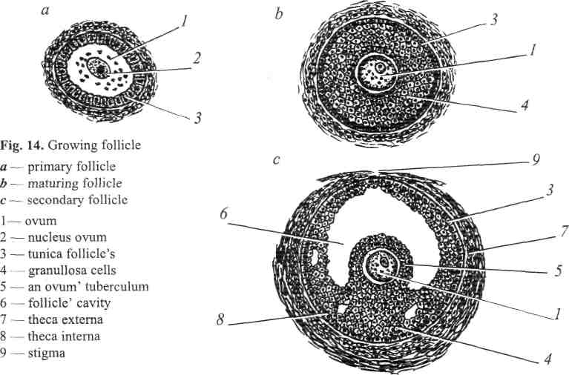
Granullosa cells produces estrogenic hormones. Theca cells produces androgenic hormones.
The dominant follicle enlarges and follicular fluid accumulates in it, it grows and rupture. It is the final stage of the follicular phase, which is called ovulation. Ovulation is the process when the membrane of mature follicle is ruptured and oocyte is expelled from the follicle. Oocyte gets into abdominal cavity and is taken by the uterine tube fimbrias. Process of fertilization (conception) takes place in the uterine tubes.
After ovulation the dominant follicle transform into the corpus luteum (the conversion of granulosa and theca cells to luteal cells with the acquinisation of LH receptors). The second phase of the menstrual cycle (luteal phase) begins. The luteal cells can synthesize and secrete large amount of progesterone, that is protein hormone inhibiting FSH secretion.
The corpus luteum has a fixed life term during 14 days, since 15-th to 28-th days of menstrual cycle. There are following processes in corpus luteum: 1) vascularization 2) blossoming 3) involution — in case when pregnancy doesn't occur corpus luteum is called corpus luteum of menstruation. Regression of corpus luteum lasts for 2 months and is over with the formation of white body. If oocyte becomes fertilized and implants within the endometrium, the early pregnancy begins secreting human chorionic gonadotropin (hCG), which sustains the corpus luteum for the following 10-12 weeks. Corpus luteum of pregnancy produces such hormone as relaxin which has tocolytic effect on the uterus.
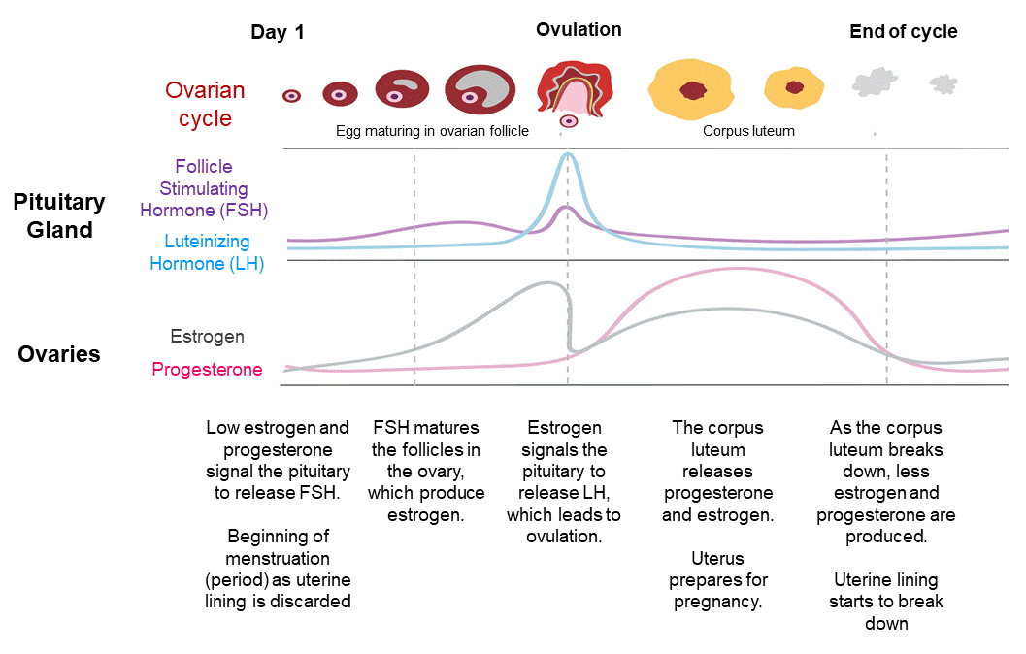
I level—target organs - uterus, vagina breasts and atc.(Uterine cycle)
Uterine cycle consists of the following phases: desquamation, regeneration, proliferation and secretion. The uterine cycle and the ovarian cycle occur simultaneously. Changes during the ovarian cycle provide changes during the uterine cycle. This means that if the function of the ovary is impaired, there is a violation of changes during the uterine cycle.
Regeneration phase takes place simultaneously with desquamation. The thickness of the endometrium at this moment is 2-5 mm. These two phases occur during menstruation – when the endometrium is sloughed out with blood.
The proliferation phase lasts from the 7th to the 14th days of the cycle. The endometrium thickens, the endometrial glands lengthen under the influence of estrogens. The thickness of the endometrium is 20 mm, but its glands are not functioning. The endometrial glands are straight or somewhat curved. During this phase, the endometrial glands become sinuous, and the spiral arteries reach the surface of the endometrium. With rising estradiol production during the follicular phase of the cycle, there is growth of the spiral arteries those extend into the surface of endometrium only at the end of the proliferative phase.
This means that desquamation, regeneration and proliferation take place simultaneously with follicular phase of the ovarian cycle and correspond to changes in the amount of estrogen as the follicle grows: from a low content of estrogen (desquamation), an increase in the amount of estrogen (regeneration) to a high content of estrogen (proliferation). Estrogen is a mitogenic hormone, which stimulates cell growth.
The secretion phase occurs simultaneously with the luteal phase of the ovarian cycle. This means that changes in the endometrium during the secretory phase occur under the influence of progesterone: secretory transformation of the endometrium - increasing the size of endometrial glands and promoting the synthesis and secretion of proteins and other factors in preparation for pregnancy and implantation. There is an excessive growth of the spiral arteries in the secretory phase. They become most twisty and look like tangles. The capillaries those are situated in the superficial layer of endometrium enlarge in their sizes and look like sinusoids. Spiral arteries of the functional layer contracts before the beginning of menstruation. It causes blood stasis, thrombosis, increasing vessel's permeability and their destroying. The necrosis and sloughing of the tissue occurs. It finishes on the third or fourth day of the menstrual cycle.This phase lasts from the 14th until the 28th day of cycle.
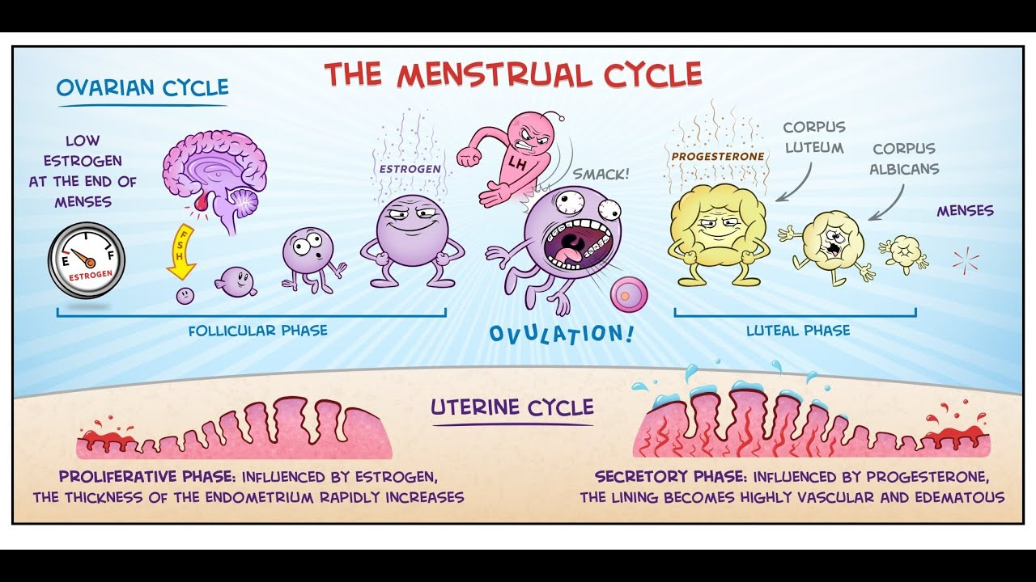
2. Characteristics of the normal menstrual cycle.
Regular menstrual cycle is a sign of normal function of female reproductive system.
Characteristics of the normal menstrual cycle:
- its duration varies from 21 to 35 days.
- the duration of menstruation varies from 3 to 7 days
- the amount of blood lost is about 50-150 ml per cycle.
- the menstruation must be regular, painless.
3. Classification of menstrual disorders.
Amenorrhea — absence of menses.

Violation of menses rhythm:
opsomenorrhea — menses come extremely rarely: in 6-8 weeks
spaniomenorrhea — the extremely long menstrual cycle, menses come 2-4 times per year
proiomenorrhea (tachimenorrhoea) — shortened menstrual cycle, menses come in 21 days
Change of blood amount, that exudes during menses:
hypermenorrhea — a excessive amount of blood, more than 100-150 ml
hypomenorrhea — reduced amount of blood, less than 50 ml Abnormal menses' duration:
polymenorrhea — menses' duration is 7-12 days
oligomenorrhea — menses duration is less than 2 days Painful menses:
algomenorrhea — pain during menses in genital organs region
dysmenorrhea — general disturbances during menses (headache, nausea, anorexia, raised irritability)
algodysmenorrhea — a combination of local pain and general state distur-bance
Menorrhagia—the cyclic uterine bleeding, associated with menstrual cycle, lasting more than 12 days.
Methrorrhagia — acyclic uterine bleeding that is not associated with menstrual cycle.

There are distinguished hypomenstrual syndrome (opsomenorrhea, oligomenorrhea, hypomenorrhea) and the hypermenstrual syndrome (proiomenorrhea, hypermenorrhea, polymenorrhea).

According to the woman's age the bleeding is classified:
in child age and in period of pubescence —juvenile
in women of puberty age — bleeding of reproductive or genital period
in climacteric period — climacteric bleeding

According to recurrence ovulative (cyclic, diphasic) disorders of menstrual cycle and anovulative (monophased).
4.Amenorrhea: definition, classification.
Amenorrhea is means absence of menstruation during 3-6 months.
It is a symptom and not a disease
physiological |  | pathological
primary | Secondary | concealed |  | real
before Puberty | - During Pregnancy  - During Lactation  - Following Menopause | Congenital | Acquired | primary | Secondary
 |  | 1.Imperforate hymen 2.Transverse vaginal septum 3.Atresia of upper-third of vagina and cervix (the syndrome of Mayer-Rokitansky-Kustner) | 1.Stenosis of the cervix following amputation, deep cauterization and conization. 2.Secondary vaginal atresia following neglected and difficult vaginal delivery.
Primary Amenorrhea - there are no menstruations and there were no.
Secondary Amenorrhea - there were menstruations and suddenly they disappeared.
5. Primary amenorrhea without delay of sexual development (atresia of the hymen, the syndrome of Mayer-Rokitansky-Kustner): clinic, diagnostics, treatment. – concealed and Congenital
there is periodic shedding of the endometrium and bleeding but the menstrual blood fails to come out from the genital tract due to obstruction in the passage.
The commonest cause is congenital due to imperforate hymen (atresia of the hymen). If the site of obstruction is low down in the vagina, the accumulated blood results in hematocolpos → hematometra → hematosalpinx. If the obstruction is at the cervix, it will produce hematometra → hematosalpinx. Hematocolpos produces marked elongation of the urethra → retention of urine.
The patient aged about 13–15 (congenital type) complains of periodic pain lower abdomen. Hematocolpos is usually associated with urinary problems to the extent of retention of urine. Abdominal examination reveals an uniform globular mass in the hypogastrium. Vulval inspection reveals the bulging hymen. Rectal examination confirms the fullness of the vagina and uterine mass.
Management Cruciate incision of the hymen and drainage of blood.
6. Primary amenorrhea with delayed sexual development (gonadal dysgenesis, testicular feminization syndrome, pituitary hypogonadotropic hypogonadism, hypothalamic hypogonadotropic hypogonadism, hypothalamic hypopituitarism): clinic, diagnosis, treatment.
Gonadal dysgenesis (ovarian primary amenorrhea) - congenital defect of the development of the genital glands (ovaries) a congenital defect in the development of the sex glands (ovaries) or their absence due to chromosomal abnormalities.
There are 4 forms of gonadal dysgenesis:
- typical (Shereshevsky-Turner syndrome, 45 HO)
- Erased 45 X / 46 XY (mosaic character)
- "clean"(Swyer syndrome) All patients have a female phenotype and a normal karyotype of 46 XX or 46 XY; there are no multiple developmental anomalies.
- mixed. on one side there is a testicle, and on the other — a heavy-shaped gonad. The karyotype is usually 45 X / 46 XY. The direction of sexual development depends on the number of cells with the 46 XY karyotype.
Testicular feminization syndrome (STF) is a disease caused by the complete or partial absence of the action of androgens on the target tissue, due to a violation of the sensitivity of receptors to androgens or post-receptor defects.
Pituitary hypogonadotropic hypogonadism. It occurs with an organic lesion of the Turkish saddle area, less often-a consequence of functional (biochemical) disorders. At the same time, there is insufficient production of FSH, LH, TSH.
Hypothalamic hypogonadotropic hypogonadism. (Kallmann syndrome, anosmia) isolated hypothalamic gonadoliberin insufficiency, which leads to a violation of the synthesis of FSH and LH in the pituitary gland. During autopsy, signs of agenesis of the olfactory bulb are found.
Hypothalamic hypopituitarism. violation of the exchange of neurotransmitters, the production or delivery of hypothalamic releasing hormones or inhibins to the anterior lobe or vasopressin to the posterior lobe of the pituitary gland.
Diagnostics.
- complaints about a violation of the menstrual cycle (there are no menstruations and there were no - Primary Amenorrhea).
- height less than 150 cm.
- levels of FSH and LH are elevated. (due to Gonadal dysgenesis)
- cytogenetic examination to clarify the diagnosis (primary amenorrhea=chromosomal abnormality in most cases).
- Anomalies of the kidneys and urinary tract (horseshoe kidney, pelvic kidney dystopia or doubling of the ureter) are detected by excretory urography - that is, anomalies in the development of other organs - Shereshevsky Turner syndrome.
- Gonadal dysgenesis can be combined with aortic coarctation and other malformations of the heart and blood vessels.
- Thyroid function is regularly examined, since patients with gonadal dysgenesis are predisposed to chronic lymphocytic thyroiditis.
- Before and during treatment, bone age is determined by radiographs of the left hand and wrist.
Treatment. Hormone replacement therapy. In the presence of the Y-chromosome, the risk of malignant degeneration of the gonads is high, therefore, their removal is indicated.
+treatment of concomitant diseases
7. Secondary hypothalamic amenorrhea (anorexia nervosa, psychogenic amenorrhea, amenorrhea with weight loss, hyperprolactinemia): clinic, diagnosis, treatment.
Secondary Amenorrhea - there were menstruations and suddenly they disappeared.
8. Secondary pituitary amenorrhea (Shihen's syndrome, Simmonds ' disease, amenorrhea in Cushing's disease, acromegaly and gigantism, prolactin-secretory pituitary adenoma): clinic, diagnosis, treatment.
Secondary Amenorrhea - there were menstruations and suddenly they disappeared.
9. Secondary amenorrhea ovarian syndrome (resistant ovary syndrome, ovarian failure): clinic, diagnostics, treatment.

Secondary Amenorrhea - there were menstruations and suddenly they disappeared.
POLYCYSTIC OVARIAN SYNDROME (PCOS) AND RESISTANT OVARY SYNDROME (in the next class!)

10. Secondary uterine amenorrhea: clinic, diagnosis, treatment.
Secondary Amenorrhea - there were menstruations and suddenly they disappeared.
Etiology:
— Destruction of the endometrium or inhibition of ovarian function
by tubercular toxin (Tubercular endometritis)
— Destruction of the endometrium(Postradiation)
— Intrauterine adhesions → viscerocortical refl ex → amenorrhea(Synechiae)
— Ablation of endometrium by laser, resectoscope(urgical removal)
TUBERCULAR ENDOMETRITIS: The family history or past history of tuberculosis in the patient herself may or may not be present. Physical and pelvic examination may not be informative. The diagnosis is often accidentally made following diagnostic curettage or at laparotomy or laparoscopy
UTERINE SYNECHIAE (SYN: ASHERMAN’S SYNDROME) There is formation of adhesions following postabortal and puerperal curettage and also following diagnostic curettage in dysfunctional uterine bleeding. Rarely, it follows tubercular endometritis. Menstrual abnormalities include hypomenorrhea, oligomenorrhea or amenorrhea. Progesterone challenge test is negative. Hysterosalpingography shows honeycomb appearance. Hysteroscopy reveals the extent of adhesions directly.
11. Etiology, pathogenesis, clinic, diagnosis and treatment of dysmenorrhea.
Dysmenorrhea - painful menstruation that leads to disruption of day-to-day activities.
Primary | Secondary
Mostly confined to adolescents.   Almost always confined to ovulatory cycles.   The pain is usually cured following pregnancy and vaginal delivery.   The pain is related to dysrhythmic uterine contractions and uterine hypoxia.  Causes of pain:  1. Psychosomatic factors  2. Abnormal anatomical and functional aspect  of myometrium.  3. Imbalance in the autonomic nervous ontrol  of uterine muscle.  4. Role of prostaglandins  5. Role of vasopressin  6. Endothelins  7. Platelet activating factor (PAF)  Clinical features: The pain begins a few hours before or just with the onset of menstruation. The severity of pain usually lasts for few hours, may extend to 24 hours but seldom persists beyond 48 hours. The pain is spasmodic and confined to lower abdomen; may radiate to the back and medial aspect of thighs. Systemic discomforts like nausea, vomiting, fatigue, diarrhea, headache and tachycardia may be associated. It may be accompanied by vasomotor changes causing pallor, cold sweats and occasional fainting. Rarely, syncope and collapse in severe cases may be associated. Abdominal or pelvic examination does not reveal any abnormal findings. For detection of any pelvic abnormalities, ultrasound is very useful and it is not invasive.  Treatment: General measures include improvement of general health and simple psychotherapy in terms of explanation and assurance. Usual activities including sports are to be continued. During menses, bowel should be kept empty; mild analgesics and antispasmodics may be prescribed. Habit forming drugs such as pethidine or morphine must not be prescribed. With these simple measures, the pain is relieved in majority. Severe cases:  Drugs  Surgery  Drugs: ≈ Prostaglandin synthetase inhibitors.  ≈ Oral contraceptives (combined estrogen and progestogen).  ≈NSAIDs | Secondary dysmenorrhea is normally considered to be menstruation — associated pain occurring in the presence of pelvic pathology. Causes of pain: The pain may be related to increasing tension in the pelvic tissues due to pre-menstrual pelvic congestion or increased vascularity in the pelvic organs. Common causes of secondary dysmenorrhea: Cervical stenosis, chronic pelvic infection, pelvic endometriosis, pelvic adhesions, adenomyosis, uterine fibroid, endometrial polyp, IUCD in utero and pelvic congestion. Obstruction due to mullerian malformations are the other causes. Patient profile: The patients are usually in their thirties; more often parous and unrelated to any social status. Clinical features: The pain is dull, situated in the back and in front without any radiation. It usually appears 3–5 days prior to the period and relieves with the start of bleeding. The onset and duration of pain depends on the pathology producing the pain. There is no systemic discomfort unlike primary dysmenorrhea. The patients may have got some discomfort even in between periods. There are symptoms of associated pelvic pathology. Abdominal and vaginal examinations usually reveal the offending lesion. At times, the lesion is revealed by laparoscopy, hysteroscopy or laparotomy Treatment: The treatment aims at the cause rather than the symptom.
12. Clinic, diagnosis and differential diagnosis of AUB.
AUB - excessive bleeding in duration (more than 7 days), volume (more than 80 ml), or frequency (the interval between menstruation is less than 21 days). In other words, this is any uterine bleeding that does not correspond to the norms of menstruation.
There are 2 types of AUB:
- Organic (PALM-clasification)
- Nonorganic (COEIN- clasification)
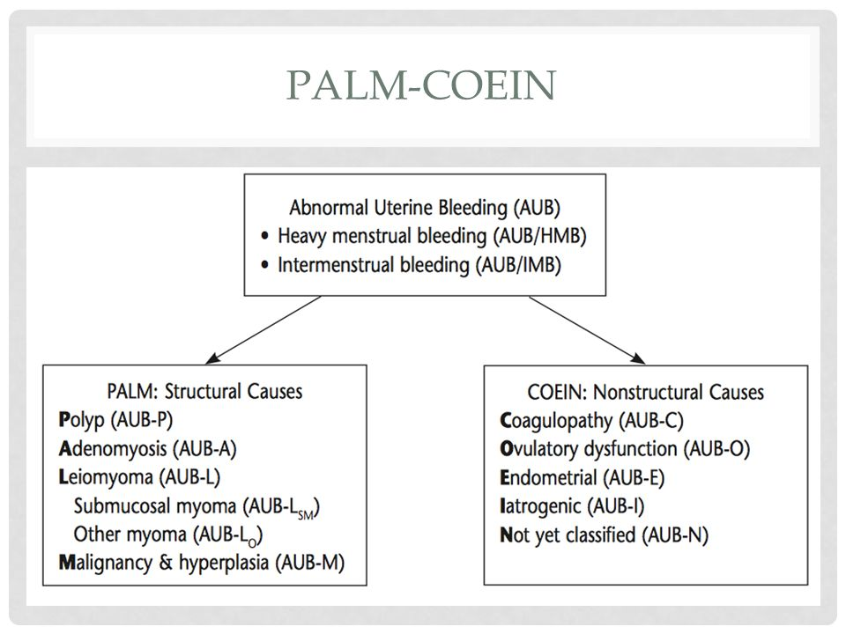
Diagnostics.
• complaints about excessive in duration, volume or frequency bleeding.
- increased bleeding, a history of bleeding, a violation of hemostasis in the family history.
- to clarify the presence of an intrauterine device, taking sex hormones, anticoagulants, recent intrauterine procedures (termination of pregnancy, diagnostic curettage, etc.)
- exclude the presence of pregnancy (pregnancy-related bleeding)
- special obstetric and gynecological examination: examination in mirrors (presence of blood in the vagina+exclude bleeding from the cervix or from the vagina), vaginal-abdominal examination (increase in the size of the uterus, the shape of the uterus, increase in the appendages of the uterus)
- To clarify the presence of anemia (a blood test), a violation of homeostasis (coagulogram), hormonal research methods - laboratory diagnostics.
- Diagnosis of organic pathology of the uterus (visualization of pathology using ultrasound or other imaging examinations).
- endoscopic research methods for better visualization and surgical treatment (diagnostic curettage, hysteroresectoscopy, laparoscopy).
13. Treatment of AUB.
Treatment in accordance with the identified pathology.
14. Types of hemostasis in the gynecology.
ahormonal | hormonal | surgical
Tranexamic acid (TA)  500-1000 mg 3 times per day during 4 – 5 days | Norethisterone acetate  • Medroxyprogesterone acetate  • Dydrogesterone  • Equine conjugated estrogen  • Combined estrogens and progestogens  (contraceptive pills)  • 19 Norsteroid derivative (Gestrinone)  • Danazol (17 α-ethinyl testosterone)  • Progestin releasing IUCD LNG – IUS  • Mifepristone  • GnRH analogues  • Desmopressin | 1.diagnostic curettage, hysteroresectoscopy  2. endometrial ablation  3. myomectomy  4. hysterectomy  5. uterine artery embolization

