**Topic 1. Background, precancerous and benign diseases of the female genitalia.**

**BENIGN OVARIAN TUMORS**  
  
Ovarian tumors are very common among all gynecologic diseases. The mortality rate is high because no effective screening devices are available for early detection.  
  
According to pathogenic theory of ovarian tumors, gonadotropic ovarian hyperstimulation is the leading factor in the development of ovarian tumors. This theory should be recommended for pathogenetical explainatum of malignant ovarian tumors diagnosis and treatment.  
  
The risk factors associated with ovarian carcinoma are:

* women with impairment of ovarian function
* women with postmenopausal bleeding
* women that have been monitored for a long period of time with the diagnosis of uterine fibromyoma, chronic inflammatory processes of uterine adnexa, benign ovarian tumors
* women that have had surgical intervention in pre- or postmenopause with keeping ovaries (or their resection)

All ovarian tumors should be divided into two main groups:

* blastomatic unproliferative tumors (ovarian cysts)
* blastomatic proliferative tumors (ovarian cystadenomas)

Clinical manifestations of ovarian tumors are various and usually uncertain. It depends on tumor's type and character, and also on the spread of the process in the case of malignant tumor.  
  
**OVARIAN TUMORS CLASSIFICATION**  
  
Only histologic signs can give a possibility to distinguish benign and malig­nant ovarian tumor. From the prognostic or survival standpoint, however tumor grade remains the most important factor for all the ovarian tumors.  
  
Histologic classification of ovarian tumors is presented below.

* 1. **Epithelial tumors:**  
       
     **A.** Serous  
       
     B. Mucinous  
       
     C. Endometriod  
       
     D. Clear cell  
       
     E. Brenner  
       
     F. Mixed epithelial  
       
     G. Undifferentiated  
     H. Unclassified.  
       
     There are benign and malignant tumors in each of these groups of neoplasms  
       
     **II. Sex cord stromal tumors:**  
       
     **A.** Granulosastromal cell  
       
     B. Androblastoma  
       
     C. Gynandroblastoma  
       
     D. Unclassified
  2. **Lipid cell tumors**

**III**  
**Germ cell tumors:**

**A.** Dysgerminoma  
  
B. Endodermal sinus tumor  
  
C. Embryonal carcinoma  
  
D. Polyembryoma  
  
E. Choriocarcinoma  
  
F. Teratoma  
  
G. Mixed forms  
  
**V. Gonadoblastoma:**  
  
**A.** Only blastoma (without any forms);  
  
B. Mixed with disgerminoma and other forms of germ cell tumors.  
  
**VI. Soft tissue tumors not specific to the ovary.**  
  
**VII. Unclassified tumors.**  
  
**VIII. Secondary (metabolic) tumors.**  
  
**VIII. Tumor-like conditions:**  
  
A. Pregnancy luteoma  
  
B. Ovarian stroma hyperplasia and hyperkeratosis  
  
C. Considerable ovarian edema  
  
D. Functional follicle cyst and luteal cyst  
  
E. Multiple luteal follicle cysts and (or) luteal cysts  
  
F. Endometriosis  
  
G. Superficial epithelial cysts-inclusions  
H. Simple cysts  
  
I. Inflammatory processes   
  
J. Paraovarian cysts

**UNBLASTOMATIC UNPROLIFERATIVE OVARIAN TUMORS**  
  
**(ovarian cysts)**  
  
Ovarian cyst is the cavity of mature or atretic follicle that become distended with pale, straw-colored fluid as a result of its retention and excessive secretion. They are usually localized in ovaries (corpus luteum cyst, follicle cyst, theca luteal cyst, dermoid cyst) and in its adnexa (paraovarian cyst).  
  
**Follicle cyst**  
  
Follicle ovarian cyst is a single tumor with a thin membrane of mobile consis­tency with a straw-colored fluid. Its formation is a result of fluid retention in atretic follicles. Follicle cyst may be found in women of any age more often after inflammatory processes. True ovarian blastomatic process is absent in such tumor. Cyst membrane is not a new created tissue, it's a result of the excessive extension of follicle membrane. Although these cysts may attain a size from 8 to 10 cm in diameter, spontaneous resolution usually occurs within the weeks. It has been growing inside of abdominal cavity.  
  
***Clinic.***The main symptom is the low abdominal pain, rarely menstrual cycle impairment or uterine bleeding as a result of hyperstimulation from exogenous gonadotropins is observed. Signs of acute abdomen are present in the case of ovarian cyst torsion. Bimanual examination reveals ovarian enlargement up to 10 cm. It is mobile, cystic, unilateral mass. Sometimes inflammatory processes in uterine adnexa are present. Follicle cysts rarely produce any symptoms and diagnosis is often made during monitoring.  
  
*Treatment.*Observation for 2-3 menstrual cycles is necessary. If a spon­taneous resolution doesn't occur, surgical intervention — ovarian resection or oophorectomy — should be recommended. It is very necessary because before surgical intervention it is difficult to make a differential diagnosis of ovarian cyst and serous cystadenoma. Total hysterectomy should be performed in climacteric and postmenopausal women.  
  
Additional therapy is not recommended after operation.  
  
**Corpus luteum cyst**  
  
The evidence of corpus luteum cyst is 2-5% among all the ovarian tumors.  
  
Corpus luteum cyst is an unilateral cystic enlargement which exceeds 8 cm in diameter. Grossly, the cyst protrudes from the contour of the ovary and the wall appears convoluted and thick. The cyst is filled with yellow fluid or blood. It may be found at the age from 16 to 55 years old.  
  
***Clinic.***Symptoms are related to large size or complications of torsion, rupture or hemorrhage. The main complaint of the patient is abdominal pain as a result of concomitant inflammatory processes of uterine adnexa. Special clinical signs are absent. Bimanual examination reveals unilateral ovarian enlargement with tuberculosis uneven consistency. During pregnancy the corpus luteum becomes truly cystic with growth and continued function. At the absence of pregnancy, the corpus luteum normally collapses and is eventually replaced by hyaline con­nective tissue.  
  
***Treatment***More commonly luteum cysts produce no symptoms and undergo absorption or regression. It is necessary to make observation for 2-3 reproductive cycles. Surgical intervention should be recommended in the case if corpus luteum cyst regression doesn't occur.  
  
**Theca lutein**cysts belong to retential ovarian cysts. These cysts are almost bilateral and the enlargement may exceed up to 15 cm. They should be present during pregnancy, hydatidiform mole or choriocarcinoma. They are growing very quickly. They can dissolve after the main disease treatment — hydatidiform mole or choriocarcinoma.  
  
**Parovarian cyst**  
  
Parovarian cyst is formed as a result of fluid retention in ovarian adnexa which has been situated in the broad ligament. It arises at the age of 20-40 years old because only in reproductive period ovarian epoephoron is well developed and it undergoes atrophic changes in climacteric women. Children can have parovarion cyst very rarely. Intraligamentous cysts may be small or may reach 8-10 cm or more in diameter. They are thin-walled and unilocular with solid consistency, they have smooth surface with vessels which are situated outside, it is filled with fluid *(fig. 164).*  
  
  
Fig.164. Parovarian cyst of enormous size:  
  
1 — cyst; 2 — right fallopian tube uterus; 4 — left ovary llopian tube  
  
  
  
  
***Clinic.***Pain in the lower abdomen and sacral region may be present. Symp­toms of adjacent organs compression are present if the tumor reaches large sizes. Symptoms of acute abdomen are common in the case of parovarian pedicle cyst torsion. At bimanual examination pelvic mass with smooth surface and elastic consistency which is palpated near uterus is found. It is painless and immobile.  
  
***Treatment.***Surgical removal of parovarian cyst. It is very necessary to store the ovarian function. Puncture of the cyst should be indicated in some cases.  
  
Thus, retential cysts are more often found in young women. After exception of true ovarian tumor such diagnosis is made in climacteric women. Ultrasono­graphy and laparoscopy should be prescribed for diagnostics.  
  
Patients with ovarian cysts should undergo careful monitoring. Retential cysts of small sizes may undergo spontaneous regression under the effects of anti-inflammatory drags. Thus, they may be treated within 4-6 weeks. One should remember that interm diagnosis and treatment of retential cysts is the prevention to ovarian cancer. True ovarian tumor is revealed in one out of four women with the diagnosis of retential cyst. That's why, these patients require interm surgical intervention.  
  
**BLASTOMATIC PROLIFERATIVE OVARIAN TUMORS**  
  
**(ovarian cystadenomas)**  
  
**Serous cystadenoma**  
  
Serous cystadenoma *(fig. 165)*is unilocular unilateral benign cystic neo­plasm derived from the surface epithelium of the ovary and lined by epithelium that resembles the mucosa of the oviduct *(fig. 166).*It contains clear yellow fluid. The benign serous cystadenoma is usually between 5-15 cm in diameter. Occasionally it fills the entire abdomen. Tumor growing may lead to the enlarge­ment of abdomen, adjacent organs function impairment. No symptoms are specific for this tumor. Rarely, patient may complain on dull abdominal pain. Reproductive  
  
Fig.165. Serous ovarian cystadenoma. (Laparoscopy)  
  
  
cycle is normal. The symptoms of peritoneal irritation are present in the case of pedicle torsion. These tumors are revealed during monitoring.  
  
  
  
  
  
  
Fig.166. Serous cystadenoma. (Laparoscopy)  
  
  
Pelvic examination reveals mobile, painless and unilateral tumor with smooth external surface. Ultrasonography and laparoscopy may confirm the diagnosis.  
  
***Treatment***is surgical because of the relatively high rate of malignancy. In the patients after the childbearing age (after 40 years old) treatment should consist of bilateral salpingoophorectomy and hysterectomy not only because of chance of future malignancy, but because of the increased risk of similar occurrence in the contralateral ovary. In the younger patients with smaller tumors an attempt can be made to perform an ovarian cystectomy to try to minimize the amount of ovarian tissue removed. For large, unilateral serous tumors in young patients, unilateral oophorectomy with preservation of the contralateral ovary is indicated to maintain fertility.  
  
**Papillary serous cystadenomas**  
  
The papillary projections of ovarian cystadenomas may grow inside *(fig. 167)*and outside of the tumor capsule. There are also mixed tumors when these projections are placed into internal and external surfaces of the tumor. Papillary projections may involve peritoneum in the case of malignant degeneration. These tumors are multilocular, they rarely reach large sizes, have a short pedicle. They may be situated intraligamentously. The tumor contains serous or sometimes serous-hemorrhaged fluid. Tumor may coexist with ascites.  
  
  
Fig.167. Papillary ovarian cystoma  
  
  
No characteristic symptoms are specific for this tumor. Frequently, it is revealed during monitoring. The diagnosis is based on the results of bimanual examination, ultrasonography and laparoscopy.  
  
Bimanual examination reveals immobile painless lobulated tumor which is situated near uterus. Frequently it resembles the subserosal uterine fibroid. These tumors have high frequency of malignant change.  
  
*Treatment*is surgical and it is the same as in case of serous cystadenomas.  
  
**Mucinous cystadenoma**  
  
Mucinous cystadenoma is a benign epithelial tumor which may be present in women of different age. It may reach large sizes, sometimes it is multilocular, with round or oval form. The cut surface shows the individual cysts or lobules of various sizes that contain sticky slimy or viscid material of yellow or brown color *(fig. 168).*  
  
  
***Clinic.***No symptoms are specific for this tumor even in case of large sizes. Pain in the lower part of the abdomen and back region may be present in case of intraligamentous location. Symptoms of adjacent organs compression are present if a tumor is huge. Ascites is rare. Bimanual research reveals elastic tumor with lobular surface in the adnexal region. Laparoscopy and ultrasonography can be used for diagnostics.  
  
The usual ***treatment***for the obviously benign mucinous cystadenoma is unilateral oophorectomy. In older women after 45 bilateral oophorectomy and hysterectomy are preferable. Total hysterectomy with bilateral salpingoopho-rectomy are indicated in case of coexisting cervical pathology.  
  
**Pseudomyxoma**  
  
Pseudomyxoma is one of the kinds of mucinous cystadenoma. The incidence of these tumors is low. The tumor is multilocular and has a thin wall. It can be ruptured spontaneously or during the pelvic exam. Pseudomyxoma peritoneal is the complication that may result if the contents of mucinous cyst is spilled into the peritoneal cavity by rupture, extension or at surgery. Sticky slimy material which is spilled into the peritoneal cavity doesn't absorb. Diffuse implants develop into all the peritoneal surfaces with tremendous accumulation of mucinous material within the peritoneal cavity. It supports the chronic inflammatory process in the pelvis, thus chronic pelvic pain is a true result of this. Diffuse implants develop on all the peritoneal surfaces with the tremendous accumulation of mu­cinous material within the peritoneal cavity.  
  
*Clinic.*Pain is the main characteristic sign of pseudomyxoma. The clinical course is usually progressive malnutrition and emaciation. The palpation of the abdomen is painful.  
  
Pelvic exam reveals elastic tumor, frequently of large sizes which is situated near uterus. The diagnosis is proved during operation.  
  
***Treatment***is surgical. The fluid is difficult to remove because of its viscosity. Repeated chemotherapy may be required in postoperative period.  
  
**Cystadenofibroma**  
  
Cystadenofibroma is a benign tumor which is developed from ovarian stroma. It has round or oval form, it is firm and unilateral and may reach the sizes of fetal head. The age distribution is 40-50 years old. It has asymptomatic duration or sometimes it is accompanied by ascitis. Hydrothorax and anemia may be present in rare cases (Meigs Syndrome).  
  
**SPECIAL FORMS OF OVARIAN TUMORS**  
  
**Androblastoma (arrhenoblastoma)**  
  
Androblastoma which is usually masculinizing tumor is reported to produce masculinization. It occurs very rarely and its duration is also malignant. Andro­blastoma is unilateral tumor with smooth or lobular surface. It has small sizes and pedicle and it is mobile.  
  
*Clinic.*Breast, uterine and female external genitalia atrophy are the charac­teristic signs. Uterine and ovarian hyporplasia, endometrial atrophy are common. Amenorrhea and all masculinizing features are present. The combination of mas­culinizing and feminizing symptoms is possible.  
  
*Diagnosis.*Ultrasonography, laparoscopy and ovarian biopsy play an important role at confirmation of diagnosis.  
  
*Treatment*is surgical — removal of the tumor.  
  
In the majority of cases *prognosis*is favorable.  
  
**Thecoma (Theca cell tumor)**  
  
Thecoma belongs to the feminizing tumors. It occurs at all ages but is com­mon after 40 years old and later. The evidence indicates that thecomas arise from the ovarian cortical stroma. Theca cell tumors are unilateral and in most cases they are not malignant. Their sizes may vary from small to those of fetal head. The external surface is firm, ovoid or round, smooth, and gray, occasionally streaked with yellow. Symptoms are related to estrogen production. When the granulosa cell tumor occurs in the pediatric age group, it may contribute to signs and symptoms of precocious puberty and vaginal bleeding. In women of reproduc­tive age group such symptoms as impairment of menstrual function, infertility and pregnancy loss are common. Menopause bleeding, enlarged sizes of uterus and breasts, increasing libido are present in these patients. Ascites may be present in favorable and unfavorable duration of disease. Malignant degeneration of tumor is frequently common in young patient.  
  
*Diagnosis*is based on clinic, bimanual research, ultrasonography, laparo­scopy and hysteroscopy.  
  
*Treatment*is surgical.  
  
*Prognosis*is good in favorable duration and it is unfavorable during the malignant course.  
  
**Folliculoma**  
  
Folliculoma is a hormonal active tumor which produces estrogenic compo­nents and may be manifested in patients through feminizing characteristics. It varies from microscopic inclusions to 40-50 cm in diameters, they are yellow-colored. Folliculoma may have good as well as malignant potential. It is always unilateral with lobular surface. They occur at all ages but are common in women older than 40. Uterine fibromyoma and uterine cancer can coexist with folliculoma.  
  
***Clinic.***Symptoms depend on the level of hyperestrogenemia and on the women age. The girls have the signs of precocious puberty. In reproductive age group women amenorrhea, acyclic bleeding, and later menopausal uterine blee­ding may be present. Combination of feminizing syndrome with infertility and menstrual function impairment testifies the presence of hormonal active tumor.  
  
***Diagnosis***is based on the ultrasonography results, laparoscopy, histologic examination of tissue.  
  
***Treatment***is surgical. In malignant duration of the disease total hysterectomy with omentum major incision should be performed. Chemotherapy is prescribed in III-IV stages of cancer.  
  
**Benign cystic teratoma (Dermoid cyst)**  
  
  
  
  
  
Fig.169. Dermoid cyst: a — dermoid cyst; b — dermoid cyst on sectioning  
  
Dermoid cysts are almost always ovarian tumors. The tumors may occur at any age. Dermoids are bilateral and have 5-10 cm in diameter. At operation, the tumors are found to be round with smooth, glistening, grey surface. At body temperature, they have the consistency of other tensely cystic tumors. Outside the body, they have a soft pultaceous consistency. On sectioning, they are usually unilocular and filled with thick sebaceous material and tangled masses of hair   
  
  
*(fig. 169 a, b).*In 30% to 50% of cases cysts contain the formed teeth. Slow growing, without any symptoms, as a rule, is a characteristic feature of the tumor. Moreover, a dermoid cyst often has a long cruz. At pelvic examination it allows to palpate the cyst in the abdomen or anterior to the uterus.  
  
***Clinic.***No symptoms are common for small sizes tumors. Pain is present in case of large tumors. Ultrasonography, laparoscopy are used for diagnosis.  
  
***Treatment***is surgical. It consists of excision of the cyst, conserving the remaining portion of the ovary.  
  
***Prognosis***is favorable. In 0,4-1, 7% of patients malignant degeneration of tumor is present.  
  
**Brenner tumor**  
  
The Brenner tumor is a fibroepithelial tumor with gross characteristics similar to those of fibroma. It constitutes approximately l%-2% of all the ovarian tumors and is rarely malignant. Brenner tumors have been reported in patients older than 50. Frequently a tumor is unilateral, its shape, sizes and consistency are similar to fibroma *(fig. 170).*According to the most widely accepted theory of histogenesis, Brenner tumors arise from the Walthard cell rests which are a modification and inclusion of the surface or germinal epithelium of the ovary *(fig. 171).*  
  
***Clinic.***A few Brenner tumors are associated with postmenopausal bleeding, and it is suggested that some may contain hormonally active stroma. Bimanual examination, ultrasonography and laparoscopy are diagnostics.  
  
***Treatment***consists in simple excision or oophorectopmy.  
  
***Diagnosis***of benign ovarian tumors.  
  
General and pelvic examination should be performed. Differential diagnosis should be made with uterine fibromyoma *(fig. 172),*endometriosis, inflammatory tuboovarian tumors and moving kidney.  
  
Additional methods of investigation such as uterine probbing, culdoscopy, cystoscopy, urography, X-ray examination, ultrasonography and laparoscopy should be performed.  
  
***Thus, benign ovarian tumors have****some****common peculiarities of clinical****course, such as:*

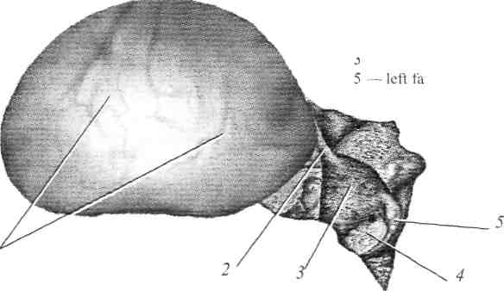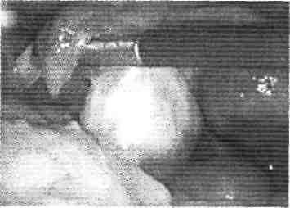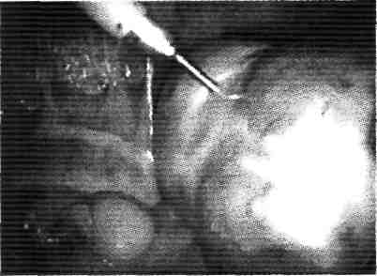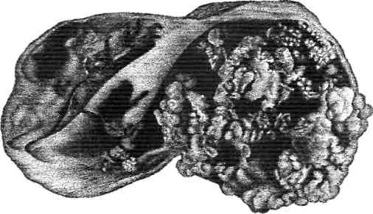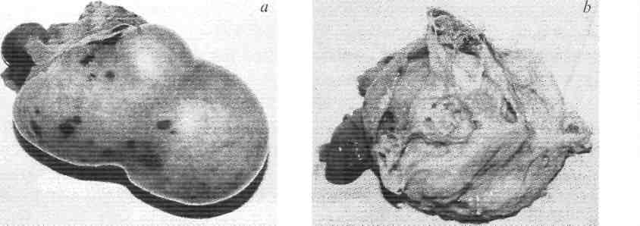

* for a long period of time they are asymptomatic, they are growing into direction of abdominal cavity. Pain is a common symptom in case when the tumor is growing intraligamentously *(fig. 173)*

in the majority of cases cysts and cystadenomas are mobile as a result of pedicle presence. The anatomical and surgical pedicles are distinguished. The anatomical pedicle is composed of the infundibulopelvic ligament, the  
  
  
  
**Fig.172.**Ovarian cystoma. Determination of correlation between a tumor and adnexa in bimanual research by Vebl'  
  
  
  
  
ovarian ligament and mesoovarium. Surgical ligament composes of all of these structures and fallopian tube with its nerves vessels. During tumor removal the clamps should be put on the surgical pedicle below the place of torsion

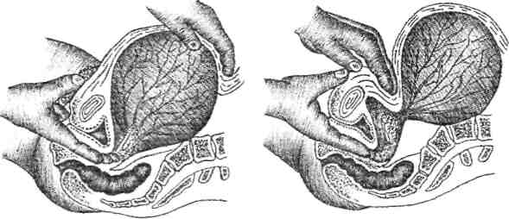

* the signs of adjacent organs compression are present during tumor' growing
* the tumors are palpated as a rule in the lateral sides of the uterus

**Ovarian cysts and cystadenomas' complications**  
  
***Malignant degeneration.***It is most commonly found in serous and papillary cystadenomas, frequently — in mucinous cystadenomas and very rare in dermoid ovarian cysts. It is very difficult to reveal the moment of tumor' malignant degeneration, that's why it is very important to remove the tumor at early stages.  
  
***Torsion.***If the torsion is incomplete, the result is congression and enlarr gement of the neoplasm and thrombosis of the vessels. If the torsion is complete and obstructs the arterial blood supply, a gangrenous necrosis can appear as a result. The symptoms may be gradual pain and tenderness in the region of the tumor or the abrupt onset of pain typical of an acute abdominal condition. Immediate surgery is necessary to remove the compromised tissue.  
  
***Purulention.***High temperature, symptoms of peritoneal irritation, abdominal pain are common. Immediate surgery is recommended.  
  
***Rupture.***In the result of hemorrhage or torsion ovarian cyst may rupture and spill its contents into the abdominal cavity resulting in intensification of the symptoms. Rupture of suspected neoplasm should initiate immediate laparotomy for a prudent removal of the neoplasm  
  
All ovarian tumors warrant surgical removal because of their potential for malignancy, but it is very difficult to reveal this tumor at early stages.

**BENIGN AND MALIGNANT TUMORS  
  
OF EXTERNAL GENITAL ORGANS  
  
AND VAGINA**  
Benign tumors of external genital organs (fibroma, myoma, lypoma, fibro-myoma, hydradenoma, myxoma, angiofibroblastoma) are found rarely in any age and are asymptomatic. Nodes of the tumor on pedicle or on the wide base reach considerable size, sometimes hang down between hips. Malignant trans­formation of the tumor is possible. Edema, hemorrhage, necrosis, secondary infection can develop due to violation of blood supply.  
  
**Fibroma**is a rare tumor arising from connective tissue and smooth muscle elements of the vaginal wall. Depending on the arrangement of fibres, these tumors can be soft, solid and dermoid. A tumor is situated in the depth of labia major or under the vaginal mucosa. It grows slowly and gives no clinical symptoms until it reaches considerable size, that creats discomfort in walking and sexual intercourse. Only dermoid fibroma can become malignant.  
  
**Lipoma**develops from adipose and connective tissue. It consists of mature adipose tissue, that is divided into lobules by partitions of connective tissue. It is localized in the region of pubis or labia major. The tumor is of soft consistency, it is round in shape, rather mobile and is not adhered with skin. It grows slowly.  
  
**Myxoma**is formed from remnants of mesenchyme. It is localized in the region of pubis and labia major. It occurs more frequently in the aged women.  
  
**Hemangioma**appears on the basis of congenital anomaly of skin vessels and mucosa of sexual organs. The capillary and cavernous hemangioma have been distinguished. It is localized in the region of labia major as a nodule of red or blue colour. It grows rapidly reaching considerable size, sometimes passing to vagina and cervix.  
  
**Papilloma**is formed from the epithelium of labia major, has fibroepithelial structure. Macroscopically it is a single or plural tumor on the pedicle or wide base with granular surface. It should be differed from condyloma acuminata. Prognosis is usually favorable, but for some conditions malignization is possible.  
  
***Treatment***of all the forms of benign tumors is surgical (tumor removal).  
  
**Bartholin duct cyst**  
  
Bartholin gland cyst is formed in the result of blocking of its excretory duct. It is situated in the lower one-third of labia major. The formation has 2-4 cm in diameter, round or oval shape and elastic consistency. It is frequently complicated with suppuration, that is followed by symptoms of acute inflammation (pain, edema, hyperemia, infiltration of tissues, violation of general state of health, raising tem­perature).  
  
***Treatment***is surgical — over the most prominent place the dissection of the skin 2-3 cm long is made, the gland is shelled off and removed by obtuse and sharp way. Hemostasis is performed and the stitches are put in.  
  
**The Gartner's duct cyst**  
  
  
  
  
Fig.177. The Gartner's duct cyst   
  
  
The cyst of Gartner's duct has embrional origin. It is developed from the remnants of vestigial mesonephric duct. It is situated on the lateral wall of vagina, has up to 3-4 cm in diameter and dense or soft-elastic consistency. It is diagnosed during gynecological exami­nation *(fig 177).*In some cases it should be differentiated from sarcoma of vagi­na, and in case of suburethral location of the cyst — from the diverticle of urethra.  
  
**Treatment**is surgical. Vagina is opened by specula and its wall is incised in the place of the biggest prominence of the cyst that is shelled off.   
  
  
**PRECANCEROUS DISEASES OF THE VULVA**  
  
To precancer diseases of the vulva belong:   
  
leukoplakia  
  
vulvar kraurosis  
  
Bowen's disease  
  
Paget's disease  
  
pigmented spots, inclined to growth and ulceration  
  
  
***Treatment***Replacement therapy, psychotherapy, sleeping-draughts, sedative remedies are prescribed. Baths with camomile decoction, prednisolon ointment, oxycort, ointment with anesthesin are prescribed locally. Treatment is not always effective. From non-medicinous methods magneto-laser therapy, gas and semi­conductor apparates have been also used.  
  
**Bowen's disease**  
  
Bowen's disease is followed by appearing on the external genitals skin of flat or slightly rising above skin level spots with clear margins. Histologically the signs of hyperkeratosis and acanthosis are found.  
  
**Paget disease**  
  
  
  
  
  
Fig. 179. Histological picture in Paget disease  
  
At Paget disease during gynecological examination on skin of vulva scarlet eczema-like spots with granular surface are found *(fig. 179).****Treatment***is surgical. Vulvectomy is recommended. 

