**Topic 2. Background, pre-cancer and benign diseases of the reproductive system of a woman (uterine myoma, endometriosis).**

**Endometriosis**

Endometriosis – benign hormone-dependent disease, which is based on heterotopias of endometrium (glandular and stromal components), the signs of which are nonspecific inflammation and elevated levels of enzymes on the background of disturbances of hypothalamic-pituitary-ovarian system, immune balance in the presence of genetic predispositions. The problem of endometriosis is medical and social - a common cause of disruptions of working capacity and reproductive function of women, therapeutic and diagnostic - the complexity of early clinical diagnosis and conservative treatment in the later stages of the disease, cancer - an increasing number of observations of malignant diseases at an early stage have been diagnosed as endometriosis, The occurrence in general population - 5 - 10%, it occupies the third place in the structure of gynecological diseases after inflammation and uterine fibroids and affects, according to WHO, 25 - 30% of women of reproductive age. 27% of women who gave birth , 30 - 40% woman with infertility, 10% of girls at the age of menarcheand approximately 2 - 5% of women in menopause are diagnosed with endometriosis. The hypothesis of origin according to P. J. Q. van der Linden, 1997 are: in situ formation, transplantation, the combination of the formation of transplantation and implantation of endometrium, embriological hypothesis, hypothesis of metaplasia due to inflammation or hormonal stimulation, immunological theory. The risk factors include: history of abnormal births, gynecological operations, abortions, hormonal disorders, the decline of immunological tolerance, hereditary predisposition, early menarche, age older than 35-45 years, reducing the length of the menstrual cycle, the increase of menstrual blood loss, inflammatory diseases of the genitalia, the first labor families in the older age, waiver of breast feeding, the abuse of alcohol, caffeine, adiposity. Factors that lower the risk are: use of

hormonal contraceptives, previous use of IUD, smoking, belonging to a particular race.

**Topical classification**

• І. Genital endometriosis

▪ Internal endometriosis (adenomiosis) o Endometriosis of corpus uteri І,ІІ,ІІІ stages depth of invasion into endometrium : glandular, cystic, fibrous (focal, nodular, diffuse) form o Endomeetriosis of the cervical canal o Endometriosis of the isthmic part of the fallopian tubes ▪ External endometriosis o Peritoneal endometriosis

✓ of ovaries (infiltrative and tumor forms)

✓ of fallopian tubes

✓ of pelvic peritoneum (red, black, white form) o Extraperitoneal endometriosis ✓ vaginal part of cervix

✓ of vagina, vulva

✓ retrocervical

✓ of uterine ligaments

✓ Parametrial, paravezical, paravaginal tissue with or without invasion into the bladder, rectum

▪ External-internal endometriosis

▪ Combinations of endometriosis (genital or extragenital pathology)

• Extragenital endometriosis (gastrointestinal tract, urinary organs, skin, navel, postoperative wounds, lungs, pleura, etc.

**Symptoms** include: pain (pelvic pain, algodismenorrhea, dyspareunia), infertility, hemorrhagic syndrome, long ineffective treatment of chronic genital inflammation, mental disorders, impaired function of adjacent organs, absence of symptoms. Typical symptoms include: dysmenorrheal, dyspareunia (sexual disorders), infertility, pelvic pain. Less typical symptom - dysheziya (disturbance of bowel movements), dark bloody discharges before and after menses, dysfunctional uterine bleeding, dysuria. More rare symptoms are frequent urge to urination, haematuria, bleeding from the rectum. Very rare symptoms are haemoptyzys (bloody cough), intestinal obstruction, edema of the kidney and ureter, skin nodes. Chronic pelvic pain. This is the most common symptom of endometriosis. The intensity depends on localization of ectopy (especially pronounced in endometriosis of isthmus, sacro-uterine ligaments, nodular form), the extent of the process, duration of disease, individual characteristics.

Menstrual cycle disturbances include progressive algomenorrhea, menometrorragia, bloody discharges before and after menstruation, contact bloody discharges, irregular menstruation. The disease for a long time may be hiding under the mask of various pathological processes.

**Special methods of diagnosis include**: X-ray examination, ultrasound, endoscopic methods including hysteroscopy and oth., CT, MRI ( fiber – accuracy of diagnostics - 98-100%), cytological, histological (diagnostic accuracy 98-100%), determination of the levels of tumor markers (CA-125, HE - 4) . **Hysterosalpingography**. The accuracy of diagnosis ranges from 33.2 to 97.4%. Its not posssible to diagnose a focal or nodal form. The procedure is done 2-3 days after menstruation or 24 hours after thorough curettage of the uterus, or 68 days after endometrial curettage because of the best penetration of contrast in endometrioid moves. During the procedure aqueous solutions are preferred.

**Ultrasound** is the best and affordable screening method. There may be difficulties in accurate diagnosis if adhesive processes are present, it is impossible to identify depth of the lesion of external genital and extragenital endometriosis In some of the cases the evaluation and visualization is not accurate.

**Hysteroscopy**. This method if Miniinvasive and highly informative. During the procedure there is a high incidence of diagnosing submucous nodes, adenomyosis, chronicendometritis, hyperplasia of endometrium, polyps.

The procedure is done not only for diagnosis but as a surgical method of treatment too. There is a possibility to do biopsy or curettage, remove tumors or septas, separate adhesions.

**Laparoscopy** has a high diagnostic accuracy with direct visualization, ability to biopsy and histological examination. If it is already diagnosed appropriate therapeutic rather than diagnostic laparoscopy is applied.

**Endometriosis of vagina and perineum.**

The symptoms are: pain in the vagina and in the pelvis from mild to severe, cyclic pain that is related to the MC, the pain may be accompanied by local itching. The diagnosis criteria are: during menses painful nodes may be palpated in the vagina, after the menstruation they decrease in size or disappear leaving scars, hystological investigation may be performed.

**Endometriosis of the cervix.**

During the speculum examination cyanotic cysts may be seen. To confirm the diagnosis colposcopy and biopsy is performed. The sysmptoms include dark bloody discharges from vagina before and after menses. This is the only form that the pain symptom is not present.

**Endometriosis of the ovaries**

Emndometrial cysts of the ovaries as the small heterotopias may be either unilateral or bilateral with different diameters of the cysts (from 0.5 up to 10.0 cm in diameter). The symptoms include: pain especially before and during menses, infertility, disuria, dysheziya. In case of rupture of the cysts the pain is accompanied by vomiting, unconsciousness, elevated body temperature. Diagnoses. Bimanual examination: One or both sides tumors are palpated in the pelvis, inactive painful especially during menstruation, with bumpy surface, located at the sides or behind the uterus, with a dense capsule, limited mobility, often along with the uterus are palpated as one conglomerate. The other diagnostic measures include ultrasound, endoscopic methods (laparoscopy)( small size cyanotic nodes or cysts of various size).

**Retrocervical endometriosis** occurs relatively frequently. Behind the cervix a dense bumpy, sharp pain, formation of different size, limited in mobility is palpated. The symptoms are - severe pain syndrome, difficulties of bowel movement.

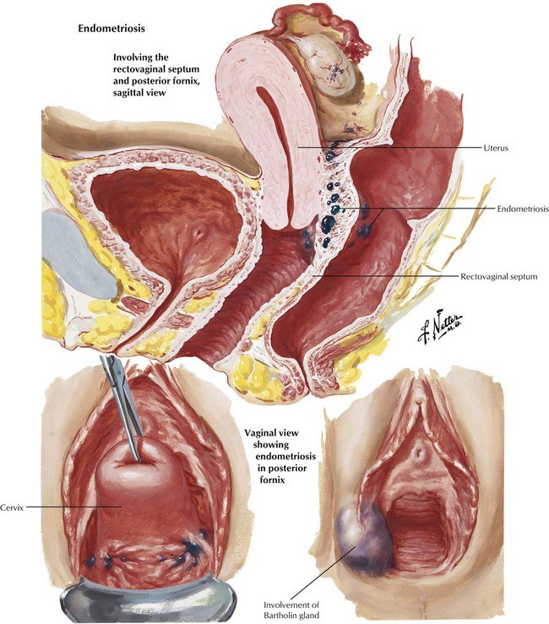

**Extragenital endometriosis** - endometriosis of the naval, endometriosis of the postoperative scar and others.

**Adenomyosis.**

Pathological classification V.I.Zheleznov , AN Strizhakova

• I degree. – germination of mucosa to a depth of one field of view at low magnification of the microscope

• II degree - Germination mucosa to the middle of the wall thickness

• III degree - the entire muscle layer is involved into the pathological process Symptoms.

It is believed that the clinical manifestations occur in women with II and III degree and nodular form, whereas I degree is a histological finding during hysterectomy . The course may be asymptomatic - 19-40%, algomenorrhea - 76%, hypermenorrhea - 50-66%, "chocolate“ like vaginal discharges - 56%, increased dysmenorrhea - 30% (at a depth of myometrial lesions by more than 80%) , pelvic pain, metrorrhagia, dyspareunia, infertility.

**Diagnoses**. Bimanual examination (a moderate increase in uterine anteroposterior size, tenderness, when nodular form dense nodes are palpated, painfulness and the value of which increase during menstruation).

**Ultrasound** (increased anterio-posterior uterine size (80%), a thickening of one of the walls of uterus (81.8%), the presence of zone of increased echogenicity, occupying more than half the thickness of the myometrium (96%), hysteroscopy, hysterosalpingography, laparoscopy.

**Treatment** The choice of treatment strategy depends on the age of woman, localization and extent of the disease, severity of symptoms and duration of illness, fertility and the need to restore fertility, the effectiveness of previous treatment, presence of comorbidity, common therapeutic approaches. The methods of treatment include surgical therapy, hormonal therapy, during menopause if minimal manifestations of the disease are present expectant management, auxilary (for all symptoms) therapy, IVF if infertility Conservative therapy includes hormonal therapy, non-specific antiinflammatory therapy, medications that affect the central nervous system, immunomodulators, antioxidants, vitamin, medications that support the function of gastrointestinal and hepatobiliary systems, physiotherapy treatment, treatment of comorbidity. According to the consensus for the treatment of chronic pelvic pain syndrome and endometriosis (2002) the first line of treatment include Monophasic COC + nonsteroidal anti-inflammatory therapy if treatment failure. The second line of treatment is surgery (laparoscopic or laparotomy) treatment. In our country the second-line treatment should be considered a destination of agonist of gonadotropin-releasing hormone after failure are surgical treatment is performed. If untreated, the disease progresses with the development of common tumor forms, malignant degeneration.

Indications for surgical treatment of endometriosis are

• internal endometriosis combined with hyperplastic processes of ovaries and / or endometrial precancerous

• adenomyosis (diffuse or nodular form) accompanied by hyperplasia of endometrium

• Endometrial ovarian cysts (larger than 5 cm)

• No effect of conservative treatment, which was carried out continuously for 6 months

• pathological involvement of other organs and systems with violation of their functions

• purulent lesions of the uterus, affected by endometriosis

• endometriosis of navel

• adhesions of the fallopian tube in ampullar departments with infertility

• endometriosis of the postoperative scar

• presence of somatic pathology, which precludes long-term hormone therapy With the ineffectiveness of hormone therapy, infertility, malignant forms of internal endometriosis, suspected malignancy In reproductive age – organ retaining surgery by laparotomy or laparoscopy access, conservative treatment, treatment of infertility, in perimenopause – radical surgery.

**Fibroid**

Fibroid is a commonest benign tumor of the uterus and also the commonest benign solid tumor in female. Histologically tistumor is composed of smooth muscle and fibrous connective tissue, so named as uterine **leiomyoma**, **myoma** or **fibromyoma**. Incidence – at least 20 per cent of women at the age of 30 have got fibroid in their wombs. The incidence of symptomatic fibroid in hospital outpatient is about 3 per cent.

Etiology still remain unclear. The prevailing hypothesis is that, it arises from the neoplastic single smooth muscle cell of myometrium. The possible causes are: chromosomal abnormality (rearrangements, deletions), role of polypeptide growth factors, a positive family history is often present. The growth is predominantly oestrogen-dependent tumour. Increased risk factors include nuliparity, obesity, hyperoestogenic state, black woman, reduced risk multiparity, smoking.

Classification:

• The fibroid of the uterus body

• The fibroid of the cervix

o Anterior

o Posterior

o Lateral

o Central

Depending on the location of the nodes the fibroid are divided into:

• Interstitial or intramural (about 70%)

• Subperitoneal or subserous (15%, may be subserous, pedunculated, or broad ligament fibroid)

• Sumbmucous (5%) - it produces maximum symptoms

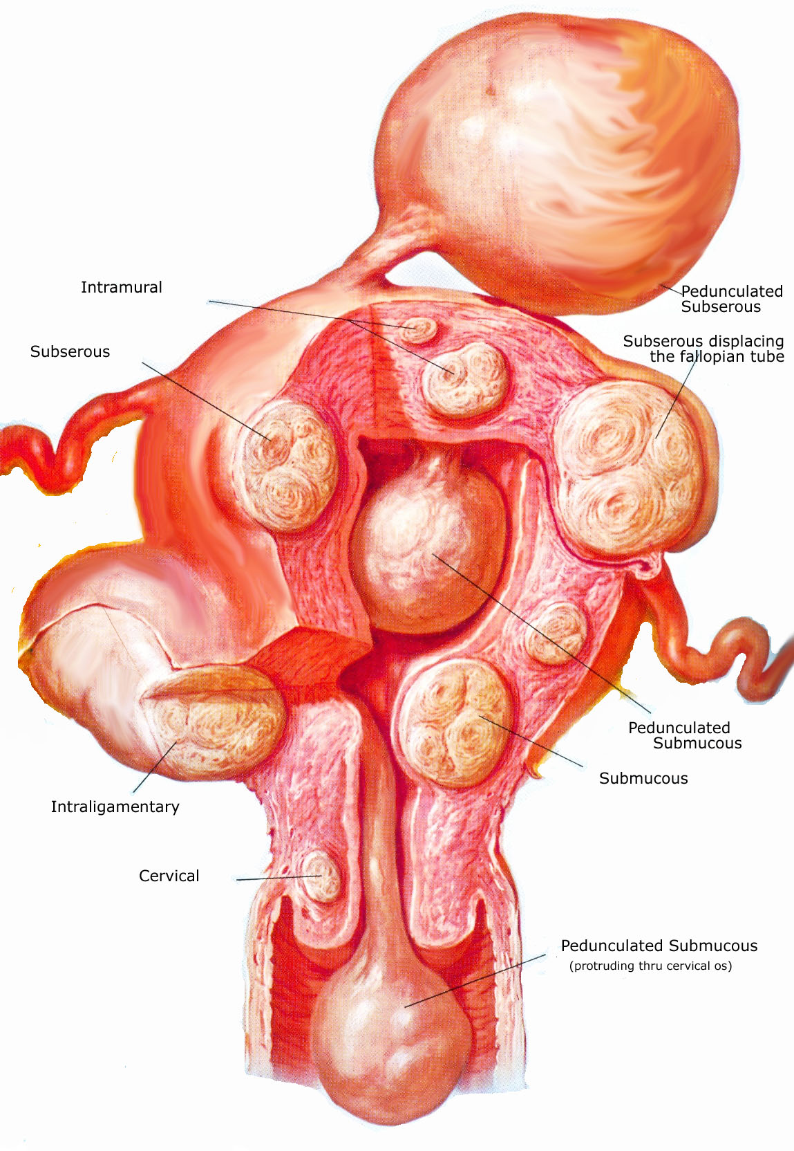

Symptoms:

• Asymptomatic (75%). They may be accidentally discovered by the physician during routine examination or at laparotomy or laparoscopy.

• Menstruation abnormalities. Menorrhagia is the classic symptom of symptomatic fibroid,

• Metrorrhagia or irregular bleeding.

• Dysmenorrhea

• Infertility

• Pain in the lower abdomen

• Abdominal swelling (lump)

• Pressure symptoms

• Abdominal enlargement

• Reccurent pregnancy loss (miscarriage, preterm labour)

Diagnosis:

1. Abdominal examination – if the uterus body is enlarged up to 12 weeks of pregnancy, the uterus body may be palpated through the abdomen. It feels firm, more towards hard, surface in nodular, mobility is restricted.

2. Percussion – the swelling is hard on percussion

3. Pelvic examination: the swelling of the uterine. The size of the uterus is evaluated in weeks, according to size corresponding the gestational term. The uterus is not felt separated from the swelling, the cervix moves with the movement of the tumour felt per abdomen, with the exeption subserous pedunculated fibroid. The doctor should evaluate the size, motility, nodularity.

4. Ultrasound and Colour Doppler: uterine contour is enlarged and distorted, may be hypoechoic or hyperechoic. Transvaginal ultrasound can accurately assess the myoma location, dimansions and volume, is mostly done in case of fibroids less than 12 weeks of gestation.

5. Saline infusion sonography

6. Magnetic resonance imaging – not used routinely for the diagnosis

7. Laparoscopy – it may differentiate a pedunculated fibroid from ovarian tumour not revealed by clinical examination.

8. Hysteroscopy is of help to detect submucous fibroid in unexplained infertility and repeated pregnancy wastage.

9. Uterine curettage – in the presence of irregular bleeding, to detect any coexisting pathology and to study the endometrial pattern, curtage is helpful. It additionally helps to diagnose a submucous fibroid by feeling a bump.

**Cervical fibroid.**The symptoms are due to pressure effect on the surrounding structures.

Anterior cervical –bladder symptoms, posterior cervical – rectal symptoms in the form of constipations, lateral cervical – vascular obstruction, that may lead to haemorrhoids and oedema legs, central cervical – predominantly bladder symptoms.

Treatment – myomectomy, hysterectomy.

Differential diagnosis. The fibroids should be differentiated from pregnancy, full bladder, adenomyosis, myohhyperplasia, ovarian tumour.

Complications of the fibroids:

• Persistans mennorrhagia, metrorrhagia or continued vaginal bleeding that leads to severe anaemia

• Severe intraperitoneal haemorrhage due to rupture of veins over subserous fibroid

• Ischemia or necrosis of the fibroid nodes, leading to peritonitis

• Sarcoma (malignant changes in the uterus) Polyps is a clinical entity reffering a tumour attached by a pedicle.

The type of **operation** depends on the age of the women, the course of the disease, the need to preserve the reproductive function, the location ond number of nodes. Indications for surgical treatment:

1. Symptomatic fibroid ( with heamoragic and pain syndrome, anemia, symptoms of the compression of the adjacent organs)

2. The size of the uterus 13-14 weeks of gestation and more

3. A submucous node

4. A suspicion of a node malnutrition

5. A subserous pedunculated node (because of the risk of torsion)

6. Rapid growth of the fibroid ( 4-5 weeks during a year or more) or resistancy to GnRH agonists therapy

7. Fibroid accompanied by premalignant pathology of endometrium and ovaries

8. Infertility because of the fibroid

9. Appehdages commorbidity