Topic 4. Operative gynecology.

1. Preoperative preparation of the patient for gynecological surgery
Preoperative Management
The purpose of the preoperative workup is to assist the gynecologic surgeon in preparing their patient for surgery. In most cases, this workup includes patient evaluation, stratification of risk, and risk factor modification. The surgeon is thus able to reduce delays in the preparation phase, to enhance patient safety, to recognize and treat complex medical problems, to reduce evaluation costs, and to minimize case delays and cancellations.
Goals of the preoperative examination: Obtain and review specialty consultations. Assist with patient evaluation and risk-factor modification. Identify significant medical conditions by reviewing the following:
- History and physical examination findings
- Hospital and clinic medical records
- Appropriate test results

Modify significant conditions that are associated with perioperative complications.
Educate the patient. Provide information about the anesthetic plan, including available options and their associated risks. Notify the patient about preparation issues, such as nothing-by-mouth (ie, NPO) requirements and medication instructions. Develop an appropriate anesthetic plan. Communicate the results of the whole evaluation to the patient, surgeon, primary care physician (PCP), and anesthesiology team.
Preoperative evaluation
The purpose of the preoperative evaluation is not to provide a general screening examination. Normal healthy women undergoing minor procedures may be seen by both the surgeon and the anesthesia personnel on the day of surgery in the preoperative holding area. These patients should receive written and oral instructions and be allowed to ask questions while in the waiting area. However, women with significant medical conditions should be seen at least 1 week before surgery to allow time for risk assessment, specialty consultation, and patient preparation. Many medical conditions can change or occur within a few weeks, days, or hours after the preoperative evaluation. These complicated patients and their conditions require additional evaluation or treatment before surgery is performed. Other time restrictions on evaluation may be required by individual hospitals.
History
A thorough medical and surgical history and review of systems regarding significant medical conditions is an important start to the preoperative evaluation. By obtaining information from the patient and other sources, one may determine a woman's perioperative risk. A comprehensive review of a woman's history is the first step in determining the depth of physical examination and laboratory and radiologic workup that is required.
Physical Examination
The goal of the preoperative physical examination is to identify physical findings consistent with medical disease states. This examination is not designed to document the condition for which the surgical procedure is indicated but only to confirm the patient's history.
An appropriate examination consists of the following:
- Vital signs – Blood pressure, pulse, respiratory rate, body temperature, height, and weight
- General – Body habitus and physical appearance
- Head, ears, eyes, nose, and throat (HEENT) – Abnormalities of the HEENT and airway
- Lungs – Auscultation for equal bilateral breath sounds and presence of rales, rhonchi, and wheezes
- Heart – Auscultation for regularity of rate and rhythm and presence of gallops, rubs, and murmurs; auscultation for carotid bruits and observation of jugular venous distention, as indicated
- Neurologic – General observation of mental status, cranial nerve function, and sensorimotor ability
- A thorough abdominal and pelvic examination is a major component of the physical examination. One must use these physical findings to determine if the disease process is stable, has improved, or has worsened.
The surgeon should discuss with the patient the extent of the surgery, the incision planned, and any variations in technique or extent of surgery, depending on the intraoperative findings. This discussion, and also a thorough examination, reassures the patient and her physician.
Informed consent
A thorough discussion of the proposed procedure and possible complications should occur and be documented. This ensures that the patient and her family’s expectations for her surgical outcome are realistic and appropriate.
In general, the informed consent discussion should include the indications, expected benefits, alternatives, and the expected course of the problem if the procedure is not performed. The patient should be informed that complications can occur in any surgical procedure. In addition, one should explain that treatment of complications or unexpected findings may require consultation with other surgical specialists.
Discussing what the surgeon will do to prevent complications, such as use of prophylactic antibiotics to lower the risk of infection or low molecular weight heparin to prevent pulmonary embolism, may be helpful.
Preoperative Indications for Laboratory Tests
In the current climate of the desire of high-quality, low-cost health care, the use of many "routine" preoperative laboratory tests has been called into question. As described above, an appropriate history and physical examination determine the need for tests beyond a complete blood cell (CBC) count.
Prothrombin time (PT), platelet count, and activated partial thromboplastin time (aPTT) are not routinely indicated unless a bleeding disorder is suspected. Blood glucose determination is indicated only in the elderly population because of the high prevalence of diabetes mellitus. Blood urea nitrogen (BUN) determination only (ie, no creatinine) seems indicated in the absence of a history of urinary tract problems. Serum creatinine may be considered in gynecologic patients who are at high risk or who have ureteral injury. This provides a baseline to use for postoperative follow-up. A routine urinalysis (UA) is not indicated.
Chest radiographs have been shown to be of minimal value in women younger than 30 years who are undergoing elective surgical procedures. [2] Intravenous pyelogram (IVP) has been a standard study used when extensive pelvic surgery is indicated, but IVP is not indicated before routine gynecologic surgery.
Electrocardiograms (ECGs) are not indicated in patients younger than 35 years who have a benign cardiac history and physical examination. When an ECG is deferred, review of exercise tolerance is an important part of the patient history.
In summary, patient age, disease diagnosis, procedure risk class (see Anesthesia Evaluation in Other Preoperative Considerations), and prevalence of associated disease states, coupled with a careful and detailed history and physical examination, determine the need for specific preoperative testing.
he anesthesiologist's preoperative visit is key in preparing the patient for the operating room. The method of anesthesia; the agents available; and the use of epidural anesthesia, patient-controlled analgesia (PCA), or other modalities for postoperative pain relief are discussed.
The assignment of surgical risk is made using the ASA physical status classification. The letter E is added to any of the classes when an emergency surgical procedure is performed. Anesthesia and surgical morbidity increase as the physical status increases from status I through status V, as follows:
- Status I – A healthy patient
- Status II – Patient with mild to moderate systemic disease (eg, anemia, morbid obesity)
- Status III – Patient with severe systemic disease that limits activity but not to the point of incapacitation (eg, healed myocardial infarction, diabetes with vascular complications)
- Status IV – Patient with incapacitating systemic disease that is life-threatening (eg, advanced hepatic or renal insufficiency)
- Status V – Moribund patient who is not expected to survive (eg, major cerebral trauma, massive pulmonary embolus)

Antimicrobial Prophylaxis
A wound infection develops as a result of a complex interaction between the bacteria inoculated into the wound during surgery and the local and systemic resistance of the host to infection. The size of the bacterial inoculum is correlated directly with the risk of a postoperative wound infection. Factors such as prolonged preoperative hospital stay and the excessive use of antibiotics increase the risk of colonization with hospital-acquired pathogens. Alterations in the resistance of the host to infection may occur systemically or locally (ie, within the wound).

Nutritional support and control of distant infection reduce the risk of wound infection. Achievement of optimal local resistance to infection is predominantly a surgical task. Various factors, such as the presence of blood, foreign bodies, ischemia, or necrotic tissue at the operative site, may impair local host defenses and increase the risk of infection. Meticulous surgical technique helps avoid many of these contributing factors. The primary benefit of antibiotics is a reduction of the inoculum of viable bacteria in the wound.

Principles of antibiotic administration
See the list below:
Timing: Adequate concentrations of the drug must be present in the tissues at the onset and throughout the procedure. The latter problem is particularly significant when antibiotics with a short serum half-life are used, the operative procedure is prolonged, or both.
Route of administration: Intravenous administration of antibiotics is the optimal method to ensure adequate levels are present in tissues during most operative procedures. The exception to this principle is in bowel preparation. Preoperative oral administration of antibiotics is effective in preventing wound infections. Antibiotics administered orally prevent infection by reducing the high colonic bacterial inoculum rather than by achieving high concentrations in the wound.
Duration: A single dose of antibiotics immediately before surgery is sufficient for most procedures. If the procedure is going to last longer than 3 hours, consideration should be given to repeating the dose
Choice of antibiotic regimen
The regimen chosen depends on the pathogens usually associated with wound infection in a given operation, the serum half-life of the antibiotic, the antimicrobial susceptibility patterns in the local hospital, and the cost of the medication. Postoperative wound sepsis is the most common nosocomial infection in patients undergoing surgery. Wound sepsis is an important cause of illness resulting in a prolonged hospital stay, an increase in the cost of medical care, and an inconvenience to patients and their families.
The most important principle is that the antibiotic selected should be effective against the pathogens most frequently responsible for wound infection after the particular operation. The recommended regimen for women undergoing vaginal hysterectomy, abdominal hysterectomy, or radical hysterectomy is a single intravenous dose of cefazolin (1 g) or cefotetan (1 g) at induction of anesthesia.
Indications for antibiotic prophylaxis include the following:
- Vaginal hysterectomy
- Abdominal hysterectomy
- Radical hysterectomy
- Female pelvic reconstructive surgery
- Hysterosalpingogram or chromotubation
- Dilatation and evacuation
- Low-risk of infection but significant consequences if infection occurs
- Clean-contaminated procedures
Select clean procedures.
Antibiotics administered intravenously immediately before surgery ensure adequate levels in tissues throughout the surgical procedure. Therapy should last less than 24 hours and usually should consist of a single dose. The antibiotic regimen is chosen based on expected pathogens at the surgical site and local susceptibility patterns of these microorganisms. Appropriate use of antibiotics reduces wound infection rates and decreases morbidity and cost.

Deep Vein Thrombosis/Pulmonary Embolism Prophylaxis
Preoperative patients should be classified according to levels of risk of thrombosis (listed below) to determine the benefits and risks of pharmacologic and physical methods of preventing VTE.
Classification of risk levels for deep VTE among gynecologic surgery patients:
- Low risk – Younger than 40 years and surgery lasting less than 30 minutes
- Moderate risk – Surgery lasting less than 30 minutes in patients with additional risk factors; surgery lasting less than 30 minutes in patients aged 40-60 years with no additional risk factors; major surgery in patients younger than 40 years with no additional risk factors
- High risk – Surgery lasting less than 30 minutes in patients older than 60 years or with additional risk factors; major surgery in patients older than 40 years or with additional risk factors
- Highest risk – Major surgery in patients older than 60 years plus previous VTE, cancer, or molecular hypercoagulable state

Additional VTE risk factors
- Prolonged surgery
- Trauma
- Previous deep venous thrombosis (DVT) or pulmonary embolism
- Varicose veins
- Infection
- Malignancy
- Estrogen therapy/selective estrogen receptor modulators
- Smoking
- Central venous catheterization
- Acute medical illness
- Heart or respiratory failure
- Inflammatory bowel disease
- Myeloproliferative disorders
- Paroxysmal nocturnal hemoglobinuria
- Nephrotic syndrome
- Obesity
- Immobility
- Cancer therapy
- Estrogen-containing oral contraception or hormone therapy
- Inherited or acquired thrombophilias
- Deficiencies of protein C, protein S, or antithrombin III (AT-III)
- Factor V Leiden mutation
- Prothrombin gene mutation G20210A

General recommendations for VTE prophylaxis:
Prophylaxis for low-risk patients – Encourage patients to move their legs frequently while in bed. Provide a footboard for those patients not likely to achieve early ambulation (ie, evening of surgery or next morning). Encourage early ambulation.
Prophylaxis for moderate-risk patients – Recommendations are the same as for low-risk patients, plus the following:
Low-dose unfractionated heparin (5000 U q12h) or
Low molecular weight heparin (LMWH) (dalteparin 2500 U daily or enoxaparin 40 mg daily) or
Intermittent pneumatic compression devices before surgery or
Graduated compression stockings before surgery
Prophylaxis for high-risk patients – Recommendations are the same as for low-risk patients, plus the following:
Low-dose unfractionated heparin (5000 U q8h) or
LMWH (dalteparin 2500 U daily or enoxaparin 40 mg daily) or
Intermittent pneumatic compression devices before surgery
Prophylaxis for highest-risk patients
Low-dose unfractionated heparin (5000 U q8h) or
LMWH (dalteparin 2500 U daily or enoxaparin 40 mg daily) or
Intermittent pneumatic compression devices/graduated compression stockings plus low-dose unfractionated heparin (5000 U q8h) or low LMWH (dalteparin 2500 U daily or enoxaparin 40 mg daily)

2. managing the postoperative period in gynecological patients.

The surgeon's goal during the postoperative period is twofold. The first goal is to provide appropriate support that allows for the maintenance of homeostasis and the prevention of potential complications. The second goal is to recognize unfavorable trends in the course of recovery and respond expeditiously to prevent further compromise. With diligent care, the surgical patient should eventually return to her preoperative level of function.

Vital signs
Much information can be obtained by close monitoring of vital signs, including blood pressure, pulse, and respiratory rate. More importantly, the trend and changes of these measurements more accurately reflect the patient's ongoing condition. In the immediate postoperative period, the recovery room staff usually obtain frequent vital sign measurements.
Selected parameters are more important during various stages of the recovery period. Initially, respiratory rate and blood pressure are of greater significance during recovery from anesthesia, because these factors reflect hemodynamic stability and the level of anesthetic reversal. Later, after adequate analgesia and pulmonary function have been obtained, the pulse rate correlates better with intravascular volume status. After discharge from the recovery room, vital signs should be monitored every 4 hours until stable and then every 8 hours depending on the patient's progress.

Postoperative activity
Early ambulation is extremely important after surgery. In addition to improving diaphragmatic excursion with its subsequent decrease in pulmonary atelectasis, early ambulation also prevents the development of DVT.
To further decrease the incidence of pulmonary ventilating defects and to improve mobilization of mucous secretions, patients are encouraged to cough and breathe deeply. To assist with this respiratory exercise, an incentive spirometer is used at least every hour while the patient is awake.

Nutrition
A low-residue diet 6 hours after major gynecologic surgery for benign indications is not associated with increased postoperative gastrointestinal complaints, including ileus. [15] Healthy recovery from surgery may include transient loss of appetite and mild nausea. This is usually secondary to anesthetic agents and other perioperative medications. Symptoms can be treated easily with antiemetics, such as promethazine at 25 mg intramuscularly every 4 hours, as needed. After a major transperitoneal procedure, adynamic ileus may be responsible for continued nausea, abdominal distention, and absence of flatus. The return of small bowel function occurs within 6 hours of surgery and is highlighted by the return of bowel sounds.
Gastric emptying and pyloric sphincter function require 2-3 days and coincide with decreased nausea and decreased nasogastric (NG) tube output. Finally, the return of colonic peristalsis that occurs in 3-5 days is signaled by the passage of flatus.

Fluid and electrolyte management
Postoperative fluid management is dependent on current deficits, maintenance requirements, and abnormal losses. The status of the patient's current conditions should be determined first. The patient's fluid status or deficits can be determined by preoperative vomiting, bowel distention, oral intake, intraoperative hemorrhage, extravascular fluid accumulation (third space), and previous fluid replacement.
A physical examination, vital signs, recent weight change, and a record of fluid balance also can help determine the status of the intravascular volume and total body water. If uncertainty exists regarding the patient's actual fluid status, invasive monitoring using a Swan-Ganz catheter can be used to measure central venous pressure (CVP) or left ventricular filling pressure (ie, preload).
The daily maintenance requirement for water in the healthy individual with normal renal function is approximately 1 L. In the surgical patient with a higher insensible loss and less than optimal renal concentrating ability, a daily maintenance requirement from 35-40 mL/kg/d is necessary. Electrolyte replacement after uncomplicated surgery rarely requires more than sodium chloride and potassium supplementation, both at 1 mEq/kg/d. This requirement is met easily by administering 0.25% normal saline with 20 mEq KCl/L at the volume predicted above for daily fluid needs.
In consideration of the volume, electrolytes, and glucose requirements, one generally begins with 0.25% normal saline with 20 mEq KCl/L at 100-125 mL/h. Additional fluid requirements for low blood pressure, inadequate urine output, or decreased CVP/left ventricular filling volume can be supplemented with isotonic sodium chloride solution. Urine output is important because it is a direct reflection of tissue perfusion. The patient who voids less than 17 mL of urine per hour is, by definition, oliguric. For most patients, a urine flow of less than 30 mL/h should demand clinical attention.
Oliguria can be prerenal, renal, or postrenal. To determine the cause of the low output, a variety of laboratory data, clinical measurements, and physical findings should be gathered to assist in the diagnosis. Heart rate, orthostatic changes, and daily weights are easily measurable and usually correlate with the intravascular volume status. More accurately, CVP or a Swan-Ganz catheter measuring pulmonary capillary wedge pressure (PCWP) can be used in diagnostically difficult situations. Laboratory data, including serum sodium, BUN-to-creatinine ratio, fractional excretion of sodium, and serum osmolality, are suggestive but often nondiagnostic in the acute situation. Physical examination noting jugular venous distention, mucous membrane turgor, pulmonary rales, S3 heart sounds, or pitting edema adds valuable data to the clinical evaluation.
Once a working diagnosis is made, therapy should be provided. The patient's response is followed and her condition reevaluated, thus confirming the accuracy of the initial diagnosis. When corrected, potential complications, such as volume overload or acute tubular necrosis, can be avoided.
Postoperative oliguria most commonly has a prerenal etiology. Intravascular volume is decreased most commonly due to operative blood loss and third-space sequestration of extracellular fluid. Cardiogenic failure may be present. Treatment consists of an initial bolus of isotonic solution at 300-500 mL, repeated, but not to exceed 1 L. Failure to respond may require invasive monitoring with a Swan-Ganz catheter. Cardiogenic failure requires diuretics and/or inotropic agents, depending on the PCWP and cardiac output (CO).
A postrenal etiology may be found with ureteral obstruction (ie, bilateral to produce anuria). The diagnosis is made with the assistance of renal ultrasonography. If the ultrasonogram is inconclusive, ureteral catheters are diagnostic and therapeutic. A renal etiology should be suspected when prerenal and postrenal causes are excluded.
The most common pathology in the immediate postoperative period is acute tubular necrosis. More specifically, this results from (1) ischemia due to hypoperfusion or (2) nephrotoxicity secondary to aminoglycoside or radiocontrast dye use. Laboratory data should include serum sodium, BUN-to-creatinine ratio, fractional excretion of sodium, serum osmolality, and microscopic examination of the urine.
In treatment of acute tubular necrosis, close attention must be paid to fluid balance and electrolyte abnormalities. Fluid diuresis is initiated with an intravenous diuretic such as furosemide. Dosages are doubled until an adequate response (ie, approximately 100 mL/h) is achieved or a maximal dose of furosemide 600 mg/d is reached. If good urinary output cannot be achieved, maintenance fluid replacement should be adjusted to include only insensible losses and ongoing losses from the previous 24 hours. If conservative management fails to maintain homeostasis, hemodialysis should be employed.

Pain control
Preemptive treatment of perioperative pain
The traditional approach to postoperative analgesia is to begin therapy when surgery is completed and pain is experienced. Preemptive analgesia is defined as "antinociceptive treatment that prevents the establishment of altered central processing, which amplifies postoperative pain." Intense noxious stimulation (surgical incision) can sensitize the CNS to subsequent input. Such stimulation may lead to changes in the dorsal horn of the spinal cord that are later perceived as postoperative pain. This may be perceived as even more painful than it would otherwise have been.
In addition to reducing acute perioperative pain arising from surgical wounds, preemptive analgesia may also offer prophylaxis against certain pathologic chronic pain states. One routine method of preemptive pain management is to use oral NSAIDs the day before surgery and the day of surgery. In addition, injection of the skin at the incision site with a few milliliters of 1% lidocaine or 0.25% bupivacaine (Marcaine) before incising adds to the analgesic effect. Anecdotally, patients require less narcotic overall for pain control and go home earlier. This effect is even greater for outpatient procedures, such as tubal fulguration.

Incision care
The management of the incision is based on the normal biology of the healing process, which is conceptually divided into 3 phases.
- Initial phase (inflammation): Local chemical mediators are released, causing an influx of leukocytes. Epidermal migration results in epithelialization within 24-48 hours (closure). Endothelial budding and production of granulation begin. Epithelialization and neovascularization of the skin edges occurs by approximately the fifth postoperative day.
- Second phase (fibroblast proliferation): Rapid collagen deposition is noted from the 5th postoperative day and reaches its maximal volume by the 17th day. Collagen fibers are disoriented, with suboptimal interfibrillar cross-linking. Tensile strength of the incision steadily increases from the fifth day onward due to the production of this collagen lattice.
- Third phase (maturation): Complex cross-linking occurs with replacement of the previous fibers with a thicker, more organized, polarized collagen. Tensile strength continues to increase with this remodeling for as long as 2 years without any additional increase in collagen content.

Incision care is based on understanding these biologic principles. With the attainment of epithelial closure, the operative dressing can be removed after 24-48 hours. If wound drainage is noted upon inspection, a sterile dressing must be replaced until the drainage ceases and closure is attained. The timing of suture removal is based on 2 opposing guidelines. Staples or sutures should be left in place until adequate tensile strength is obtained by collagen deposition and maturation. On the other hand, allowing sutures to stay in place for a long period increases scar formation at the sites of skin penetration.

Shock
Shock is a state of inadequate tissue perfusion and is directly proportional to blood pressure. Causes of postoperative hypotension include hypovolemia from decreased intravascular volume, decreased peripheral resistance from sepsis or neurogenic collapse, and cardiogenic failure. The clinical presentation can be very helpful in differentiating these types of shock and may direct subsequent management. Because the central problem is lack of perfusion to vital organs, oliguria and decreased mental status are objective signs of inadequate tissue perfusion. Because of its life-threatening potential, immediate therapy should be initiated before diagnostic evaluation. An intravenous fluid bolus should be given to those thought to have vascular collapse, and the patient should be placed in the Trendelenburg position (ie, head down and feet up).
When the patient stabilizes and if the cause of the hypotension is still in doubt, invasive monitoring may be required. A central line placed in the superior vena cava can be used to measure the intravascular volume. The CVP normally ranges from 8-12 cm water.
In patients with possible right heart failure, other cardiac dysfunction, sepsis, respiratory failure, or severe preeclampsia, CVP is inadequate to evaluate left heart filling pressure. A Swan-Ganz catheter allows for a more accurate measurement of left ventricular end-diastolic pressure (ie, left atrial pressure). PCWP, normally from 10-18 cm Hg, is a measurement of left heart filling volume, thus correlating with intravascular fluid status.

Respiratory management
Respiratory care plays an important role in the care of the postoperative patient. Anesthesia, splinting, and immobilization lead to retention of pulmonary secretions and atelectasis. Turning, ambulation, coughing, and use of an incentive spirometer are integral parts of an aggressive pulmonary toilet program. Bronchodilators may be beneficial in patients who smoke or have underlying pulmonary disease.
In the postoperative patient, acute hypoxia is likely due to a ventilation/perfusion (V/Q) mismatch. This may arise if alveoli are perfused but not ventilated, commonly observed with postoperative atelectasis. If alveoli are ventilated adequately but perfused poorly, as with pulmonary emboli or pulmonary edema, an alveolar dead space is present. Ventilation failure is often due to excessive sedation from anesthetics or narcotics.
Treatment of respiratory dysfunction requires oxygen therapy when the PaO2 falls below 60 mm Hg. Oxygen can be administered by nasal cannula or face mask. A maximum of 4 L can be given by cannula, corresponding to a fraction of inspired oxygen (FIO2) of 35%. A non-rebreathing face mask is superior to nasal cannula because it can deliver up to 40-60% FIO2.
Patients who cannot maintain a PO2 of 60 mm Hg, a PCO2 less than 50 mm Hg, or a respiratory rate of less than 45 require intubation and mechanical support. FIO2 should be kept less than 50% to decrease the risk of oxygen toxicity from the production of free oxygen radicals. Use of positive end-expiratory pressure (PEEP) can support oxygenation by reducing functional reserve capacity (FRC), thus reducing the requirements of FIO2. PEEP should not be administered greater than 10 mm water without close hemodynamic monitoring because of the risk of barotrauma and pneumothorax.

Postoperative fever
Temperature elevation greater than 100°F (38°C) in the surgical patient should alert the surgeon of potential complications. Evaluation and subsequent therapy are dependent on how soon after surgery the fever develops. Postoperative fever may be broken down into the following 3 categories.
First 24-48 hours
Minor: Pyrogens are released from hematogenous seeding of leukocytes or bacteria (eg, manipulation of a pelvic abscess). Pulmonary atelectasis develops from hypoventilation secondary to mechanical splinting from incisional pain. Treatment is symptomatic and consists of antipyretics, an incentive spirometer, and increased ambulation.
Major: Necrotizing wound infection is uncommon. Signs may include crepitus, pain, and edematous discoloration. Treatment consists of aggressive intraoperative debridement and drainage and broad-spectrum antibiotics.
Postoperative days 2-4
UTI, an infected intravenous line, or pneumonia may be present. The workup should include a thorough physical examination, including intravenous sites, urinalysis, chest radiography, and sputum culture. Treatment for UTI or pneumonia consists of appropriate broad-spectrum antibiotics. For infected intravenous lines, remove the line, apply local heat, and elevate.
Fifth postoperative day and beyond
The differential diagnosis expands to wound infections, for which the skin must be opened and drained. Broad-spectrum antibiotics are administered and adjusted when culture results are available. Local wound care with adequate drainage is necessary. If no evidence of a wound infection is present, a computed tomography (CT) scan is obtained to examine for intra-abdominal or intrapelvic abscess. Abdominal abscess requires surgical or percutaneous drainage. Intravenous antibiotics may also be required.

3. Typical gynecological operations on the uterus.

Typical gynecological operations on the uterus are the following operations:
- Dilatation and Curettage of the Nonpregnant Uterus
- Myomectomy
- Hysterectomy

Dilatation and Curettage of the Nonpregnant Uterus
Dilatation and curettage, commonly called D&C, is the sampling of the uterine endometrial lining and contents of the uterine cavity. Dilatation, or dilation, refers to the opening of the cervical canal which is the portal into the uterine cavity. Curettage is the scraping of the endometrial lining of the uterine cavity.

Differential Diagnosis
■ Abnormal uterine bleeding, perimenopausal bleeding, postmenopausal bleeding, fibroids, endocervical or endometrial polyps, cervical cancer, endometrial hyperplasia, uterine cancer, pyometra, hematometra, retained products of conception.
■ In cases of Mullerian defects, such as uterus didelphys, bicornuate uterus, or septate uterus, D&C should be performed under ultrasound guidance.

PREOPERATIVE PLANNING
■ A complete history and physical examination is necessary to rule out pregnancy, to determine the ease or difficulty of uterine access, to illicit any medical comorbidities that will affect anesthesia, and to determine coagulation risks.
■ Cervical stenosis prevents the passage of a 2.5-mm Pratt dilator. Stenosis can be anticipated if there is a history of prior cervical or uterine procedures such as a LEEP or cone biopsy, routine biopsies, cryotherapy, laser surgery, or endometrial ablation. It can result from lack of vaginal deliveries, infection, or estrogen deficiency.
■ Treat cervical stenosis with preoperative Misoprostol 400 mcg, oral or sublingual, 12 hours prior to D&C. Various regimens have been recommended and may facilitate cervical access.2,3 Alternatively, laminaria are osmotic dilators that can soften and dilate the cervix in order to prevent uterine perforation during the dilatation process. They are placed in the office at least 12 to 24 hours before the D&C is performed and removed intraoperatively.

Positioning
The patient is placed in the lithotomy position with her legs in candy cane or Allen stirrups. Be careful not to hyperflex the hips or hyperextend the knees

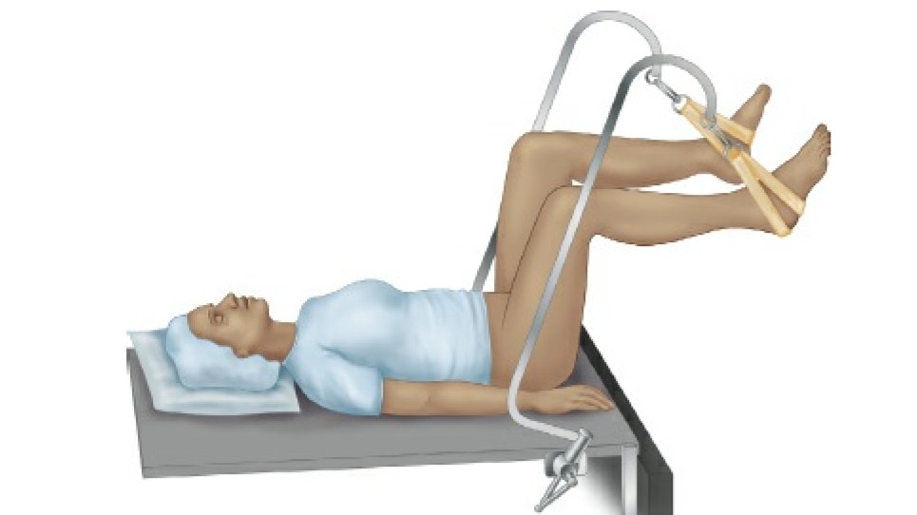

Approach
Perform a pelvic examination (Perform pelvic examination prior to the procedure. It is imperative to determine whether the uterus is anteflexed or retroflexed to avoid uterine perforation. The degree of flexion is also important to note. Pratt or Hank dilators have the advantage of having tapered shank which accommodate the flexion of the uterus so that the instrument will not perforate a severely retroflexed or anteflexed uterus.). After the pelvic examination place a weighted speculum posteriorly under the cervix and use a right-angle or singlebladed retractor to elevate the anterior vaginal wall. Grasp the anterior lip of the cervix with a single-tooth tenaculum. Сarefully sound the uterus, serially dilate the cervix using dilators, and then systematically scrape the uterine lining. Using a Heaney serrated curette, the uterine cavity is systematically scraped. In an anteflexed uterus, start at the 12-o’-clock position and scrape along the anterior uterine wall from the fundus toward the cervix. This motion is repeated in a clockwise fashion. It is better to start at the fundus and pull toward yourself rather than to scrape back and forth. As the tissue extrudes from the cervix, collect it in a spoon or directly onto a piece of Telfa that has been placed in the posterior fornix.
If there is a high suspicion for the presence of uterine polyps, a polypectomy should be done before the curettage. If endometrial carcinoma is highly suspected, a fractional curettage is performed. Tissue is first obtained from the endocervical canal. Then, the endometrial canal is sampled. This is done in order to avoid contamination of the sites.
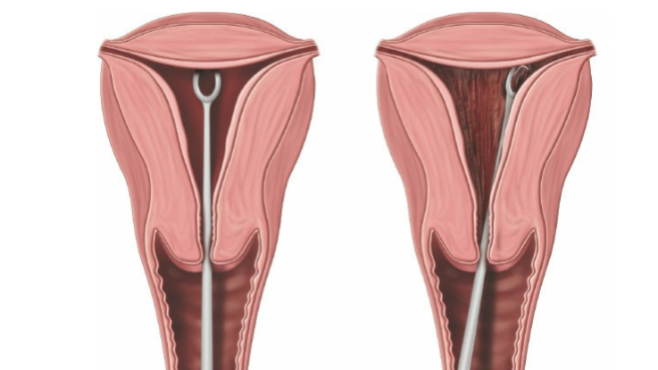
POSTOPERATIVE CARE
■ Monitor the patient for bleeding, pain, and anesthesia complication in the PACU. Mild cramping and light spotting are to be expected for a few days. To avoid infection, nothing should be placed inside the vagina until menses resume or cleared by their physician. Patients are also instructed to avoid bathtub soaking, swimming, intercourse, and tampon usage for 14 days.

Myomectomy
Abdominal Myomectomy
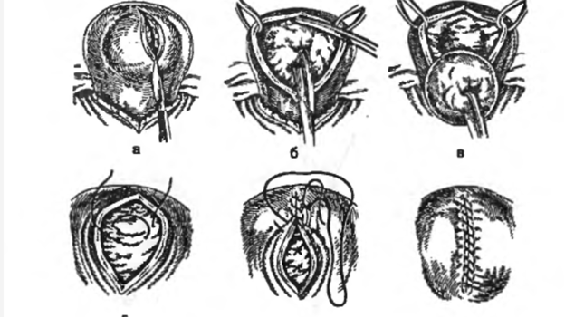
Definition:
■ Abdominal myomectomy is performed via a laparotomy incision and is also referred to open myomectomy. It is the surgical removal of uterine leiomyomas which leaves the uterus intact. Reproductive-aged patients continue to have menstrual cycles and are able to theoretically able to conceive following abdominal myomectomy.
■ Uterine leiomyomas are also called uterine fibroids, myomas, or fibromyomas. They are benign proliferative, unicellular, wellcircumscribed, pseudoencapsulated, benign growths composed of smooth muscle and fibrous connective tissue. They are the most common benign growth of the uterus.
■ The pathogenesis of leiomyomas remains unknown. However, several pathogenic theories may be associated with uterine fibroids including genetic predisposition, epigenetic factors, estrogens, progesterone, growth hormone factors, cytokines, chemokines, and extracellular matrix components.

Surgical intervention may be indicated in patients with:
■ Failed medical therapy for the treatment of symptomatic disease
■ Intracavitary distortion leading to infertility or recurrent miscarriage
■ Unrelenting abdominal pain due to acute leiomyoma torsion, degeneration, or vaginal prolapse
■ Failure of medical therapy for intractable or heavy menstrual dysfunction
■ While uncommon, obstruction of ureters, renal insufficiency, marked hydronephrosis, or acute urinary retention may predispose to intervention
■ Concern for leiomyosarcoma
the following clinical scenarios provide a practical clinical guide to recommend abdominal myomectomy to women:
■ Symptomatic patients with bulk symptoms, abnormal bleeding, and cosmetic concerns from increased uterine size.
■ Patients who do not meet inclusion criteria for minimally invasive options including laparoscopic or robotic myomectomy approach.
■ Patients who do not have access to physicians who perform minimally invasive myomectomy.
■ More than five uterine fibroids with variable individual size
■ Potential difficulty in reconstruction of the uterus with a laparoscopic or robotic approach in patients desirous of pregnancy
■ Large fibroids in the broad ligament that distorts the ureter
■ MRI pelvic imaging that is highly suggestive of hyaline degeneration with extensive liquefaction or gelatinous material that would be difficult to extract with minimally invasive techniques.
■ Extensively calcified leiomyoma that coexist more frequently with pedunculated subserous leiomyoma. Extensive degeneration of intramural fibroids.

Abdominal myomectomy is contraindicated:
■ with coexisting endometrial cancer, cervical cancer, or known leiomyosarcoma. ■ with fibroids that enlarge and become symptomatic in menopause.

After induction of anesthesia and legs appropriately placed, an abdominal bimanual and rectal examination performed. Uterine mobility should be accessed and will aid in the determination of the abdominal incision.
Surgical incision
■ Depending upon the size of the uterine fibroid, the mobility of the uterus, or prior abdominal surgical incisions, a Pfannenstiel incision, Maylard incision, or vertical abdominal incision is made. This author prefers the Maylard incision when the uterine size is greater than 15-week gestational weeks and limited uterine mobility noted under anesthesia. This muscle splitting incision provides excellent lateral visualization.
■ If the patient has had a prior vertical incision, then that incision may be used.
■ Traditional entrance and safeguards are taken to enter the peritoneal cavity.
Exploration of the abdominal cavity
■ Once the peritoneal cavity has been entered, the surgeon should determine, if the uterus is mobile, the presence of adhesive peritoneal disease, determine if there are adnexal masses, endometriosis, or unanticipated surgical findings.
■ If the uterus is mobile, it should be elevated out of the peritoneal cavity.
■ Advise the anesthesiologist that the uterus is being elevated out of the uterine cavity, especially if it is over 20 weeks gestational size, because changes in the hemodynamic state can occasionally occur when pressure is taken off of the great vessels.
■ If uterine mobility limits extirpation of the uterus, then leave the uterus in the pelvis and extracts as many fibroids until uterine mobility permits exteriorization of the uterus and removal of remaining fibroids.
Evaluate and palpate location of all fibroids
■ Choose an incision in which most fibroids can be removed with a single incision. Sometimes this is not practical as multiple incisions may be needed for safe removal.
■ A transverse or vertical serosal incision can be utilized.
■ Avoid incisions that will extend into the tubes, cornua, and uterine arteries.
■ Palpate the myometrium throughout the procedure as additional smaller fibroids may be encountered after enucleation of larger myomas.
■ Anterior incisions are associated with less risk of postoperative adhesions. However, if a fibroid is posterior it is recommended to make an incision posteriorly rather than tunnel through anteriorly.
Removal of myomas
■ The easiest fibroids to treat are those that are pedunculated. The base of the pedunculated area should be injected with a dilute solution of vasopressin. The incision is made into the serosa over the leiomyoma until the pseudocapsule is reached. Using a towel clamp or single tooth tenaculum, the myoma can be bluntly dissected away from the stalk. Avoid transection of the fibroid from its stalk as brisk bleeding might occur and require many sutures for hemostasis.
■ A monopolar instrument set on 30 to 40 W cutting current is used to make a vertical or horizontal serosal incision. The incision is extended until the pseudocapsule is reached. The length of the incision should incorporate the majority of the area involved with the fibroid.
■ Grasp the myoma with towel clamps and apply traction to fibroid. Separate the pseudocapsule from the myoma bluntly with an open 4 × 4 sponge or back of an empty knife handle . When the surgeon is in the appropriate plane the myoma literally peels away from the pseudocapsule and myometrium.
Avoiding use of fingers to bluntly shell out the fibroids as more bleeding is encountered because the blood vessels are torn in the periphery and base of the leiomyoma.
■ Push the surrounding tissue planes away from the fibroid. The towel clamps or Lahey clamps should be advanced as the fibroid begins to separate from the myometrium.
■ The surgeon can squeeze the leiomyoma. This will help it bulge out further from the myometrial bed.
■ With a large fibroid greater than 6 to 8 cm, a myoma cork screw may be used to apply traction to the myoma helping to enucleate the fibroid. Visible pseudocapsule that envelops the myoma may be cut in order to extricate the myoma.
■ Small-surface blood vessels are coagulated with Bovie tip cautery. Hemostasis should be prioritized throughout the surgical procedure.
■ If the leiomyoma protrudes into the endometrial cavity, identify the endometrium and separate it from the fibroid. The goal is to not have any endometrium removed with the leiomyoma.
■ If the endometrial cavity is entered, it must be closed separately from the myometrium. Then the myometrium is reapproximated over the endometrium, avoiding closure of the endometrial cavity.
■ Carefully palpate the myometrium after the dominant fibroid is removed in order to detect other lesions. The decision to close the defects immediately or after total enucleation of fibroids will depend upon the amount of bleeding that is encountered.
Closure of the myometrial defects
If there are small residual areas of dead space, apply AristaTM (Bard), Floseal (Baxter International Inc., Hayward, CA), or Surgiflo (Ethicon, San Angelo, TX). They are thrombin-infused gelatin products and can be placed in the myometrial bed and dead spaces for additional hemostasis. Deeper intramural fibroids should be closed when possible with a three-layer closure, with zero-delayed reabsorbable suture beginning at the base and obliterating the space with a continuous-running suture or interrupted figure of eight sutures. During suturing, the assistant should squeeze the uterine walls together to help the surgeon close the myometrium effectively. Continue this deep-layer closure approximating the myometrium until the serosal edge is reached.
The edges of the serosa are closed with an imbricating continuous, “baseball” stitch on the serosa. Synthetic absorbable 3-0 sutures are used including Vicryl, PDS, or Maxon suture, which are associated with delayed absorption and limited inflammatory response. Attempt to bury all surgical knots to a decrease adhesion formation. Place adhesion barriers such as InterceedTM (oxidized cellulose) over the suture lines, after irrigating the peritoneal cavity and ensuring hemostasis, if conditions ideal.
Send all leiomyomas for histological evaluation. Tabulate the number, size, and aggregate weight of all fibroids. The myometrium should be closed meticulously in a layered fashion. Surgeons must avoid placement of just a few two or three large through-and-through closures if the patient is interested in future pregnancy. A limited follow-up of patients who had abdominal myomectomy with meticulous closure and subsequent pregnancy observed that the majority of scars were symmetric and with uniform thickness compared with surrounding myometrium. Maintain awareness of the location of the fallopian tubes and avoid ligation of the fallopian tubes during myometrial closure. Copiously lavage the peritoneal cavity with saline or Ringer lactate solution after completion of the surgery. Once hemostasis is confirmed, application of an adhesion barrier is advised. Two current adhesion barriers are currently available for abdominal myomectomy. Seprafilm, a bioresorbable membrane (Genzyme Corporation, Cambridge, MA), and Interceed (oxidized regenerated cellulose) have been associated with decreased postoperative adhesion formation.
Abdominal Hysterectomy
Definition
Abdominal hysterectomy is defined as the surgical removal of the uterus via a laparotomy incision. A total hysterectomy removes both the uterus and cervix. A subtotal or supracervical hysterectomy removes the uterus only. The ovaries may remain in situ for both kinds of hysterectomy. The decision to retain or excise ovaries is a complex decision to be made by the patient and her physician after extensive counseling.

PREOPERATIVE PLANNING
■ It is essential to have a comprehensive discussion with the patient regarding perioperative complication risk, choice of abdominal incision, and whether the ovaries, fallopian tubes, and cervix will be removed. These decisions should be well documented both in the patient’s medical record as well as on the surgical consent form. The patient should be counseled that decisions made preoperatively are subject to change intraoperatively for patient safety.
■ Preoperative optimization strategies for women undergoing gynecologic surgery include medical consultation for patients with medical comorbidities and regarding perioperative medication management, pregnancy testing in all women of reproductive age, up-to-date screening with pap testing, mammography and colonoscopy, and endometrial sampling in perimenopausal/postmenopausal women with abnormal uterine bleeding. Further testing with EKG and CXR are recommended for women >50 years. Laboratory testing including complete blood count, electrolytes, creatinine, and type and screen are not required, however, may be useful in the postoperative setting.
■ The type of abdominal incision is based on several factors that include uterine size and the anticipation of anatomic abnormality such as extensive adhesions. If a woman has a prior vertical abdominal scar, most surgeons prefer to use this incision. However, if uterine size and the absence of adhesiophylic pathology permit, a transverse abdominal incision is a good option that improves cosmesis and decreases both postoperative pain and the incidence of incisional hernias. Although earlier studies demonstrated an increase in vertical incision dehiscence rates, compared to transverse abdominal incision, more recent studies have found no difference in dehiscence rates between these two incisions.
The decision to remove both fallopian tubes and ovaries at the time of hysterectomy is complicated and requires a frank discussion between the patient and her surgeon. Benign indications for oophorectomy at the time of hysterectomy include endometriosis, tubo-ovarian abscess, and pelvic pain. In 2005, a nationwide study reported that unilateral or bilateral salpingo-oophorectomy was performed in 68% of women undergoing abdominal hysterectomy in the United States.2 Historically, the rationale for elective oophorectomy at the time of hysterectomy was ovarian cancer prevention in women nearing menopause. More recently, the thought has shifted to favor ovarian conservation, as new evidence suggests there are long-term health benefits associated with ovarian preservation and more risks than previously appreciated with elective oophorectomy.3 Furthermore, the incidence of ovarian cancer in the general population remains low and does not warrant elective oophorectomy at the time of hysterectomy.
■ In contrast, there are no proven medical or surgical benefits to performing a subtotal hysterectomy if the cervix can easily be removed
with the uterus. Retaining the cervix commits the patient to continued cervical cancer screening and may result in posthysterectomy bleeding. The only absolute contraindication to supracervical hysterectomy is a malignant or premalignant condition of the uterus or cervix.
SURGICAL MANAGEMENT
■ Women undergoing abdominal hysterectomy require venous thromboembolism (VTE) prophylaxis. Guidelines for perioperative thromboprophylaxis published by both the American College of Obstetricians and Gynecologists and the American College of Chest Physicians consistently define patients undergoing abdominal hysterectomy as at least moderate risk of VTE.4,5 Therefore, mechanical VTE prophylaxis with sequential compression devices should be used in all women undergoing abdominal hysterectomy. Consideration for pharmacologic prophylaxis with heparin should be based upon risk factors further delineated in the aforementioned guidelines. Many institutions have developed routine, perisurgical thromboprophylaxis protocols, and administer both mechanical and pharmacologic therapies for women undergoing abdominal hysterectomy.4
■ Prophylactic antibiotics to prevent surgical site infection are given as a single intravenous injection prior to induction of anesthesia. The greatest efficacy for antibiotic administration is within an hour prior to bacterial inoculation (i.e., abdominal incision).6 For women greater than 50 kg, a dose of 2 g cefazolin is routinely used (1 g for women with BMI <30). If bowel penetration is anticipated, metronidazole 500 mg may be given in addition to cefazolin. Alternatively, cefoxitin 2 g can be administered to cover a broader spectrum of bacteria. Women who are penicillin-allergic require a combination of clindamycin (600 mg) and gentamicin (1.5 mg/kg; max 240 mg). For lengthy procedures, additional intraoperative doses of antibiotic are given at intervals of one or two times the half-life of the drug to maintain adequate levels throughout the operation. For cefazolin, a second dose is necessary at 3 hours. An increased blood loss greater than 1,500 mL also warrants a second dose of antibiotic.3
■ Bowel preparation is not indicated in women undergoing abdominal hysterectomy unless there is a high probability of bowel injury secondary to adhesions. In these cases, it is reasonable to consider using a parenteral antibiotic regimen that is effective in preventing infection among patients undergoing elective bowel surgery. There is no evidence that mechanical bowel preparation further reduces infection risk.3
Positioning
■ After the patient is brought to the operating room, preoperative prophylactic antibiotics and subcutaneous heparin are administered prior to the start of the procedure. Sequential compression devices are placed bilaterally on the patient’s lower extremities. The patient may be positioned in either the dorsal supine or lithotomy position using Allen stirrups with careful attention to pressure points to avoid neurologic injury. A “time-out” is performed in which the surgeon, anesthesia, and operating room staff confirm and agree upon the patient’s identity, indicated treatments and surgery including any procedure laterality (i.e., right salpingooophorectomy) followed by an examination under anesthesia. The vagina, perineum, and abdomen (from the anterior thighs to xiphoid) are then prepared with antiseptic solution and draped in a sterile fashion. In sterile fashion, a Foley catheter is placed in the bladder and drained to gravity. The surgeon then changes her gloves before moving to the abdomen.
Approach
■ The skin incision may be transverse or midline vertical and is determined by a variety of factors, such as the presence of a prior surgical scar, need for upper abdomen exploration, uterine size, shape, and mobility, and desired cosmetic results. If a prior incision exists, most surgeons prefer to use this incision. If the prior scar is cosmetically unacceptable, it may be excised at the beginning or end of the procedure. This is accomplished by elevating the old scar with Allis clamps and creating an elliptical incision around the old scar.
■ If a transverse abdominal incision is desired, consider a few options. The most commonly used transverse incision is a Pfannenstiel incision; however, this incision provides the least amount of exposure because the recti remain intact. Transverse Cherney and Maylard incisions improve exposure because the rectus muscles are transected. A Cherney incision transects the rectus muscles at their tendinous insertions into the symphysis pubis, while the Maylard incision is a true transverse transection through all layers, including the rectus muscles, and necessitates identification and suture ligation of the deep, inferior epigastric vessels.
Exposure
■ Once the peritoneum has been opened, a self-retaining retractor is placed and the target organ is exposed and delivered. The type of retractor used depends on the type of incision (vertical or transverse) and surgeon preference. When positioning retractors it is important to avoid placing the lateral blades over the femoral nerve as it emerges lateral to the psoas muscle. This can lead to peripheral neuropathy and postoperative difficulty with walking. To ensure safe placement, lift the abdominal wall as the retractor is placed, then check to confirm no bowel has been trapped beneath a blade and that the blade is not pressing on the sidewall of the pelvis.
■ If pelvic or intra-abdominal adhesions are present, first mobilize the pelvic organs and restore normal anatomy before packing the bowel away from the pelvis. This may require dividing omental, intestinal, or abdominal wall adhesions with either Metzenbaum scissors or radiofrequency energy. Once normal anatomy is restored, use moist laparotomy sponges to pack away small and large bowels, carefully placing the blades of the retractors in such a way that no bowel is strangulated.
Broad ligament dissection
■ Large Kelly clamps are placed across each uterine cornu including the round ligament to allow easy retraction of the uterus during surgery. The round ligament is then clamped at approximately the mid-portion and divided with a monopolar instrument. The clamped end is then suture ligated and the clamp removed. If the round ligament is divided too close to the uterus, exposure of the broad ligament becomes limited making the incision of the peritoneum over the broad ligament more difficult.
■ The anterior and posterior leaves of the broad ligament are incised. Anteriorly, the broad ligament is divided to the level of the uterine artery, then medially along the vesicouterine peritoneum, separating the bladder from the lower uterine segment and underlying vagina. The retroperitoneum is then entered by extending the incision on the posterior leaf of the broad ligament superiorly, remaining lateral to the infundibulopelvic ligament. Blunt dissection with a Yankauer suction tip or a finger clears the loose connective tissue overlying the external iliac artery
allowing for identification of the ureter. By following the external iliac artery superiorly to its bifurcation, the ureter can be identified at its most superficial point crossing into the pelvis over the bifurcation of the internal and external iliac arteries. The ureter can then be traced to the medial leaf of the peritoneum coursing inferior to the infundibulopelvic ligament. Visualization of ureteral peristalsis confirms the ureter’s identity.
Adnexal removal
■ If the ovaries are to be removed, first identify the ureter, then create a peritoneal window located inferior to the infundibulopelvic ligament, superior to the ureter and lateral to the ovary. This is accomplished by dissecting the vessels away from the ureter and clamping the intervening tissue with two curved clamps. The vessels are then transected and suture ligated first with a free tie followed by a suture ligature placed just medial to the free tie. This technique prevents hematoma formation. The underlying medial leaf of the broad ligament is then skeletonized up to the utero-ovarian ligament.
Conservation of ovaries and tubes
■ If the ovaries are to be conserved, identify the ureter, and then create a peritoneal window in the posterior leaf of the broad ligament located under the utero-ovarian ligament and fallopian tube. Clamp the utero-ovarian with two clamps (the large Kelly clamp placed on the cornua initially may be adjusted to ensure complete occlusion of the utero-ovarian vessels at the uterine cornua, the second clamp used is generally a Heaney clamp), incise and ligate with a free tie followed by a suture ligature placed medially to the free tie.
Uterine artery ligation
■ Prior to ligating the uterine artery, it is imperative to dissect both the bladder and rectum away from the uterus. By dissecting the bladder off the lower uterine segment, the ureter is concomitantly lateralized, reducing the risk for ureteral injury during uterine artery ligation. This is accomplished by incising the vesicouterine peritoneum and identifying the avascular plane between the bladder and the lower uterine segment. Once this plane is entered, gently dissect the bladder away using small amounts of monopolar energy with blunt dissection or sharply with the Metzenbaum scissors.
■ If the rectum requires mobilization from the posterior cervix, identify a similarly avascular plane between the rectum and vagina. This plane can be found by incising the posterior peritoneum between the uterosacral ligaments just beneath the cervix. Dissecting this plane mobilizes the rectum away from the posterior vagina and cervix.
■ Identify and skeletonize the uterine vessels using a monopolar instrument to dissect away any loose connective tissue overlying the vessels. Place a curved clamp perpendicular to the uterine artery at the junction of the cervix and lower uterine segment. The tip of the clamp should rest directly adjacent to the cervix. Place a clamp medial to the curved clamp to prevent bleeding from the uterus. Finally, cut and ligate the uterine artery.
■ For an extrafascial technique, the cardinal ligament and any remaining broad ligament are divided by placing straight clamps medial to the uterine vascular pedicle and parallel to the cervix, incising with a scalpel, or radiofrequency electrical energy, and suture ligating these pedicles until the end of the cervix is reached. Colpotomy can then be made either by placing curved clamps across the vagina just beneath the cervix. Be careful to preserve as much vagina as possible, then amputate the cervix from the vagina using Jorgenson scissors. Another technique is to place a sponge stick in the vagina pushing anteriorly in order to delineate the anterior vaginal apex. Using a monopolar instrument, incise the vagina where the vaginal sponge stick is demarcated and until the sponge is identified. Continue this incision circumferentially around the cervix with an active electrode or with clamps placed along the vaginal–cervical junction and incise with Mayo scissors. Deliver the specimen through the abdominal incision and carefully inspect the tissue to ensure the entirety of the cervix has been removed.
■ An intrafascial hysterectomy is performed in theory to preserve the neurovascular supply at the cervicovaginal junction by maintaining the pubovesicocervical fascia. This technique differs from an extrafascial hysterectomy after the uterine artery has been ligated (see Tech Fig. 8.1.41). Make transverse incisions on the anterior and posterior surfaces of the cervix, below the level of the uterine vasculature. Then, bluntly dissect the pubovesicocervical fascia off the lower uterine segment and cervix (i.e., with a
gauze-covered finger). If the incision is made too deeply into the cervix, the loose fascial plane can be easily missed and cause unnecessary bleeding. Place a curved clamp inside the fascia on each side of the uterus to incorporate the uterosacral ligaments and upper vagina just below the cervix. Incise the vagina with Mayo scissors and amputate the uterus and cervix.
Supracervical hysterectomy ■ In order to preserve the cervix, transect the cardinal and broad ligaments midway between the level of the internal and external cervical ostia. Then, amputate the cervix with a scalpel or a monopolar instrument. To avoid continued cyclical bleeding from retained endometrial tissue, use an electrocautery loop or radiofrequency energy to resect or fulgurate the endocervix.7 Use a large absorbable suture, to approximate the cervical stump in either a running fashion or with interrupted figure-of-eight sutures.
Vaginal cuff closure
■ Place Kocher clamps on the anterior and posterior aspects of the vaginal cuff. Using large absorbable suture, secure both angles with figure-of-eight stitches being careful to incorporate full thickness vagina with vaginal mucosa in each stitch. If curved clamps are used to incise the vagina, then the clamps at each angle can be used to facilitate angle stitch placement. Once the angles are secured, place interrupted figure-of-eight stitches between the angles to close the vaginal cuff and to achieve hemostasis.
■ The association between hysterectomy and pelvic organ prolapse is controversial; however, many experts agree that the vaginal apex should be suspended at the time of hysterectomy. This can be accomplished either by performing an intrafascial hysterectomy or by incorporating the uterosacral ligaments in the vaginal cuff closure, specifically while placing the angle stitches.8 Unfortunately, there is no data to support either method. Therefore, the decision
to perform an apical suspension and the technique are largely based on surgeon preference.
Abdominal closure
■ Thoroughly irrigate the pelvis with warm saline or Ringer’s lactate solution. Confirm hemostasis of all pedicles and inspect the bladder and ureters. For a vertical incision, it is not required to close the peritoneum. Approximate the fascia with permanent suture in a running unlocked fashion. Fascial closure of a Pfannenstiel or Maylard incision may be performed using large delayed absorbable suture. A Cherney incision requires a more tailored closure in order to provide additional support for the approximated musculature. Close the peritoneum using a running absorbable stitch. Transfix the ends of the rectus tendons to the inferior portion of the lower flap of the rectus sheath with five or six interrupted delayed-absorbable or permanent sutures in a horizontal mattress configuration. To avoid osteomyelitis, do not suture the rectus muscles to the periosteum of the symphysis pubis.

4.Typical gynecological operations on the uterus appendages.

Typical gynecological operations on the uterus appendages are the following operations:
Ovarian Cystectomy
Oophorectomy
Ovarian remnant
Salpingectomy

Ovarian Cystectomy
Definition
■ An ovarian cyst is a fluid-filled sac located on the surface or within the wall of the ovary. Simple cysts contain serous fluid with no opacities or solid elements, whereas complex cysts contain semisolid or solid elements.
Differential Diagnosis
■ Benign ovarian: functional cyst, endometrioma, mature teratoma, serous cystadenoma, mucinous cystadenoma.
■ Benign tubal: tubo-ovarian abscess, ectopic pregnancy, hydrosalpinx, paratubal cyst.
■ Malignant ovarian: germ cell tumor, sex cord–stromal cell tumor, epithelial carcinoma of ovary or fallopian tube, metastatic tumors.
■ Nongynecologic: diverticular or appendiceal abscess or mucocele, bladder or urethral diverticulum, peritoneal inclusion cyst.

Anatomic Considerations
■ Major considerations in planning the surgical approach include patient habitus, history of prior abdominal or pelvic surgery, and comorbidities predictive of pelvic adhesive disease and risk of intraoperative injury to adjacent structures.
■ Most patients, including those who are morbidly obese, are good candidates for minimally invasive surgery if there is a low suspicion for ovarian malignancy. Laparoscopic ovarian cystectomy with or without robotic assistance has been shown to reduce postoperative morbidity and recovery time compared to laparotomy
Ovarian cystectomy is the treatment of choice for symptomatic benignappearing cysts in women of reproductive age that do not resolve with conservative management.

Approach
■ Laparoscopic approach is the gold-standard approach for suspected benign ovarian cystectomy.
■ Laparotomy should be undertaken as clinically indicated due to large mass size, high suspicion for malignancy or known extensive adhesive disease, and other factors, such as combined cases for colorectal disease. Laparotomy should be the approach of choice if the surgical team has insufficient equipment, training, skill, and/or experience to safely attempt minimally invasive surgery.
■ Ultrasound-guided transabdominal or transvaginal drainage of cysts may be considered for preoperative preparation in cases of large cysts with low suspicion for malignancy or for management of symptoms in patients with multiple functional cysts resulting from ovulation induction for infertility.
Laparoscopic ovarian cystectomy with or without robotic assistance
Vaginal field
■ A Foley catheter should be placed sterilely in the bladder and secured to the drape to prevent traction on the urethra during the procedure. Position the urine collection bag so that the anesthesia team or circulating nurse can monitor the patient’s urine output during the procedure.
■ For patients with a uterus, place a Hulka tenaculum into the uterus for uterine manipulation.
■ A minimum of three trocars are used to perform ovarian cystectomy and include a 12-mm trocar to accommodate a tissue extraction bag. Two additional 5-mm ports are used to decrease neuropathic injury and do not require fascial closure. In pregnant patients, patients with a large pelvic–abdominal mass or those with a previous midline incision, a left upper quadrant primary entry is recommended.
Pelvic field
Inspect the pelvis and collect pelvic cytology. Irrigate the pelvis with saline and collect pelvic washings for cytology. Inspect all pelvic structures and assess for adhesions, endometriosis, excrescences, or implants suspicious for malignancy. Lyse adhesions only as needed to achieve visualization. If malignancy is suspected, seek intraoperative consultation with gynecologic or surgical oncologist prior to proceeding with ovarian cystectomy or oophorectomy. If surgical oncology is not available, abort the procedure after collection of photographs, washings, and nondisruptive tissue biopsies, and refer the patient to a gynecologic oncologist for primary excision and staging.
Inspect the adnexa and identify the ovary containing the cyst Using an atraumatic grasper, retract the utero-ovarian ligament.
Identify the ipsilateral ureter and vasculature This ensures that these structures are safely away from the surgical field
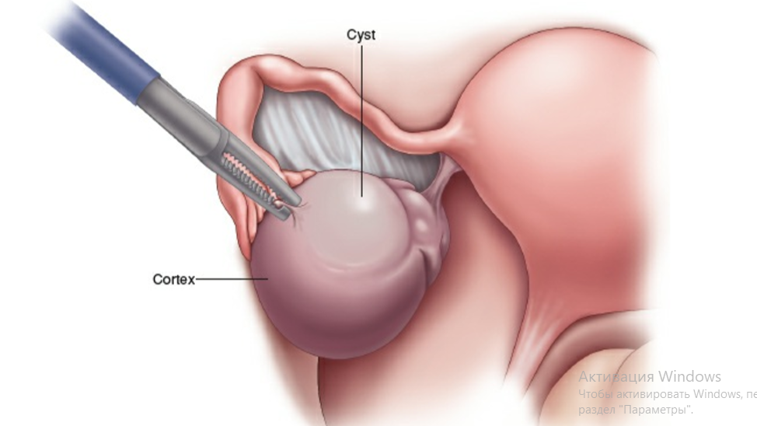

Identify an optimal area for ovarian incision Avoid the vascular hilum of the ovary (the meso-ovarium) and the ipsilateral fallopian tube.
Incise the ovarian cortex Incise with the use of an electrosurgical instrument such as a monopolar needle set at low power (10 W) or bipolar instrument.
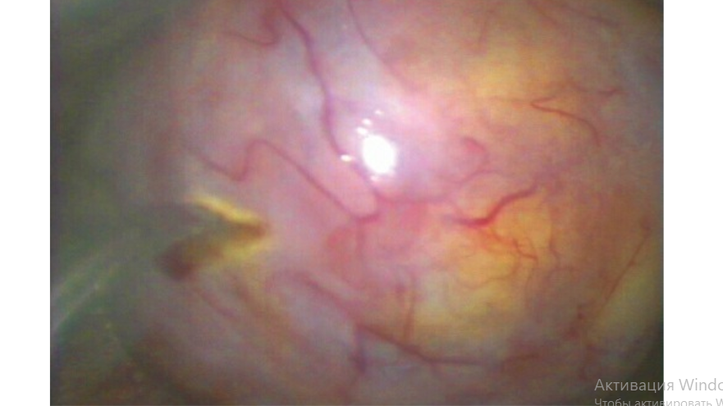
The size of the contact point of the instrument to the tissue is important, as tissue damage increases with the increasing size of the electrode.5 The degree of tissue damage caused by electrical energy is also determined by the waveforms, the density of the current, and the duration of the energy application: longer application of current is associated with increased tissue damage.5 Increasing levels of power also increase the degree of tissue damage.5 Monopolar instruments such as monopolar needle, hook, or scissors should be used in pure cut or blended cut setting to dissect with minimal destruction of adjacent tissues. Pure cut setting has high-density, low-voltage current that minimizes thermal spread, while coagulation setting has low-density, high-voltage current with greater thermal spread and risk of destruction or injury to adjacent tissue. Blend 1 adds some coagulation effect to pure cut setting, while Blend 3 adds some cutting effect to a pure coagulation setting, while Blend 2 balances cutting and coagulation. In general, a lower power setting such as 45 W should be used, with increasing wattage only if a lower setting is ineffective. The harmonic scalpel, which cuts with high-frequency vibration, is also an option that minimizes damage to adjacent tissues.
Grasp the edge of the cortex with an allis, and extend the incision along the ovarian axis to expose the underlying cyst from pole to pole In some cases, the suction–irrigation cannula can be introduced in between the cyst and cortex and fluid introduced to develop the plane.
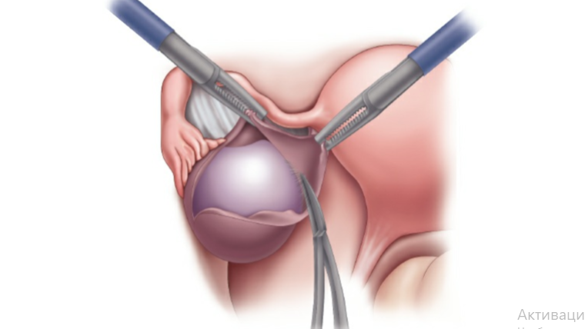
Lyse adhesion to the ovarian cortex with a blunt probe or suction irrigator tip
■ Lysis of adhesions should be done before the cystectomy. The cyst wall easily yields to gentle pressure as there is little fibrosis compared to an endometrioma.
Excessive use of electrosurgery causes destruction of the ovarian stroma and decreases fertility.
■ Apply traction and countertraction Use blunt dissection and/or sharp dissection, applying electrocautery to bleeding vessels as needed while enucleating the intact cyst away from the normal ovarian stroma.
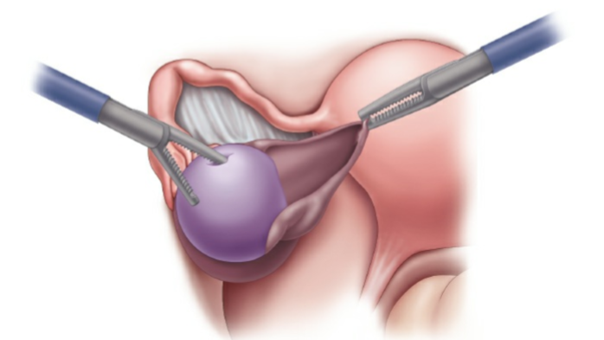
Use traction and countertraction to enucleate the intact cyst away from the normal ovarian stroma. Continue to bluntly enucleate the cyst until all ovarian attachments are lysed.
Place the cyst in a tissue extraction bag To facilitate removal from the abdominal cavity, the tissue extraction bag may be partially exteriorized at the skin, carefully opened to expose the surface of the cyst, and the cyst fluid may then be evacuated with a syringe or other suction device. If possible, cyst contents should not be allowed to spill into the peritoneal cavity due to risk of dissemination of an undiagnosed malignancy. Although we perform morcellation of the cyst within the tissue containment bag, be aware that the device manufacturer states that morcellation within the tissue extraction bag is not recommended. The manufacturer of the tissue extraction bag states that the surgeon should extend the abdominal wall incision to accommodate removal of the bag with the specimen intact.
or complex cysts with solid components, such as mature teratomas, extend the port site to ensure the bag does not rupture due to compression of solid material in the cyst. Rupture of the extraction bag will result in spillage of the cyst contents, leading to prolonged evacuation of extruded material from the peritoneal cavity, possible dissemination of undiagnosed malignancy, and the potential for retained material from a ruptured tissue extraction bag.
Irrigate the cyst bed and achieve hemostasis
■ Use sparse radiofrequency electrical energy to achieve hemostasis. Sutures can be used within the cyst to achieve hemostasis. Do not place them through the cortex. Hemostatic agents such as FloSeal can also be used.
■ Once the cyst bed is hemostatic, it is not necessary to re-approximate the ovarian edges. Although some areas of the remaining ovary will be very thin, stromal tissue should not be removed or trimmed as this may reduce oocyte reserve.
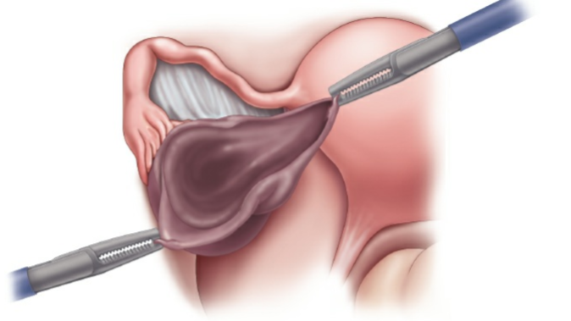
Irrigate and suction
■ Irrigate and suction the pelvis of any debris and perform a final survey to ensure no extruded material or foreign bodies remain.
■ Once hemostasis is confirmed, apply anti-adhesion barrier such as Interceed.
■ If you apply Interceed, the cyst bed must be perfectly hemostatic and irrigation fluid must be removed. The sheet of Interceed should be wrapped around the ovary alone. Do not wrap the tube with the ovary.
■ Allow the pneumoperitoneum to escape and perform the first instrument and sponge count.
■ Re-approximate fascial incisions greater than 10 mm and skin incisions.
■ Remove instruments from the vaginal field and confirm hemostasis.

POSTOPERATIVE CARE
■ Initial postoperative care is dictated by surgical approach and by intraoperative or postoperative complications. In general, patients should be routinely evaluated in the office anywhere from 2 to 6 weeks after surgery for inspection of the incision sites and to review pathology results with the patient.
■ For patients undergoing uncomplicated, minimally invasive surgery, discharge to home with oral pain medication is expected within 4 to 6 hours after surgery. Patients who experience increased perioperative bleeding, intractable nausea and/or vomiting, pain not controlled by oral analgesics, insufficient urine output, or other symptoms that preclude discharge to home, extended recovery is indicated. All patients should be given explicit instructions and contact information to seek urgent follow-up care in the event of severe pain, intractable vomiting, heavy bleeding, wound dehiscence, fever, or urinary retention.

5.Typical gynecological operations in case of ptosis and prolapse of internal genitalia.
The most common options for surgery are the following groups of operations :
I group – operation to strengthen the pelvic floor – colpoperineoplasty. Produced when the prolapse and prolapse of the vaginal walls due to the old perineal tears or lowering the tone of the tissues. Given that the pelvic floor muscles always pathogenetically involved in the pathological process, colpoperineoplasty should be performed in all cases, surgical interventions about the omissions and dropouts of the genital organs as additional or basic allowance. This also includes plastic surgery on the anterior wall of the vagina, aimed at strengthening the vesico-vaginal fascia.
Group II – operations with various modifications of the shortening and strengthening of the suspensory apparatus of the uterus. They are produced when the prolapse and prolapse of the vaginal walls and uterus in older women, often complementary operations on the vagina and perineum. After these operations, sometimes there is pain, which reduces the ability to work, impaired nutrition of the uterus, there is rapid urination.
The most typical and often used are shortening of the round uterine ligaments with their fixation to the anterior or posterior surface of the uterus, shortening of the round ligaments of the uterus through the inguinal canals by Alexander – Adams, ventrosuspension of the uterus by Doleri –Gilliams, ventrofixation of the uterus by Kocher, etc.however, This group of operations is considered ineffective, since after them there is the highest percentage of relapses of the disease. This is due to the fact that as a fixing material is used obviously untenable tissue – round ligaments of the uterus.
Group III-operations aimed at strengthening the fixing apparatus of the uterus (cardinal, sacroiliac ligaments) by stitching them together, transposition, etc.However, these operations, despite the fact that they involve the consolidation of the uterus due to the most powerful ligaments, the problem is not solved until the end, as they eliminate one link in the pathogenesis of the disease. This group of operations include "Manchester operation", which is shown in the omission and partial loss of the uterus, especially with the elongation of the cervix and the presence of cystocele. During this operation, it is often resorted to amputation of the cervix (with its hypertrophy, elongation, ruptures, the presence of erosion), which violates the subsequent pregnancy or excludes the possibility of it, so it is not recommended to use this operation in childbearing age.
Group IV - operations with rigid fixation of the fallen organs to the pelvic walls (to the pubic bones, to the sacral bone, sacrospinal ligament, etc.).
Group V – operations with the use of alloplastic materials to strengthen the ligamentous apparatus of the uterus and fixing it. They do not reduce the number of recurrences of the disease as a result of frequent rejection of the alloplast, lead to the development of fistulas.
VI group operations to partial obliteration of the vagina (median colporrhaphy Lefort – Neugebauer, vaginal -, perineal clasic – operation of Labhardt). Middle colporraphy is indicated for elderly and senile women who do not live a sexual life, with complete loss of the uterus, recurrence of vaginal loss after vaginal extirpation of the uterus in the absence of any disease of the uterus and cervix. Its disadvantages are the exclusion of the possibility of sexual life, the inaccessibility of the cervix for examination and treatment.
Group VII-a radical method of surgical treatment of loss of internal genitals: vaginal extirpation of the uterus. It is usually produced with complete loss of the uterus in elderly patients with pathological processes of the vaginal part of the cervix (pseudoerosis, trophic ulcers, leukoplakia, etc.), as well as with the existing uterine myoma. This operation does not eliminate the main cause of uterine prolapse – the weakness of the pelvic floor muscles, so it should be combined with plastic perineum and vagina.

7.Endosurgical methods of treatment in gynecology.

Diagnostic Laparoscopy
Diagnostic laparoscopy is the surgical examination of the pelvis and abdomen with the intent to diagnose various pathologies.

Differential Diagnosis
■ Ruptured ectopic pregnancy
■ Adnexal masses—benign versus malignant
■ Adnexal torsion
■ Endometriosis

Anatomic Considerations
■ Aorta
■ The aortic bifurcation is located cephalad to the umbilicus in 90% of nonobese, supine patients.
■ In a patient with body mass index (BMI) <25 kg/m2, the abdominal wall is approximately 2 to 3 cm thick. At a 90-degree angle, the distance to the bifurcation is between 6 and 8 cm and directly correlates to the patient’s BMI. Therefore, an entry angle of 45 degrees is recommended to avoid vascular injury.
■ In a patient with BMI >25 and >30 kg/m2, the distance from the umbilicus to the aortic bifurcation averages 10 and 13 cm, respectively.
■ Inferior epigastric vessels
■ The deep inferior epigastric vessels originate from external iliac vessels and travel along the anterior abdominal wall on the inferior side of the rectus abdominus.
■ Their path begins medial to the insertion of the round ligament into the deep inguinal ring.
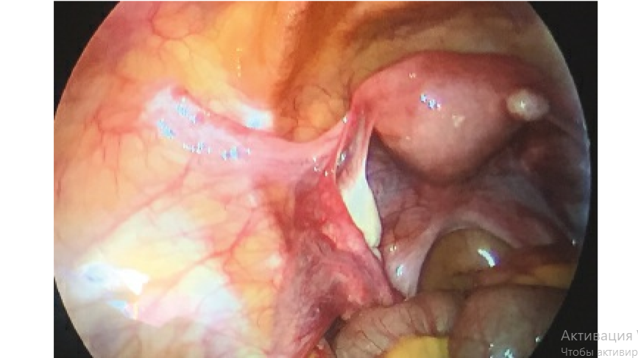
■ At the level of pubic symphysis, the vessels are lateral to the rectus abdominis.
■ At the level of the anterior superior iliac spine (ASIS), the vessels are an average of 3.5 (2.6 to 5.5) cm from the midline.
■ During laparoscopy, the deep inferior epigastric vessels can be identified in the lateral peritoneal umbilical folds bilaterally.
■ Iliohypogastric and ilioguinal nerves
■ The iliohyogastric nerve provides sensory innervation to the oblique abdominal muscles and the suprapubic skin.
■ The ilioguinal nerve provides sensory to the transversus abdominis, internal oblique, skin of medial thigh, and the vulva.
■ Classically, when a nerve has been injured or entrapped, patients report a burning sensation near the incision sites that radiates toward the groin.
■ Both nerves originate from L1 vertebra, after emerging from the lateral border of the psoas muscle. They wrap around the iliac crest to pierce through the transversus abdominis and internal oblique.
■ The ilioinguinal nerves emerge 3.1 cm medial and 3.7 cm inferior to the ASIS. The iliohypogastric emerges 2.1 cm medial and 1 cm inferior to the ASIS.
■ Both nerves emerge near classic locations for lateral trocar placement.

SURGICAL MANAGEMENT
Positioning
■ Proper patient positioning is essential to ensure patient safety.
■ Position the patient in low lithotomy position using adjustable stirrups. These stirrups allow for quick and easy position changes and should neutralize pressure points from the patient’s own leg weight.
■ Ideal low lithotomy position: The hips are flexed with minimal internal or external rotation.
Hip flexion should not be less than 60 degrees and preferably set at 80 to 90 degrees in high lithotomy to avoid compression of the femoral nerve. The hips should also not be extended beyond 170 degrees in low lithotomy as this places strain on the lumbar spine.
■ Similarly, avoid excessive abduction of the legs. The angle between thighs should be limited to 90 degrees.
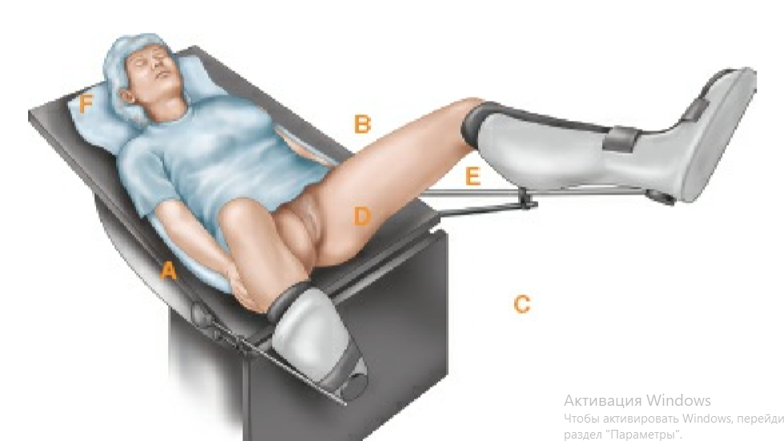
■ Knees should be flexed and padded with foam to avoid lateral compression which can result in a peroneal nerve injury. Knee flexion should be 90 to 120 degrees. Increased knee flexion can put strain on the femoral nerve and promote venous stasis in the lower leg.
■ Use an egg crate or gel cover on the top of the surgical table and in direct contact to the patient’s back to prevent the patient from slipping while in the Trendelenburg position. Avoid using shoulder supports to stabilize the patient as these supports can cause brachial plexus injury. A padded chest strap or large Velcro strap can be placed across the patient’s chest and secured to the surgical bedframe to prevent slippage in the obese, but should also allow for maximum ventilation.
■ Tuck the arms to the patient’s side using disposable positioning systems, sheets, foam, or a combination of the above. Place the wrist in a neutral position with the thumb anterior. Place padding under the wrist and elbow to avoid ulnar nerve compression. Take great care not to compress peripheral intravenous access and to cushion the patient’s fingers from the table joint. In obese patients, use low-profile surgical sleds or bed extensions to provide extra support and space to accommodate increased patient habitus.
■ This position allows the surgeon closer proximity to the patient and protects the patient’s hands, wrists, and joints.
■ Ensure the bed is level and the patient is lying flat.
■ Avoid Trendelenburg position initially as this position shifts the aortic bifurcation closer to the umbilicus and increases the risk of aortic injury.
■ Confirm a nasogastric tube and Foley catheter are inserted as distention of these organs increases the risk of injury during surgical entry.
■ Place a uterine manipulator to facilitate uterine mobility.
■ Complex manipulators have been designed to aid in more complicated operative procedures. In the case of a diagnostic procedure, consider a reusable low-cost option such as a cervical dilator secured to a tenaculum or a Hulka tenaculum.

Approach
■ Entry into the peritoneal cavity and establishment of pneumoperitoneum is the essential first step to all laparoscopies. It also carries the highest risk.
■ The primary entry site is typically at the umbilicus or Palmer’s point.
■ Palmer’s point is located 3 cm below the costal margin in the midclavicular line. This site has significantly less adipose tissue compared to the periumbilical area and typically has a smaller skin to peritoneum distance. It may be preferable in obese patients.
■ Palmer’s point can be utilized when there is concern for adhesions from prior laparotomy (including cesarean section), large fibroid uterus, pelvic mass, or prior umbilical hernia repair with mesh.
■ The stomach and liver are the closest structures and are at increased risk of injury.
■ Relative contraindications to Palmer’s point include splenomegaly, hepatomegaly, and a known left upper quadrant mass. Adhesions from prior upper abdominal surgery should also be considered.
■ A supraumbilical site can also be used for the same preoperative risks. This site is located 3 to 5 cm above the umbilicus in the midline.
■ Adhesions in the infraumbilical area can be as high as 50% after prior low transverse laparotomy and up to 90% after prior midline laparotomy.
■ Entry techniques in laparoscopy are typically classified as closed or open entry. Open entry refers to a mini-laparotomy or Hasson approach. Closed entry is the blind insertion of an instrument into the peritoneal cavity. The most common methods of both types of techniques will be described below.
■ Multiple studies have affirmed that over 50% of major complications, specifically bowel and vascular injury, occur at initial entry.
■ No method has been proven to be superior at preventing injuries. We recommend perfecting one technique to acquire mastery and proficiency,
then gradually adding other techniques to your surgical repertoire.
■ Consistency, experience, and good technique lead to safe entry, no matter the approach.

Procedures and Techniques
Veress needle
The Veress needle is a thin long needle with a spring-loaded blunt tip that is used for closed entry. Once this needle is passed into the peritoneal cavity, it is then used to insufflate the abdomen prior to trocar insertion.
Primary direct trocar placement
Angle of insertion for closed entry
The instrument must be inserted at a trajectory that guides it into a safe anatomical location to avoid puncture injury but also is short enough that the instrument penetrates the peritoneum. A 45-degree angle of insertion at the umbilicus aims the trocar toward the hollow of the lumbar and sacral spine. This area carries minimal risk of major vessel injury. At this angle, failed peritoneal entry is also uncommon in nonobese patients.
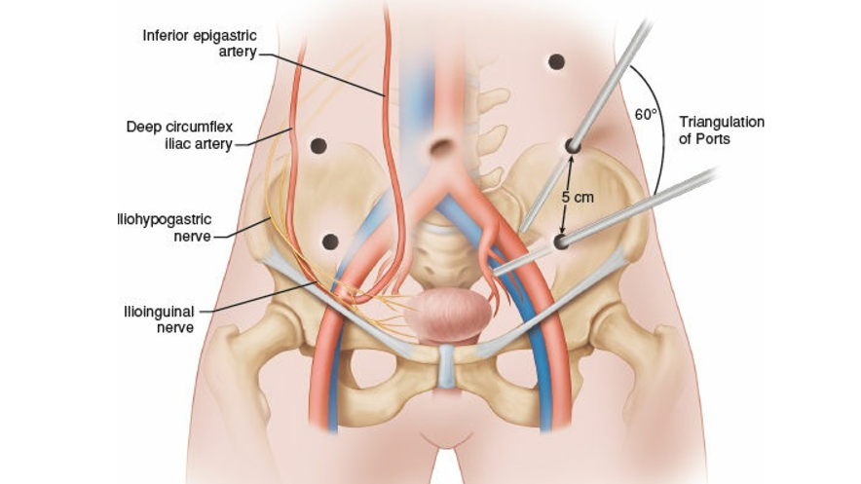
Pelvic survey
■ Inspect the pelvis in a systematic manner. Begin with the area of primary entry and the area just posterior to the abdominal wall entry, regardless of the entry method. Assess for any evidence of injury.
■ Evaluate the upper abdomen: the liver, gallbladder, diaphragm, stomach, and bowel. Take particular note of perihepatic adhesions, masses, or enlarged structures.
■ Place the patient in Trendelenburg position to maximize exposure of the pelvis. ■ Globally survey the pelvis to assess for abnormalities or adhesions.
■ If adhesions are present, address only those that require adhesiolysis in order to complete the pelvic survey.
■ The systematic survey of all pelvic structures includes pelvic and abdominal walls. The pelvis is divided into zones based on anatomical boundaries to prevent exclusion of important structures.
■ Using the same systematic approach, the findings for each area should be described in the operative report.
■ Zone 1: anterior abdominal and pelvic structures with round ligaments limiting the lateral borders.
■ Evaluate the uterine dome and anterior uterine surface, anterior surface of the broad ligament, bladder dome, internal ring of the inguinal canals, and the inferior epigastric vessels.
■ Evaluate the uterus for size and lesions such as fibroids or endometriosis.
■ Retroflexing the uterus may improve visualization of these structures.
■ Zone 2: midline posterior structures located between the uterosacral ligaments.
■ Antevert the uterus with the manipulator and evaluate the posterior surface of the uterus, posterior cul-de-sac, rectovaginal septum, sigmoid colon, and presacral peritoneum.
■ The posterior cul-de-sac should be inspected for endometriosis lesions and peritoneal windows.
■ The entire depth and breadth of the cul-de-sac should be evaluated with a wide view and also with a zoomed, close-up examination of the tissues, for adhesions and obliterating endometriosis.
■ Zone 3: the area between the uterosacral ligaments inferiorly and extending superiorly to the lateral pelvic side walls including the ovaries, fallopian tubes, and infundibular pelvic ligaments.
■ Evaluate the fallopian tubes, posterior surface of the broad ligament, ovaries, and adnexal vessels, and ureters.
■ The ovaries should be evaluated on all sides for abnormalities or adhesions. Place a blunt probe inferior to the infundibular pelvic ligament to flip the ovary over to evaluate its inferior aspect.
■ Evaluate the fallopian tubes for nodularity or sclerosis. Do not grasp these fragile structures. Instead, use blunt manipulation. If absolutely necessary, use a Babcock to grasp only the mesosalpinx and limit traumatic manipulation.
■ Zone 4: pelvic side walls superior to the adnexa.
■ The appendix should be identified and inspected, especially if the patient suffers from undiagnosed pelvic pain.
■ The survey should be completed before an operative procedure is initiated since manipulation of the tissues can cause bleeding and obscure initial findings.
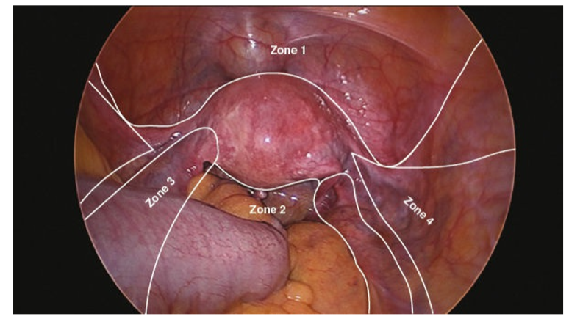
Port removal and closure
■ Ports larger than 8 mm require fascial closure with either a suture closure device, such as a Carter Thomason device, or with direct closure using S retractors, Kocher clamps, and a delayed, absorbable suture. Always begin with the larger port sites and remember to switch the insufflation tubing to the smaller caliber ports to maintain pneumoperitoneum.
■ Following completion of the laparoscopy, remove the ports under direct visualization to ensure no structures are inadvertently incorporated.
■ To optimally evacuate the pneumoperitoneum, turn off the insufflation, and either
suction the remaining intraperitoneal gas while the suction device is placed over a safe viscous or ask the anesthesiologist to have the patient take several deep breaths while the abdominal wall is compressed. Place the laparoscope in the final remaining port site and withdraw both the scope and port simultaneously, ensuring no bowel is entrapped within the abdominal wall.
■ Reapproximate the skin with a small caliber, absorbable suture, or dermal glue

