**TOPIC 6. INFERTILE MARRIAGE. FAMILY PLANNING.**

**Causes of female infertility**

The main causes of female subfertility can be related to hypothalamic–pituitary–ovarian (HPO) axis dysfunction, ovulatory disorders secondary to ovarian factors, tubal disease and endometrial factors. There is however, also a significant group of patients where their diagnosis is unexplained.

**Ovulation problems**

The landmark physiological process of the development of the human oocyte is illustrated in Figure 8.3. Ovulation is intricately regulated by the HPO axis. Gonadotrophin-releasing hormone (GnRH) controls the release of follicle-stimulating hormone (FSH) and luteinizing hormone (LH) from the pituitary gland, and the process is regulated via a feedback loop. The surge of LH mid-cycle causes ovulation. Where the function of the HPO axis is disrupted, for example in women with BMI >29 or <19, in polycystic ovarian syndrome (PCOS), hyper- or hypothyroidism and hyperprolactinaemia, ovulation occurs suboptimally. The most common cause of anovulation is PCOS. Women with PCOS also suffer from menstrual irregularities (usually oligo- or amenorrhoea), increased hair growth (hirsutism), acne and are more commonly overweight. They also are at higher risk of diabetes and cardiovascular disorders. The diagnosis of PCOS is based on a score of two out of three of the Rotterdam criteria.

**Marker of ovarian reserve**

In the ovary, anti-Müllerian hormone (AMH) is produced by the granulosa cells. AMH levels can be measured in blood and are shown to be proportional to the number of small antral follicles. In women, serum AMH levels decrease with age and are undetectable in the post-menopausal period. AMH levels represent the quantity of the ovarian follicle pool and are a useful marker of ovarian reserve. AMH measurement can also be useful in the prediction of the extremes of ovarian response to gonadotrophin stimulation for in vitro fertilization, namely poor and hyper-response.

**Tubal blockage**

Tubal blockage can be the result of previous pelvic inflammatory disease, such as a Chlamydia infection, but can also be the result of any inflammatory process within the abdominal/pelvic cavity. Inflammatory processes as a result of surgery or endometriosis may result in the formation of internal scars, called adhesions, which may result in organs adhering abnormally to each other. If the Fallopian tubes are involved, then this may result in partial or complete blockage of the tubes.

**Endometrial factors**

Abnormalities within the endometrium may prevent the successful implantation of the embryo. The endometrium or the cavity may be abnormal in the presence of uterine fibroids, adhesions and polyps. These pathologies can often be surgically managed to improve the chances of conception.

**Causes of male infertility**

In the human, the process of spermatogenesis starts at puberty and continues throughout life. The total process of spermatogenesis in humans takes 74 days within the seminiferous tubules. It takes a further ten days for the sperm to travel to the epididymis to be stored for use during ejaculation. The head of the epididymis stores 70 per cent of the mature sperm and, during ejaculation, the sperm exit via the vas deferens which then passes through the inguinal canal and opens into the urethra adjacent to the prostate. The supporting cells of the testis are the Leydig and Sertoli cells. The Leydig cells are contained in the connective tissue of the testis and are the prime source of the male hormone, testosterone. LH from the pituitary gland regulates Leydig cell function by the negative feedback loop. The Sertoli cells are highly specialized cells that maintain the integrity of the seminiferous epithelium (so that spermatogenesis can occur in an immune privileged area) as well as nourish the developing sperm. Approximately one in 20 men are subfertile, about 85 per cent have suboptimal semen quality, while azoospermia, coital dysfunction and immune factors contribute to the rest. Any factors, whether genetic, physiological, pathological or mechanical, that affect the spermatogenesis process from the production to time of ejaculation will influence male fertility.

**History and examination**

Table 1 illustrates the key points in performing history and examination in patients with subfertility.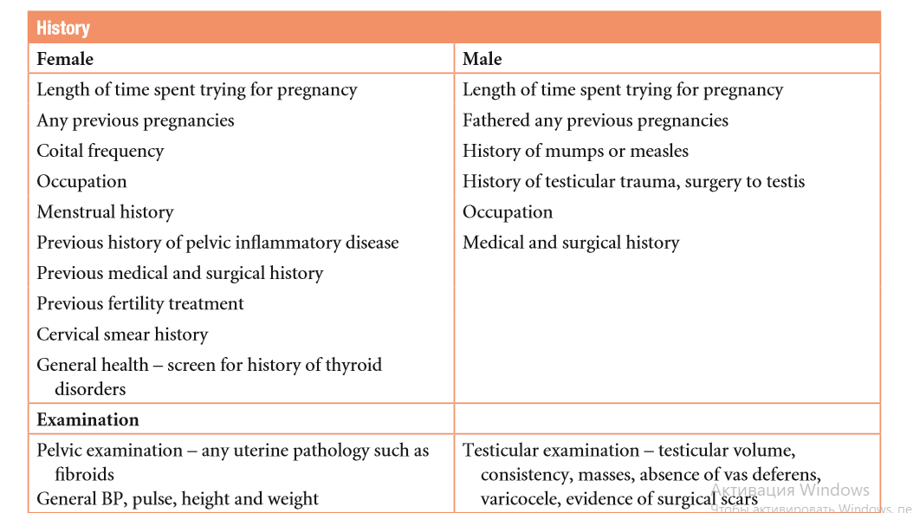

**Investigations**

Investigations are necessary to check for HPO dysfunction (follicular phase FSH, LH, oestradiol), tubal patency (hysterosalpingogram (HSG), hysterocontrast synography (HyCoSy) or an operative laparoscopy and dye test) and semen analysis for males. In general, tubal patency is checked using either HSG or HyCoSy as screening tests, and if these tests suggest potential blockage of the Fallopian tubes, then the patient can be counselled regarding the need to undergo an operative laparoscopy and dye test for diagnostic purposes; with the intention of treating any pelvic pathology that can be surgically corrected at the time of operation. HSG and HyCoSy are both comparable in terms of effectiveness as screening tests for tubal patency. Both require instrumentation of the uterine cavity and instilling radio-opaque dye (HSG) or sonoopaque contrast medium (HyCoSy) via a very fine catheter. During HSG, the time lapse of the flow of dye is captured by x-rays while in HyCoSy, it is visualized via an ultrasound scan. If there is a blockage of the Fallopian tube, dye will be seen to accumulate in a pocket representing the blocked end of the Fallopian tube. It is crucial that one remembers that tubal patency is not equivalent to tubal function. Currently, there is as yet no effective test to check for tubal function.

**Semen analysis**

Semen analysis should be performed after the patients have abstained from sexual intercourse for 3–4 days. Two abnormal test results are required to diagnose male subfertility. The normal sperm parameters are shown in Table 2. For men with a very low sperm count or azoospermia, it is important to check their testosterone levels (low levels suggest a production impairment) and LH/FSH. (Hypogonadotrophic hypogonadism is rare and can be treated with FSH and hCG injections.) It is also important to screen for the cystic fibrosis (CF) mutation as a congenital bilateral absence of the vas deferens (CBAVD) is a minor variant of cystic fibrosis. If the male partner is found to have the CF mutation, it is important to screen the female partner for it. If both partners are carriers, there is a one in four chance of the child being affected by CF and therefore the couple will require pre-conceptual genetic counselling prior to assisted conception. Karyotyping is also offered as there may be Y chromosome deletion defects (AZF region). Specific types of Y chromosome deletion, namely AZFa and AZFb Y chromosome deletions, carry poor prognosis for surgical sperm retrieval procedures.

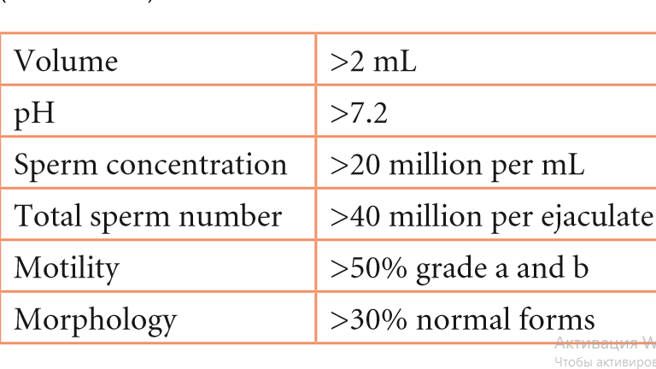

**2. Classification of infertility.**

1. by the presence of pregnancies in history - primary and secondary;
2. if possible, pregnancy - absolute and relative;
3. on the mechanism of development - congenital and acquired;
4. on duration-temporary, permanent, physiological;
5. by etiopathogenesis:

* endocrine - anovulation, luteal phase insufficiency: dysfunction of the hypothalamic-pituitary system, hyperandrogenation, hyperprolactinemia, chronic inflammatory processes of the uterine appendages, Hypo-or hyperthyroidism, luteinization syndrome of the unovulated follicle;
* tubal and peritoneal - dysfunction of the fallopian tubes, organic lesion of the fallopian tubes, the peritoneal form of infertility;
* gynecological diseases with the disorder of anatomical and functional state of the endometrium that are not associated with anovulation and obstruction of the fallopian tubes (internal endometriosis, submucous myoma, endometrial polyps, hyperplasia of endometrium, external endometriosis with the formation of antiendometrial antibodies, repeated diagnostic curettage of the mucous membrane of the uterus, postpartum and postoperative complications, the effect of chemical substances, endometritis of various etiologies);
* immunological - the formation of antisperm antibody;
* psychogenic;
* infertility of unknown genesis.

**3. Types of endocrine infertility, diagnosis, treatment**

**Types of endocrine infertility:**

anovulation, luteal phase insufficiency: dysfunction of the hypothalamic-pituitary system, hyperandrogenation, hyperprolactinemia, chronic inflammatory processes of the uterine appendages, Hypo-or hyperthyroidism, luteinization syndrome of the unovulated follicle.

The main symptom of endocrine infertility is chronic anovulation on the background of hormonal abnormalities. These abnormalities may be the cause of impaired folliculogenesis (hypoprolactinemia, hyperandrogenation, multidirectional changes of the level of gonadotropins) and its consequence (disorder of the rhythm of cyclic production of estrogen and progesterone). A sign of endocrine infertility is also the insufficiency of the luteal phase (ILF) cycle (hypofunction of the ovarian yellow body).

Endocrine infertility depends on the following pathological conditions:

* hypothalamic-pituitary insufficiency (hypogonadotropic hypogonadism in lesions of the hypothalamus, pituitary gland or hyperprolactinemia);
* hypothalamic-pituitary dysfunction (normogonadotropic amenorrhea, oligomenorrhea or ILF, accompanied or not by polycystic ovary syndrome);
* ovarian failure that is not related to a primary disorder of the hypothalamic-pituitary regulation (gonadal dysgenesis, syndromes of drug-resistant and exhausted ovaries, iatrogenic damage to the ovaries, primary ovarian hyperandrogenism, accompanied or not by polycystic ovary syndrome);
* congenital hyperplasia of the adrenal cortex, accompanied or not by polycystic ovary syndrome;
* hypothyroidism (accompanied or not hyperprolactinemia).

**Diagnosis of endocrine infertility:**

1. evaluation of menstrual function.

2. Evaluation of the hormonal function of the ovaries and the presence of ovulation by means of tests of functional diagnostics

3. Hormone screening.

4. Hormonal tests.

5. Ultrasound of the pelvic organs.

6. X-ray, tomographic and nuclear resonance studies on the testimony.

7. Laparoscopy.

8. Diagnostic curettage of the uterus according to indications.

Treatment of patients with endocrine infertility begins with the restoration of an adequate hormonal balance, additionally used drugs that stimulate ovulation. Ovulation stimulators in endocrine infertility can be used initially and as an independent type of therapy, if the fact of ovulatory disorders is established in infertile patients, but their cause is not identified.

In patients with endocrine infertility associated with LPI conduct therapy with gestagens: dydrogesterone 10-20 mg/day inside, the progesterone-200-400 mg/day vaginally. If infertility persists, ovulation stimulants are used, followed by support for the luteal phase of the cycle with the help of the above drugs.

Women with endocrine infertility who remain infertile during the year on the background of adequate hormonal therapy are prescribed diagnostic laparoscopy, since the absence of pregnancy is often the result of a combination of endocrine and tubal-peritoneal infertility factors.

**4. Tubal-peritoneal infertility: diagnosis, treatment. Methods of surgical endoscopy in infertility treatment.**

Tubal and peritoneal infertility (TPB) cause anatomical and functional disorders of the fallopian tubes, adhesions in the pelvic area. The reason for the obstruction of the fallopian tubes can be their functional disorders (violations of contractile activity (hypertension, hypotension, discoordination) without obvious anatomical and morphological changes) and organic lesions (obstruction against the background of adhesions, twists, ligation with voluntary surgical sterilization, compression by pathological formations, etc.).

To a violation of the function of the fallopian tubes lead: hormonal imbalance (violation of the synthesis of female sex steroids, hyperandrogenia of various origins); persistent abnormalities in the sympathoadrenal system, provoked by chronic psychological stress about infertility; local accumulation of biologically active substances (prostaglandin, thromboxane A2, IL, etc.), strongly formed in chronic inflammatory processes in the uterus and appendages, provoked by persistent infection or endometriosis.

The causes of organic lesions of the fallopian tubes and peritoneal infertility are transferred inflammatory diseases of the female genital organs, surgery on the uterus, appendages, intestines (including appendectomy), invasive diagnostic and therapeutic procedures (HSG, diagnostic scraping), inflammatory and traumatic complications after abortion and childbirth, severe forms of external genital endometriosis.

For the diagnosis of TPB, anamnesis, gynecological examination (signs of adhesive process - restriction of mobility and change of the position of the uterus, shortening of the vaginal arches), HSG, examination for STI, diagnostic laparoscopy are important.

Treatment of tubal-peritoneal infertility is conservative and operative. Conservative treatment of TPB:

1. If STI is detected, it is a complex etiopathogenetic therapy aimed at the elimination of the pathogen that caused inflammation of the pelvic organs.

2. Immunotherapy.

3. Resolving therapy, which includes General and local application of biostimulants, enzymes (Wobenzym, serta, lidaza, trypsin, ronidase, etc.).

4. Physiotherapy: drug electrophoresis with the use of salts I, Mg, Ca, enzyme preparations and biogenic stimulants, ultraphonophoresis of the pelvic organs, electrical stimulation of the uterus and appendages, EHF therapy, gynecological irrigation, gynecological massage, mud applications, etc.

In the operative treatment of TPB use laparoscopy (supplemented by postoperative therapy and stimulants of ovulation), ECO.

Contraindications to surgical treatment of TPB in order to restore natural fertility: age over 35 years, duration of infertility over 10 years, acute and subacute inflammatory diseases, endometriosis III-IV degree classification AFS, adhesive process in the pelvis III-IV degree classification Hulka, previously undergone reconstructive plastic surgery on the fallopian tubes, tuberculosis of the internal genitals.

Microsurgery: fimbriolata (release fimbria tubes from adhesions), salpingolysis (the separation of adhesions around the tubes, elimination of excesses, curvature), salpingostaphyline (creating a new hole in the pipe with the sealed end of the ampule), salpingo-salpingoneostomy (resection of the tube, followed by connecting end to end), transplant tube to the uterus if obstruction in the interstitial Department.

In the postoperative period to improve the efficiency of endoscopic operations can be used restorative physiotherapy procedures aimed at the activation of local and General metabolic processes, normalization of microcirculation, prevention of postoperative adhesions (electrophoresis of zinc and copper, ultrasound in pulsed mode, currents of supratonal frequency).

**5. Immunological infertility: diagnosis, treatment.**

Immunological infertility is associated with the formation of antispermal antibodies in both men and women. In men, autoantibodies to sperm are formed in seminal plasma, in women - synthesized in the mucous membrane of the cervical canal (less often in the endometrium and tubes) and cause complete immobilization of sperm, their agglutination. Antibody production occurs in the result of entering into the secret of the female reproductive tract sperm-specific antigens (surface and intracellular antigens of sperm, the sperm enzymes, and antigens of the blood group systems ABO, MNSS, Rh-Hr system antigens HLA contained in the sperm).

The diagnosis is established on the basis of biological samples (post-coital) and special tests, evaluating sperm motility in cervical mucus: postkoitalny test Shuvarskogo – Guner; test Kurzrok - Miller - penetration of spermatozoa in the cervical mucus of women in the ovulation period; sample Isojima - definition of immobilization of spermatozoa in cervical mucus.

Treatment of immunological infertility includes: condomtherapy for 6-8 months, the appointment of small doses of corticosteroids for 2-3 months or shock doses for 7 days before ovulation, nonspecific desensitization with antihistamines, Immunostimulants, intrauterine administration of sperm of the husband or donor (after the exclusion of endocervicitis and colpitis in women, prostatitis and urethritis in men).

**6. Plan examination of the married couple with infertility. Methods of diagnosis of infertility.**

Investigations are necessary to check for HPO dysfunction (follicular phase FSH, LH, oestradiol), tubal patency (hysterosalpingogram (HSG), hysterocontrast synography (HyCoSy) or an operative laparoscopy and dye test) and semen analysis for males. In general, tubal patency is checked using either HSG or HyCoSy as screening tests, and if these tests suggest potential blockage of the Fallopian tubes, then the patient can be counselled regarding the need to undergo an operative laparoscopy and dye test for diagnostic purposes; with the intention of treating any pelvic pathology that can be surgically corrected at the time of operation. HSG and HyCoSy are both comparable in terms of effectiveness as screening tests for tubal patency. Both require instrumentation of the uterine cavity and instilling radio-opaque dye (HSG) or sonoopaque contrast medium (HyCoSy) via a very fine catheter (Figure 1). During HSG, the time lapse of the flow of dye is captured by x-rays while in HyCoSy, it is visualized via an ultrasound scan. If there is a blockage of the Fallopian tube, dye will be seen to accumulate in a pocket representing the blocked end of the Fallopian tube (Figure 1). It is crucial that one remembers that tubal patency is not equivalent to tubal function. Currently, there is as yet no effective test to check for tubal function.

Figure 1. HSG

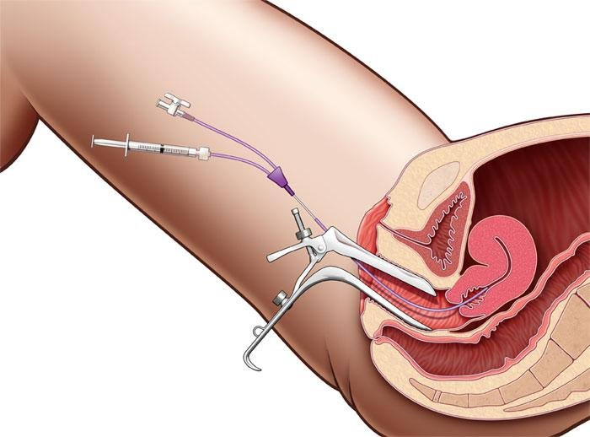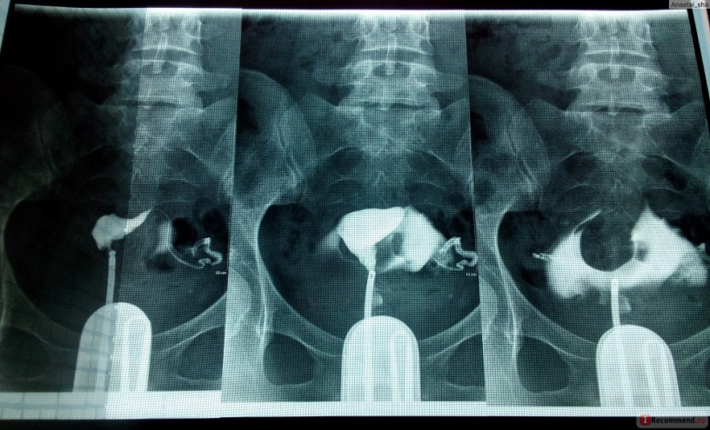

Semen analysis

Semen analysis should be performed after the patients have abstained from sexual intercourse for 3–4 days. Two abnormal test results are required to diagnose male subfertility. The normal sperm parameters are shown in Table 8.3. For men with a very low sperm count or azoospermia, it is important to check their testosterone levels (low levels suggest a production impairment) and LH/FSH. (Hypogonadotrophic hypogonadism is rare and can be treated with FSH and hCG injections.) It is also important to screen for the cystic fibrosis (CF) mutation as a congenital bilateral absence of the vas deferens (CBAVD) is a minor variant of cystic fibrosis. If the male partner is found to have the CF mutation, it is important to screen the female partner for it. If both partners are carriers, there is a one in four chance of the child being affected by CF and therefore the couple will require pre-conceptual genetic counselling prior to assisted conception. Karyotyping is also offered as there may be Y chromosome deletion defects (AZF region). Specific types of Y chromosome deletion, namely AZFa and AZFb Y chromosome deletions, carry poor prognosis for surgical sperm retrieval procedures.



**7. Assisted reproductive technologies. Artificial insemination (IVF, ICSI).**

Types of assisted reproductive technologies: embryo carrying by a female volunteer ("surrogate" motherhood) for subsequent transfer of the child (children) to genetic parents, donation of oocytes and embryos, ICSI, cryopreservation of oocytes and embryos, preimplantation diagnosis of hereditary diseases, reduction of embryos in multiple pregnancy, IVF and PE proper.

Indications: absolute tubal infertility in the absence of fallopian tubes or obstruction; infertility of unknown origin; infertility, not amenable to therapy, or infertility, the probability of overcoming which with IVF is higher than using other methods; immunological forms of infertility (the presence of antispermal at on MAR test ≥50%); various forms of male infertility (oligo–, asteno-or teratozoospermia), requiring the use of ICSI; PCOS; endometriosis.

Contraindications: congenital malformations or acquired deformities of the uterine cavity, in which it is impossible to implant embryos or carry pregnancy; benign tumors of the uterus that require surgical treatment; malignant tumors of any localization (including history); ovarian tumors; acute inflammatory diseases of any localization; somatic and mental diseases that are contraindicated for pregnancy and childbirth.

For a woman, the following examinations are required: blood test for syphilis, HIV, hepatitis B and C; the conclusion of the therapist about the state of health and the possibility of pregnancy; a study on the microflora of the urethra, cervical canal and the degree of vaginal purity; clinical blood test, including the determination of blood clotting time; General and special gynecological examination; determination of blood group and RH factor; ultrasound of the pelvic organs. According to the indications, an additional bacteriological study of the material from the urethra and the cervical canal is carried out; endometrial biopsy; infectious examination (chlamydia, ureaplasm, Mycoplasma, HSV, CMV, Toxoplasma, rubella virus); examination of the state of the uterus and fallopian tubes (HSG or hysterosalpingoscopy and laparoscopy); examination for the presence of antispermal and antiphospholipid at; determination of plasma concentrations of FSH, LH, estradiol, prolactin, testosterone, cortisol, progesterone, hormones thyroid, TSH, STG; cytological examination of cervical smears. If necessary, appoint consultations with other specialists.

For men required: blood test for syphilis, HIV, hepatitis B and C; spermogram. According to the indications: infectious examination (chlamydia, ureaplasm, Mycoplasma, HSV, CMV); FISH-diagnosis of sperm (method of fluorescent hybridization in situ); determination of blood group and RH factor. Also prescribed consultation of the andrologist. For a couple over 35 years of age, medical genetic counseling is required.

The IVF procedure consists of the following stages: selection, examination, detection of abnormalities - preliminary preparation of patients; stimulation of superovulation, including monitoring of folliculogenesis and development of the endometrium; puncture of ovarian follicles to obtain preovulatory oocytes; insemination of oocytes and cultivation developed as a result of fertilization of embryos in vitro; implantation of embryos into the uterine cavity; support for the period after embryo transfer; diagnosis of pregnancy in the early stages.

Complications: allergic reactions to drugs to stimulate ovulation, inflammation, bleeding, multiple pregnancy, ovarian hyperstimulation syndrome, ectopic pregnancy.