Topic 6. Family planning

Medical abortion: social and medical aspects of the problem. Methods of termination of pregnancy in the early and late term - indications, contraindications, complications, impact on reproductive function, prevention, rehabilitation.

Women have attempted to end unplanned pregnancies by a variety of methods for centuries. In many countries, illegal abortion still remains the cause of considerable morbidity and mortality. Abortion is a subject that attracts very strong opinions and there is a widespread divergence of views on the subject worldwide, mainly related to cultural and religious backgrounds. Abortion can be carried out legally up to 24 weeks of gestation.
Any medical practitioner who has an objection to abortion is not required to participate in abortion services unless the treatment is necessary to save the life of the pregnant woman. However, a medical practitioner who conscientiously objects to abortion should still provide advice and refer a woman promptly to another doctor who would be willing to consider her request sympathetically and arrange the termination if appropriate.
Abortions are carried out within hospitals or in private hospitals and clinics run by charitable organizations depending on the local arrangement. Many regions have set up dedicated abortion services to allow rapid referral and the efficient management of women seeking abortion, staffed by individuals who are particularly sensitive and sympathetic. It is very important that women seeking abortion should not have unnecessary delays in their referral, as increasing gestation increases the risks and complexity of the abortion procedure. Almost all abortions are carried out as day-case procedures.
Prior to an abortion, a woman should have the following assessments:
• Confirmation of the pregnancy by a sensitive pregnancy test.
• Assessment of the gestation: the date of the last menstrual period should be documented. Pelvic and/or abdominal examination is performed. Most women will also have an ultrasound scan.
• Infection screen: all women should be screened for Chlamydia (around one in10 will have a positive result). Consider the need for further STI screening (including HIV and hepatitis B) if the woman has any symptoms (such as abnormal vaginal discharge), is a rape victim or is in a high-risk category. Some units will routinely give antibiotic prophylaxis.
• Haemoglobin and blood grouping: give anti-D immunoglobulin at the time of the procedure if the woman is rhesus negative.
• Cervical smear if this is due.
• Medical history to determine if there is any contraindication to surgery or anaesthetic or a history of allergies or drug reactions. Pre-abortion counselling is extremely important. The clinician should provide a supportive, nonjudgemental setting which offers the woman adequate information and explanation to make an informed choice. Some women will need time to consider their options, while others will be very certain of what they want to do. Consent from the woman’s partner is not required. The following areas should be discussed in the counselling process.
• The individual woman’s feelings for pregnancy, abortion, her partner, her future life plans and her ability to care for a child at present and in the future.
• The type of abortion that can be performed.
• The risks of the procedure.
• Ensuring the woman has adequate personal support both before and after the abortion.
• Accessing specialist pre- and post-termination support counselling if the decision is particularly difficult.
• Contraception to be used after the abortion.
• Arrangements for follow up.

Abortion techniques
The technique of inducing abortion is determined primarily by gestation. Ideally, an abortion should always be performed at the earliest possible gestation, as both morbidity and mortality rates rise with increasing gestation. The risk of death from an early surgical termination of pregnancy is less than one per 100 000, which is substantially lower than the maternal mortality associated with a full-term pregnancy. The discovery of the antiprogestogen mifepristone (or RU 486) has made medical abortion possible. Mifepristone blocks progestogen receptors in the uterus and has been licensed for early abortion since 1991. The licence was subsequently extended to include pregnancies over 13 weeks gestation. Figure 2 shows the options for terminating a pregnancy based on gestation.
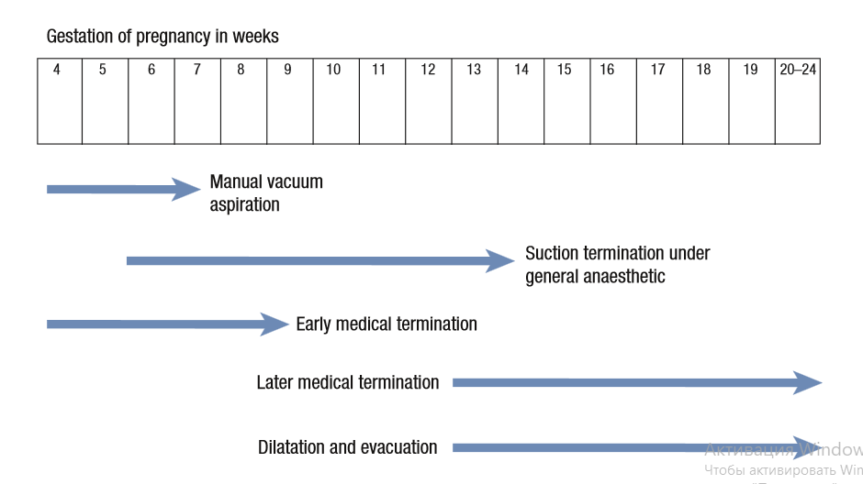
First trimester abortion
Surgical The contents of the uterus are removed by suction using a small plastic cannula inserted through the cervix and attached to an electrical pump or a manual vacuation aspiration (MVA) syringe. Dilatation of the cervix is required to allow a cannula to pass into the uterine cavity, and the greater the gestation of the pregnancy, the greater the amount of dilatation required. Priming of the cervix with agents such as a prostaglandin (inserted into the vagina or taken orally) around 3 hours prior to surgery reduces the risk of cervical trauma and haemorrhage.
Medical
As mifepristone on its own will only induce complete abortion in around 60 per cent of women, it is given in combination with a prostaglandin. This increases the rate of complete abortion to more than 95 per cent. The commonly used schedule is to give 600 mg of oral mifepristone 486, followed 48 hours later by insertion of 1 mg gemeprost vaginal pessary. Lower-dose regimens may be equally effective. Most women stay in hospital for 4–6 hours after insertion of the pessary, during which time most women will abort the pregnancy. The nursing staff confirm passage of the pregnancy. Some UK units facilitate women to remain at home during an early medical abortion (Figure 3).
Late abortion
Although only about 10–15 per cent of all abortions in the UK are carried out at this stage, mid-trimester abortions are associated with more complications. Major fetal abnormalities detected on ultrasound may necessitate a termination at a very late stage. Not infrequently, the women who present for abortion at advanced gestations are often the very young, or occasionally older women who attribute amenorrhoea to being menopausal.

Figure 3. Characteristics of early abortion methods.
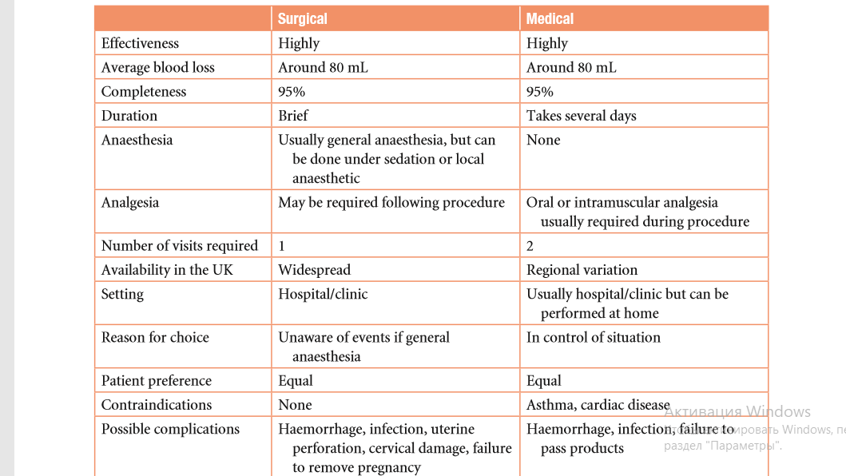
Medical
Most mid-trimester terminations in the UK involve the pre-treatment administration of mifepristone, followed 36 hours later by vaginal prostaglandin pessaries. A gemeprost pessary is inserted into the vagina every 3–6 hours until the fetus is aborted. Opiate analgesia is usually required, and around 10 per cent of women need a subsequent surgical evacuation of the uterus. The older techniques involving intraamniotic injections of urea or hypertonic saline combined with intravenous infusions of oxytocin or prostaglandins were relatively inefficient, and it often took women many days to abort. The combination of mifepristone and prostaglandins used currently significantly shortens the time taken to abort the pregnancy to around 6–8 hours.
Surgical
Surgical techniques involve dilatation of the cervix and evacuation of the uterus (D&E) under general anaesthetic. D&E is widely performed in the USA and, although often preferred by women, this procedure is generally disliked by many members of staff as fetal parts may have to be removed piecemeal from the uterus. The procedure should only be performed by specially trained gynaecologists.
Complications of abortion
Incomplete abortion Placental and/or fetal tissue may remain in the uterus after both medical and surgical abortion. Many women will spontaneously pass the remaining tissue with time, but surgical evacuation of the uterus may be required if there is heavy bleeding or the cervix is still dilated. Very occasionally, the entire pregnancy remains within the uterus after an abortion technique. The woman may then present at an advanced gestation, unaware that the abortion had been unsuccessful. Infection and subfertility Pelvic infection following an abortion will present with a febrile illness, an offensive vaginal discharge, lower abdominal pain and tenderness of the pelvic organs on vaginal examination. Antibiotic therapy should be instituted promptly. Infection after an abortion occasionally may cause tubal damage and subsequent subfertility. With modern abortion techniques and screening for pelvic infection, such as Chlamydia and gonorrhoea in high-risk women, the risk of subsequent subfertility is very low.
Traumatic injuries.
The risk of trauma to the genital tract during an abortion is minimal where there is a high standard of gynaecological practice. During surgical abortion, perforation of the uterus can occur or there may be damage to the cervix, which can predispose to the risk of preterm labour in subsequent pregnancies (cervical incompetence). Psychological problems.
These can be minimized if the woman has been well counselled prior to the abortion. Many women feel emotionally vulnerable in the weeks following an abortion, although for many it is an enormous relief to have the ordeal over. It is quite normal for women to experience feelings of regret and guilt after an abortion, although there is no evidence of an increase in serious psychiatric disease. Many abortion units offer a post-termination support service that women may refer themselves to in the months and even years following an abortion.
Follow up
All women who have had an abortion should be seen for follow up around 2 weeks following the procedure. Most hospitals do not arrange follow-up visits, so this should be carried out in the general practice setting or sexual health clinic. This visit is essential to: • ensure that the abortion is complete; • exclude an ongoing pregnancy – the woman should always be examined vaginally; • check for possible pelvic infection; • offer advice on contraception and sexual health; • assess the woman’s emotional state.

9. Contraception: classification of methods and means of contraception.

Classification of contraception:
• Combined hormonal contraception
- The pill
- Patches
- The vaginal ring
• Progestogen-only preparations
- Progestogen-only pills
- Injectables
- Subdermal implants
• Hormonal emergency contraception
• Intrauterine contraception
- Copper intrauterine device (IUD)
- Hormone-releasing intrauterine system (IUS)
• Barrier methods
- Condoms
- Female barriers
- Coitus interruptus
- Natural family planning
• Sterilization
- Female sterilization
- Vasectomy

10. Intrauterine contraception: indications, contraindications, complications, efficacy.
Modern intrauterine contraception is highly effective and is becoming increasingly popular in the UK. It is ideal for women who want a medium- to long-term method of contraception independent of intercourse and where regular compliance is not required. Intrauterine contraception protects against both intrauterine and ectopic pregnancy but, if pregnancy occurs, there is a higher chance than normal that it will be ectopic. Fitting of an intrauterine contraception is performed by trained healthcare personnel and is a brief procedure associated with mild to moderate discomfort. A fine thread is left protruding from the cervix into the vagina and the IUD can be removed in due course by traction on this thread (Figure 4).
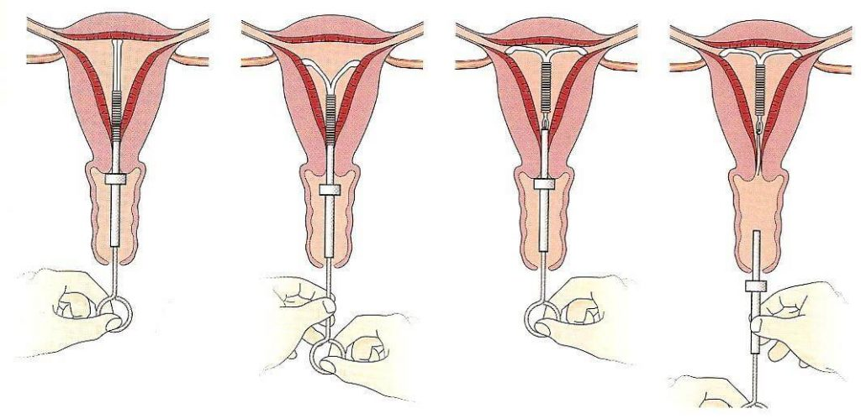
Copper-bearing devices
Copper-bearing devices are available in various shapes and sizes. They cause much less menstrual disruption than the older plastic devices which are now no longer available. Most copper IUDs are licensed for ten years of use, although the small devices may only be for five years. The more copper a device has, the more effective it is. The modern ‘banded’ device has copper on the stem and copper sleeves on the arms (Figure 5). An IUD without a frame, which consists of six copper beads on a prolene thread, has been developed and is anchored into the uterine fundus with a knot (GyneFix®).

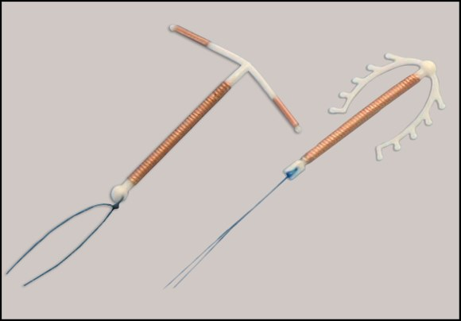
Hormone releasing intrauterine system (Mirena)
Hormone-releasing devices have also been developed (Figure 6). The Mirena has a capsule containing levonorgestrel around its stem which releases a daily dose of 20 µg of hormone. It is associated with a dramatic reduction in menstrual blood loss and is licensed for contraception, the treatment of heavy menstrual bleeding and as part of a hormone replacement therapy (HRT) regimen.
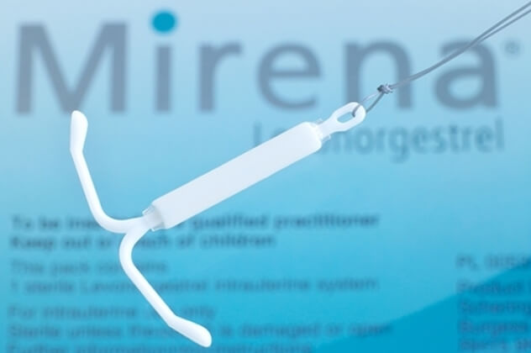
There are very few absolute contraindications to the use of intrauterine contraception, but the following category 4 conditions:
• current STI or PID, including post-abortion and following childbirth;
• malignant trophoblastic disease;
• unexplained vaginal bleeding (before assessment);
• endometrial and cervical cancer (until assessed and treated);
• known malformation of the uterus or distortion of the cavity, for example with fibroids;
• copper allergy (but could use a Mirena).

11. Principle and method of use of different groups hormonal contraceptives. Indications and contraindications to hormonal contraception, efficacy.
The contraceptive consultation
During the contraceptive consultation, there is often a great deal of information to discuss and not much time. The user needs to make an informed choice about which method to use.
The discussion about a method needs to cover:
• mode of action;
• effectiveness;
• side effects or risks;
• benefits;
• how to use the method.
It is often helpful to give back-up written information. Contraceptive counselling is multidisciplinary and specialist nurses play an important role. Some methods of contraception are only available on prescription, whereas others can be used without ever having to seek medical advice. Counselling about sexually transmitted infections (STI) and HIV risk reduction and prevention is an integral part of a comprehensive contraceptive consultation.
Combined oral contraceptive pills

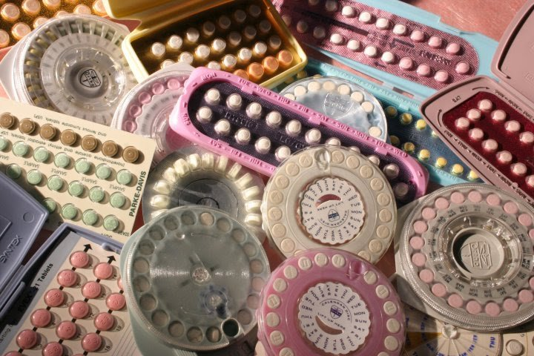
Combined oral contraception (COC) – ‘the pill’ – was first licensed in the UK in 1961 and its development marked a very significant milestone in contraception. It contains a combination of two hormones: a synthetic oestrogen and a progestogen (a synthetic derivative of progesterone). Since COC was first introduced, the doses of both oestrogen and progestogen have been reduced dramatically, which has considerably improved its safety profile.
It is estimated that at least 200 million women worldwide have taken COC since it was first marketed, and there are currently around three million users in the UK alone. A combined hormonal patch and a combined contraceptive vaginal ring (CCVR) are also available. They are discussed specifically below, but share most of the benefits and risks of combined oral contraception. A combined contraceptive injection which is given monthly is also licensed in some countries, but not the UK. Combined oral contraception is easy to use and offers a very high degree of protection against pregnancy, with many other beneficial effects. It is mainly used by young, healthy women who wish a method of contraception that is independent of intercourse. For maximum effectiveness, COC should always be taken regularly at roughly the same time each day. Mode of action Combined oral contraception acts both centrally and peripherally. • Inhibition of ovulation is by far the most important effect. Both oestrogen and progestogen suppress the release of pituitary follicle-stimulating hormone (FSH) and luteinizing hormone (LH), which prevents follicular development within the ovary and therefore ovulation. • Peripheral effects include making the endometrium atrophic and hostile to implantation and altering cervical mucus to prevent sperm ascending into the uterine cavity.
Formulations There are many different formulations and brands of COC which increasingly offer different hormones, dosages and pill taking schedules. In practice, in the UK, many women will take the same basic formulation, although women from abroad may present requesting a much wider range of pills.
Oestrogens Most modern preparations contain the oestrogen ethinyl estradiol (EE) in a daily dose of between 15 and 35 µg. Those containing lower dosages are associated with slightly poorer cycle control. Those containing higher daily dosages, for example 50 µg EE, are generally now only prescribed in special situations, discussed below. Higher dosages of oestrogen (above 50 µg EE) are strongly linked to increased risks of both arterial and venous thrombosis (see below). A new combined preparation contains the natural oestrogen, estradiol valerate, in place of synthetic EE, although it is not known if this confers any significant advantages.
Progestogens
Most COC contains progestogens that are classed as second or third generation. Second generation pills contain derivatives of norethindrone and levonorgestrel. The third generation pills include desogestrel, gestodene and norgestimate. Pills containing the newer progestogens, drospirenone and dienogest, are also available in the UK. A combined preparation licensed for the treatment of acne and hirsutism (but not contraception) contains the potent anti-androgen cyproterone acetate (Dianette®)
Regimens
Monophasic pills are almost always used and contain standard daily dosages of oestrogen and progestogen. Biphasic, triphasic or quadriphasic preparations have two, three or four incremental variations in hormone dose but are more complicated for women to use and have few real advantages. Most brands contain 21 pills; one pill to be taken daily, followed by a 7-day pill-free interval (the traditional 21/7 model). There are also some everyday (ED) preparations that include seven placebo pills that are taken instead of having a pill-free interval. Newer brands, particularly from abroad, offer a wider combination of active pills and pill-free days with combinations such as 24/4, 84/7 and 365 (where a pill is taken daily without any breaks).
Contraindications The UK Medical Eligibility criteria have helpful tables on the category 3 and 4 contraindications to COC (see Tables 7 and 8). Most of these relate to the side effects of sex steroid hormones on the cardiovascular and hepatic systems. Women should ideally discontinue COC at least two months before any elective pelvic or leg surgery because of the risk of venous thromboembolism. Side effects and risks The vast majority of women tolerate COC well, with few problems. However, COC has effects throughout

Tables 7 and 8
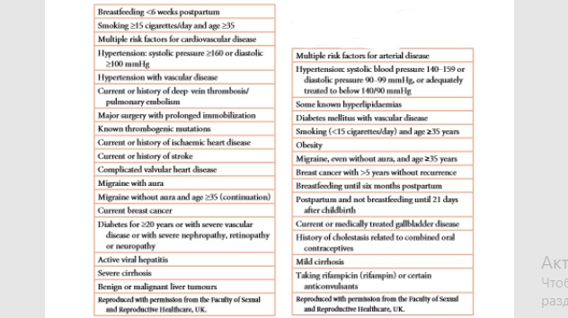
the entire body and a large number of potential side effects/risks exist. Common side effects are listed in Table 7.6 and, although often minor, frequently lead to early discontinuation. Many minor side effects will settle within a few months of starting COC. The most important risks relate to cardiovascular disease, as detailed below.
Venous thromboembolism
COC increases risk of venous thromboembolism (VTE) three- to five-fold. Oestrogens (in COC, pregnancy and with hormone replacement therapy) alter blood clotting and coagulation in a way that induces a pro-thrombotic tendency, although the exact mechanism of this is poorly understood. The effect appears independent of dose of EE dose below 50 µg (but is significantly increased with higher dosages above this).
The type of progestogen also affects the risk of VTE, with users of COC containing third-generation progestogens being twice as likely to sustain a VTE than those using older second-generation preparations. The absolute risk of an event with COC is very small but increased in the presence of an inherited thrombophilia. Women with a significant family history of VTE should be carefully assessed and tested for inherited thrombophilias prior to being prescribed COC. The risks of VTE are: • 5 per 100 000 for normal population; • 15 per 100 000 for users of second-generation COC; • 30 per 100 000 for users of third-generation COC; • 60 per 100 000 for pregnant women.
Arterial disease
Arterial disease with COC is much less common than VTE but more serious. The risk of myocardial infarction and thrombotic stroke in young, healthy women using low-dose COC is extremely small.
However, cigarette smoking and high blood pressure will both increase the risk, and any woman who smokes must be advised to stop COC at the age of 35 years. Around 1 per cent of women taking COC will become significantly hypertensive and they should be advised to stop taking it.
Breast cancer
Advising women about the association between breast cancer and COC is very difficult. Most data do show a slight increase in the risk of developing breast cancer among current COC users (relative risk around 1.24). This is not of great significance to young women, as the background rate of breast cancer is very low at their age. However, for a woman in her forties or one with a strong family history, these are more relevant data, as their background rate of breast cancer is higher. Most data also show that any effect of COC on breast cancer risk has disappeared ten years after stopping COC.
Drug interactions
This can occur with enzyme-inducing agents, such as some anti-epileptic drugs. Higher dose estrogen pill combinations of 50 µg EE may need to be prescribed. Some broad-spectrum antibiotics can alter intestinal absorption of COC and reduce its efficacy. Additional contraceptive measures should therefore be recommended during antibiotic therapy and for 1 week thereafter.
Positive health benefits
Not all side effects of COC are unwanted! COC users generally have light, pain-free, regular bleeds and therefore COC can be used to treat heavy or painful periods. It can also improve premenstrual syndrome (PMS) and reduce the risk of pelvic inflammatory disease (PID). COC offers long-term protection against both ovarian and endometrial cancers. It can also be used as a treatment for acne.
Patient management
For a woman to take COC successfully there must be careful teaching and explanation of the method. Before COC is prescribed, a detailed past medical and family history should be taken and blood pressure checked (Figure 7.2). Routine weighing, breast and pelvic examinations are not required. Most women are given a three-month supply of COC in the first instance, and have 6–12-monthly reviews thereafter. Woman need clear advice about what to do if they miss any pills.
Combined hormonal patches
A contraceptive transdermal patch containing oestrogen and progestogen is licensed in the UK and releases norelgestromin 150 mg and ethinylestradiol 20 mg per 24 hours Patches are applied weekly for 3 weeks, after which there is a patch-free week. Contraceptive patches have the same risks and benefits as COC and, although they are relatively more expensive, may have better compliance.
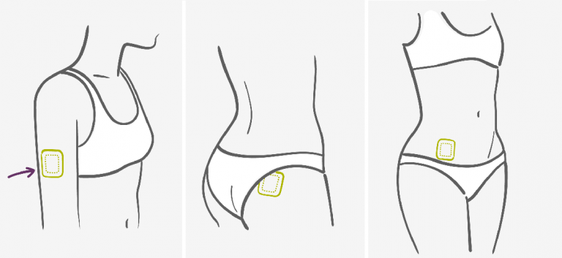
Combined hormonal vaginal rings
It is made of latex-free plastic and has a diameter of 54 mm. It releases a daily dose of ethinyl estradiol 15 µg and etonorgestrel 120 µg. The ring is worn for 21 days and removed for 7 days, during which time a withdrawal bleed occurs. Insertion and removal of the ring is easy and it does not need to fit in any special place in the vagina. The cycle control is excellent and probably better than with COC. As with combined patches, the vaginal ring has the same risks and benefits as COC but is more expensive.
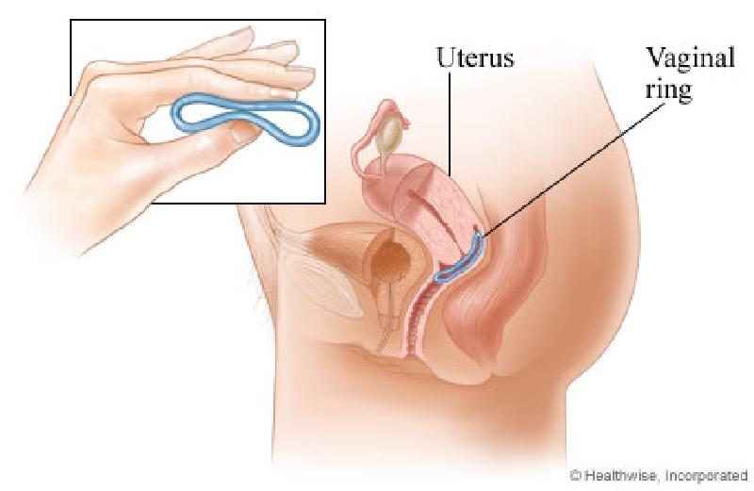
Progestogen-only contraception
Progestogen-only contraception avoids the risks and side effects of oestrogen. The current methods of progestogen-only contraception are:
• progestogen-only pill, or ‘mini-pill’
• subdermal implant (Implanon)
• injectables (Depo-Provera®, Noristerat®)
• hormone-releasing intrauterine system (Mirena) (see ‘Intrauterine contraception’ below).
All progestogen-only methods work by a local effect on cervical mucus (making it hostile to ascending sperm) and on the endometrium (making it thin and atrophic), thereby preventing implantation and sperm transport. The higher dose progestogenonly methods will also act centrally and inhibit ovulation, making them highly effective. As they do not contain oestrogen, progestogenonly methods are extremely safe and can be used if a woman has cardiovascular risk factors, for example older women who smoke. The common side effects of progestogen-only methods include:
• erratic or absent menstrual bleeding;
• simple, functional ovarian cysts;
• breast tenderness;
• acne.

11. Voluntary surgical sterilization: indications, contraindications, types, effectiveness.

Sterilization
Female sterilization and male vasectomy are permanent methods of contraception and are highly effective. They are usually chosen by relatively older couples who are sure that they have completed their families. Occasionally, individuals who have no children or who, for example, carry an inherited disorder may choose to be sterilized. The uptake of female sterilization and vasectomy in the UK is relatively high compared to many other European countries, with around 50 per cent of couples over the age of 40 years relying on one or other permanent method. Vasectomy is easier, cheaper and slightly more effective than female sterilization. It does not require a general anaesthetic. Semen analysis has to be checked after the procedure to ensure that it has been successful.
Technically, both female sterilization and vasectomy can be reversed, with subsequent pregnancy rates of about 25 per cent, but reversals are not funded by the NHS in many parts of the UK. Individuals should not have a sterilization procedure performed if there is a chance that one day they might want to have it reversed. It is estimated that around 10–15 per cent of individuals in the UK subsequently regret the decision to be sterilized. Regret is more common in individuals who are aged less than 30 years at the time, have no children or in women who are within a year of delivery. Long-acting reversible contraception is highly effective and the option to use these methods instead of a sterilization procedure should always be raised in the counselling session. They are reversible should a woman wish to keep her options open for a future pregnancy.
Consent
It is essential that individuals are very carefully counselled before sterilization and give written consent. Consent forms do not ask for the partner’s written consent. The consent form should clearly indicate that sterilization: • is a permanent procedure; • very occasionally can fail. The failure of sterilization and vasectomy is a major area of medical litigation.
Female sterilization
This involves the mechanical blockage of both Fallopian tubes to prevent sperm reaching and fertilizing the oocyte. It can also be achieved by hysterectomy or total removal of both Fallopian tubes. Female sterilization will not alter the subsequent menstrual pattern as such, but if a woman stops the combined pill to be sterilized, she may find that her subsequent menstrual periods are heavier. Alternatively, if she has an IUD removed at the time of sterilization, she may find her subsequent menstrual periods are lighter.
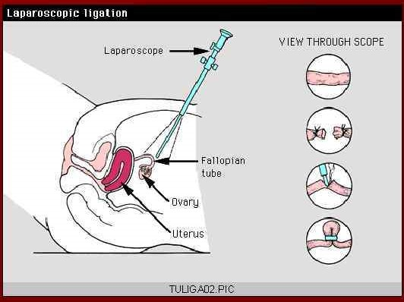
Sterilization in the UK is most commonly performed by laparoscopy under general anaesthesia, which enables women to be admitted to hospital as a day case. Alternative techniques are mini-laparotomy with a small transverse suprapubic incision or, less commonly, through the posterior vaginal fornix (colpotomy). Mini-laparotomy is the technique of choice when the procedure is carried out post-natally (the uterus is enlarged and more vascular) and in developing countries where laparoscopic equipment is not available. Different ways of occluding the Essure® is a newer technique which is becoming popular. It involves insertion of metal springs into each Fallopian tube guided by the hysteroscope. Scar tissue grows round the metal springs and blocks the tubes. It can be performed under local anaesthetic or light sedation making it a cheaper and easier option than conventional laparoscopic sterilization.
Complications of female sterilization Very occasionally, a woman may experience anaesthetic problems or there may be damage to intraabdominal organs during the procedure. Sometimes it is not possible to visualize the pelvic organs at laparoscopy due to adhesions or obesity; it may then be necessary to proceed to mini-laparotomy. Female sterilization is highly effective. If it does fail, 30 per cent of pregnancies are likely to be ectopic. Any sterilized woman who misses her period and has symptoms of pregnancy should seek early medical advice.
Vasectomy
Vasectomy involves the division of the vas deferens on each side to prevent the release of sperm during ejaculation. It is technically an easier and quicker procedure than female sterilization and is usually performed under local anaesthesia. Various techniques exist to block the vas, and their effectiveness is related primarily to the skill and experience of the operator. Vasectomy differs from female sterilization in that it is not effective immediately. Sperm will still be present higher in the genital tract and azoospermia is therefore achieved more quickly if there is frequent ejaculation. Men should be advised to hand in two samples of semen at 12 and 16 weeks to see if any sperm are still present. If two consecutive samples are free of sperm, the vasectomy can be considered complete. An alternative form of contraception must be used until that time.
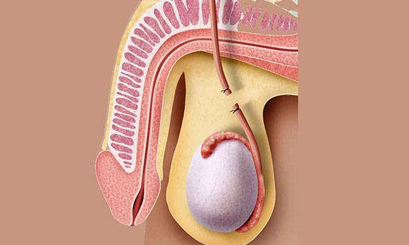
Complications Immediate complications such as bleeding, wound infection and haematoma may occur. Occasionally, small lumps may appear at the cut end of the vas as a result of a local inflammatory response. These socalled ‘sperm granulomas’ may need surgical excision. Some men will develop anti-sperm antibodies following vasectomy. These do not cause symptoms, but if the vasectomy is reversed, pregnancy may not occur because the autoantibodies inactivate sperm. Chronic scrotal pain following a vasectomy is uncommon – one third of men will have pain at 12 weeks post-vasectomy, but only 6–8 per cent of men will still complain of significant discomfort at the end of a year. Over the years, a possible association between vasectomy and the development of both prostate and testicular cancers has been raised and received widespread media interest. In practice, there is insufficient evidence to support any association.

12. Traditional methods of contraception: indications, contraindications, efficacy.
Barrier methods of contraception
Barrier methods prevent STIs and are therefore of enormous importance globally. They prevent pregnancy by creating a physical barrier to the sperm reaching and fertilizing the egg. They can be used in conjunction with a hormonal method or IUD to give personal protection against infection and to increase contraceptive efficacy.

Condoms
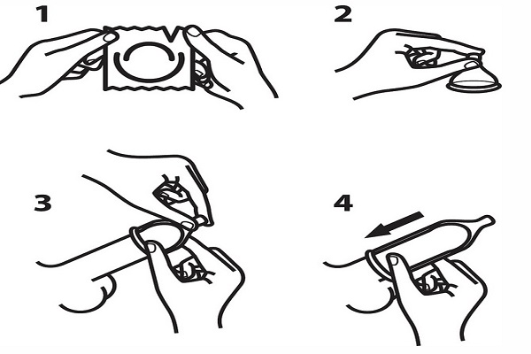
Male condoms are usually made of latex rubber. They are cheap and are widely available for purchase or free from many clinics. They have been heavily promoted in Safe Sex campaigns to prevent the spread of STIs, particularly HIV. Condoms of varying sizes and shapes are available and increasingly with different textures, flavours, colours and scents. It is important to use condoms that reach European Union standards and are within their sell-by date. Emergency contraception can be used in the event of a condom bursting or slipping off during intercourse. Some men and women may be allergic to latex condoms or spermicide, and hypoallergenic latex condoms and plastic male condoms are available. Healthcare professionals may need to teach individuals how to use condoms properly. Men must be instructed to apply condoms before any genital contact and to withdraw the erect penis from the vagina immediately after ejaculation.
Spermicides
Very few spermicidal preparations are now available in the UK. The only marketed product is a gel; other countries have a wider range of pessaries, foams and creams. They all contain the active ingredient nonoxynol-9. Spermicides are designed to be used with another barrier method to make them more effective. Nonoxynol-9 may provide protection against some STIs, but a recent concern has been the finding of a higher risk of HIV transmission in frequent spermicide users. For this reason, it is strongly recommended that individuals at high risk of HIV do not use these products for either vaginal or anal sex.
Female barriers
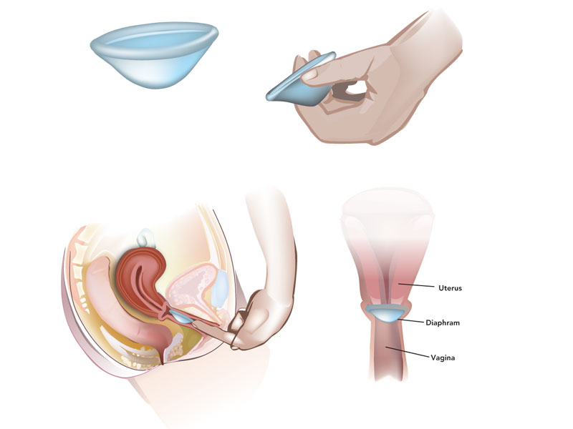
The diaphragm is the female barrier used most commonly in the UK. Various cervical caps are also marketed. They should all be used in conjunction with a spermicidal cream or gel. Diaphragms are inserted immediately prior to intercourse and should be removed no earlier than 6 hours later. Using a diaphragm requires careful teaching and fitting. Female barriers offer protection against pelvic infection, but can increase the risk of urinary tract infection and vaginal irritation. Female condoms made of plastic are also available (Femidom®). They offer particularly good protection against infection as they cover the whole of the vagina and vulva and, being plastic, are less likely to burst. However, many couples find them unaesthetic and they have not achieved widespread popularity.
Withdrawal
Although not strictly speaking a barrier method, withdrawal, or coitus interruptus, is a widespread practice and obviously does not require any medical advice or supplies. The penis is removed from the vagina immediately before ejaculation takes place. Unfortunately, it is not particularly reliable, as preejaculatory secretions may contain millions of sperm and young men often find it hard to judge the timing of withdrawal. The use of emergency contraception should be considered if a couple have used withdrawal (see below).
Natural family planning
This is extremely important worldwide and may be the only type of contraception acceptable to some couples for cultural and religious reasons. It involves abstaining from intercourse during the fertile period of the month.
The fertile period is calculated by various techniques, such as:
• changes in basal body temperature;
• changes in cervical mucus;
• tracking cycle days;
• combined approaches.
Some commercially available kits are available, such as Persona® in the UK, and use readings of urinary hormone levels to define fertile periods when abstinence is required. The failure rates of natural methods of family planning are quite high, largely because couples find it difficult to abstain from intercourse when required. The lactational amenorrhoea method (LAM) is used by fully breastfeeding mothers. During the first six months of infant life, full breastfeeding gives more than 98 per cent contraceptive protection.

13. The concept of emergency contraception.
Emergency contraception
Emergency contraception (EC) is a ‘back-up’ method that is used after intercourse has taken place and before implantation has occurred. EC should be considered if unprotected intercourse has occurred, if there has been failure of a barrier method, for example a burst condom, or if hormonal contraception has been forgotten. There are two types of EC in general use: Hormonal emergency contraception Levonorgestrel can be taken for EC in a single dose of 1.5 mg (Levonelle®). It has to be used within 72 hours of an episode of unprotected intercourse and the earlier it is taken the more effective it is. There are no real contraindications to its use. Levonelle® is not 100 per cent effective but will prevent around three-quarters of pregnancies that would otherwise have occurred. It is available free on prescription or over the counter in pharmacies (either to buy or free in some regions). It can be used on more than one occasion in a short space of time, but women should consider other more effective methods if they are using EC repeatedly. The precise mechanism of action is not known, but probably involves disruption of ovulation or corpus luteal function, depending on the time in the cycle when hormonal EC is taken. A progestogen receptor modulator (ulipristal 30 mg) ellaOne® is now licensed for EC. It is used up to 120 hours following unprotected intercourse or contraceptive failure. It will be available on prescription only in the UK.
An IUD for emergency contraception A copper IUD can be inserted for EC and is highly effective. It can be inserted up to 5 days after the calculated earliest day of ovulation covering multiple episodes of intercourse in the same menstrual cycle, or up to 5 days after a single episode of unprotected intercourse at any stage in the cycle. The IUD prevents implantation and the copper ions exert an embryotoxic effect. The normal contraindications to an IUD apply and, if there is a risk of sexually transmitted infection, antibiotic cover should be given. The Mirena has not been shown to be effective for EC and should not be used in this situation. The copper IUD can remain in situ for ongoing contraception or be removed once the menstrual period has started.

