The left and right **hip bones** (innominate bones, pelvic bones) are two irregularly shaped bones that form part of the pelvic girdle – the bony structure that attaches the axial skeleton to the lower limbs.

The hip bones have three main articulations:

* **Sacroiliac joint** – articulation with the sacrum.
* **Pubic symphysis** – articulation between the left and right hip bones.
* **Hip joint** – articulation with the head of femur.

In this article, we shall look at the anatomy of the hip bones – their composition, bony landmarks, and clinical relevance.

[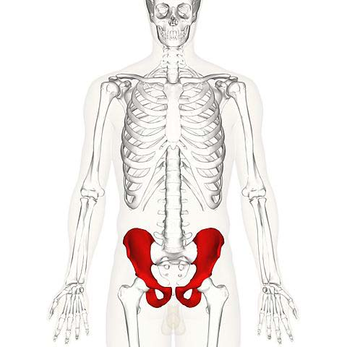](https://cdn1.teachmeseries.com/tmanatomy/wp-content/uploads/20171222214547/Overview-of-the-Hip-Bones.jpg)

Fig 1 – Overview of the anatomical position of the hip bones.

**Composition of the Hip Bone**

The hip bone is comprised of the three parts; the ilium, pubis and ischium. Prior to puberty, the**triradiate cartilage** separates these parts – and fusion only begins at the age of 15-17.

Together, the ilium, pubis and ischium form a cup-shaped socket known as the **acetabulum** (literal meaning in Latin is ‘*vinegar cup*‘). The head of the femur articulates with the acetabulum to form the [hip joint](http://teachmeanatomy.info/lower-limb/joints/the-hip-joint/).

We shall now look at the individual parts of the hip bone, and their respective bony landmarks.

[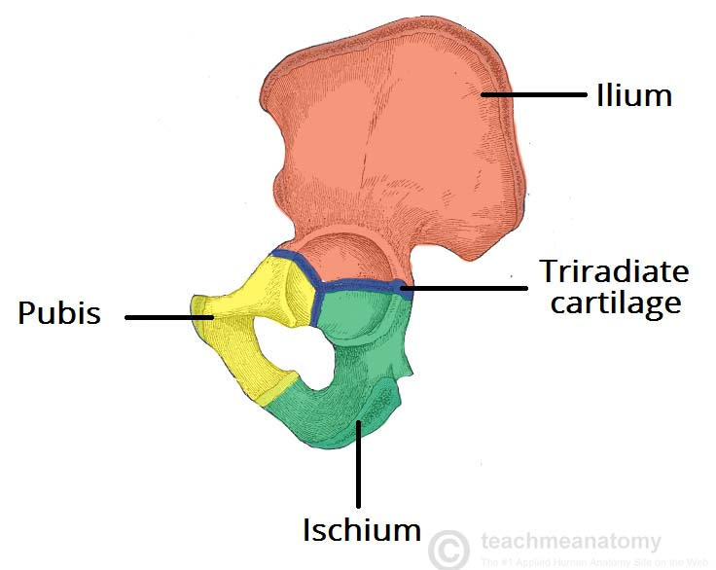](https://cdn1.teachmeseries.com/tmanatomy/wp-content/uploads/20171222214539/Hip-Bone-of-a-5-year-old-Triradiate-Cartilage-Present.jpg)

Fig 2 – The hip bone of a 5 year old, with triradiate cartilage still present.

**The Ilium**

The **ilium** is the widest and largest of the three parts of the hip bone, and is located superiorly. The body of the ilium forms the superior part of the acetabulum (acetabular roof). Immediately above the acetabulum, the ilium expands to form the wing (or ala).

The wing of the ilium has two surfaces:

* **Inner surface** – has a concave shape, which produces the iliac fossa (site of origin of the iliacus muscle).
* **External surface** (gluteal surface) – has a convex shape and provides attachments to the gluteal muscles.

The superior margin of the wing is thickened, forming the **iliac crest.**It extends from the anterior superior iliac spine (ASIS) to the posterior superior iliac spine (PSIS).

On the posterior aspect of the ilium there is an indentation known as the **greater sciatic notch**.

[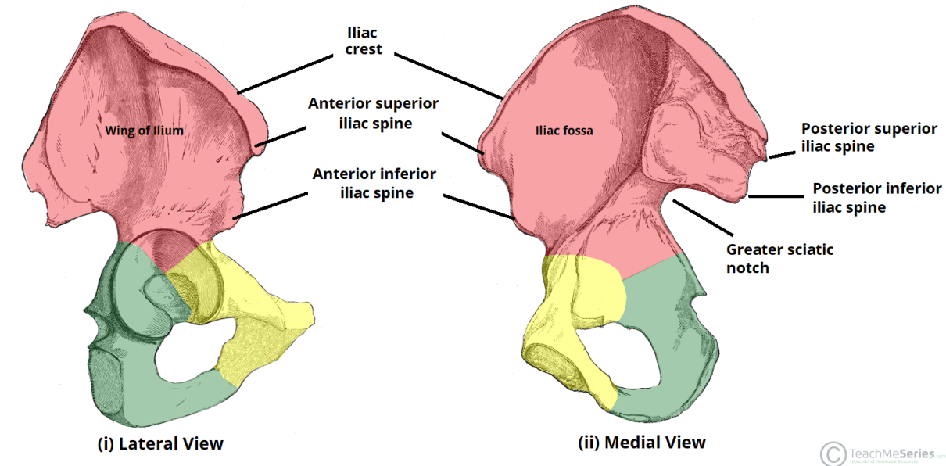](https://cdn1.teachmeseries.com/tmanatomy/wp-content/uploads/20180204192931/Bony-Landmarks-of-the-Ilium-Wing-ASIS-PSIS-Hip-Bone.-1024x504.png)

Fig 3 – The bony landmarks of the ilium.

**Clinical Relevance: Anterior Superior Iliac Spine**

The anterior superior iliac spine (ASIS) is an important anatomical landmark:

* **Mid-inguinal point** – halfway between the ASIS and the centre of the pubic symphysis. The femoral artery can be palpated here.
* **Mid-point of the inguinal ligament** – halfway between the ASIS and the pubic tubercle.

In clinical practice, a patient’s **“true” leg length** is measured from the ASIS to the medial malleolus at the ankle joint. This is distinct from “apparent” leg length, which is measured from the umbilicus to the medial malleolus.

True leg length discrepancy is a feature of various hip disorders, as well as being a potential complication of **hip joint replacement** (arthroplasty).

**The Pubis**

The **pubis** is the most anterior portion of the hip bone. It consists of a body, superior ramus and inferior ramus (ramus = branch).

* **Pubic body**– located medially, it articulates with the opposite pubic body at the pubic symphysis. Its superior aspect is marked by a rounded thickening (the pubic crest), which extends laterally as the pubic tubercle.
* **Superior pubic ramus** – extends laterally from the body to form part of the acetabulum.
* **Inferior pubic ramus** – projects towards the ischium.

Together, the superior and inferior rami enclose part of the **obturator foramen** – through which the obturator nerve, artery and vein pass through to reach the lower limb.

[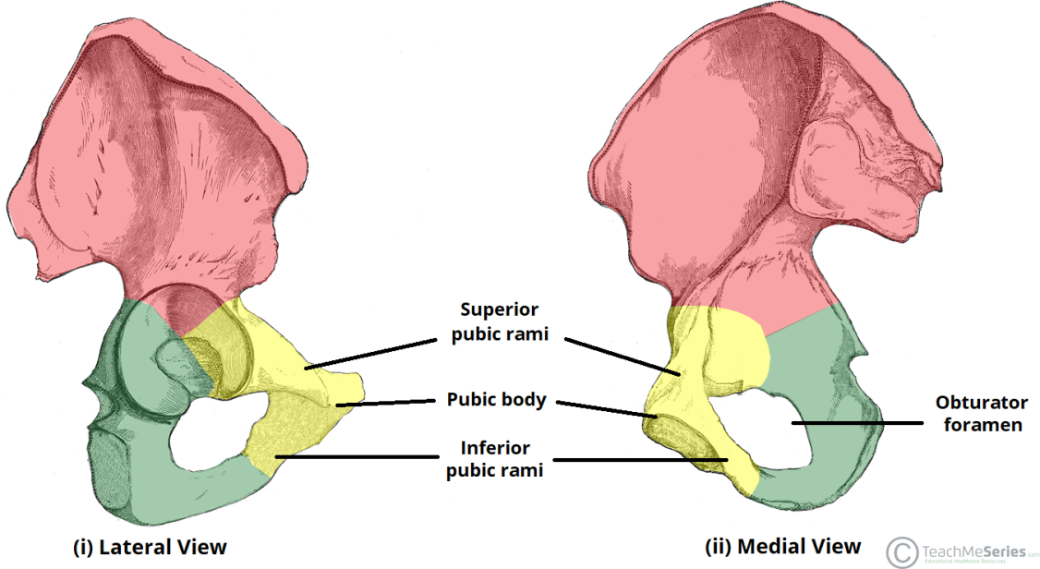](https://cdn1.teachmeseries.com/tmanatomy/wp-content/uploads/20180204194521/Bony-Landmarks-of-the-Pubis-1024x560.png)

Fig 4 – Bony landmarks of the pubis.

[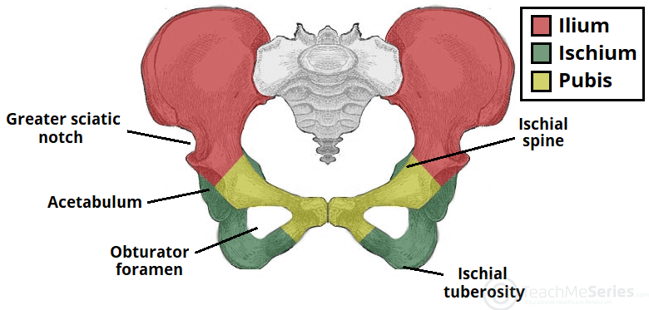](https://cdn1.teachmeseries.com/tmanatomy/wp-content/uploads/20180214154907/The-Hip-Bones-within-the-Pelvic-Girdle.png)

Fig 5 – The orientation of the hip bones within the pelvis.

**Clinical Relevance – Pubic Rami Fractures**

**Pubic rami fractures** can sometimes be observed on x-rays in elderly patients who are investigated after simple low energy falls from standing height. In this context and provided they are the only injury a patient has sustained, these fractures are usually treated without surgery.

Healing can be expected within **6-8 weeks** and patients are encouraged to fully weight bear straightaway.

**The Ischium**

The **ischium** forms the posteroinferior part of the hip bone**.** Much like the pubis, it is composed of a body, an inferior ramus and superior ramus.

The **inferior ischial ramus** combines with the inferior pubic ramus forming the ischiopubic ramus, which encloses part of the obturator foramen. The posterorinferior aspect of the ischium forms the **ischial tuberosities** and when sitting, it is these tuberosities on which our body weight falls.

Near the junction of the superior ramus and body is a posteromedial projection of bone; the **ischial spine**.

Two important ligaments attach to the ischium:

* **Sacrospinous ligament** – runs from the ischial spine to the sacrum, thus creating the greater sciatic foramen through which lower limb neurovasculature (including the sciatic nerve) transcends.
* **Sacrotuberous ligament** – runs from the sacrum to the ischial tuberosity, forming the lesser sciatic foramen.

[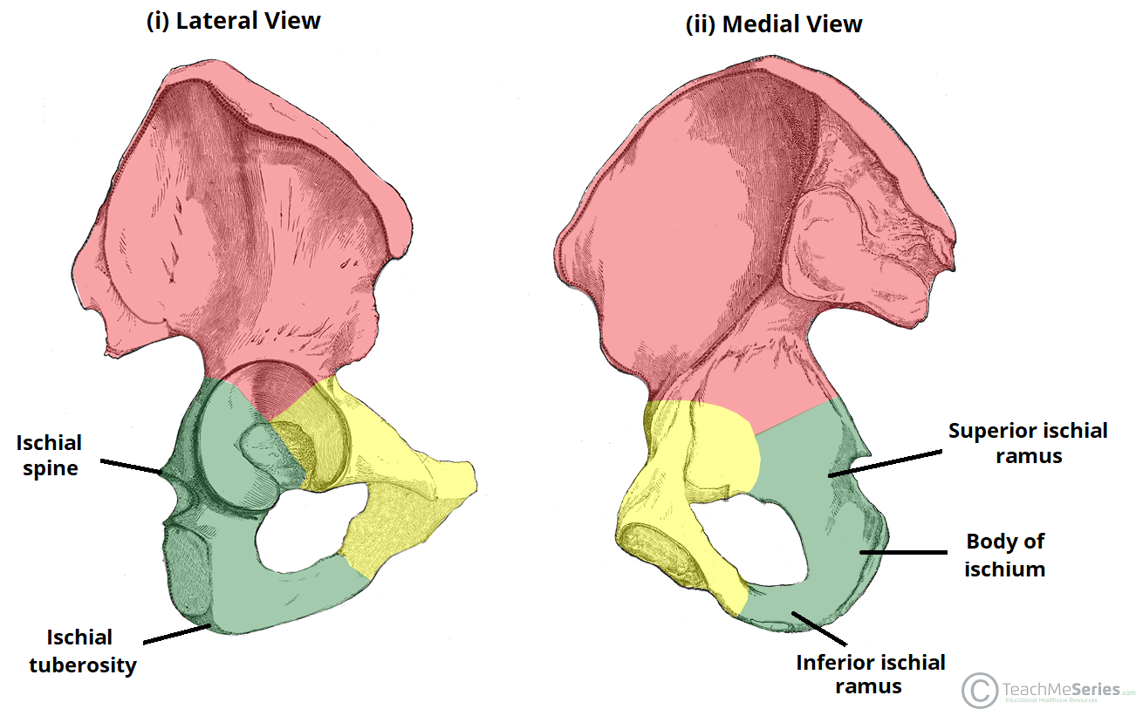](https://cdn1.teachmeseries.com/tmanatomy/wp-content/uploads/20180204195723/Bony-Landmarks-of-the-Ischium-1024x639.png)

Fig 6 – Bony landmarks of the ischium.

**Clinical Relevance: Pelvic Fractures**

There are two broad groups of pelvic fractures:

* **Low energy injuries:**
  + For example, a simple fall from standing height in an osteoporotic patient resulting in pubic rami fracture.
  + These are usually ‘stable’ injuries, not requiring surgery.
* **High energy injuries with direct or transmitted trauma:**
  + For example, after a high speed road traffic accident. These result in more extensive fractures which may include the acetabulum and sacroiliac joint.
  + These can be ‘unstable’ injuries and may require urgent surgery.
  + Higher energy injuries can be associated with soft tissue and vascular injury. In particular, the bladder and urethra are at high risk of damage. Vascular injury can result in life threatening haemorrhage.

In the context of a high energy major trauma patient, the pelvis can be a major source of bleeding due to fracture. As a result, major trauma patients are assumed to have a pelvic fracture until proven otherwise and a ‘**pelvic binder**’ is used to stabilise the pelvis and minimise further bleeding. Circumferential pressure is applied by the binder at the level of the greater trochanters – an important anatomical landmark.

The **pelvic girdle** is a ring-like bony structure, located in the lower part of the trunk. It connects the axial skeleton to the lower limbs.

In this article, we shall look at the anatomy of the pelvic girdle – its bony landmarks, functions, and its clinical relevance.

**Structure of the Pelvic Girdle**

The bony pelvis consists of the two [**hip bones**](http://teachmeanatomy.info/pelvis/the-hip-bone/) (also known as innominate or pelvic bones), **sacrum** and **coccyx**.

There are four articulations within the pelvis:

* **Sacroiliac Joints (x2) –**Between the ilium of the hip bones, and the sacrum
* **Sacrococcygeal symphysis –**Between the sacrum and the coccyx.
* **Pubic symphysis** – Between the pubis bodies of the two hip bones.

Ligaments attach the lateral border of the sacrum to various bony landmarks on the bony pelvis to aid **stability**.

[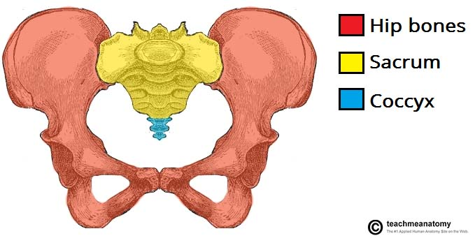](https://cdn1.teachmeseries.com/tmanatomy/wp-content/uploads/20171222214537/The-Parts-of-the-Pelvic-Girdle-Hip-Bones-Sacrum-and-Coccyx.jpg)

Fig 1 – The pelvic girdle is formed by the hip bones, sacrum and coccyx.

**Functions of the Pelvis**

The strong and rigid pelvis is adapted to serve a number of roles in the human body. The main functions being:

* **Transfer of weight** from the upper axial skeleton to the lower appendicular components of the skeleton, especially during movement.
* **Provides attachment** for a number of muscles and ligaments used in locomotion.
* **Contains and protects** the abdominopelvic and pelvic viscera.

**The Greater and Lesser Pelvis**

The osteology of the pelvic girdle allows the pelvic region to be divided into two:

* **Greater pelvis (false pelvis)** – located superiorly, it provides support of the lower abdominal viscera (such as a ileum and sigmoid colon). It has little obstetric relevance.
* **Lesser pelvis (true pelvis)** – located inferiorly. Within the lesser pelvis reside the pelvic cavity and pelvic viscera.

The junction between the greater and lesser pelvis is known as the **pelvic inlet**. The outer bony edges of the pelvic inlet are called the pelvic brim.

[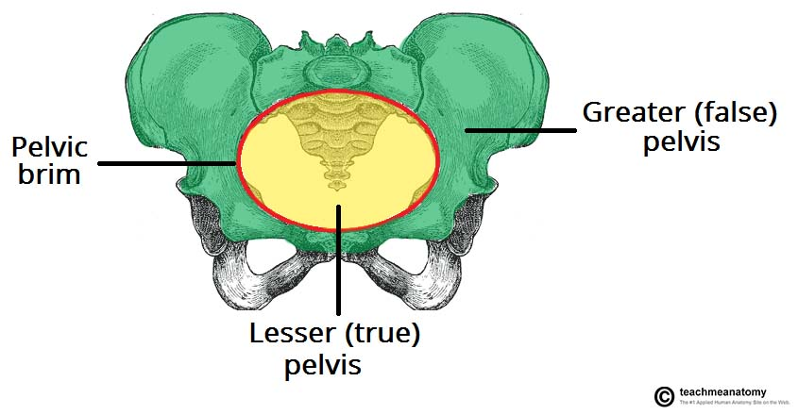](https://cdn1.teachmeseries.com/tmanatomy/wp-content/uploads/20171222214554/Greater-and-Lesser-Pelvis-Divided-by-the-Pelvic-Brim.jpg)

Fig 2 – The greater and lesser pelvis. The lesser pelvis is the ‘true’ pelvis, and contains the pelvic cavity.

**Pelvic Inlet**

The pelvic inlet marks the boundary between the greater pelvis and lesser pelvis. Its size is defined by its edge, the **pelvic brim**.

The borders of the pelvic inlet:

* **Posterior**– sacral promontory (the superior portion of the sacrum) and sacral wings (ala).
* **Lateral** – arcuate line on the inner surface of the ilium, and the pectineal line on the superior pubic ramus.
* **Anterior** – pubic symphysis.

The pelvic inlet determines the size and shape of the birth canal, with the prominent ridges key areas of muscle and ligament attachment.

Some alternative descriptive terminology can be used in describing the pelvic inlet:

* **Linea terminalis** – the combined pectineal line, arcuate line and sacral promontory.
* **Iliopectineal line** –the combined arcuate and pectineal lines. This represents the lateral border of the pelvic inlet.

[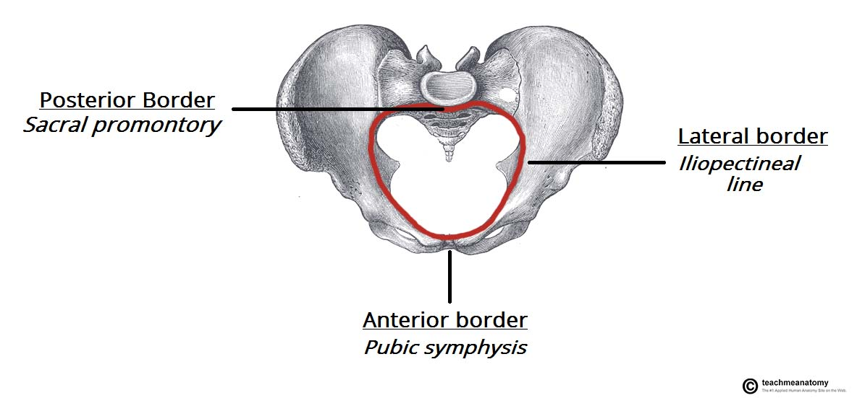](https://cdn1.teachmeseries.com/tmanatomy/wp-content/uploads/20171222214552/Borders-of-the-Pelvic-Inlet-The-Pelvic-Brim-1024x477.jpg)

Fig 3 – Looking down onto the pelvis, the borders of the pelvic brim.

**Pelvic Outlet**

The pelvic outlet is located at the end of the lesser pelvis, and the beginning of the pelvic wall.

Its borders are:

* **Posterior**: The tip of the coccyx
* **Lateral**: The ischial tuberosities and the inferior margin of the sacrotuberous ligament
* **Anterior**: The pubic arch (the inferior border of the ischiopubic rami).

The angle beneath the pubic arch is known as the **sub-pubic angle** and is of a greater size in women.

[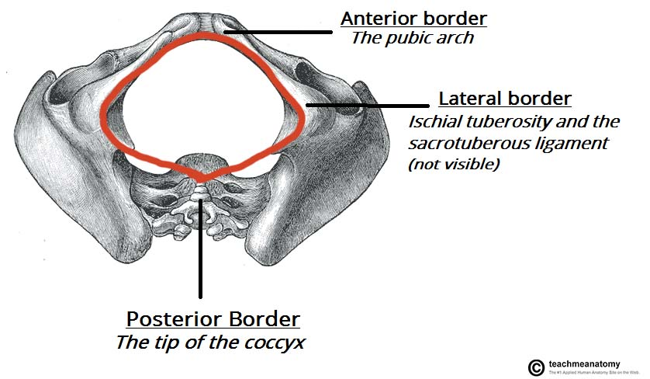](https://cdn1.teachmeseries.com/tmanatomy/wp-content/uploads/20171222214555/Borders-of-the-Pelvic-Outlet.jpg)

Fig 4 – The borders of the pelvic outlet.

**Adaptation for Childbirth**

The majority of women have a **gynaecoid** pelvis, as oppose to the male **android** pelvis. The slight differences in their structures creates a greater pelvic outlet, adapted to aid the process of childbirth. When comparing the two, the gynaecoid pelvis has:

* A **wider** and **broader** structure yet it is **lighter** in weight
* An **oval-shaped inlet** compared with the heart-shaped android pelvis.
* Less prominent ischial spines, allowing for a **greater bispinous diameter**
* A greater angled sub-pubic arch, more than **80-90 degrees**.
* A sacrum which is shorter, more curved and with a **less pronounced sacral promontory**.

In addition to the bony adaptations, the sacrotuberous and sacrospinous ligaments can stretch under the influence of progesterone and increase the size of the outlet further.

[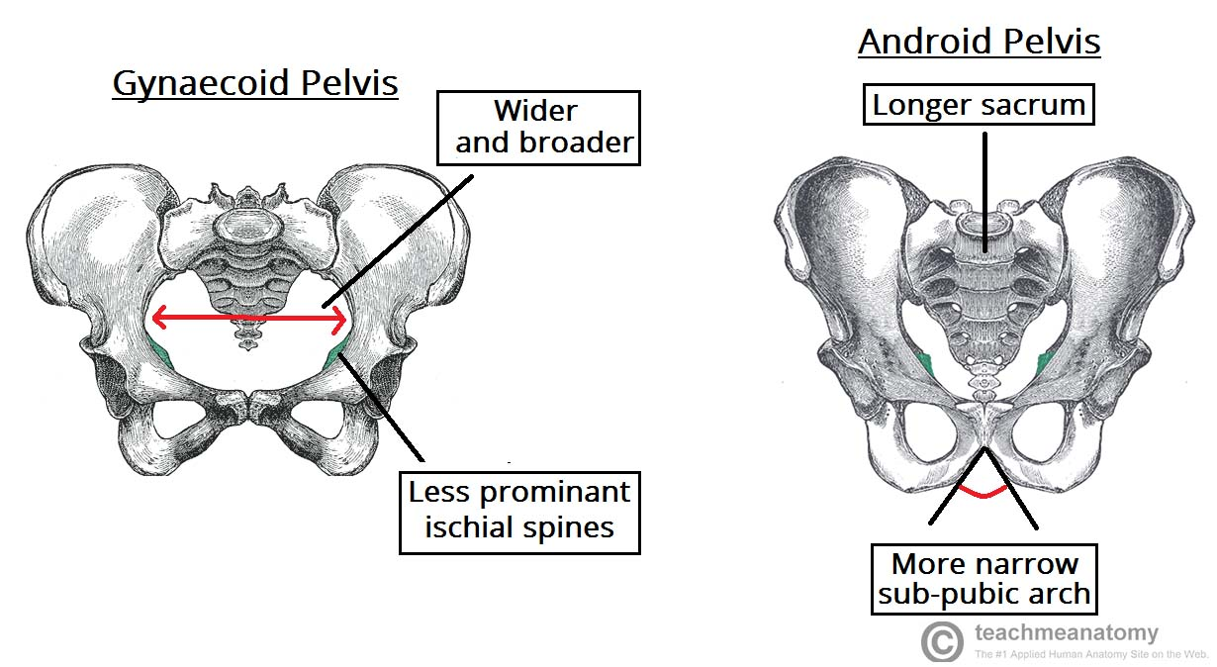](https://cdn1.teachmeseries.com/tmanatomy/wp-content/uploads/20171222214557/Gynaecoid-Pelvis-vs-Android-Pelvis-1024x561.jpg)

Fig 5 – Gynaecoid pelvis vs the android pelvis.

**Clinical Relevance: Assessment of the Female Bony Pelvis**

The lesser pelvis is the bony canal through which the fetus has to pass during childbirth. It is therefore of great importance to determine the diameter of this canal and therefore the childbearing capacity of the mother.

The diameter can be determined by a **pelvic examination** or radiographically. There are two measurements that are of importance:

**Obstetric Conjugate**

In order to determine the narrowest fixed distance that the foetus would have to negotiate, the minimum **antero-posterior diameter** of the pelvic inlet is measured.

This distance is between the sacral promontory and the midpoint of the pubic symphysis (where the pubic bone is thickest) and is known as the **obstetric conjugate** (or true conjugate). However, this measurement cannot be taken clinically, due to the presence of the bladder.

**Diagonal Conjugate**

The diagonal **conjugate** is the alternative, measuring from the inferior border of the pubic symphysis to the sacral promontory and can be measured manually via the vagina.

(To do this you use the tip of your middle finger to measure the sacral promontory and then using the other hand to mark the level of the inferior margin of the pubic symphysis on the examining hand. You then use the distance between the index finger and the pubic symphysis to measure the obstetric conjugate, ideally 11cm or greater)

In addition to measuring the diagonal conjugate, a **mid-pelvis check** is carried out. Here, the clinician is testing for straight side walls and measuring the bispinous diameter which is narrowest part of the pelvic canal. The width of the subpubic angle at the pelvic outlet can be determined by the distance between the ischial tuberosities.

[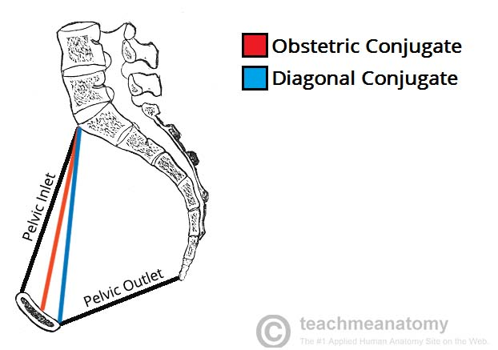](https://cdn1.teachmeseries.com/tmanatomy/wp-content/uploads/20171222214559/Measuring-the-Female-Pelvis-Obstetric-and-Diagonal-Conjugates.jpg)

The pelvic viscera (bladder, rectum, pelvic genital organs and terminal part of the urethra) reside within the **pelvic cavity** (or the true pelvis). This cavity is located within the lesser part of the pelvis, beneath the pelvic brim.

A number of **muscles** help make up the walls of the cavity – the lateral walls include the obturator internus and the pirformis muscle, with the latter also forming the posterior wall

In this article, we shall look at the anatomy of the muscles that make up the inferior lining of the cavity; the **pelvic floor muscles**. The pelvic floor is also known as the pelvic diaphragm.

We shall look at the individual roles of these muscles, their innervation and blood supply, and any clinical correlations.

[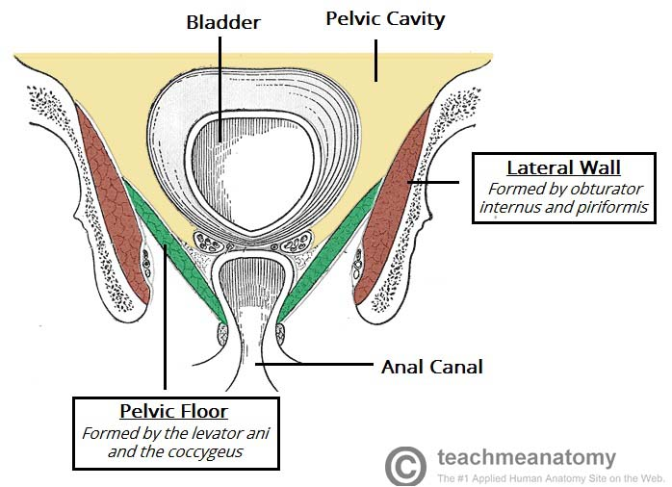](https://cdn1.teachmeseries.com/tmanatomy/wp-content/uploads/20171222214637/Overview-of-the-Pelvic-Cavity-and-the-Pelvic-Floor-Muscles.jpg)

Fig 1 – An overview of the pelvic cavity and its walls. Note the funnel shape of the pelvic floor.

**Pelvic Floor Structure**

The **pelvic floor** is a funnel-shaped structure. It attaches to the walls of the lesser pelvis, separating the **pelvic cavity** from the **perineum** inferiorly (region which includes the genitalia and anus).

In order to allow for urination and defecation, there are a few gaps in the pelvic floor. There are two ‘holes’ that have significance:

* **Urogenital hiatus** – an anteriorly situated gap, which allows passage of the urethra (and the vagina in females).
* **Rectal hiatus** – a centrally positioned gap, which allows passage of the anal canal.

Between the urogenital hiatus and the anal canal lies a fibrous node known as the **perineal** **body**,which joins the pelvic floor to the perineum.

**Functions**

As the floor of the pelvic cavity, these muscles have important roles to play in the correct functioning of the pelvic and abdominal viscera.

The roles of the pelvic floor muscles are:

* **Support of abdominopelvic viscera** (bladder, intestines, uterus etc.) through their tonic contraction.
* **Resistance to increases in intra-pelvic/abdominal pressure** during activities such as coughing or lifting heavy objects.
* **Urinary** **and** **fecal continence.**The muscle fibers have a sphincter action on the rectum and urethra. They relax to allow urination and defecation.

**Muscles**

When learning about the muscles of the pelvic floor, it is important to keep in mind its **funnel-shaped** structure. There are three main components of the pelvic floor:

* Levator ani muscles (largest component).
* Coccygeus muscle.
* Fascia coverings of the muscles.

We shall now consider each of these components in more detail.

**Levator Ani Muscles**

*Innervated by branches of the pudendal nerve (roots S2, S3 and S4).*

The levator ani is a broad sheet of muscle. It is composed of **three** separate paired muscles; pubococcygeus, puborectalis and iliococcygeus.

These muscles have attachments to the pelvis as follows:

* **Anterior** – pubic bodies of the hip bone.
* **Laterally** – thickened fascia of the obturator internus muscle, known as the tendinous arch.
* **Posteriorly** – ischial spines of the hip bone.

**Puborectalis**

The puborectalis muscle is a U-shaped sling, extending from the bodies of the pubic bones, past the **urogenital hiatus**, around the anal canal. Its tonic contraction bends the canal anteriorly, creating the anorectal angle (90 degrees) at the **anorectal junction** (where the rectum meets the anus).

The main function of this thick muscle is to maintain faecal continence – during defecation this muscle relaxes.

Some fibers of the puborectalis muscle (**pre-rectal fibers**) form another U-shaped sling that flank the urethra in the male and the urethra and vagina in the female (in some textbooks they appear as *pubovaginalis or sphincter urethrae / vaginae).*These fibers are very important in preserving urinary continence, especially during abrupt increase of the intra-abdominal pressure i.e. during sneezing.

[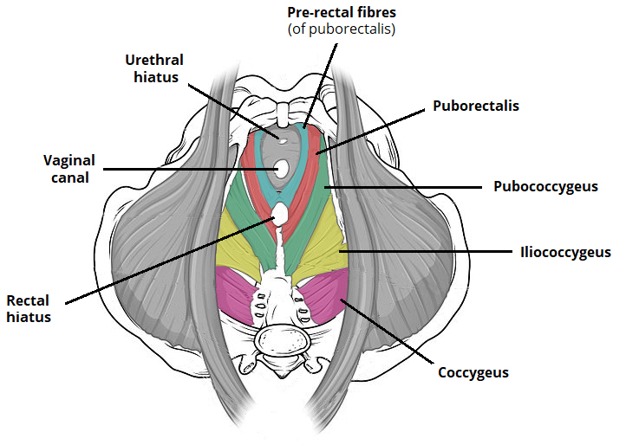](https://cdn1.teachmeseries.com/tmanatomy/wp-content/uploads/20180107114554/Muscles-of-the-Pelvic-Floor.jpg)

Fig 2 – Superior (bird’s eye) view of the pelvic floor. Note the prerectal fibres of the puborectalis.

**Pubococcygeus**

The muscle fibres of the pubococcygeus are the main constituent of the levator ani. They arise from the body of the **pubic bone** and the anterior aspect of the **tendinous arch**. The fibres travel around the margin of the urogenital hiatus and run posteriomedially,attaching at the **coccyx** and **anococcygeal ligament**.

**Iliococcygeus**

The iliococcygeus has thin muscle fibres, which start anteriorly at the **ischial spines** and posterior aspect of the **tendinous arch**. They attach posteriorly to the coccyx and the anococcygeal ligament.

This part of the levator ani is the actual “levator” of the three: its action elevates the pelvic floor and the anorectal canal.

**Coccygeus**

*Innervated by the anterior rami of S4 and S5.*

The coccygeus (or ischiococcygeus) is the smaller, and most posterior pelvic floor component – as the levator ani muscles are situated anteriorly.

It originates from the **ischial spines** and travels to the lateral aspect of the sacrum and coccyx, along the sacrospinous ligament.

[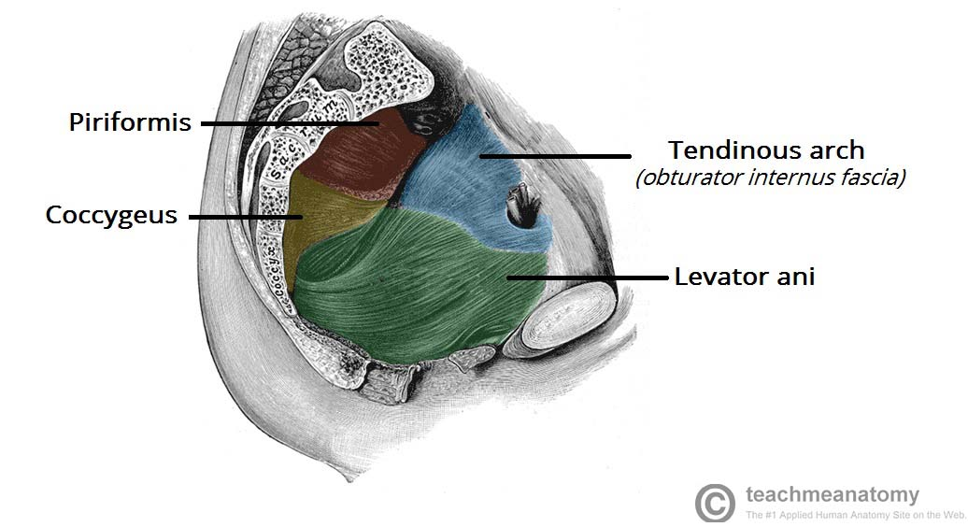](https://cdn1.teachmeseries.com/tmanatomy/wp-content/uploads/20171222214640/The-Muscles-of-the-Pelvic-Floor-Levator-Ani-and-Coccygeus-2-1024x557.jpg)

Fig 3 – Sagittal cut through the pelvis, showing a lateral view of the pelvic floor and walls.

**Clinical Relevance: Pelvic Floor Dysfunction**

The pelvic floor support acts to support the pelvic viscera, and assist in their functions. If the muscles of the floor become damaged, then dysfunction of these viscera can occur.

The levator ani muscles are involved in supporting the **foetal head** during cervix dilation in childbirth. During the second phase of childbirth, the levator ani muscles and/or the **pudendal nerve** are at high risk of damage. **Pubococcygeus** and **puborectalis** are the most prone to injury due to them being situated most medially.

Due to their role in supporting the vagina, urethra and anal canal, injury to these muscles can lead to a number of problems. The primary problems include **urinary stress incontinence** and **rectal incontinence**. Urinary incontinence is most noticeable during activities where there are increased abdominal pressure – coughing, sneezing and lifting heavy objects.

[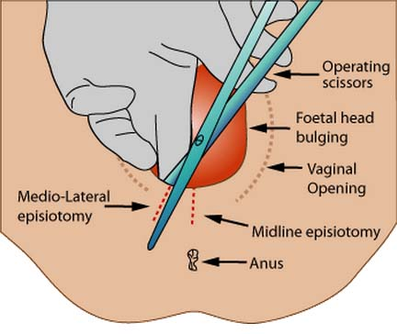](https://cdn1.teachmeseries.com/tmanatomy/wp-content/uploads/20171222214642/Episiotomy.jpg)

Fig 4 – An episiotomy is delivered to avoid tearing of the perineum and/or the pelvic floor. There are two different episiotomies that can be performed.

**Prolapse** of the pelvic viscera (such as the bladder and vagina) can occur if there is trauma to the pelvic floor or if the muscle fibres have poor tone. Prolapse of the vagina can also occur if there is damage to the **perineal body** in childbirth.

This may be avoided by **episiotomy** (surgical cut in the perineum), which itself can cause damage to the vaginal mucosa and submucosa but helps prevent uncontrolled tearing of the perineal muscles. If the medial fibres of the puborectalis are torn within the perineal body, then **rectal herniation** can also occur.

There are a number of risk factors which can increase the chances of prolapse: –

* Age
* Number of vaginal deliveries
* Family history of pelvic floor dysfunction
* Weight
* Chronic coughing (e.g from a lung disorder)

The pelvic floor can be repaired surgically, however a way to generally strengthen the muscles is to carry out **pelvic floor exercises** on a regular basis (Kegel exercises).

**Gametogenesis** is the process whereby a haploid cell (n) is formed from a diploid cell (2n) through meiosis and cell differentiation. Gametogenesis in the male is known as **spermatogenesis** and produces spermatozoa. Gametogenesis in the female is known as **oogenesis** and result in the formation of ova. In this article we shall look at both spermatogenesis and oogenesis.

**Spermatogenesis**

Males start producing sperm when they reach puberty, which is usually from 10-16 years old. Sperm are produced in large quantities (~200 million a day) to maximise the likelihood of sperm reaching the egg. Sperm are continually produced as males need to be ready to utilise the small window of fertility of the female.

Sperm production occurs in the testes of the male, specifically in the**seminiferous tubules**. The tubules are kept separate from the systemic circulation by the blood-testis barrier.

The blood-testis barrier is formed by Sertoli cells and is important in preventing hormones and constituents of the systemic circulation from affecting the developing sperm, and also in preventing the immune system of the male from recognising the sperm as foreign – as the sperm are genetically different from the male and will express different surface antigens. Sertoli cells also have a role in supporting the developing spermatozoa.

**Spermatogonia** are the initial pool of diploid cell that divide by mitosis to give two identical cells. One of these cells will be used to replenish the pool of spermatogonia – these cells are A1 spermatogonia. This replenishment of spermatogonia means that males are fertile throughout their adult life. The other cell –type B spermatogonium – will eventually form mature sperm.

Type B spermatogonia replicate by mitosis several times to form identical diploid cells linked by cytoplasm bridges, these cells are now known as primary spermatocytes. Primary spermatocytes then undergo meiosis.

* **Meiosis I** produces two haploid cells known as secondary spermatocytes
* **Meiosis II** produces four haploid cells known as Spermatids

The cytoplasmic bridges break down and the spermatids are released into the lumen of the seminiferous tubule – a process called **spermiation**. The spermatids undergo spermiogenesis (remodelling and differentiation into mature spermatozoa) as they travel along the seminiferous tubules until they reach the epididymis.

From the seminiferous tubule they travel to the rete testis, which acts to “concentrate” the sperm by removing excess fluid, before moving to the epididymis where the sperm is stored and undergoes the final stages of maturation.

Spermatogenesis takes approximately**70 days**, therefore in order for sperm production to be continuous and not intermittent, multiple spermatogenic processes are occurring simultaneously within the same seminiferous tubule, with new groups of spermatogonia arising every 16 days (spermatogenic cycle). Each of these populations of spermatogenic cells will be at different stages of spermatogenesis.

Note that once sperm leave the male body and enter the female reproductive tract, the conditions there cause the sperm to undergo**capacitation**, which is the removal of cholesterol and glycoproteins from the head of the sperm cell to allow it to bind to the zona pellucida of the egg cell.

[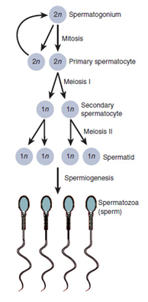](http://cdn1.teachmeseries.com/tmphysiology/wp-content/uploads/2017/07/22091127/Spermatogenesis-1.png)

Fig 1 – Spermatogenesis

**Oogenesis**

Oogenesis differs from spermatogenesis in that it begins in the foetus prior to birth. Primordial germ cells (which originate in the yolk sac of the embryo) move to colonise the cortex of the primordial gonad and replicate by mitosis to peak at approximately 7 million by mid-gestation (~20 weeks). Cell death occurs after this peak to leave 2 million cells which begin meiosis I before birth and are known as **primary oocytes**. Therefore, a human female is born with approximately 2 million primary oocytes arrested in meiosis and these make up a finite supply of potential ova.

The primary oocytes are arranged in the gonads in clusters surrounded by flattened epithelial cells called follicular cells and these form **primordial follicles**. The primary oocytes are arrested in prophase stage of meiosis I.

During childhood, further **atresia** (cell death) occurs, leaving ~40,000 eggs at puberty.

Once puberty begins, a number of primary oocytes (15-20) begin to mature each month, although only one of these reaches full maturation to become an oocyte.

The primary oocytes undergo 3 stages:

* Pre-antral
* Antral
* Preovulatory

**Pre-antral Stage**

The primary oocyte grows dramatically whilst still being arrested in meiosis I. The follicular cells grow and proliferate to form a stratified cuboidal epithelium. These cells are now known as granulosa cells and secrete glycoproteins to form the zona pellucida around the primary oocyte. Surrounding connective tissue cells also differentiates to become the **theca folliculi**, a specialised layer of surrounding cells that is responsive to LH and can secrete androgens under its influence.

**Antral Stage**

Fluid filled spaces form between granulosa cells, these eventually combine together to form a central fluid filled space called the antrum. The follicles are now called **secondary follicles**. In each monthly cycle one of these secondary follicles becomes dominant and develops further under the influence of FSH, LH and oestrogen.

**Pre-Ovulatory Stage**

The LH surge induces this stage and meiosis I is now complete. Two haploid cells are formed within the follicle, but they are of unequal size. One of the daughter cells receives far less cytoplasm than the other and forms the **first polar body**, which will not go on to form an ovum. The other haploid cell is known as the secondary oocyte. Both daughter cells then undergo meiosis II, the first polar body will replicated to give two polar bodies but the secondary oocyte arrests in metaphase of meiosis II, 3 hours prior to ovulation.

**Ovulation**

The follicle has grown in size and is now mature – it is called a **Graafian follicle**. The LH surge increases collagenase activity so that the follicular wall is weakened, this combined with muscular contractions of the ovarian wall result in the ovum being released from the ovary and being taken up into the fallopian tube via the fimbriae (finger-like projections of the fallopian tube).

**Fertilisation**

The secondary oocyte will only complete meiosis II on fertilisation, giving off a third polar body once meiosis II is completed and a fertilised egg. If fertilisation never occurs, the oocyte degenerates 24 hours after ovulation, remaining arrested in meiosis II.

If the egg is fertilised however, the peristaltic movements of the fallopian tube move the egg to the uterus where it can implant into the posterior uterine wall.

By Henry Vandyke Carter - Henry Gray (1918) Anatomy of the Human Body (See "Book" section below)Bartleby.com: Gray's Anatomy, Plate 5This is a retouched picture, which means that it has been digitally altered from its original version. Modifications: vectorization (CorelDraw). The original can be viewed here: Gray5.png. Modifications made by Mysid., Public Domain, https://commons.wikimedia.org/w/index.php?curid=1415394

[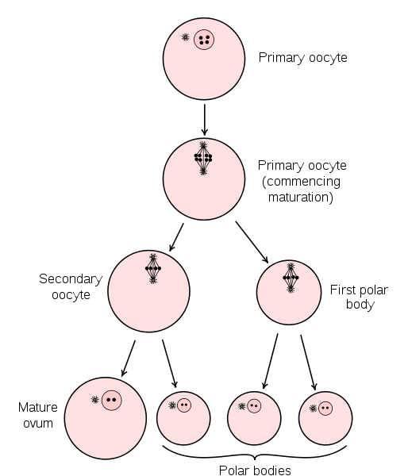](http://cdn1.teachmeseries.com/tmphysiology/wp-content/uploads/2017/07/22091127/Oogenesis.png)

Fig 2 – Oogenesis

The **placenta** is a vital connecting organ between the maternal uterus and the fetus.

It supports the developing fetus, in utero, by supplying nutrients, eliminating waste products of the fetus and enabling gas exchange via the maternal blood supply.

In this article, we shall look at the development of the placenta.

[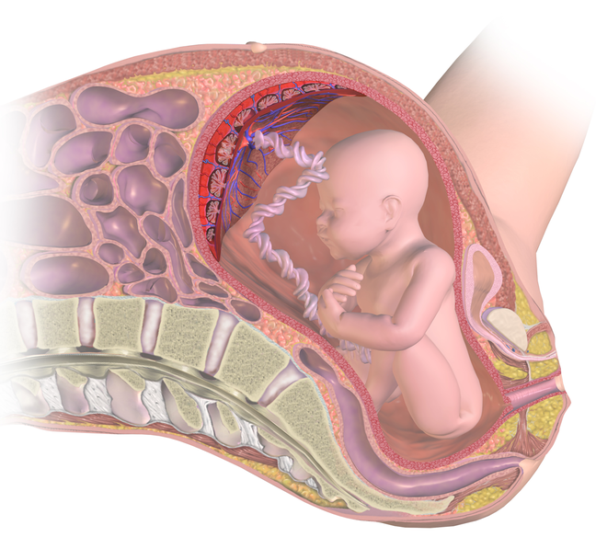](http://cdn1.teachmeseries.com/tmphysiology/wp-content/uploads/2018/05/09074604/The-Placenta-Cover-Image.png)

Fig 1 – The placenta supports the developing fetus in utero.

**Pre-Implantation**

The development of the placenta begins during implantation of the **blastocyst**.

The 32-64 cell blastocyst contains two distinct differentiated embryonic cell types: the outer **trophoblast** cells and the inner cell mass. The trophoblast cells form the placenta. The inner cell mass forms the fetus and fetal membranes.

**Implantation**

On the 6th day, as the zona pellucida disintegrates, the blastocyst “hatches”, allowing for implantation to take place. The trophoblast cells interact with the endometrial decidual epithelia to enable the invasion into the maternal uterine cells. The embryo secretes proteases to allow deep invasion into the uterine stroma. Implantation is interstitial. Normal implantation occurs on the anterior or posterior wall of the body of the uterus. The most common ectopic implantation site is in the ampulla of the Fallopian tube.

On the 8th day of development, the trophoblast cells differentiate into the outer multinucleated **syncytiotrophoblast**which erodes maternal tissues by sending out projections and the inner mononucleated cytotrophoblast which is actively proliferating.

The syncytiotrophoblast is responsible for producing hormones such as the **Human Chorionic Gonadotrophin** (hCG) by the second week which is used in pregnancy testing.

**Post-Implantation**

On day 9, lacunae or spaces form within the syncytiotrophoblast. The syncytiotrophoblast also erodes the maternal tissues allowing maternal blood from uterine **spiral arteries** to enter the lacunar network. Thus early uteroplacental circulation is established by the end of week 2.

Meanwhile, the cytotrophoblast begins to form **primary chorionic villi** or finger-like projections which penetrate and expand into the surrounding syncytiotrophoblast. In the 3rd week, extraembryonic mesoderm grows into these villi forming a core of loose connective tissue, at which point these structures are called secondary chorionic villi. By the end of the third week, embryonic vessels begin to form in the embryonic mesoderm of the secondary chorionic villi making them tertiary chorionic villi.

The cytotrophoblast cells from the tertiary villi grow towards the decidua basalis of the maternal uterus and spread across it to form a cytotrophoblastic shell. The villi that are connected to the decidua basalis through the cytotrophoblastic shell are known as **anchoring villi**. Villi growing outward within the intervillous space from the stem (anchoring) villi are called branching villi and provide surface area for exchange of metabolites between mother and fetus. Imagining the villi as tree-like projections can help visualise their structure.

**Establishment of Circulation**

Maternal spiral arteries undergo remodelling to producelow resistance, high blood flow conditions in order to meet the demands of the fetus. **Cytotrophoblast** cells invade the maternal spiral arteries and replace maternal endothelium. They undergo an epithelial to endothelial differentiation. This increases the diameter and reduces the resistance of the vessels.

Pre-eclampsia is a trophoblastic disorder related to failed or incomplete differentiation of cytotrophoblastic cells during the epithelial to endothelial transformation.

[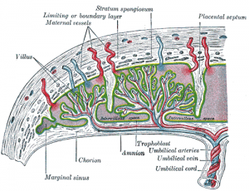](http://cdn1.teachmeseries.com/tmphysiology/wp-content/uploads/2017/07/22091138/placental-circulation.png)

Fig 2 – Established placental circulation

**Placental Barrier**

In the first trimester (0-13 weeks), the surface of the chorionic villi is formed by the syncytiotrophoblast. These cells rest on a layer of cytotrophoblastic cells that in turn cover a core of vascular mesoderm. Therefore, the placental barrier is relatively thick.

The surface area for exchange dramatically increases by full-term (27-40 weeks). The placental barrier is much thinner and the cytotrophoblast layer beneath the syncytiotrophoblast is lost.

The placental barrier is not a true barrier as it allows many substances to pass between the maternal and fetal circulations. Unfortunately, this means various drugs (e.g. heroin, cocaine) and viruses (e.g. CMV, rubella, measles) can enter the foetal circulation. As the maternal blood in the intervillous spaces is separated from the foetal blood by chorionic derivatives, the human placenta is known as the **haemochorial type**.

By the fourth month, the placenta has two components: the maternal portioni.e. the decidua basalis and the fetal portion i.e. the chorion frondosum. As the pregnancy advances, the chorion frondosum or the “bushy” chorion is formed as more villi develop on the embryonic pole. On the fetal surface, the placenta is covered by the **chorionic plate**; on the maternal side it is bordered by the decidua basalis of which the decidual plate is most intimately incorporated into the placenta.

During the fourth and fifth months, the decidua form **decidual septa** which project into the intervillous space but do not join the chorionic plate. These septa have a core of maternal tissue but are covered by a layer of syncytial cells. At all times there is a syncytial layer that separates maternal blood in intervillous lakes from foetal tissue of the villi. The septa divide the placenta into compartments called cotyledons. Cotyledons receive their blood supply through 80-100 spiral arteries that pierce the decidual plate.

[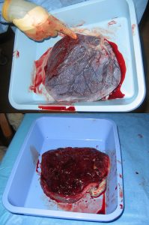](http://cdn1.teachmeseries.com/tmphysiology/wp-content/uploads/2017/07/22091139/human-placenta.jpg)

Fig 3 – Human placenta, maternal side (bottom) and fetal side (top)

**Full-Term Placenta**

Discoid in shape with a diameter of 15-25cm, approximately 3 cm thick and weighs about 500-600g.

At birth, it is torn from the uterine wall and around 30 minutes after the birth of the child it is expelled from the uterine cavity.

The **maternal side** will have 15-20 bulging areas which are the cotyledons, covered by a thin layer of decidua basalis. Intervillous lakes of the fully grown placenta contain approximately 150 mL of maternal blood, which is renewed 3-4 times per minute.

The **foetal surface** is covered by it’s chorionic plate. The **chorionic vessels** converge toward the **umbilical cord**. These are a number of large arteries and veins. The chorion is covered by a layer of amnion.The umbilical cord usually attaches in the middle of the placenta, perpendicular to it. A **velamentous insertion**may occur if the umbilical cord inserts outside of the placenta, but this is rare.

**End of Pregnancy**

The aim of the changes that occur to the placenta at the end of pregnancy is to reduce exchange between the maternal and foetal circulations. These changes are as follows:

* Increase in the **fibrous** tissue in the core of the villus
* Thickening of foetal capillary basement membranes
* Obliterative changes in small capillaries of the villi
* Deposition of **fibrinoid** on the surface of the villi in the junctional zone and in the chorionic plate.

Deposition of fibrinoid results in infarction of an intervillous lake or sometimes an entire cotyledon, which subsequently turns whitish in colour.

In order to meet with the demands of pregnancy, physiological adaptations occur in the mother. These adaptations allow her to support and protect the foetus. In this article, we will take a systems based approach to discuss the different changes which occur during pregnancy.

**Endocrine System**

During pregnancy a woman experiences a change in her endocrine system. Throughout pregnancy the levels of progesterone and oestrogen increase; the oestrogen being produced by the placenta and the progesterone being produced by the corpus luteum and later by the placenta.

Increase in oestrogen levels results in an increase in hepatic production of thyroid binding globulin **(TBG).** As a result, more free T3 and T4 bind to the TBG, this causes more thyroid stimulating hormone to be released from the anterior pituitary gland. Therefore, the *free* T3 and T4 levels remain unchanged – but the *total* T3 and T4 levels rise.

**Thyroxin** is essential for foetus’s neural development, but the foetal thyroid gland is not functional until the second trimester of gestation. Hence, increasing T3 and T4 levels in the mother ensures that there is a constant supply of thryoxin to the foetus early in pregnancy.

During pregnancy, mainly during there second trimester, there is an increase of human placental lactogen, prolactin, cortisol levels along with the increase in progesterone and oestrogen levels. These are **anti-insulin hormones** therefore, they increase insulin resistance in the mother and reduce peripheral uptake of glucose. This ensures that there is a continuous supply of glucose for the foetus.

The mother switches to an alternative source of energy which is provided by lipids. The increase in lipolysis means that there is an increase in free fatty acids in the plasma which provide substrate for maternal metabolism. The breakdown of lipids can result in ketogenesis thus, pregnancy is associated with an increased risk of **ketoacidosis**.

**Cardiovascular System**

As discussed above, during pregnancy progesterone levels increases. Progesterone acts to decrease systemic vascular resistance in pregnancy which leads to a decrease in **diastolic blood pressure** during the first and second trimester of pregnancy. In response to this the cardiac output increases by about 30-50%. An increase in blood pressure in pregnancy could be an indication of pre-eclapmsia.

Pregnancy results in the activation of the renin-angiotensin system. This leads to an increase in sodium levels and water retention. This means that the total blood volume increases.

**Respiratory System**

Anatomically, the growth of the foetus during pregnancy causes upward **displacement** of the diaphragm. This however, does not decrease the total lung capacity significantly since there is also an increase in the transverse and anterior-posterior diameters of the thorax.

In pregnancy a woman faces an increase in their metabolic rate which leads to an increased demand for oxygen. The tidal volume and the minute ventilation rate increases to help the mother meet the oxygen demands.

Many women experience hyperventilation during pregnancy. It is thought that the reason for this is the increased carbon dioxide production and the increased respiratory drive caused by progesterone. This **hyperventilation** results in a respiratory alkalosis with a compensated increase in renal bicarbonate excretion.

**Gastrointestinal System**

The growth of the uterus causes a number of anatomical changes related to the gastrointestinal tract. One of these would be the upward displacement of the stomach as the uterus grows. This would lead to an increase in the **intra-gastric pressure** which would predispose the mother to getting symptoms of reflux, along with symptoms such as nausea and vomitng. The appendix may also move to the right upper quadrant of the abdomen as the uterus enlarges.

The increase in progesterone during pregnancy results in **smooth muscle relaxation**. This would decrease gut motility. Although this allows for more time for nutrient absorption, it can **l**ead to constipation. Increased progesterone also causes relaxation of the gallbladder so biliary tract stasis may occur. This predisposes the mother to getting gallstones.

**Urinary System**

Increased cardiac output during pregnancy causes an increase in renal plasma flow which increases the **GFR** by about 50-60%. This would mean that there is an increase in renal excretion. So in pregnancy the levels of urea and creatinine will be lower.

Progesterone affects the urinary collecting system causing relaxation of the ureter (resulting in hydroureter). There is also relaxation of the muscles of the bladder. Both of these changes causes urinary stasis which predisposes a woman to **UTIs**, commonly pyelonephritis.

**Haematological Changes**

In pregnancy there is an increase in fibrinogen and **clotting factors**in the blood and a decrease in fibrinolysis. Additionally, due to an increase in progesterone levels stasis of blood and venodilation occurs. All these factors increase the risk of thromboembolic disease in pregnancy. Warfarin can not be given to pregnant women to counteract this as it can cross the placenta and it is a teratogen. Low Molecular Weight Heparin (LMWH) is usually considered the anticoagulant of choice during pregnancy if it is necessary to give the mother anticoagulant drug.

During pregnancy the plasma volume increases significantly. However, the red cell mass does not increase by as much. This results in a physiological **dilutional anemia**.

**Clinical Relevance – Gestational Diabetes Mellitus (GDM)**

Usually as pregnancy progresses there is an increase in **insulin resistance** however, normally this can be counteracted by increasing insulin production. In a women with [gestational diabetes](http://teachmeobgyn.com/pregnancy/medical-disorders/gestational-diabetes/) this compensatory increase in insulin levels does not occur which results in a high blood sugar levels.

The diagnostic criteria for diagnosing a women with gestational diabetes  is as follows:

* Fasting plasma glucose level of **5.6** **mmol/L** or above;
* Two-hour plasma glucose level of **7.8 mmol/L** or above.

Risk factors for developing GDM include age, high BMI before pregnancy, family history of type 2 diabetes and smoking.

Non drug treatment for GDM include changing diet and physical activity. **Insulin** can be given as treatment when lifestyle measures do not help to maintain blood sugar levels. Other agents such as metformin can also be offered.

GDM poses a risk to the mother and the baby. Two main risks to the baby are **macrosomia** in unmanaged GDM (which can lead to complications during birth as the baby is bigger in size) or intrauterine growth retardation in managed GDM. Although most women recover from GDM after pregnancy there is a chance that in some GDM will recur in future pregnancies.

An **amniocentesis** is a procedure used to sample a small amount of amniotic fluid from around the fetus. It is usually performed after 15 weeks’ gestation.

It is performed for similar reasons to [chorionic villus sampling](http://teachmeobgyn.com/operations-procedures/obstetric/chorionic-villus-sampling/) (CVS), which is carried out from 10 -13+6 weeks’ gestation. It is not the fluid itself which is of use, but the **fetal cells** that are present in the fluid.

In this article, we shall look at the procedure, indications and complications of **amniocentesis**.

[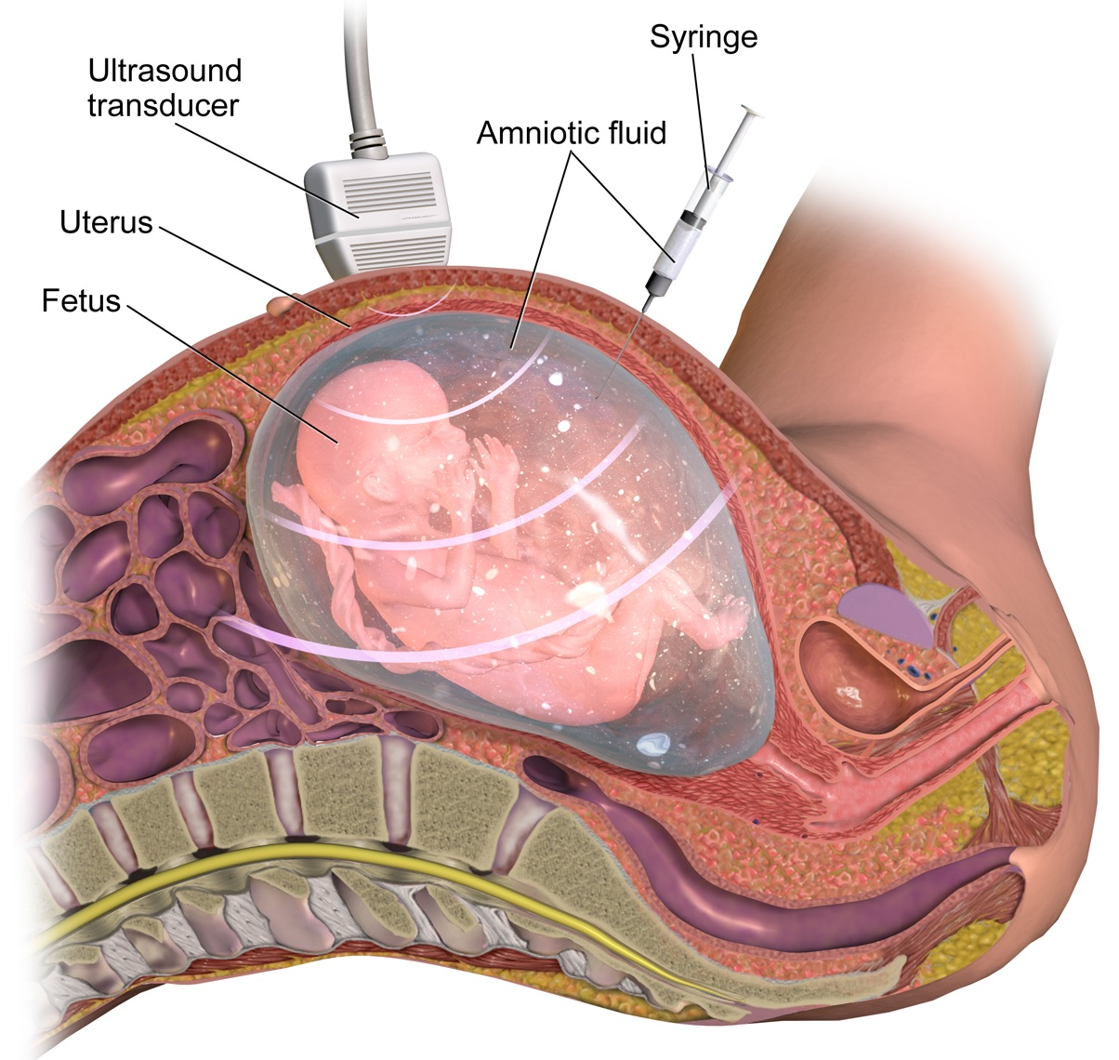](http://cdn1.teachmeseries.com/tmobgyn/wp-content/uploads/2016/10/22092555/Amniocentesis-Procedure-Obstetrics-1024x970.jpg)

Fig 1 – Amniocentesis, used to sample amniotic fluid

**Procedure**

First, a **local anaesthetic** is used to decrease pain for the mother.

Under **ultrasound guidance**, a needle is passed through the mother’s abdominal wall and into the amniotic sac. The needle should not pass through the placenta unless absolutely necessary.

A small amount of amniotic fluid is taken, and fetal cells are sent for **karyotyping** and/or PCR.

*Note: Rhesus-negative women will need****Anti-D immunoglobulin****after the test.*

**Indications**

The most common indication for amniocentesis is a “high risk” result from a **first trimester screening test**, or a previous pregnancy affected by a genetic condition.

The fetal cells that are obtained can be tested for various chromosomal conditions, such as Down’s syndrome, Edward’s syndrome and/or Patau’s syndrome.

**Therefore, the intended benefit of this procedure is diagnosis or exclusion of particular genetic diseases.**

**Complications**

The potential complications of an amniocentesis are:

* 1% risk of miscarriage (RCOG). The risk is higher if performed before 14 weeks gestation.
* False reassurance – a “normal” result may make women feel their baby will be born completely healthy when this may not be the case.
* Risk of infection, as with most surgical procedures
* Pain from the procedure
* Rhesus sensitisation
* Increased risk of club foot

**Alternatives**

The main alternative to amniocentesis is **chorionic villus sampling**. This is also an invasive procedure, with its own risks. It can come to the same conclusions as amniocentesis and is typically performed earlier in the pregnancy.

**Nuchal translucency** (measured on ultrasound) and blood tests can give the woman some information regarding the risk of Down’s syndrome, but cannot provide definitive diagnosis or reassurance.

**Chorionic villus sampling** (CVS) is an invasive prenatal diagnostic procedure that is usually performed between 11 and 13+6 weeks of gestation.

It involves the biopsy of the **placental villi** (chorionic villi), with the aim of diagnosing chromosomal abnormalities and autosomal dominant and recessive conditions.

Common abnormalities can usually be diagnosed within 48 hours. The diagnostic accuracy of CVS is considered to be between **97.5%** and **99.6%** (slightly less than amniocentesis due to placental mosaicism).

In this article, we shall look at the procedure, indications and complications of **chorionic villus sampling**.

[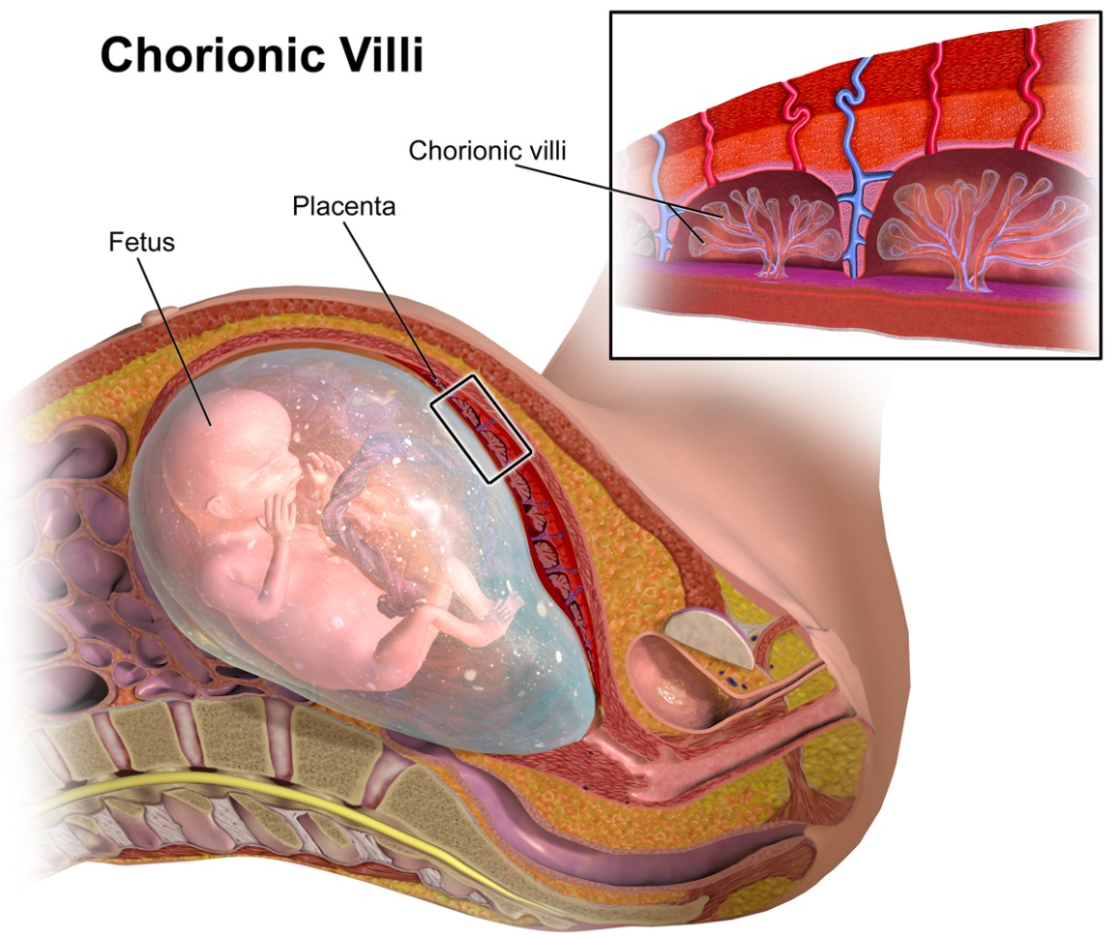](http://cdn1.teachmeseries.com/tmobgyn/wp-content/uploads/2016/12/22092530/Chorionic-Villus-Sampling-Diagram-of-Procedure-1024x853.png)

Fig 1 – The chorionic villi; these are the site of biopsy in CVS.

**Procedure**

CVS can be performed using either a **transabdominal** (most common method) or transcervical approach.

The placental sample is obtained under local anaesthetic either by an ultrasound-guided transabdominal needle or by ultrasound-guided transcervical cannula aspiration or biopsy forceps. Tissue samples are then sent for chromosomal analysis.

If the mother is **RhD negative**, Anti-D prophylaxis should be offered following the procedure.

**Indications**

Chorionic villus sampling is offered to pregnant women who have an increased risk of fetal chromosomal/genetic abnormalities. These include:

* Increased risk of abnormality identified through antenatal screening (risk **>1:150**)
* A previous child with chromosomal or genetic abnormality
* Known carrier status for a genetic condition
* A family history of a genetic condition
* Ultrasound scan evidence of fetal abnormalities that are associated with a chromosomal or genetic condition.

**Complications and Limitations**

The complications of chorionic villus sampling include:

* **Miscarriage:** There is an additional risk of 1% following chorionic villus sampling.
  + This is considered to be slightly higher than amniocentesis, however the gestation in which CVS is performed is when spontaneous miscarriage is more common.
* **Vaginal bleeding:** occurs in around 1 in 10 women (higher in transcervical approach).
* Other maternal complications include: **pain, infection,** **amniotic fluid leakage** and **resus sensitisation**

There is also a 1% risk of a **mosaic result**(where both normal and abnormal cells are found). Amniocentesis may then be offered to establish whether the baby has a mosaic karyotype or if mosaicism is just confined to the placenta (confined placental mosaicism).

**Alternatives**

The main alternative diagnostic test is **amniocentesis**. This is the most common invasive prenatal diagnostic procedure and involve sampling the amniotic fluid for karyotyping. This is typically performed from **15** weeks onwards.

CVS has the advantage of being performed earlier in gestation than [amniocentesis](http://teachmeobgyn.com/operations-procedures/obstetric/amniocentesis/), allowing for investigation and management decisions to be made sooner.