A **miscarriage** is a loss of a pregnancy at less than 24 weeks’ gestation. Early miscarriages occur in the first trimester (<12-13 weeks) and are more common than late miscarriages, which occur at 13-24 weeks.

Sadly, miscarriages are relatively common and occur in **20-25%** of pregnancies. They are classified according to clinical and ultrasound features.

In this article, we shall look at the risk factors, clinical features and management of miscarriage.

**Risk Factors**

The **risk factors** for miscarriage include:

* Maternal Age >30-35 (largely due to an increase in chromosomal abnormalities)
* Previous miscarriage
* Obesity
* Chromosomal abnormalities (maternal or paternal)
* Smoking
* Uterine anomalies
* Previous uterine surgery
* Anti-phospholipid syndrome
* Coagulopathies

[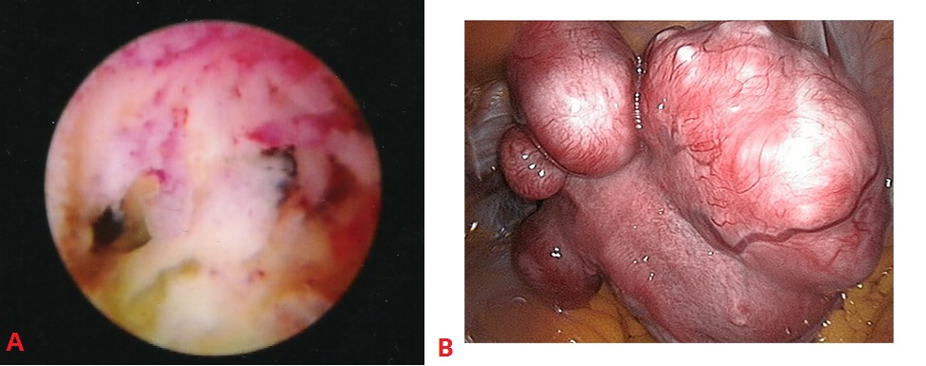](http://s3.amazonaws.com/teachmeseries/tmobgyn/wp-content/uploads/2016/09/22092646/Uterine-Structural-Abnormalities-Recurrent-Miscarriage.jpg)

Fig 1 – Examples of uterine structural abnormalities. A – Intrauterine adhesions, visible on hysteroscopy. B- Uterine fibroids, visible on laparoscopy. These are both a risk factor for miscarriage.

**Clinical Features**

The main presenting symptom of miscarriage is **vaginal bleeding**. This may include passing clots or products of conception. However, a significant number of miscarriages are found incidentally on ultrasound.

If there is excessive bleeding, this can lead to haemodynamic instability – manifesting as dizziness, pallor, and shortness of breath. The bleeding is often accompanied by a suprapubic, **cramping pain** (similar to primary dysmenorrhoea).

**Signs on examination:**

* **Haemodynamic instability** – pallor, tachycardia, tachyopnea, hypotension.
* **Abdominal examination** – the abdomen may be distended, with localised areas of tenderness.
* **Speculum** **examination**– assess the diameter of the cervical os, and observe for any products of conception in cervical canal, or local areas of bleeding.
* **Bimanual examination** – assess any uterine tenderness and any adnexal masses or collections (consider ectopic pregnancy).

**Differential Diagnosis**

The main differential diagnoses to exclude in a suspected miscarriage include:

* Ectopic pregnancy
* Hydatidiform mole
* Cervical/uterine malignancy

[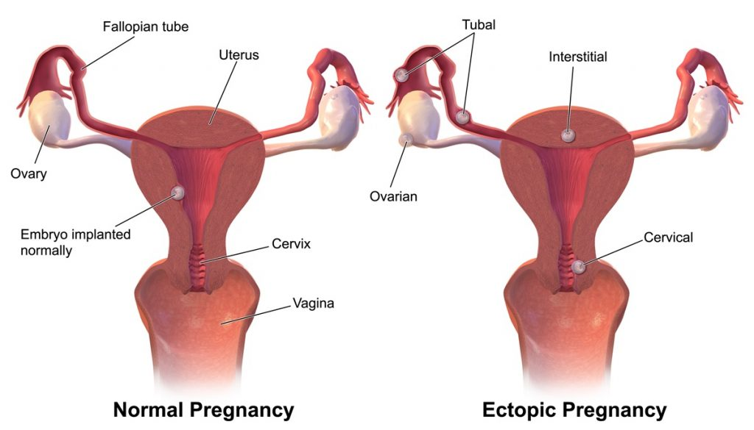](http://s3.amazonaws.com/teachmeseries/tmobgyn/wp-content/uploads/2016/07/22092644/Types-of-Ectopic-Pregnancies-1024x585.jpg)

Fig 2 – An ectopic pregnancy is one that is implanted outside the uterine cavity.

**Investigations**

In the UK, patients with a suspected miscarriage (positive urine pregnancy test + vaginal bleeding +/- pain) should be investigated in an **Early Pregnancy Assessment Unit** with access to scanning equipment and expertise in managing early pregnancy problems.

**Imaging**

The definitive diagnosis is made via a **transvaginal ultrasound scan**. The most important finding to exclude miscarriage is fetal cardiac activity. This is observed transvaginally at 5½ – 6 weeks gestation.

Gestation can be estimated by the fetal crown rump length (CRL). If the CRL <7.0mm and no fetal heart is identified, a conclusive diagnosis of miscarriage cannot be made – a repeat scan in at least 7 days is required.

If a fetal pole is not visible, but intrauterine pregnancy is confirmed with a gestational sac and yolk sac, the management depends on the **mean sac diameter (MSD)**. This is obtained by measuring the gestational sac in 3 dimensions:

* If >25mm, a diagnosis of failed pregnancy can be made.
* If <25mm, a repeat scan needs to be arranged in 10-14 days.

*Note: a transabdominal ultrasound scan can be performed if TVUS is not acceptable to the patient, or in more advanced gestations. However, the sensitivity and specificity are not as good – and the patient should be informed of this.*

[](http://s3.amazonaws.com/teachmeseries/tmobgyn/wp-content/uploads/2016/07/22092519/Delayed-or-Missed-Miscarriage-Ultrasound.gif)

Fig 3 – Ultrasound of a fetus with a CRL of 67mm. The heart is visible, but there is no heartbeat – this is a missed miscarriage.

**Blood Tests**

If ultrasound is not immediately available, a **serum b-HCG** may be indicated. This should not be used to diagnose a viable or non-viable pregnancy – but serial b-HCG measurements are useful in assessing the possibility of an ectopic pregnancy.

Other investigations indicated in women bleeding are:

* Full blood count
* Blood group and rhesus status
* Triple swabs and CRP (if pyrexial)

**Management**

There are three options for the definitive management of miscarriage, which all carry a similar risk of infection.

Regardless of treatment type, if the patient is Rhesus negative and is greater than 12 weeks gestation, they require **anti-D prophylaxis**. If they are managed surgically, regardless of the gestation, they require anti-D (if RhD-ve).

**Conservative (Expectant)**

Conservative management allows the products of conception (POC) to pass naturally. Patients should have 24/7 access to gynaecology services during this time.

* **Advantages**: Can remain at home, no side effects of medication, no anaesthetic or surgical risk.
* **Disadvantages**: Unpredictable timing, heavy bleeding and pain during passage of POC, chance of being unsuccessful requiring further intervention and need for transfusion.
* **Follow-up**: Some units will arrange a repeat scan in two weeks. Others will arrange a pregnancy test 3 weeks later.
* **Contraindications**: Infection, high risk of haemorrhage ie. Coagulopathy, haemodynamic instability.

**Medical**

Medical management involves the use of vaginal misoprostol (prostaglandin analogue) to stimulate cervical ripening and myometrial contractions. It is usually preceded by mifepristone 24-48 hours prior to administration.

* **Advantages**: Can be at home if patient desires, with 24/7 access to gynaecology services, avoid anaesthetic and surgical risk.
* **Disadvantages**: Side effects of medication: vomiting/diarrhoea, heavy bleeding and pain during passage of POC, chance of requiring emergency surgical intervention.
* **Follow-up:** Pregnancy test 3 weeks later

**Surgical**

Surgical management involves a manual vacuum aspiration with local anaesthetic if <12 weeks, or evacuation of retained products of conception (ERPC).

In ERPC, the patient is under a general anaesthetic, a speculum is passed to visualize the cervix, it is dilated allowing suction tube to be passed and remove the products of conception. Patients typically attend hospital on the day of the procedure and are discharged the same day.

* **Definite indication**: Haemodynamically unstable, infected tissue, gestational trophoblastic disease.
* **Advantages**: Planned procedure (may help patient to cope with miscarriage), unaware during the process (patient under general anaesthetic).
* **Disadvantages**: Anaesthetic risk, infection (endometeritis), uterine perforation, haemorrhage, Ashermen’s syndrome, bowel or bladder damage, retained products of conception.

[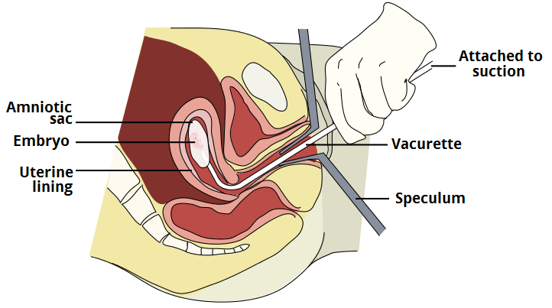](http://s3.amazonaws.com/teachmeseries/tmobgyn/wp-content/uploads/2016/07/22092518/Vacuum-Aspiration-Surgical-Management-of-Miscarriage.png)

Fig 4 – Vacuum aspiration; a procedure used in the surgical management of miscarriage.

**Classification of Miscarriage**

|  |  |  |  |
| --- | --- | --- | --- |
| **Type** | **Clinical** | **Transvaginal USS** | **Management** |
| **Threatened** | Mild bleeding +/- Pain  Cervix closed | Viable pregnancy | * If heavy bleeding admit/observe, if not reassure and back to GP/Midwife * If >12 weeks & Rhesus negative: Anti-D |
| **Inevitable** | Heavy bleeding, clots, pain  Cervix open | Internal cervical os opened  Fetus can be viable or non-viable | * If heavy bleeding admit/observe * Offer conservative/medical/surgical options. Likely to proceed to incomplete/complete miscarriage * If >12 weeks & rhesus negative: Anti-D |
| **Missed** | Asymptomatic or hx of threatened miscarriage, on-going discharge, small for dates uterus | No fetal heart pulsation in a fetus where crown rump length is >7mm* | * May want to rescan and second person to confirm * Manage conservatively (lower success rated), medically or surgically * If >12 weeks & rhesus negative: Anti-D |
| **Incomplete** | POC** partially expelled – Sx of missed miscarriage or bleeding/clots | Retained POC, with A/P endometrial diameter >15mm AND proof that were was a intrauterine pregnancy previously present (USS/clinically remove clots) | * Expectant, medical or surgical management * If >12 weeks & rhesus negative: Anti-D |
| **Complete** | Hx of bleeding, passing clots and POC and pain. Sx settling/settled now. | No POC seen in uterus, with endometrium that is <15 mm diameter AND previous proof of intrauterine pregnancy i.e. scan | * Discharge to GP * If >12 weeks & rhesus negative: Anti-D |
| **Septic** | Infected POC: fever, rigors, uterine tenderness, bleeding/discharge, pain | Leucocytosis, raised CRP + can be features of complete or incomplete miscarriage | * Medical or surgical management * IV antibiotics and fluids * If >12 weeks & rhesus negative: Anti-D |

*\*Crown rump length must be greater than 7mm before you can accurately comment on fetal heart pulsation*

*\*\*POC – Products of conception*

**Recurrent miscarriage** is defined by the Royal College of Obstetricians and Gynaecologists as *‘the occurrence of three or more consecutive pregnancies that end in miscarriage of the fetus before 24 weeks of gestation*‘.

It affects 1–2% of women of reproductive age. The **psychological impact** of recurrent miscarriage is often distressing, and these women require considerable support and care.

In this article, we shall look at the causes, investigations and management of recurrent miscarriage.

**Etiology**

Several factors have been associated with recurrent miscarriage, such as systemic disease, anatomical defects, and chromosomal abnormalities.

However, many of these associations are weak – and the cause of recurrent miscarriage remains unidentified in the majority of women.

**Antiphospholipid Syndrome**

[Antiphospholipid syndrome](http://teachmeobgyn.com/pregnancy/medical-disorders/haematological/antiphospholipid-syndrome/) refers to the association between antiphospholipid antibodies and vascular thrombosis or pregnancy failure/complications.

It is present in 15% of women with recurrent miscarriage. In these women, the live birth rate where there has been no pharmacological intervention has been reported to be as low as 10%.

**Genetic Factors**

There are two major genetic factors contributing to the risk of recurrent miscarriage:

* **Parental chromosomal rearrangements** – In approximately 2–5% of couples with recurrent miscarriage, one of the partners carries a balanced reciprocal or Robertsonian l chromosomal translocation.
  + They are phenotypically normal, but their pregnancies are at an increased risk of miscarriage, secondary to an unbalanced chromosomal arrangement.
* **Embryonic chromosomal abnormalities** – In recurrent pregnancy loss, chromosomal abnormalities of the embryo account for 30–57% of further miscarriages.

[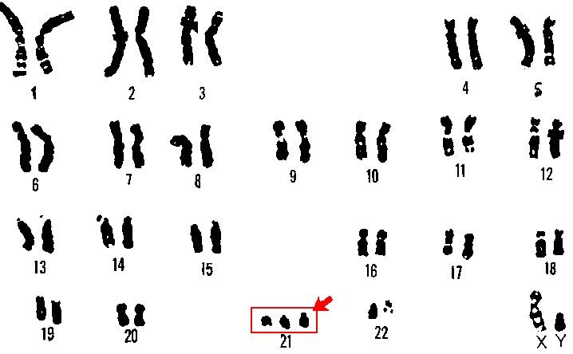](http://s3.amazonaws.com/teachmeseries/tmobgyn/wp-content/uploads/2016/09/22092650/Karyotyping-Recurrent-Miscarriage-Trisomy-21.jpg)

Fig 1 – Karyotyping performed on the products of conception, showing trisomy 21 – a embryonic genetic abnormality that is a strong risk factor for miscarriage.

**Endocrine Factors**

Diabetes mellitus and thyroid disease have both been associated with miscarriage (unless well controlled). Indeed, a high **HBA1c** at conception is linked with increased risk of miscarriage and fetal malformation.

**Polycystic ovarian syndrome** (PCOS) is also associated with an increased risk of miscarriage. Though the exact mechanism remains unclear, it is possibly due to a combination of insulin resistance, hyperinsulinaemia and hyperandrogenaemia.

**Anatomical Factors**

Structural abnormalities of the female reproductive tract are a recognised factor in recurrent miscarriage. They include:

* **Uterine malformations** – such as septate, bicornuate or acuate uterus.
* **Cervical weakness** – where the cervix begins to efface and dilate before the pregnancy reaches term. The characteristic history is of a second-trimester miscarriage that is preceded by a spontaneous rupture of membranes or painless cervical dilatation.
* **Acquired uterine abnormalities** – such adhesions (Asherman’s syndrome) or fibroids.

**Infective Agents**

Any severe infection that results in bacteraemia or viraemia can lead to sporadic miscarriage, especially if there is **pyrexia**.

However, infection is an rare cause for recurrent miscarriage – as it is unlikely to be something that persists without signs or symptoms between pregnancy episodes.

**Bacterial vaginosis** in the first trimester of pregnancy is a risk factor for second-trimester miscarriage. Some individuals are predisposed to this, so screening in the first trimester and treatment (if appropriate) should be provided.

**Inherited Thrombophilias**

Inherited thrombophilias include Factor V Leiden, prothrombin gene mutation and **deficiencies of protein C/S** and antithrombin III. They are more strongly associated with second trimester pregnancy loss, with the presumed mechanism being thrombosis of the uteroplacental circulation.

[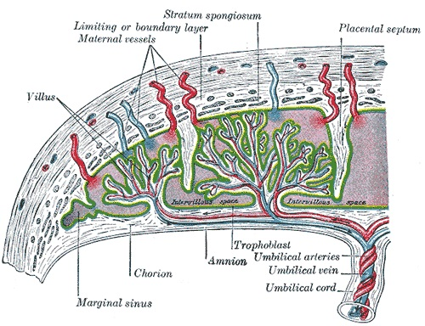](http://s3.amazonaws.com/teachmeseries/tmobgyn/wp-content/uploads/2016/08/22090339/Placental-Vasculature-Antiphospholipid-Syndrome..jpg)

Fig 2 – The vasculature of the placenta. Uteroplacental thrombosis (secondary to inherited thrombophilias or APS), is thought to be causative in some second trimester pregnancy loss.

**Risk Factors**

The epidemiology of recurrent miscarriage has been well established. Risk factors include:

* **Advancing maternal age** –there is a decline in both the number and quality of the remaining oocytes. Advanced paternal age (>40) has also been identified as a risk factor for miscarriage but the cause is less well understood. By age alone, the risk of miscarriage at age 20 is 11%, rising to 25% at age 35-39. The risk increases to 51% for age 40-44 and 93% if aged more than 45.
* **Number of previous miscarriages** – an independent risk factor for recurrent pregnancy loss. The risk of a further miscarriage increases after each successive pregnancy loss, reaching approximately 40% after three consecutive pregnancy losses. A previous live birth does not preclude a woman developing recurrent miscarriage.
* **Lifestyle** – maternal cigarette smoking, moderate to heavy alcohol intake and caffeine consumption have been associated with an increased risk of spontaneous miscarriage in a dose-dependent manner. However, although current evidence is insufficient to confirm this association.

**Investigations**

**Blood Tests**

* **Antiphospholipid antibodies***–*for the diagnosis of APS, it is mandatory that the woman has two positive tests at least 12 weeks apart for either lupus anticoagulant, anticardiolipin antibodies or anti-B2-glycoprotein antibodies.
* **Inherited thrombophilia screen**– including Factor V Leiden, prothrombin gene mutation and protein S deficiency.

**Genetic Tests (Karyotyping)**

* **Cytogenetic analysis** – this examines for any chromosomal abnormalities. It is performed on the products of conception of the third and subsequent consecutive miscarriage(s).
* **Parental peripheral blood karyotyping** – indicated when testing of products of conception reports an unbalanced structural chromosomal abnormality. It is performed on both partners.

**Imaging**

* **Pelvic ultrasound scan** – used to assess uterine anatomy.
  + If uterine anomalies are suspected, then further investigations may be required in order to confirm the diagnosis, by means of hysteroscopy, laparoscopy or three-dimensional pelvic ultrasound.

*Note: There is no test to demonstrate cervical weakness. Cervical length can be measured by ultrasound but this does not equate to strength.*

**Management**

All women with recurrent pregnancy loss should be referred to a specialist **recurrent miscarriage clinic**. Their management will depend on the underlying cause.

**Genetic Abnormalities**

Couples with an abnormal parental karyotype should be referred to a **clinical geneticist.**

Genetic counseling will offer the couple a prognosis for the risk of future pregnancies, and the opportunity for **familial chromosome studies**. Reproductive options will then include proceeding to a further natural pregnancy (with or without a prenatal diagnosis test), gamete donation and adoption.

Women with unexplained recurrent miscarriage are sometimes offered **preimplantation genetic screening** with in-vitro fertilisation treatment. However it has not been shown that this has any affect on live birth rates.

**Anatomical Abnormalities**

There are currently no published randomised trials to assess the benefit of surgical correction of uterine anomalies such as uterine septum resection on pregnancy outcome.

In some cases of cervical weakness, **cervical cerclage** (where a suture is used to close the cervix) may be indicated:

* Previous poor obstetric history (≥3x 2nd trimester losses).
* Cervical length shortening on USS (<25mm before 24/40 and a previous 2nd trimester loss).
* Symptomatic women with premature cervical dilatation and exposed fetal membranes in the vagina.

Complications of cervical cerclage include bleeding, **membrane rupture**, and stimulating uterine contractions. Hence, such a decision should be made with senior involvement and careful counselling of the woman.

Women with a history of second-trimester miscarriage and suspected cervical weakness who have not undergone cervical cerclage may be offered serial **cervical sonographic surveillance.**

[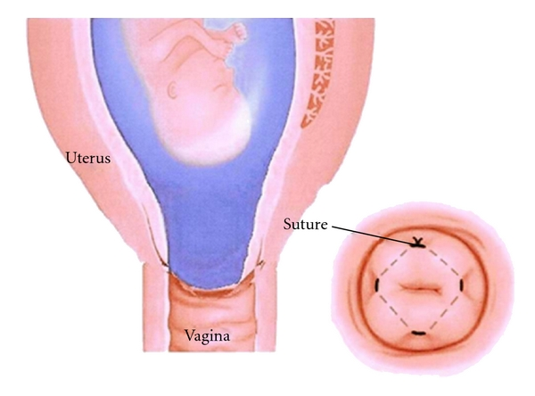](http://s3.amazonaws.com/teachmeseries/tmobgyn/wp-content/uploads/2016/09/22092645/Cervical-Cerclage-Recurrent-Miscarriage.jpg)

Fig 4 – Cervical cerclage, where a suture is used to close the cervix.

**Thrombophilias & Antiphospholipid Syndrome**

Women with **second**-trimester miscarriage associated with inherited thrombophilias may have an improved live birth rate with **heparin therapy** during pregnancy.

Treatment with **low-dose aspirin plus heparin** should be considered in pregnant women with antiphospholipid syndrome. There is no role for empirical anticoagulation in patients without a diagnosis of APS.

**Summary**

* A significant proportion of those with recurrent miscarriage remain unexplained and should be referred to a **recurrent miscarriage clinic.**
* Women should be screened for antiphospholipid syndrome and inherited thrombophilias. A **pelvic ultrasound** is necessary.
* **Cytogenetic analysis** on products of conception should also be performed on subsequent pregnancy losses.
* Women with **APS** are advised to have low-dose aspirin plus heparin antenatally.
* Heparin therapy is also considered in women with second-trimester miscarriage associated with **inherited thrombophilias**.
* **Cervical cerclage** may be indicated in certain women and senior involvement and careful counselling is advised as a benefit is not entirely clear.