**Pregnancy** can be a time of great excitement to the patient, but it can also be a time of danger, and there are certain serious illnesses of pregnancy to be aware of.

Below, we will provide a framework for capturing a basic **obstetric history**.

**Previous Obstetric History**

A good starting point is to ask about number of children the patient has given birth to. Next, sensitively ask about miscarriages, stillbirths, ectopics and terminations.

**Term Pregnancies**

For each previous pregnancy carried beyond 22 weeks, inquire about the following:

* **Gestation** – previous preterm labour is a risk factor for subsequent preterm labour.
* **Mode** of delivery – spontaneous vaginal, assisted vaginal or Caesarean.
* **Gender**
* **Birth weight** – a previous small for gestational age (SGA) baby increases the risk of a subsequent one.
* **Complications** – e.g. pre-eclampsia, gestational hypertension, gestational diabetes, obstetric anal sphincter injury (3rd, 4th degree tears), post-partum haemorrhage.
* **Assisted reproductive therapies** (ART) – e.g. ovulation induction with clomiphene, IVF.
* **Care providers** – was the patient’s care completely with a midwife or was there previous obstetric input, if so, why

ART pregnancies are often conceived after a long period of time and after much psychological distress; it is important to be aware of this. In addition, use of ARTs can increase the risk of pre-eclampsia during pregnancy.

**Other Pregnancies**

For pregnancies not carried beyond 22 weeks, inquire about:

* **Gestation** – miscarriages can be classified into early pregnancy (12 weeks or less) or second trimester (13-24 weeks).
* **Miscarriages** – outcome (spontaneous, medical management, surgical management – evacuation of retained products of conception).
* **Terminations** – method of management: medical or surgical.
* Identified **causes** of miscarriage / stillbirth – e.g. abnormal parental karyotype, fetal anomaly.

For ectopic pregnancies, ask about:

* **Site** of the ectopic
* **Management**: expectant (monitoring of serum hCG levels), medical (methotrexate injection), surgical (laparoscopy or laparotomy; salpingectomy (removal of tube) or -otomy (cutting of tube and suctioning of trophoblastic tissue))

**Gravidity and Parity**

**Gravidity** is the total number of pregnancies, regardless of outcome. **Parity** is the total number of pregnancies carried over the threshold of viability.

* Patient is currently pregnant; had two previous deliveries = G3 P2
* Patient is not pregnant, had one previous delivery = G1 P1
* Patient is currently pregnant, had one previous delivery and one previous miscarriage = G3 P1+1 (the +1 refers to a pregnancy not carried to 24+0).
* Patient is not currently pregnant, had a live birth and a stillbirth (death of fetus after 24+0) = G2 P2
* Patient is not pregnant, had a **twin** pregnancy resulting in two live births = G1 P1

**Current Pregnancy**

First, ask about the gestational age of the pregnancy. Gestation is described as weeks+days (e.g. 8+4; 30+7; 40+12 – post-dates).

The last menstrual period date (LMP) can be used to estimate gestation, with **Naegele’s rule** the most common method (to the first day of the LMP add 1 year, subtract 3 months, add 7 days). This can be imprecise, as it requires accurate recall of LMP dates as well as regular menstruation.

Instead, pregnancies are dated based on the **crown-rump length** (CRL), measured by ultrasound scan between 10+0 and 13+6. This way, we avoid unnecessary inductions for ‘post-dates’ based on LMP recalled later than in reality, and we can monitor labours where the LMP date suggests is over 37+0 but the scan suggests is preterm.

In the history of current pregnancy, ask about:

* Has there been use of **folate** prior to conception and currently
* Agreed **estimated date of delivery** (EDD): this date is when the woman will be 40+0.
* **Singleton** or **multiple** gestation.
* Uptake and results of **Down’s syndrome screening** (if scanned between 11+0 and 13+6).

At 18+0 to 20+6, women are offered a scan to check for **fetal anomalies**. Be sure to review the findings of this scan:

* **Fetal anomalies** – presence or absence.
* **Placenta position** – check it is clear of the internal os.
* **Amniotic fluid index** – oligohydroaminos, normal or polyhydraminos
* **Estimated fetal weight** – parameter for growth

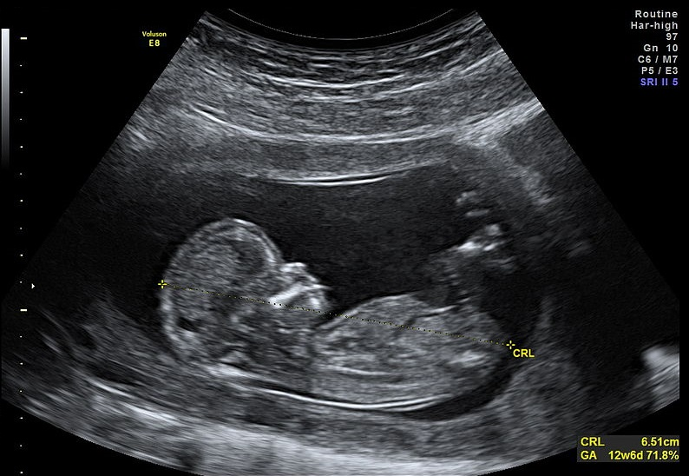

**Past Medical History**

Ask the usual questions about past medical history, abdominal or pelvic surgery and **mental health conditions**. Remember that the medical co-morbidities that are most likely to affect women of childbearing age include:

* Asthma
* Cystic fibrosis
* Epilepsy
* Hypertension (older women)
* Congenital heart disease
* Diabetes – check if type 1 or type 2
* Systemic autoimmune disease e.g. systemic lupus erythematosus (SLE), rheumatoid arthritis
* Haemoglobinopathies: sickle-cell disease, thalassaemias
* Blood-borne viruses: HIV, hepatitis B, hepatitis C

**Mental Health**

**Mental health** is extremely important – in the Saving Mothers’ Lives report covering 2011-2013, it was identified that nearly 25% of deaths occurring six months to a year post-partum were due to psychiatric causes. The same report advised the following as ‘**red flags**’ to arranging urgent senior psychiatric assessment:

* Recent significant **change in mental state** or emergence of **new symptoms**
* New thoughts or acts of **violent self-harm**
* New and persistent expressions of **incompetency** as a mother, or of **estrangement** from the infant

Inquire about **previous psychiatric disorder**, to include depression, anxiety disorders, bipolar affective disorder, schizophrenia, previous self-harm or suicide attempts.

**Drug History**

In addition to asking about drug **allergies** and intolerances, be aware that the embryonic (first 12 weeks) period of pregnancy is thought to be the time of most sensitivity for drugs to cause fetal structural defects (**teratogenicity**). Thus, inquire about drugs taken around conception and during the first 12 weeks.

Inquire about drugs currently being taken (include **herbal**/**complementary** therapies). Ask about illicit drugs and alcohol – recommend the patient to stop these drugs, and to offer referral to help-to-quit services too.

Recommend that the patient takes **400μg folic acid** per day for the first 12 weeks, to reduce the chance of the baby developing a neural tube defect.

**Family History**

Although not usually regarded as a substantial part of the obstetric history, there is increasing evidence that certain conditions are associated with adverse pregnancy outcomes.

Conditions such as cystic fibrosis and sickle-cell disease are **heritable** – the patient should be counselled as to the risk of her baby developing these conditions (based on the parental genotypes).

A family history of type 2 diabetes in a first degree relative is considered a risk factor for developing **gestational diabetes**.

[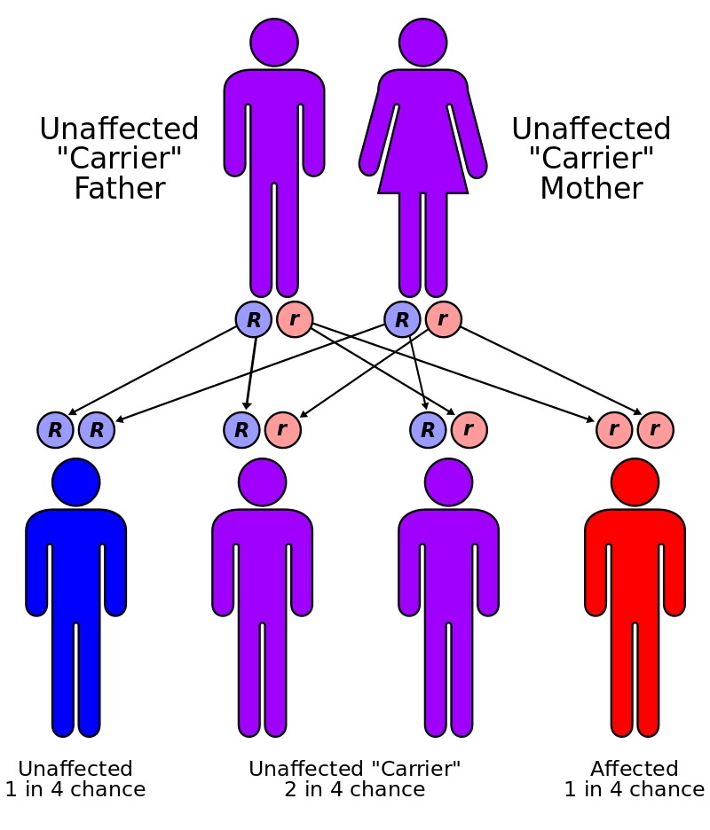](http://cdn1.teachmeseries.com/tmobgyn/wp-content/uploads/2016/08/22090348/Cystic-Fibrosis-Family-History.jpg)

Fig 2 – Mode of inheritance of autosomal recessive conditions, such as cystic fibrosis.

**Social History**

Pregnancy can be a time of great elation, intense anxiety – and quite possible a mixture of anything and everything between. Ask the patient about her **thoughts of the pregnancy**; be sensitive if the pregnancy is **unplanned**.

Ask about current / previous **occupation**, and plans for returning to work (or otherwise).

Inquire about **home circumstances**: e.g. who does the patient live with – partner / spouse? Children in the home? Ask also about support networks, e.g. parents / in-laws, neighbours, friends.

Inquire about **financial circumstances** – the cost of caring for a child in addition to being out of work can potentially have an adverse impact on the patient’s ability to cope financially. Is the patient eligible for social security / child benefit payments?

Ask about **smoking** – how many per day; what drug (tobacco, cannabis, others); duration of smoking. Would the patient like to quit, and would they like help with this? Reiterate the association between smoking and small-for-gestational-age babies, and offer her help to quit.

It is also important to remember that at least once during the course of the pregnancy, women should be asked whether they are victim to **domestic abuse**.

The **obstetric examination** is a type of abdominal examination performed in pregnancy.

It is unique in the fact that the clinician is simultaneously trying to assess the health of two individuals – the mother and the fetus.

In this article, we shall look at how to perform an obstetric examination in an OSCE-style setting.

**Introduction**

* Introduce yourself to the patient
* Wash your hands
* Explain to the patient what the examination involves and why it is necessary
* Obtain verbal consent

**Preparation**

* Measure the patient’s height and weight
* Patient should have an empty bladder
* Expose the abdomen from the xiphisternum to the pubic symphysis
  + Cover above and below where appropriate
* Ask the patient to lie in the supine position with the head of the bed raised to 15 degrees
* Prepare your equipment: measuring tape, pinnard stethoscope or doppler transducer, ultrasound gel

**General Inspection**

* General wellbeing – at ease or distressed by physical pain.
* Hands – palpate the radial pulse.
* Head and neck – melasma, conjunctival pallor, jaundice, oedema.
* Legs and feet – calf swelling, oedema and varicose veins.

**Abdominal Inspection**

In the obstetric examination, inspect the abdomen for:

* Distension compatible with pregnancy
* Fetal movement (>18-20 weeks)
* Surgical scars – previous Caesarean section, laproscopic port scars
* Skin changes indicative of pregnancy – linea nigra (dark vertical line from umbilicus to the pubis), striae gravidarum (‘stretch marks’), striae albicans (old, silvery-white striae)

[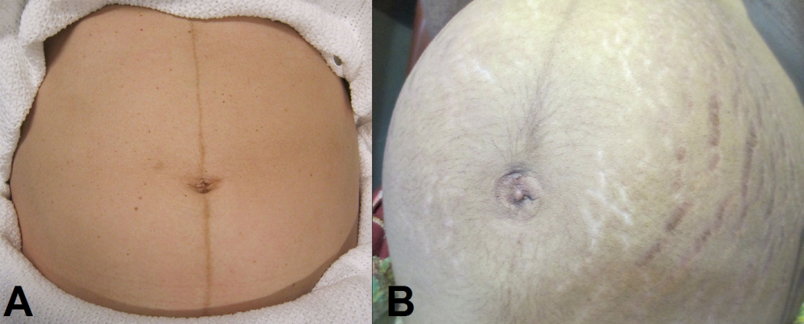](http://cdn1.teachmeseries.com/tmobgyn/wp-content/uploads/2016/10/22092459/Skin-Changes-in-Pregnancy-Linea-Nigra-and-Striae-Gravidarum-and-Albicans-1024x413.png)

Fig 1 – Skin changes in pregnancy. A) Linea nigra. B) Striae gravidarum and albicans.

**Palpation**

Ask the patient to comment on any tenderness and observe her facial and verbal responses throughout. Note any guarding.

**Fundal Height**

* Use the medial edge of the left hand to press down at the xiphisternum, working downwards to locate the fundus.
* Measure from here to the pubic symphysis in both cm and inches. Turn the measuring tape so that the numbers face the abdomen (to avoid bias in your measurements).
* Uterus should be palpable after 12 weeks, near the umbilicus at 20 weeks and near the xiphisternum at 36 weeks (these measurements are often slightly different if the woman is tall or short).
* The distance should be similar to gestational age in weeks (+/- 2 cm).

**Lie**

* Facing the patient’s head, place hands on either side of the top of the uterus and gently apply pressure
* Move the hands and palpate down the abdomen
* One side will be feel fuller and firmer – this is the back. Fetal limbs may be palpable on the opposing side

[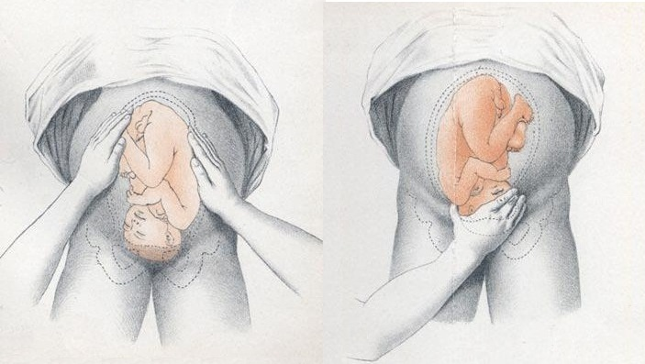](http://cdn1.teachmeseries.com/tmobgyn/wp-content/uploads/2016/10/22092457/Obstetric-Examination-Assessing-Fetal-Lie-and-Presentation.jpg)

Fig 2 – Assessing fetal lie and presentation.

**Presentation**

* Palpate the lower uterus (below the umbilicus) to find the presenting part.
* Firm and round signifies cephalic, soft and/or non-round suggests breech. If breech presentation is suspected, the fetal head can be often be palpated in the upper uterus.
* Ballot head by pushing it gently from one side to the other.

**Liquor Volume**

* Palpate and ballot fluid to approximate volume to determine if there is oligohydraminos/polyhydramnios
* When assessing the lie, only feeling fetal parts on deep palpation suggests large amounts of fluid

**Engagement**

* Fetal engagement refers to whether the presenting part has entered the bony pelvis
* Note how much of the head is palpable – if the entire head is palpable, the fetus is unengaged.
* Engagement is measured in 1/5s

[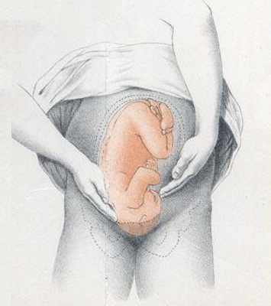](http://cdn1.teachmeseries.com/tmobgyn/wp-content/uploads/2016/10/22092458/Obstetric-Examination-Assessing-Fetal-Engagement.jpg)

Fig 3 – Assessing fetal engagement.

**Fetal Auscultation**

* Locate the back of the fetus to listen for the fetal heart, aim to put your instrument between the fetal scapulae to aim toward the heart.
  + Hand-held Doppler machine >16 weeks (trying before this gestation often leads to anxiety if the heart cannot be auscultated).
  + Pinard stethoscope over the anterior shoulder >28 weeks
* Feel the mother’s pulse at the same time
* Measure fetal HR for one minute
  + Should be 120-160bpm (>22 weeks)

**Completing the Examination**

* Palpate the ankles for oedema and test for hyperreflexia (pre-eclampsia)
* Thank the patient and allow them to dress in private
* Wash your hands
* Summarise findings
* Perform:
  + Blood pressure
  + Urine dipstick

The **bimanual examination** (also known as a pelvic examination) is an examination of the female genital organs.

In this article, we shall look at how to perform a bimanual examination in an OSCE-style setting.

**Introduction**

* Introduce yourself to the patient
* Wash your hands
* Explain to the patient what the examination involves and why it is necessary
  + Reassure that it should not be painful but you will stop immediately if it becomes too uncomfortable
* Obtain verbal consent
* Request a chaperone

**Preparation**

* Patient should have an empty bladder
* Ask the patient to remove clothing from the waist down and any sanitary protection
  + Cover with a sheet when appropriate
* When ready, ask the patient to lie on the couch on their back, with knees bent and apart.
  + Note that any abdominal inspection and palpation should be performed before this step.

**Abdominal Examination**

* Inspect the abdomen for scars and ascites
* Palpate the abdomen for masses and tenderness
* Palpate the groin for inguinal lymphadenopathy

**External Examination**

* Put on gloves
* Inspect the external genitalia and perineum for:
  + Deficiency associated with childbirth
  + Abnormal secondary sexual characteristics – hair distribution, cliteromegaly (associated with hyperandrogenism)
  + Skin abnormalities – lesions, warts, erythema
  + Discharge – colour, consistency
  + Bleeding
  + Swellings of the vulva – tumours, cysts (sebaceous, Bartholin’s)
* Ask the patient to cough to observe any incontinence or prolapse
* Palpate the labia majora with the index finger and thumb

**Bimanual Examination**

* Use lubricating gel to lubricate the right index finger and middle finger
* Ensure the patient is still happy to proceed, and gently insert fingers into the vagina
  + Enter with the palm facing sideways, then rotate so the palm is facing upwards
  + In practice, you can use one finger for the whole examination. However, for OSCE/examination purposes, two fingers should be used (unless the presenting complaint is that partner cannot enter / pain during sex).
* Move along the posterior wall of the vagina and locate the cervix and feel for:
  + Smoothness, clots, mobility and firmness
* Place fingers in the posterior fornix to lift the uterus whilst simultaneously pushing the fundus down by placing the left hand above the symphysis pubis.
  + Assess uterus size (a normal uterus is approximately the size of a plum)
  + Determine if anteverted or retroverted
  + Note tenderness, mobility and shape
* Place the fingers in the lateral fornix and press lateral to the umbilicus to feel for any adnexal tenderness or masses (repeat on the other side)
* Gently move the cervix from side to side to check for cervical tenderness (important sign with ectopic pregnancy or pelvic inflammatory disease).
* Remove fingers gently and inspect for discharge or blood

[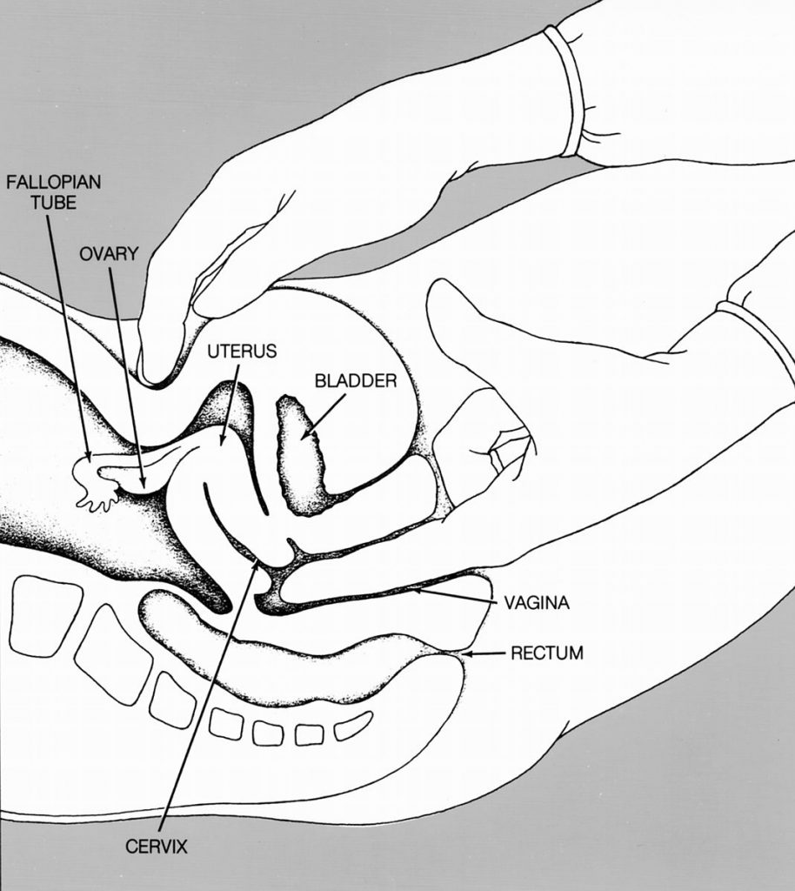](http://cdn1.teachmeseries.com/tmobgyn/wp-content/uploads/2016/10/22092501/Bimanual-Pelvic-Examination-914x1024.jpg)

Fig 2 – The bimanual examination. One hand lifts the uterus, whilst the other pushes the fundus down.

**Completing the Examination**

* Thank the patient and allow them to get dressed in private
* Remove your gloves and wash your hands
* Summarise findings and suggest further investigations (usually a pelvic ultrasound +/- bloods depending on the history and findings)